数字逻辑（双语）第二次平时测试题（2020年下学期）

1. Choose the best answer from the four choices. (20 points)
1) Compare two the binary numbers A=A₀A₁ and B=B₀B₁, output F=1 while A>B, then the expression of F is ( )
（A）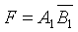 （B）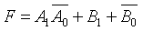
（C）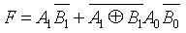 （D）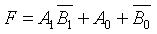
2) With the inputs A=1, B=0, Cin=1, the outputs of the Full Adder is ( ).
(A) Cout=0, Sum=0 (B) Cout=1, Sum=0;
(C) Cout=0, Sum=1 (D) Cout=1, Sum=1;
3) The inputs of 74HC85 magnitude comparator are A = 1000 and B = 1010, the outputs are ( A )
(A) A > B = 0, A < B = 1, A = B = 0 (B) A > B = 0, A < B = 0, A = B = 1
(C) A > B = 0, A < B = 0, A = B = 0 (D) A > B = 0, A < B = 1, A = B = 1
4) If a 1-of-16 decoder with active-LOW outputs exhibits a LOW on the decimal 12 output, what are the inputs? ( C )
(A) A3A2A1A0 = 1010 (B) A3A2A1A0 = 1110
(C) A3A2A1A0 = 1100 (D) A3A2A1A0 = 0100
5） If an octal-to-binary priority encoder has its 0, 2, 5, and 6 inputs at the active level, the active- HIGH binary output is ( ).
(A) 110 (B) 000 (C) 101 (D) 010
2. Design a logic circuit to implement the Gray-to-Binary code conversion specified in the following table. (20 points)
Gray Code | Binary Code
000 | 000
001 | 001
011 | 010
010 | 011
110 | 100
111 | 101
101 | 110
100 | 111

3. Implement the logic expression F = f( a,b,c,d ) = ( 0,3,4,5,7,9,13,15 ) using a 8-input data selector. (16 points)

4. Use one 8-1 multiplexer(74LS151) to implement the following function. (20 points)
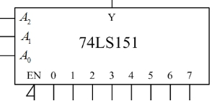

5. Analyse the logic function of the combinational circuit composed of a dual four-input multiplexer. The diagram is shown in Figure (a), and use the 74LS138 decoder in Figure (b) to implement it again. The requirements are as follows: (24 points)
- Give the truth table, and write the logic eqations.
- Explain the logic fuction.
- Draw the circuit according to Figure (b)
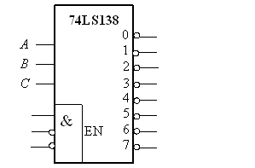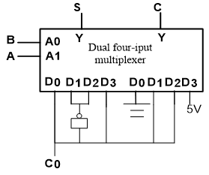
(a) (b)

