数字逻辑（双语）第二次测试题（2020年下学期）

1. Choose the best answer from the four choices. (20points)
1) Compare two the binary numbers A=A₀A₁ and B=B₀B₁, output F=1 while A>B, then the expression of F is ( )
（A）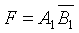 （B）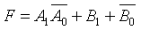
（C）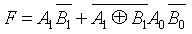 （D）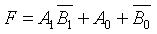
2) With the inputs A=1, B=0, Cin=1, the outputs of the Full Adder is ( ).
(A) Cout=0, Sum=0 (B) Cout=1, Sum=0;
(C) Cout=0, Sum=1 (D) Cout=1, Sum=1;
3) The inputs of 74HC85 magnitude comparator are A = 1000 and B = 1010, the outputs are ( )
(A) A > B = 0, A < B = 1, A = B = 0 (B) A > B = 0, A < B = 0, A = B = 1
(C) A > B = 0, A < B = 0, A = B = 0 (D) A > B = 0, A < B = 1, A = B = 1
4) If a 1-of-16 decoder with active-LOW outputs exhibits a LOW on the decimal 12 output, what are the inputs? ( )
(A) A3A2A1A0 = 1010 (B) A3A2A1A0 = 1110
(C) A3A2A1A0 = 1100 (D) A3A2A1A0 = 0100
5） If an octal-to-binary priority encoder has its 0, 2, 5, and 6 inputs at the active level, the active- HIGH binary output is ( ).
(A) 110 (B) 000 (C) 101 (D) 010
2. Design a logic circuit to implement the Gray-to-Binary code conversion specified in the following table. (20 points)
Gray Code | Binary Code
000 | 000
001 | 001
011 | 010
010 | 011
110 | 100
111 | 101
101 | 110
100 | 111
解：这是一个 3 输入 3 输出的问题，设格雷码由高到低各位为 a，b，c，而对应二进制码由高到底各位为 x，y，z。（2 分）
列真值表如下：（4 分）
输入 |  |  | 输出
a | b | c | x | y | z
0 | 0 | 0 | 0 | 0 | 0
0 | 0 | 1 | 0 | 0 | 1
0 | 1 | 1 | 0 | 1 | 0
0 | 1 | 0 | 0 | 1 | 1
1 | 1 | 0 | 1 | 0 | 0
1 | 1 | 1 | 1 | 0 | 1
1 | 0 | 1 | 1 | 1 | 0
1 | 0 | 0 | 1 | 1 | 1
列出方程：（方程和化简，各3 分，共 9 分）
x=abc’+abc+ab’c+ab’c’= ∑m(4，5，6，7) =a
y=a’bc+a’bc’+ab’c+ab’c’ = ∑m(2，3，6，7) =a’b+ab’=ab
z=a’b’c+a’bc’+abc+ab’c’ = ∑m(1，3，5，7) = abc
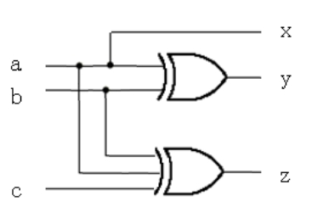 （图 5分）
3. Implement the logic expression F = f( a,b,c,d ) = ( 0,3,4,5,7,9,13,15 ) using a 8-input data selector. (16 points)
解：用 a、b、c 作为 8-1 多路器选择变量，利用真值表或卡诺图来确定多路器输入 Di 与变量 d 的关系（4 分，或写出多路复用器通用逻辑函数也得1分），得到：
D0= d’，D1= d，D2= 1，D3= d，D4= d，D5= 0，D6= d，D7= d（8 分）
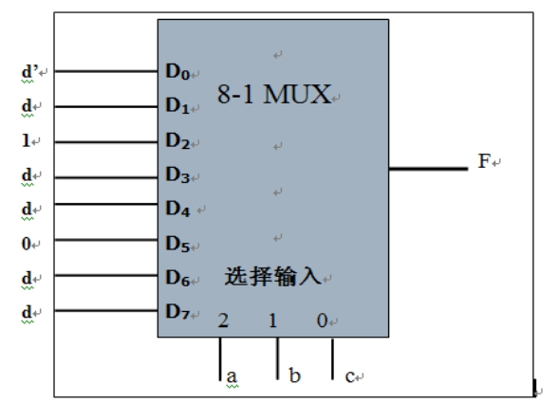
连接图如下：（画图正确得 4 分）
4. Use one 8-1 multiplexer(74LS151) to implement the following function. (20 points)
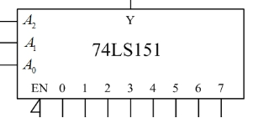
Answer：
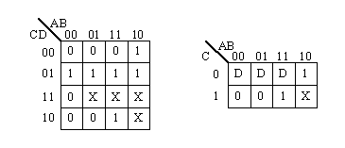
(5 points) （用真值表也可以）
Y= A₂’A₁’A₀’D₀+A₂’A₁’A₀D₁+A₂’A₁A₀’D₂+A₂’A₁A₀D₃+A₂A₁’A₀’D₄+ A₂A₁’A₀D₅+ A₂A₁A₀’D₆+ A₂A₁A₀D₇ =∑m_{i}D_{i} (5 points)

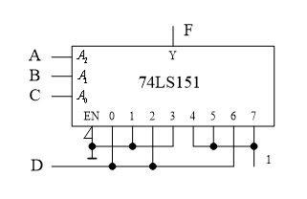(4 points)
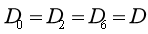 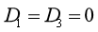 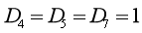 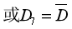 (6 points)
5. Analyse the logic function of the combinational circuit composed of a dual four-input multiplexer. The diagram is shown in Figure (a), and use the 74LS138 decoder in Figure (b) to implement it again. The requirements are as follows: (24 points)
- Give the truth table, and write the logic eqations.
- Explain the logic fuction.
- Draw the circuit according to Figure (b)
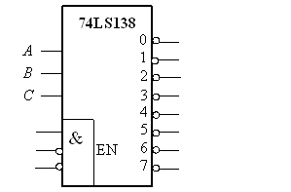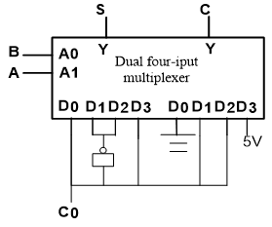
(a) (b)

(1) 真值表和表达式（真值表6分，表达式6分）
A | B | S | C
0 | 0 |  | 0
0 | 1
1 | 0
1 | 1 |  | 1
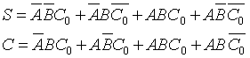
(2) 电路说明：电路实现全加器功能。S为全加器的和，C显示进位。（6分）
(3) 逻辑图（6分）
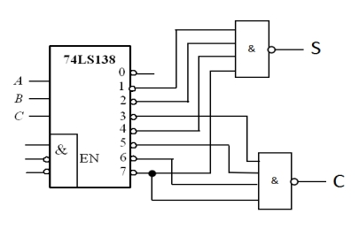
（后面两个与非门改为非或门也可以）

