数字逻辑（双语）第二次测试题（2023年下学期231129）

1. Choose the best answer from the four choices. (20 points)
1) To make the 3-8 decoder (74LS138) work properly, the level signal of the input pins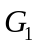、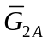、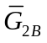 should be ( ).
(A) 100 (B) 111 (C) 011 (D) 000
2) 8 channel data selector, of which address input (select control) have ( ).
(A) One (B) Two (C) Three (D) Four
3) The inputs of 74HC85 magnitude comparator are A = 1000 and B = 1010, the outputs are ( )
(A) A > B = 0, A < B = 1, A = B = 0 (B) A > B = 0, A < B = 0, A = B = 1
(C) A > B = 0, A < B = 0, A = B = 0 (D) A > B = 0, A < B = 1, A = B = 1
4) If a 1-of-16 decoder with active-LOW outputs exhibits a LOW on the decimal 12 output, what are the inputs? ( )
(A) A₃A₂A₁A₀ = 1010 (B) A₃A₂A₁A₀ = 1110
(C) A₃A₂A₁A₀ = 1100 (D) A₃A₂A₁A₀ = 0100
5） If an octal-to-binary priority encoder has its 0, 2, 5, and 6 inputs at the active level, the active- HIGH binary output is ( ).
(A) 110 (B) 000 (C) 101 (D) 010
2. Design a logic circuit to implement the Gray-to-Binary code conversion specified in the following table. (20 points)
Gray Code | Binary Code
000 | 000
001 | 001
011 | 010
010 | 011
110 | 100
111 | 101
101 | 110
100 | 111

3. Implement the logic expression F = f( a,b,c,d ) = ( 0,3,4,5,7,9,13,15 ) using a 8-input data selector. (16 points)
4. Use one 8-1 multiplexer(74LS151) to implement the following function. (20 points)
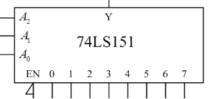

5. Analyse the logic function of the combinational circuit composed of a dual four-input multiplexer. The diagram is shown in Figure (b), and use the 74LS138 decoder in Figure (b) to implement it again. The requirements are as follows: (24 points)
- Give the truth table, and write the logic equations.
- Explain the logic function.
- Draw the circuit according to Figure (b)
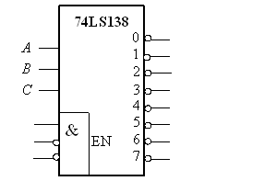
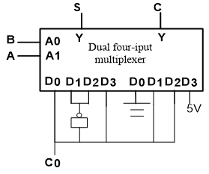
(a) (b)

