Appendices 1 - RevisedProjectProposal

CISC 7204 - Data Science and Data Visualization

Revised
Project Proposal

Course | CISC 7204 - Data Science and Data Visualization
Project | Assignment 02 - PairProject02
Item | Revised Pair Project Proposal
Student Name | DENG BORUI | XIE ZHIQUAN
Student ID | MC635364 | MC636838
Date | 24th, October, 2026

Project Topic and Research Questions
Project title:
Identifying and Analyzing Governance Pain Points and Incidents
of E-bikes Based on Online Community Platform Data:
A Case Study of Guangzhou, China
Project summary:
This revised pair proposal develops the preliminary study into a reproducible data science project. We will examine public online discussions about electric bicycles (e-bikes) and their governance in Guangzhou. The project will organize the material into a documented dataset, describe the concerns and viewpoints that appear in it, test the reliability of assisted text classification, and present the findings through readable charts and a carefully qualified map. The unit of analysis is a post or comment. A statement describing an accident or unsafe condition will be treated as a report or claim in the discussion unless it can be independently verified; online discussion counts will not be presented as official incident counts.
Research Background and Study Area
The project responds to the practical challenge of governing a fast-growing mode of urban travel. E-bikes support daily trips, food delivery, and express logistics, but their interactions with cars, buses, pedestrians, and limited curb space can produce conflicts over road use, parking, charging, safety, and enforcement. The Preliminary Proposal described Guangzhou as a representative study area and cited a municipal planning document reporting 6.512 million registered e-bikes and an average of 9.68 million daily trips. These figures are retained as contextual figures from that cited source, rather than treated as a current measurement produced by this project^{[2]}.
Guangzhou is suitable for a spatially focused case study because the original proposal identifies the city’s large travel demand, varied urban form, and distinct administrative districts as relevant conditions. The project will use the same citywide study boundary shown in Figure 1. The map provides geographic context; it does not imply that every district is equally represented in the online material. We will record which districts and smaller places are named in the collected posts and report coverage gaps alongside any spatial summaries.
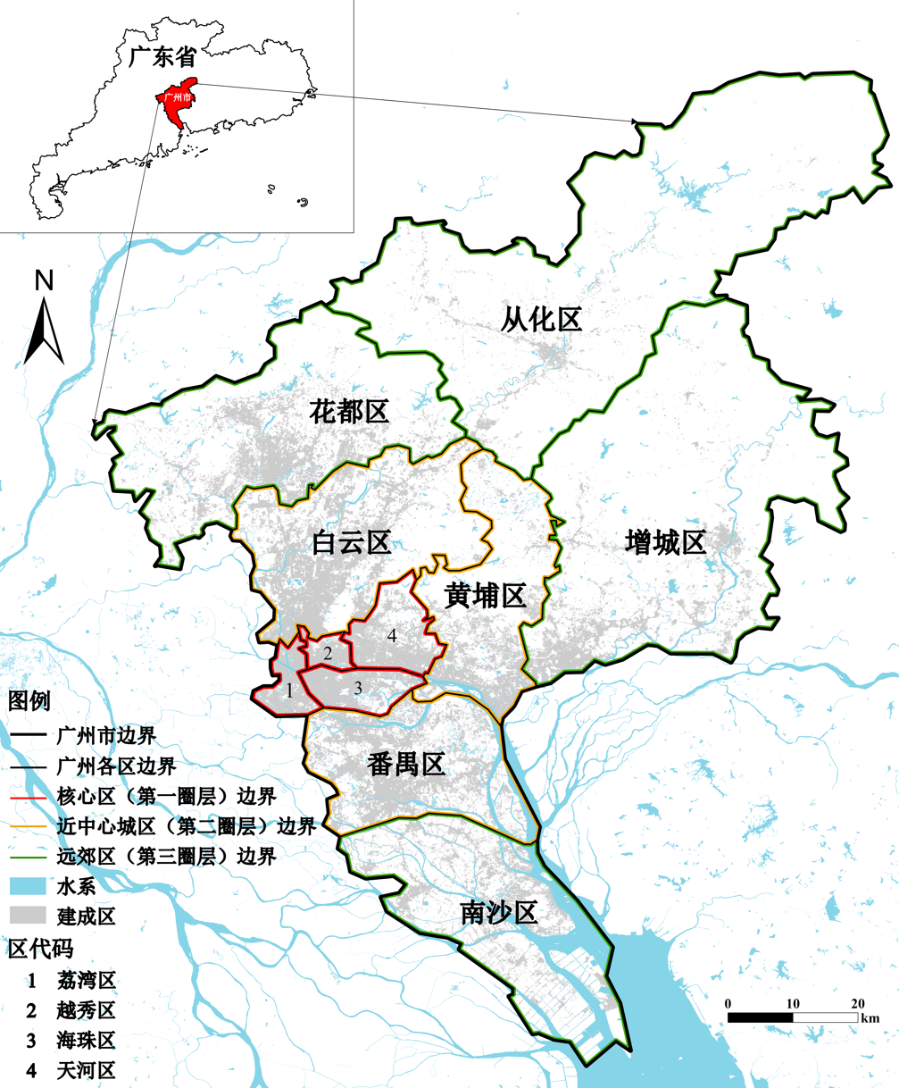
Fig. 1 Research area
Research Questions
RQ1. Stakeholder viewpoints: Which attitudes, requests, and concerns are expressed by identifiable road-user and governance groups, and what recurring points of agreement or conflict appear among them?
RQ2. Governance concerns: Which e-bike governance problems and reported incidents recur in the sampled discussions, and how does the composition of those discussions vary across the observed collection period when reliable dates are available?
RQ3. Place and response: Which Guangzhou districts or specific places are mentioned in relation to these concerns, and what targeted governance responses are consistent with the evidence and its limitations?
The questions move from description to interpretation. The first identifies the groups and positions visible in the data. The second organizes the issues raised and distinguishes an opinion, a general complaint, and a report of a particular event. The third links those coded issues to place mentions and uses the resulting evidence to frame possible responses. Together they provide a clear route from raw text to analysis and recommendation.
Scope and Unit of Analysis
The study covers public RedNote search results associated with a preselected set of 15 Guangzhou e-bike topics and the public comments collected with those results, subject to access rules and applicable course or University requirements. The final search terms and collection dates will be recorded in a data dictionary before analysis. Each eligible post or comment will be one record. If a post contains several distinct claims, the record may receive more than one issue label, while its text remains one observation for volume counts. Reposts and duplicate text will be handled using documented deduplication rules.
The design is an observational case study of platform discussion. The platform’s users are self-selected, search ranking may affect what is visible, and the collection method may omit deleted, private, or otherwise inaccessible content. Consequently, the project can describe patterns in the collected material but cannot estimate the prevalence of views among all Guangzhou residents or the actual rate of e-bike crashes, fires, or traffic violations. These boundaries will be stated in the report and shown in figure notes where they matter.
Project Purpose
Outcomes. The project applies the course's data science and data visualization methods to a real text-analysis problem. It combines data preparation, descriptive analysis, classification, validation, and geographic presentation in a traceable workflow. The purpose is not to use an automated model as a substitute for research judgment. Instead, the model will help organize a large collection of text into candidate labels that can be checked against a manually annotated sample and interpreted with explicit uncertainty.
Skills. For the student team, the work will strengthen practical skills in collecting and documenting data, cleaning noisy records, designing a codebook, evaluating categorical predictions, and selecting visual forms that match the data.
Knowledge. The work will also support the broader research interests in intelligent governance and urban public opinion described in the preliminary proposal, and build working knowledge of text classification, model validation and spatially referenced social-media data. The revised plan places reproducibility and restraint in interpretation alongside technical breadth.

Project Tasks and Methods
1. Data acquisition and search-term control
The team will begin with the 15 Guangzhou e-bike search topics represented in Figure 2. The original figure is retained as supplied in Assignment 01. Before collection, the pair will review the exact phrases, record spelling variants and colloquial terms, and freeze the final search list. A short pilot will check whether the terms return material relevant to the research questions. Any change after the pilot will be logged with its reason so that the final scope is auditable.
Collection will be limited to content that the team can access through ordinary public platform use and methods permitted by platform rules and University guidance. The plan does not include private messages, access controls, or collection of information unnecessary to the analysis. Where permitted collection methods or research requirements are unclear, the team will resolve them before collecting records. The raw extract will be stored separately from the cleaned analysis table and will not be redistributed unless the content and applicable rules allow it.
For each record, the working schema will include a project record key, post or comment type, the relevant search term, publication date when visible, text needed for coding, and engagement counts only when they are available and useful. We will not make account names, profile links, or other direct account identifiers analytical fields. The team will preserve the minimum text required for validation in controlled working files, then use coded and aggregated results in figures and the report.

2. Cleaning and record preparation
Preprocessing will be performed in a reproducible Python workflow. The team will standardize whitespace and text encoding, identify blank or near-blank records, remove material outside the study scope, and flag advertising or promotional content according to a written rule. Exact duplicates will be removed. Near-duplicates and reposts will be identified through a documented similarity check and reviewed where the decision could change counts. Every cleaning step will report the number of records affected so that the reader can trace how the initial extract becomes the final analysis dataset.
The raw extract will be retained as a read-only source version when permitted. The cleaned table will use one row per post or comment and a stable project record key that does not expose a platform account identifier. Missing dates, ambiguous place names, and unavailable engagement fields will remain explicitly missing rather than being filled by guesswork. A data dictionary will define field names, accepted values, missing-value codes, and all exclusion decisions.
3. Validation sample and manual annotation
After cleaning, 10 percent of eligible records will be selected at random for a validation dataset using a recorded random seed. The remaining records will form the analysis dataset. The sample split will be generated once and saved so that later work does not silently move records between the two sets. If the collection is large enough to contain rare but important categories, the team will also report how many examples of those categories occur in the random sample; it will not claim reliable performance for a class that has too few examples.
Both team members will apply the codebook to the validation records independently before reviewing model labels. They will compare their annotations, discuss disagreements, and keep a log of the final adjudicated labels and the reason for each material change. This step provides a human reference for evaluating model-assisted coding and reveals where category definitions need clarification. Any refinement to the codebook will be documented, and the final model evaluation will use labels that were not used to tune individual predictions.
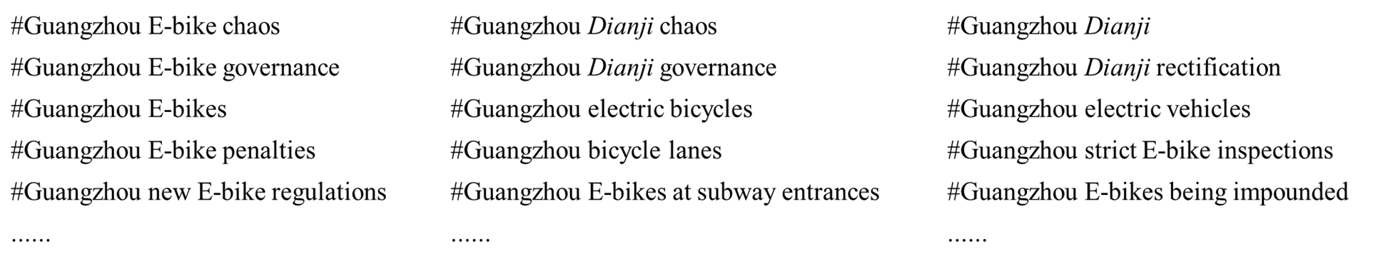
Fig. 2 Popular hashtags related to e-bike topics in Guangzhou on RedNote APP
Analysis, Validation, and Results Presentation
1. Coding framework
The codebook will organize the text into three linked layers, consistent with the preliminary plan. The text-attribute layer will identify a speaker group only when the text makes it reasonably clear, and will describe the expressed position or attitude as supportive, critical, mixed, neutral or informational, or unclear. The category “unclear” will be retained where the text does not justify an inference. The analysis will not infer a person’s identity or occupation from an account profile.
The topic layer will assign one or more governance issue labels. Candidate groups include road-use conflicts and unsafe riding, crashes or near misses reported by users, parking and obstruction, charging or fire concerns, infrastructure and access, enforcement or regulation, delivery work, and public education. These are starting categories drawn from the preliminary topic, not assumed findings. The final codebook will define inclusion and exclusion rules, give short anonymized examples where permitted, and add a new category only when repeated material cannot be represented responsibly by an existing label.
The location layer will extract place names explicitly stated in a post or comment. Mentions will be normalized to a city, district, road, junction, neighborhood, or facility where the text supports that level of precision. Ambiguous names will be marked uncertain or left unmapped. The team will not infer a location from an author profile, photograph metadata, or other information outside the approved record. A mention of a place indicates where a discussion says a concern occurred; it is not proof that the event happened there.
2. Model-assisted coding and reliability checks
A large language model may be used to propose labels and extract explicit place mentions from the analysis dataset. Before the analysis run, the team will record the model name and version, access date, relevant settings, prompt, output schema, and any retry or failure rules. The prompt will request a controlled response with a label, a short evidence span from the text, and an uncertainty flag. The model will be instructed to return “unclear” when evidence is insufficient and not to add facts, identities, or locations that are absent from the text.
The validation sample will provide a held-out comparison between model suggestions and adjudicated human labels. For the categorical text-attribute layer, the report will show a confusion matrix, accuracy, precision, recall, and F1-score, both overall and by class when sample sizes permit. Macro-averaged results will be included so that common categories do not hide weak performance on less frequent categories. The report will distinguish a zero or undefined class score caused by no predictions from a genuine measured score and will state the number of validation examples behind each result.
Topic labels will be evaluated at the level of each category because a record may carry multiple labels. The team will report per-category precision, recall, and F1-score and inspect false positives and false negatives on the validation sample. Location extraction will be evaluated separately using exact matches and normalized district-level matches. The report will explain the matching rules. Disagreements will be reviewed to locate systematic errors such as colloquial names, sarcasm, implicit subjects, or place names that refer to several locations.
If the model performs poorly for a category or produces unstable place labels, the team will not use its unreviewed outputs to support recommendations. The affected category will be manually coded where feasible, shown as exploratory, or excluded from location-specific claims. The final report will include both aggregate performance and concrete examples of the error types, with sensitive text paraphrased rather than reproduced verbatim.
3. Descriptive analysis and visualizations
The visualization plan will connect each figure to a research question and state the denominator, time period, and unit being counted. A collection-flow diagram will show the number of records retrieved, excluded, deduplicated, sampled for validation, and retained for analysis. This makes the transformation from source material to final dataset visible and helps readers distinguish data volume from substantive prevalence.
A time-series chart will summarize post and comment volume by week or month when the date coverage is sufficiently complete. It will show the actual collection period and will not use gaps or uneven collection intensity to imply a real change in public concern. A ranked horizontal bar chart will compare issue counts and shares, with the denominator and the possibility of multiple labels per record stated in its caption. A stakeholder-by-issue heat map will compare the mix of coded concerns across groups while displaying group sample sizes.
A flow diagram or Sankey-style chart may show how records move from stakeholder and attitude labels to issue categories, provided the layout remains readable and the links are not interpreted as causal relationships. A map will display only place mentions that can be normalized with adequate confidence. District-level aggregation will be preferred when a precise point could be misleading or unnecessarily revealing. The map legend will say “discussion mentions” or equivalent, rather than “incident rate,” and will include the number of mapped records and the fraction that could not be geocoded.
The validation visuals will include the required confusion matrix and a compact chart of per-class precision, recall, and F1-score. Each figure will use legible axis labels, a consistent category palette, descriptive titles, and captions that explain whether values are counts, shares, or model metrics. We will use bar, line, matrix, flow, and map forms only where they answer a question more clearly than a simpler alternative. The final report will include the selected figures in a coherent sequence rather than presenting every exploratory chart.
4. Interpretation and governance recommendations
Recommendations will be developed only after the data quality and validation results are reviewed. For each proposed response, the report will name the coded concern, summarize the evidence supporting it, identify the relevant group or type of place when supported, and state the limitation that remains. A recurrent complaint about parking, for example, could motivate a recommendation to examine parking provision in the named areas; it would not by itself demonstrate the scale of obstruction across the city.
The project will distinguish recommendations that are broadly supported by repeated discussion from those that are tentative or specific to a small number of records. It will consider the perspectives of riders, delivery workers, pedestrians, drivers, and public agencies only where those perspectives are represented in the data. It will not portray an online platform as a complete consultation sample or convert an individual allegation into a verified incident. Any policy suggestion will be framed as an evidence-informed option for further review, not as a causal conclusion from observational text.
Ethics, Privacy, and Study Limitations
Publicly visible text can still contain personal information. The team will minimize the fields collected, remove direct account identifiers from analysis files, limit access to the raw extract, and avoid publishing verbatim posts or comments that could be searched to identify an author. The written report and slides will use aggregate counts, short paraphrases, and generalized locations where needed. Retention and sharing of raw material will follow applicable platform rules, University guidance, and any course requirements. The pair will resolve any required approval or permissions before collection begins.
Several limitations are expected. Search results are not a probability sample; ranking, deletion, account activity, and term choice can shape the collected records. Some users may post repeatedly, and public discussion can overrepresent unusually positive or negative experiences. Automated labels can misread irony, slang, context, and mixed positions. Place names can be vague or duplicated. The project will report the collection dates and search terms, keep an audit trail, quantify missingness and unmapped records, evaluate model performance, and restrict claims to the records observed. These limitations will appear in the conclusion and alongside relevant visualizations, not only in a footnote.

Project Criteria for Success
The project will be successful if the three research questions are answered with a transparent chain from collection to interpretation. The collection and cleaning log must account for record counts; the data dictionary and codebook must define the fields and labels; the validation sample must be reproducible from a recorded seed; and the model evaluation must include per-class evidence and sample counts. Every map and chart must be readable, properly labeled, and explicit about whether it represents records, shares, or predictions.
Conclusions must be consistent with the observed text and the limitations of platform sampling. The team will not interpret online discussion volume as a citywide opinion estimate, a verified accident count, or a causal measure of governance performance. If a model category or place extraction does not meet a defensible quality threshold, the report will narrow that result or use human-reviewed labels instead. Code, prompts, intermediate files, and final figures must be organized so that another student can follow the analytical steps without access to private credentials or account data.

Deliverables
The final package will include the study-area map and a concise research-framework diagram; a data dictionary and versioned record of search terms and collection dates; the raw and cleaned CSV files where storage and distribution are permitted; the validation and analysis split; the codebook and annotation guidance; the recorded model prompt and settings; and a reproducible Python code package for cleaning, sampling, model evaluation, descriptive analysis, and visualization.
The presentation materials will include the collection-flow figure, issue and stakeholder summaries, the model-validation confusion matrix and per-class metrics, and the map of supported place mentions. Each figure will be available in a report-ready format with a source note and caption. The pair will also provide the presentation slides and final written report. If raw text cannot be shared under platform or University rules, the package will include a deidentified schema, aggregate outputs, and reproducibility notes instead of redistributing the restricted records.

Work Plan and Responsibilities
Weeks 1-2 will be used to confirm the scope, review the collection rules, freeze the search terms and codebook, and complete a small collection pilot. During Weeks 2-3, the pair will collect the permitted public material, document missing fields, remove irrelevant and duplicate records, and prepare the data dictionary. At the end of preprocessing, the team will generate and freeze the 10 percent validation sample.
Weeks 3-4 will focus on independent annotation, disagreement review, prompt preparation, model-assisted coding, and evaluation on the held-out sample. The pair will inspect errors before deciding which automated outputs are suitable for descriptive analysis. Week 5 will focus on issue summaries, date-based analysis where coverage allows, validation charts, place normalization, and map production. In Week 6, the team will review interpretations, prepare the report and slides, rerun the workflow from the documented files, and check that figures and conclusions agree with the final results.
XIE ZHIQUAN will lead data engineering, preprocessing, model execution, validation calculations, and mapping. DENG BORUI will lead literature and source review, proposal and report writing, presentation design, and the audit of figure captions and claims. Both members will jointly approve the codebook, independently annotate the validation sample, resolve disagreements, review model errors, and approve the final conclusions. This division keeps the technical and written work coordinated while giving both members responsibility for the validity of the results.
Project Collaboration
This project is a pair project completed by two master’s students from the Institute of Artificial Intelligence and Brain Research. The original team-information illustration from Assignment 01 is retained below without alteration. The roles described above build on the preliminary division of work and add shared responsibility for annotation and validation.
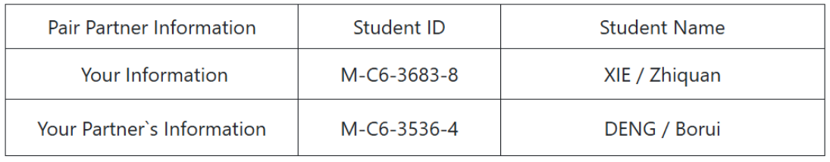

Datasets and Data Availability
Two data sources support the project:
Official regulatory document. Guangzhou's e-bike management regulations (广州市电动自行车管理规定), used to define the governance measures and to check the responses discussed online: https://gzpc.gov.cn/attachment/0/4/4746/257051.pdf (copy in this repository: https://gzpc.gov.cn/attachment/0/4/4746/257051.pdf )
Project corpus (self-collected). RedNote posts and comments retrieved for the 15 Guangzhou e-bike topics, exported to Excel (22,127 records, 11 fields: post text, keyword, visible date, engagement counts, event type, city and district, place mention): https://github.com/KarryTsuen/CISC7204-MC636838-2026GitHub/blob/main/rednote-ebike-guangzhou-dataset.xlsx

References
[1] Jing, G., Xue, M., Yang, Y., et al. (2024). Thinking and Path Selection of Current Transportation Problems in Big Cities: Debrief of the 37th Urban Transportation Development Forum in China. Urban Transport of China, 22(5), 109-123.
[2] The People’s Government of Guangzhou Municipality. (2024, November 6).
Guangzhou Territorial Spatial Master Plan (2021-2035). https://www.gz.gov.cn/zwgk/fggw/szfwj/content/post_9960352.html
[3] Li, J., & Ouyang, J. (2025). Governance of E-Bike Riding Spaces: A Case Study of Guangzhou. Urban Transport of China, 23(3), 39-44, 126.

