1. Write a program to get the following output.

Hey there,

I am “*some data*”! (assign a variable and print the variable data)

Source code:

package Wokshop1;

public class PrintVariable {

public static void main(String[] args) {

String name = "Karsang"; // Example variable

System.***out***.println("Hey there,\r\n" + "I am " + name + "!");

}

}

Output:

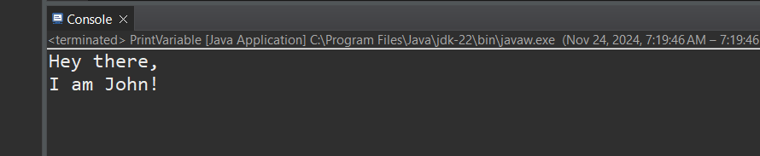

1. Write a program to print the difference and product of numbers 45 and 32.

Source code:

package Wokshop1;

public class DifferenceAndProduct {

public static void main(String[] args) {

int num1=45;

int num2=32;

System.***out***.println("difference of"+num1+" and "+ num2 +" is "+(num1-num2));

System.***out***.println("product of"+num1+" and "+ num2 +" is "+(num1*num2));

}

}

Output:

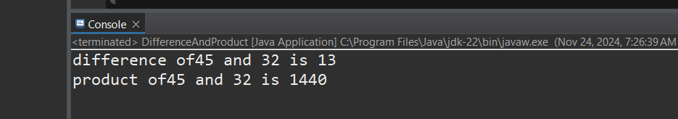

1. Write a Java program to print an int, a double, and a char on the screen.
2. package Wokshop1;
3. public class PrintVariables {
4. public static void main(String[] args) {
5. int number = 42; // An integer value
6. double decimal = 3.14; // A double value
7. char letter = 'A'; // A character value
8. // Printing the variables
9. System.***out***.println("Integer value: " + number);
10. System.***out***.println("Double value: " + decimal);
11. System.***out***.println("Character value: " + letter);
12. }
13. }

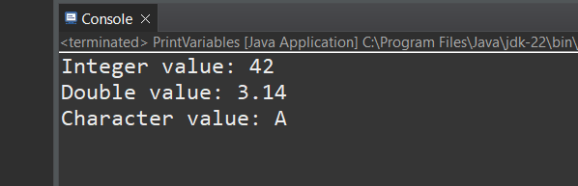

1. Write a program to calculate the area of a triangle.

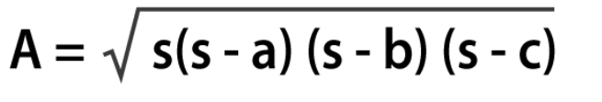

Where s is the semi-perimeter of the triangle s = (a+b+c)/2

package Wokshop1;

import java.util.Scanner;

public class AreaOfTriangle {

public static void main(String[] args) {

Scanner scanner=new Scanner(System.***in***);

System.***out***.println("enter the first side (a)");

double a=scanner.nextDouble();

System.***out***.println("enter second side (b)");

double b=scanner.nextDouble();

System.***out***.println("enter third side of a triangle (c)");

double c=scanner.nextDouble();

double s=(a+b+c)/2; //semiperimet=s

// Calculate the area using Heron's formula

double area = Math.*sqrt*(s * (s - a) * (s - b) * (s - c));

// Output the result

System.***out***.print("The area of the triangle is:%2f " + area);

scanner.close();

}

}

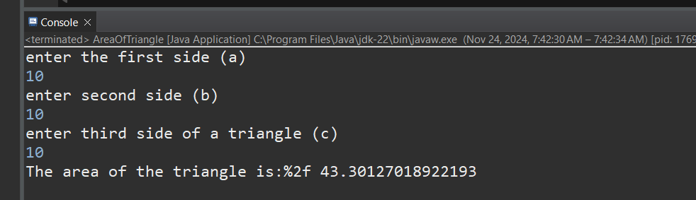

1. Write a Java program to calculate the area of a square. Prompt the user to enter the length of one side and then display the result. Ensure that the program handles user input as a double data type.
2. package Wokshop1;
3. import java.util.Scanner;
4. public class CalculateAreaOfSquare {
5. public static void main(String[] args) {
6. Scanner scanner=new Scanner(System.***in***);
7. System.***out***.println("Enter the length of square: ");
8. double length=scanner.nextDouble();
9. double areaOfSquare=length*length;
10. System.***out***.println("area of square is "+areaOfSquare);
11. }
12. }

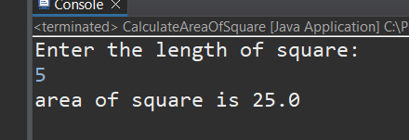

1. Create a Java program that converts a temperature in Celsius to Fahrenheit. Prompt the user to enter the temperature in Celsius, perform the conversion using the formula (F = C * 9/5 + 32), and display the result as a double.

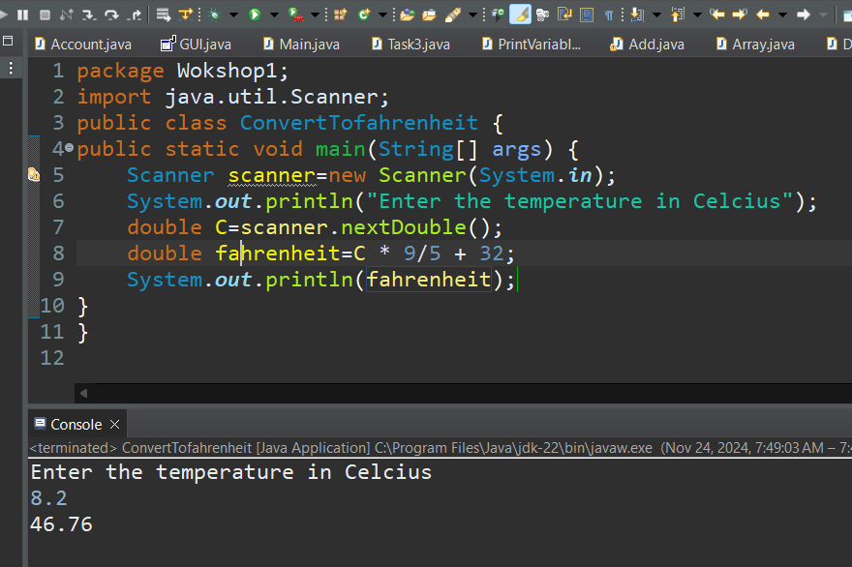

1. Develop a Java program that calculates the volume of a cylinder. Prompt the user to enter the radius and height of the cylinder and then display the result. Ensure that the program uses appropriate data types for calculation and output.

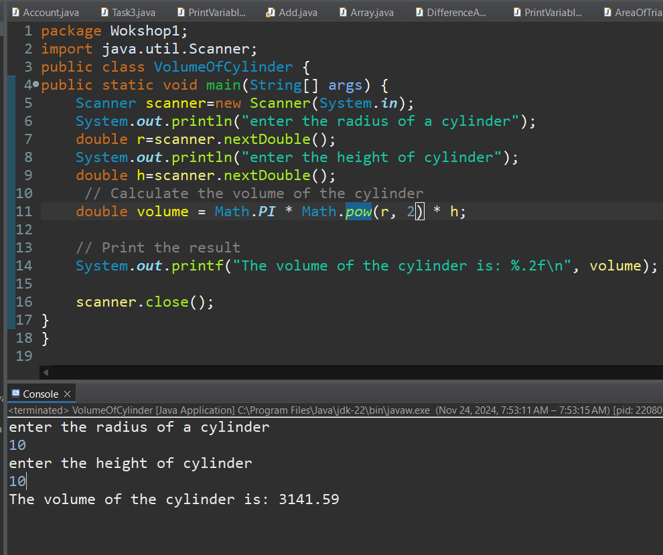

1. Write a Java program that calculates the simple interest on a loan. Prompt the user to enter the principal amount, the rate of interest, and the time period. Calculate and display the interest amount as a double.

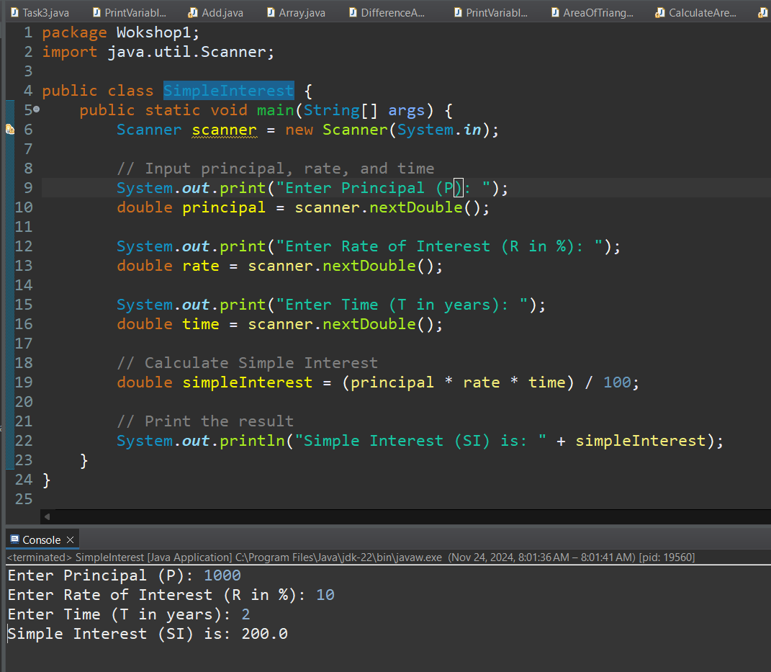

1. Create a Java program that takes two integer inputs from the user, performs all basic arithmetic operations (addition, subtraction, multiplication, and division) on these numbers, and displays the results.

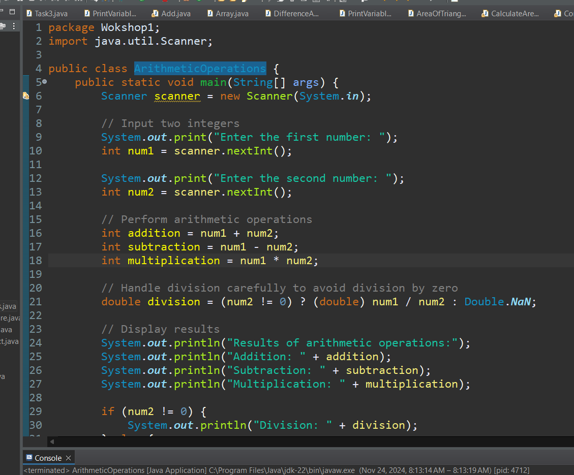

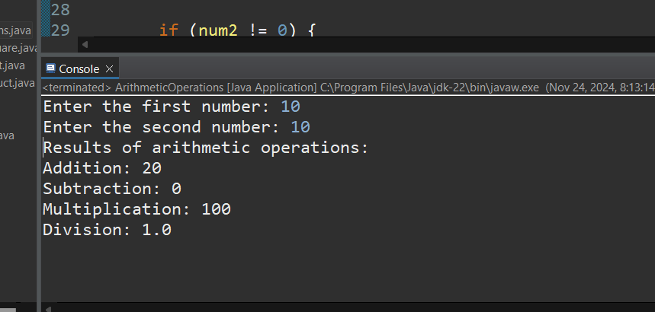

1. Write a Java program that calculates the perimeter of a rectangle. Prompt the user to enter the length and width of the rectangle, and then display the result. Use appropriate data types for calculation and output.

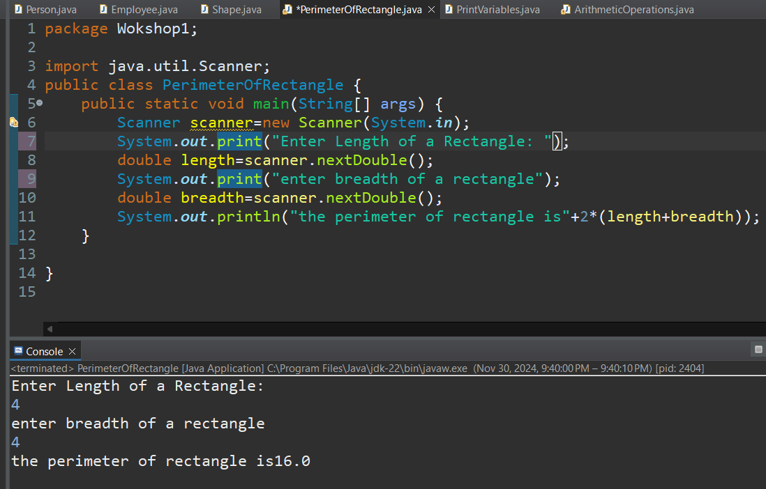

1. Develop a Java program that converts miles to kilometers. Prompt the user to enter the distance in miles and display the equivalent distance in kilometers as a double.

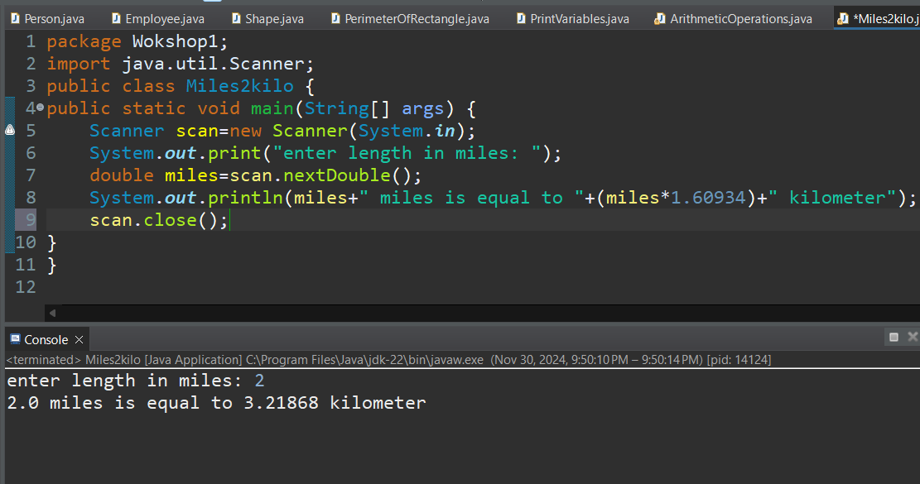

1. Create a Java program that computes the area of a circle. Prompt the user to enter the radius and display the result as a double. Use the formula (Area = π * r * r) for the calculation.

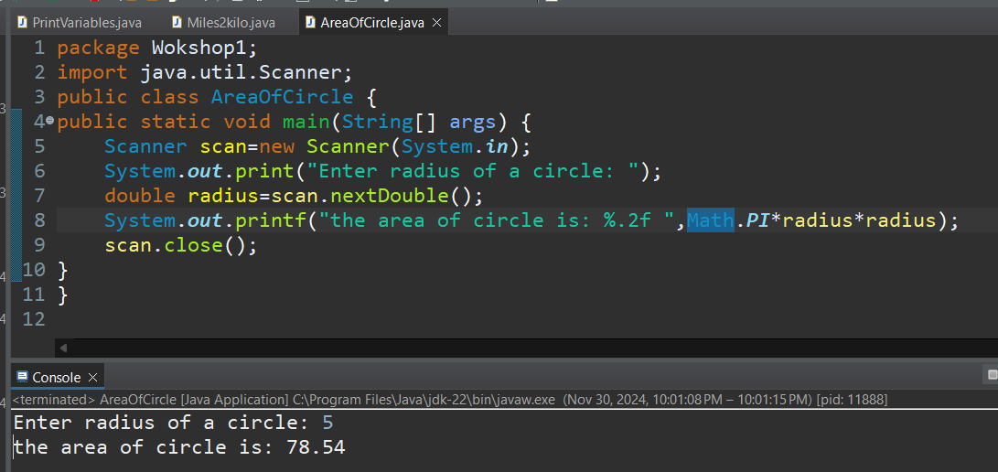

1. Develop a Java program that calculates the total cost of purchasing a given quantity of items at a certain price per item. Prompt the user to enter the quantity and price, and display the total cost as a double.

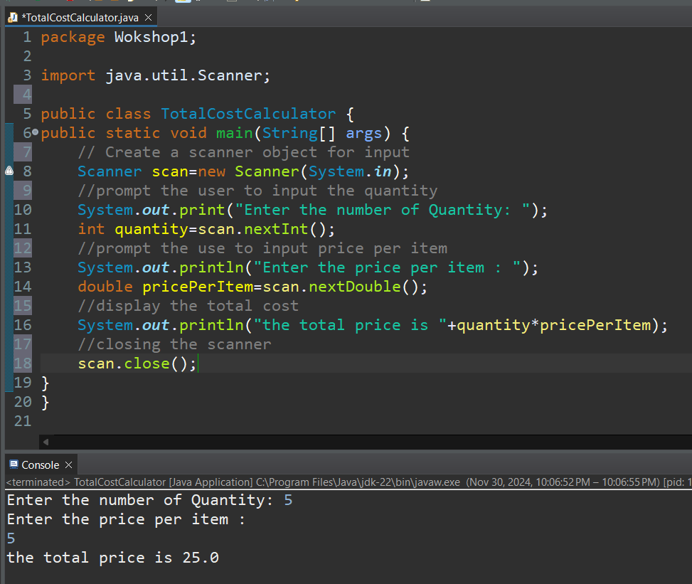

1. Write a Java program that converts a given amount of money in U.S. dollars to another currency (e.g., rupees). Prompt the user to enter the amount and the exchange rate, and display the converted amount as a double.

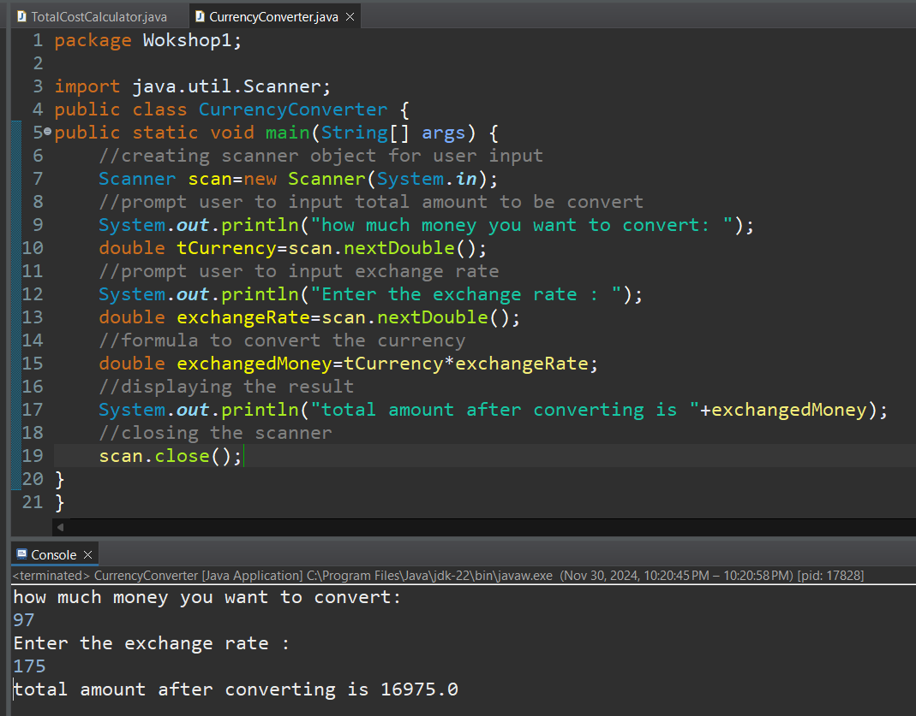

1. Create multiple Person objects using different constructors and print their details.

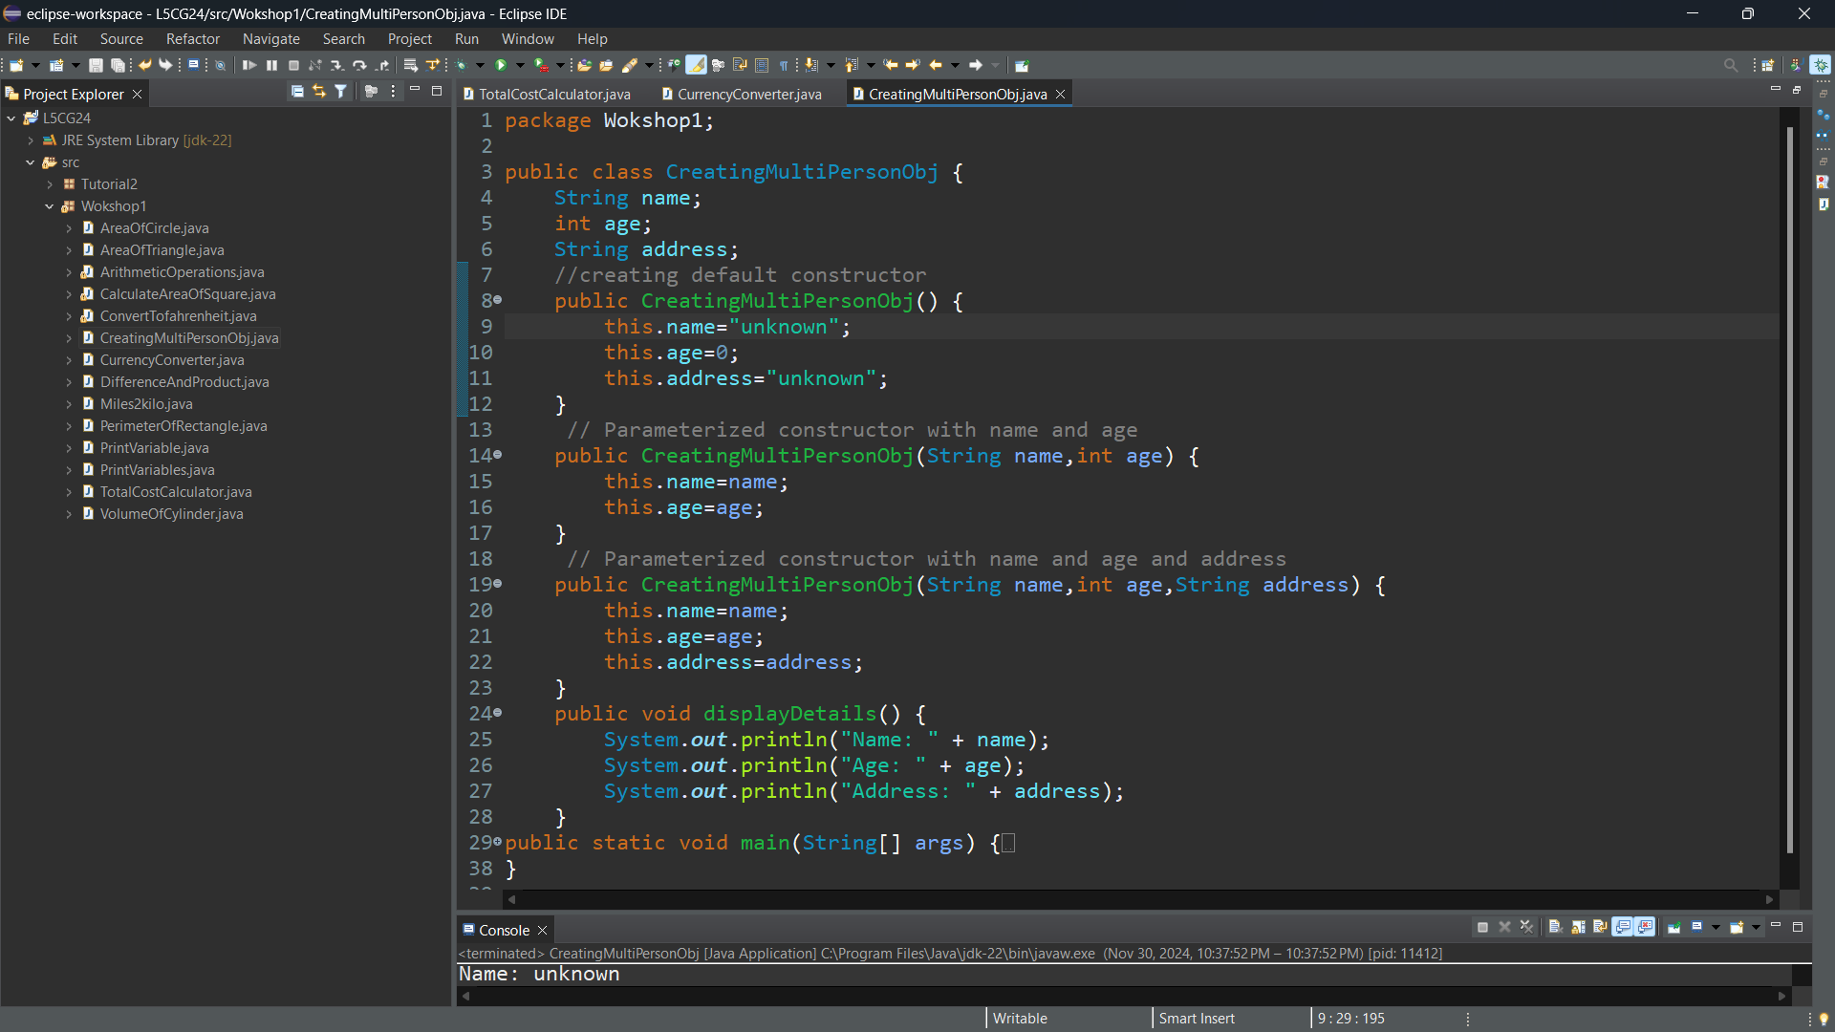

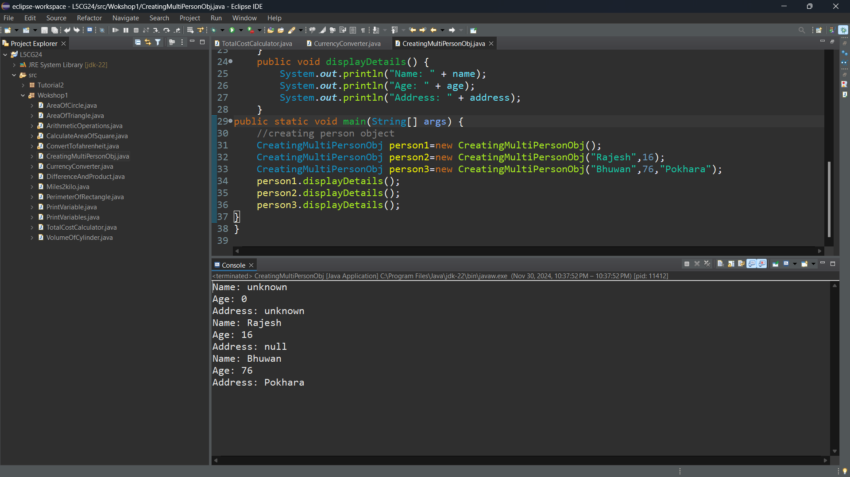

1. Create a Book class with fields title, author, and year. Override the toString() method to return a formatted string representation of a Book object.

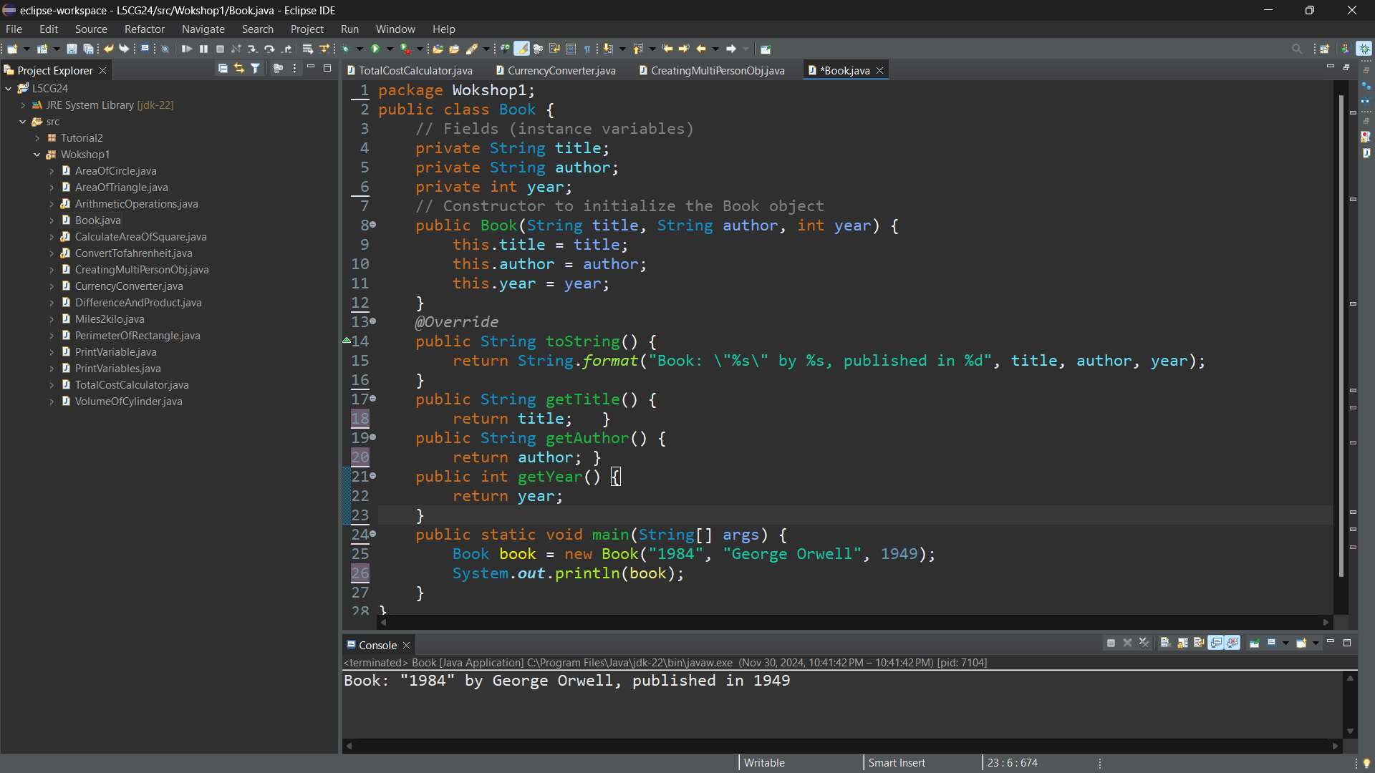

1. Create a class Rectangle with fields for width and height. Add a constructor to initialize these fields. Override the toString() method to return the rectangle's dimensions in a readable format.

