Codec Technologies

Sales Analysis and Forecasting

Internship Project Report

**Submitted by:** Karsh Mistry  
**Designation:** Data Science Intern  
**Internship Company:** Codec Technologies  
**Internship Duration:** 16/06/2025 to 16/08/2025  
**Location:** Hybrid / India  
**Reporting to:** Assigned Project Head(s)

**Table of Contents**

1. Title Page
2. Abstract
3. Introduction
4. Dataset Description
5. Project Objectives
6. Exploratory Data Analysis (EDA)
7. Forecasting Using Prophet
8. Key Insights
9. Conclusion
10. Tools & Technologies Used
11. References
12. Images of codes

# Abstract

This project aims to analyze and forecast sales data using various data science techniques, with the goal of deriving actionable business insights and accurately predicting future sales performance based on historical trends. Sales forecasting is a critical component of strategic business planning, helping organizations make informed decisions about inventory management, marketing efforts, staffing, and resource allocation.

To achieve this, the project employs a comprehensive approach involving data preprocessing, exploratory data analysis (EDA), and advanced forecasting models. Particular emphasis is placed on time series analysis, utilizing tools such as Facebook Prophet for its flexibility and interpretability in modeling seasonal effects, holiday impacts, and trend changes. In addition, data visualization techniques are used to uncover hidden patterns and communicate key findings effectively.

By leveraging these methods, the project provides not only short-term and long-term sales forecasts but also insights into the factors influencing sales fluctuations. These insights can support businesses in optimizing their sales strategies, minimizing risks, and enhancing overall operational efficiency. The methodology and findings outlined in this report aim to contribute to data-driven decision-making in real-world sales environments.

# Introduction

In today’s highly competitive and data-driven market environment, understanding and predicting sales trends is essential for effective strategic planning and business growth. Accurate sales forecasting enables companies to optimize inventory, manage budgets, plan marketing campaigns, and allocate resources more efficiently. With the increasing availability of historical data and advanced analytical tools, businesses can now leverage data science to uncover meaningful insights and make informed decisions.

This internship project, carried out at **Codec Technologies**, focuses on the end-to-end analysis and forecasting of sales data. The primary objective is to transform raw data into actionable intelligence that can help the organization improve its sales strategies. The project encompasses a complete data science workflow — starting with data collection and cleaning, followed by exploratory data analysis (EDA), pattern recognition, and forecasting future sales trends.

Key Python libraries used in this project include **pandas** for data manipulation, **matplotlib** and **seaborn** for data visualization, and **Facebook Prophet** for time series forecasting. These tools were chosen for their robustness, ease of use, and suitability for handling real-world business datasets.

Through this project, not only are sales trends identified and visualized, but predictive models are also built to anticipate future sales performance. The insights gained are intended to support Codec Technologies in making data-informed strategic decisions and improving operational efficiency.

# Dataset Description

The dataset used in this project comprises historical sales records collected over a specific period. It serves as the foundation for all stages of the analysis, including trend identification, visualization, and forecasting. The data reflects real-world business transactions and captures essential aspects of sales performance across different dimensions.

The key columns in the dataset are as follows:

* **Date**: The date on which each transaction occurred. This column is critical for performing time series analysis and identifying seasonal or temporal patterns in sales.
* **Product Category**: Indicates the type or category of the product sold. This helps in analyzing category-wise performance and understanding which products contribute most to revenue and profit.
* **Sales**: Represents the revenue generated from each transaction. This is a primary metric used for trend analysis and forecasting.
* **Region**: Specifies the geographical area or sales zone where the transaction took place. Analyzing data by region provides insights into regional performance and helps in tailoring location-specific strategies.
* **Profit**: Denotes the net profit earned from each sale after deducting costs. This allows for evaluating profitability alongside revenue and identifying high-margin products or regions.

The dataset was imported and processed using the **pandas** library in Python, which provided efficient tools for data cleaning, transformation, and analysis. Initial preprocessing steps included handling missing values, converting date columns to appropriate formats, and aggregating data to a time series structure suitable for forecasting models.

Overall, the dataset is rich in information and well-suited for conducting a thorough sales analysis that supports both descriptive and predictive insights.

# Project Objectives

The primary objective of this project is to apply data science techniques to analyze historical sales data and generate predictive insights that can inform strategic business decisions. The project follows a structured approach aimed at uncovering meaningful patterns in the data and forecasting future performance. The key objectives are outlined below:

* **Conduct Exploratory Data Analysis (EDA):**  
  Perform in-depth exploratory analysis to identify underlying trends, patterns, seasonality, and anomalies in the sales data. This step involves summarizing the data, identifying relationships between variables, and understanding the distribution and behavior of key metrics such as sales and profit over time.
* **Develop Interactive and Informative Visualizations:**  
  Create clear and insightful visualizations using libraries such as **matplotlib** and **seaborn** to illustrate performance metrics across different product categories, time periods, and geographical regions. These visualizations help stakeholders easily interpret the data and gain a comprehensive understanding of sales dynamics.
* **Implement Time Series Forecasting Using Facebook Prophet:**  
  Utilize the Facebook Prophet library to build a time series model capable of forecasting future sales for the upcoming three months. The model is designed to account for trends, seasonal variations, and holiday effects, providing a reliable forecast to support planning and decision-making.
* **Derive Actionable Business Insights:**  
  Analyze the results of both the exploratory and predictive phases to provide practical recommendations. These insights aim to support Codec Technologies in enhancing sales strategies, identifying growth opportunities, optimizing regional performance, and improving overall business efficiency.

# Exploratory Data Analysis (EDA)

Exploratory Data Analysis (EDA) was a crucial step in this project, aimed at gaining a comprehensive understanding of the sales dataset before applying predictive models. EDA was used to explore the structure, distribution, and relationships within the data, helping to uncover patterns, outliers, and trends that might influence sales performance.

Several types of visualizations and statistical summaries were employed to support this analysis:

* **Line Plots:**  
  Used to observe sales and profit trends over time, highlighting monthly or seasonal fluctuations. These plots helped identify peak sales periods and assess whether there were any consistent upward or downward trends.
* **Bar Charts:**  
  Utilized to compare sales and profit across different product categories and regions. This visualization made it easier to evaluate which categories or locations performed best in terms of revenue and profitability.
* **Heatmaps:**  
  Created to examine correlations between numerical variables and visualize performance metrics across time or categorical groupings. For example, heatmaps were used to highlight month-wise sales concentration across different regions.

The analysis revealed meaningful patterns such as seasonal spikes in sales, varying profit margins across product lines, and differences in performance between regions. These findings provided a foundation for building accurate forecasting models and formulating data-driven recommendations.

EDA was conducted using Python libraries such as **pandas**, **matplotlib**, and **seaborn**, which offered powerful tools for data manipulation and visualization. The insights gained from this phase guided the selection of forecasting techniques and helped in interpreting the model results more effectively.

# Sales Forecasting using Prophet

To predict future sales trends, the Facebook **Prophet** library was utilized for time series forecasting. Prophet is a robust, open-source forecasting tool designed to handle real-world business time series data that may have missing values, outliers, or strong seasonal effects. It is especially effective for capturing trends and seasonality in data with daily, weekly, or yearly cycles.

For this project, the following steps were performed:

* **Data Preparation:**  
  The sales data was first aggregated at the daily level to ensure it conformed to Prophet’s expected input format, which requires two columns: ds (date) and y (value to forecast, i.e., sales). The data was then cleaned to remove anomalies and missing values that could affect the model’s accuracy.
* **Model Training:**  
  The cleaned historical sales data was used to train the Prophet model. Prophet automatically detected trends, weekly and yearly seasonality, and incorporated them into the forecast. Additional functionality such as changepoint detection allowed the model to adapt to significant shifts in sales behavior over time.
* **Forecast Generation:**  
  Once trained, the model was used to forecast sales for the next **90 days**. The forecast included not only point predictions but also confidence intervals, which provided a sense of uncertainty around the projections—helpful for risk management and planning.
* **Visualization:**  
  The forecast results were visualized using Prophet’s built-in plotting capabilities as well as **matplotlib** for enhanced customization. These visualizations included the overall forecast, trend components, and seasonal patterns, making it easier to interpret the underlying factors influencing the predicted values.

Using Prophet enabled the generation of reliable and interpretable forecasts that can guide short-term business decisions. The model's transparency and ease of customization made it a practical choice for time series forecasting in a business context.

# Key Insights & Observations

Based on the exploratory data analysis and time series forecasting conducted in this project, several important insights and observations were drawn that can support strategic decision-making. These findings highlight critical patterns and trends within the sales data:

* **Seasonal Peaks in Sales:**  
  Analysis revealed that peak sales consistently occurred during specific months, particularly aligning with festival periods and holiday seasons. This seasonal pattern suggests that targeted marketing and inventory planning during these times could significantly boost revenue.
* **Regional Profitability Variations:**  
  Certain regions demonstrated consistently higher profit margins compared to others. This indicates the potential for region-specific strategies, such as increased investment in high-performing areas or targeted promotions to improve underperforming regions.
* **Positive Sales Outlook:**  
  The 90-day forecast generated using Prophet indicates a trend of **steady growth** in sales over the upcoming quarter. This projected growth can be used to prepare operations, manage stock levels, and align marketing efforts with expected demand.
* **Effective Handling of Seasonality and Trends by Prophet:**  
  Prophet successfully modeled complex sales patterns, including seasonality, trend shifts, and irregular fluctuations. Its ability to incorporate holidays and changepoints added robustness to the forecast, making it a reliable tool for business planning.

These insights not only validate the effectiveness of data-driven forecasting but also provide actionable recommendations for improving sales strategy, optimizing resource allocation, and enhancing overall business performance.

# Conclusion

This project successfully demonstrates the practical application of data science techniques to analyze and forecast historical sales data. Through a structured workflow that included data cleaning, exploratory data analysis (EDA), and time series forecasting, valuable insights were extracted that can support informed and strategic decision-making in a business context.

The use of EDA allowed for the identification of key sales patterns, seasonal trends, and regional performance differences, offering a deeper understanding of the underlying dynamics affecting sales and profit. The implementation of the **Facebook Prophet** model provided reliable short-term forecasts, helping anticipate future demand and optimize planning for upcoming business periods.

Overall, this project highlights how leveraging data-driven methodologies can enhance business intelligence, improve operational efficiency, and provide a competitive edge in today's data-centric marketplace. The approach and findings outlined in this report can be extended to other domains and serve as a foundation for more advanced predictive analytics initiatives.

# Tools and Technologies Used

The following tools and technologies were utilized throughout the project to perform data analysis, visualization, modeling, and version control:

* **Python** – Primary programming language used for data analysis and forecasting
* **Jupyter Notebook** – Interactive environment for writing, testing, and documenting code
* **Pandas** – Data manipulation and analysis library used for cleaning and transforming data
* **Matplotlib** – Visualization library for creating static, animated, and interactive plots
* **Seaborn** – Statistical data visualization library built on top of matplotlib
* **Facebook Prophet** – Time series forecasting library used to model and predict future sales
* **GitHub** – Version control platform for managing code, collaboration, and project documentation

# References

This section includes references to the key resources and materials consulted during the project, along with optional supporting documentation that provides further clarity on the implementation and results.

**References**

1. **Facebook Prophet Documentation**  
   <https://facebook.github.io/prophet/>   
   Official documentation for Prophet, used extensively for understanding model functionality, parameter tuning, and visualization features.
2. **Python Official Documentation**  
   <https://docs.python.org/3/>  
   Reference for core Python functionality, including data structures, functions, and modules used throughout the analysis.
3. **Pandas Documentation**  
   <https://pandas.pydata.org/docs/>   
   Used for data cleaning, transformation, and aggregation.
4. **Matplotlib and Seaborn Documentation**  
   <https://matplotlib.org/stable/contents.html>   
   <https://seaborn.pydata.org/>   
   These resources supported the development of data visualizations used in EDA and result presentation.
5. **Internal Internship Training Materials (Codec Technologies)**  
   Internal documents and training sessions provided by Codec Technologies were instrumental in understanding project expectations, business context, and technical best practices.

# Images of code

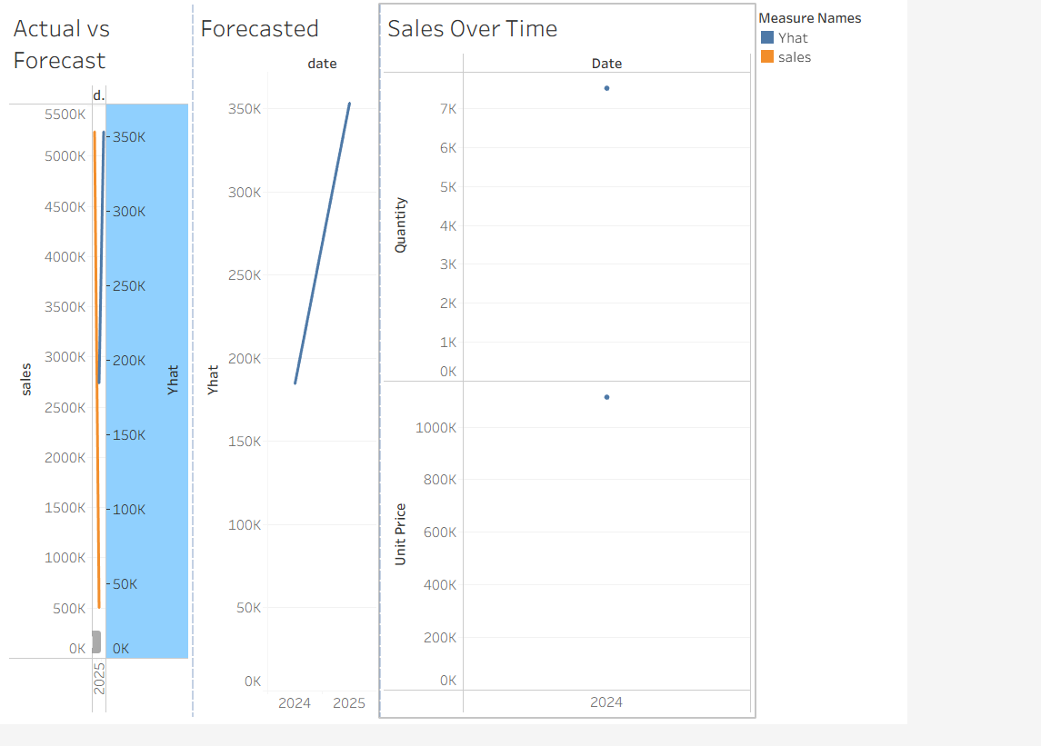

Image-1

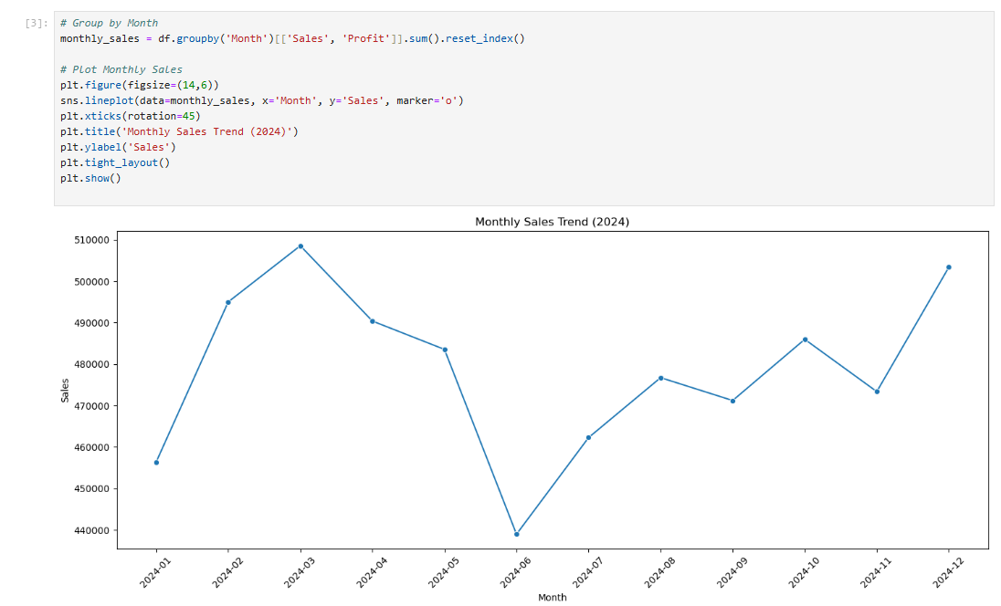

Image-2

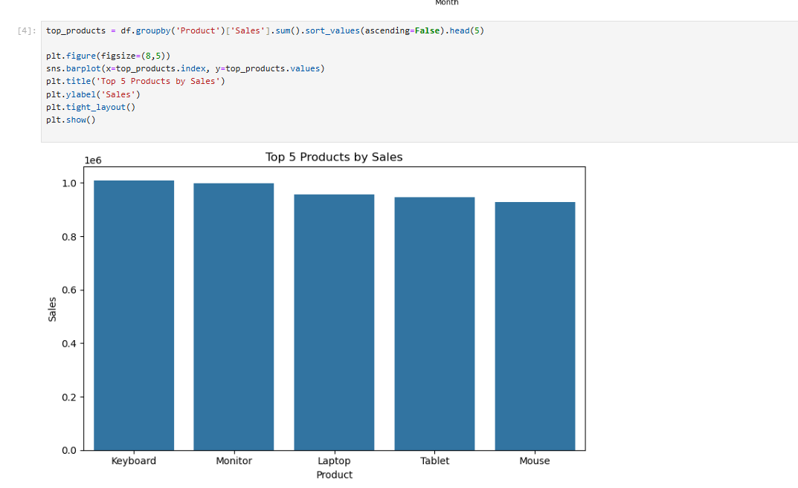

Image-3

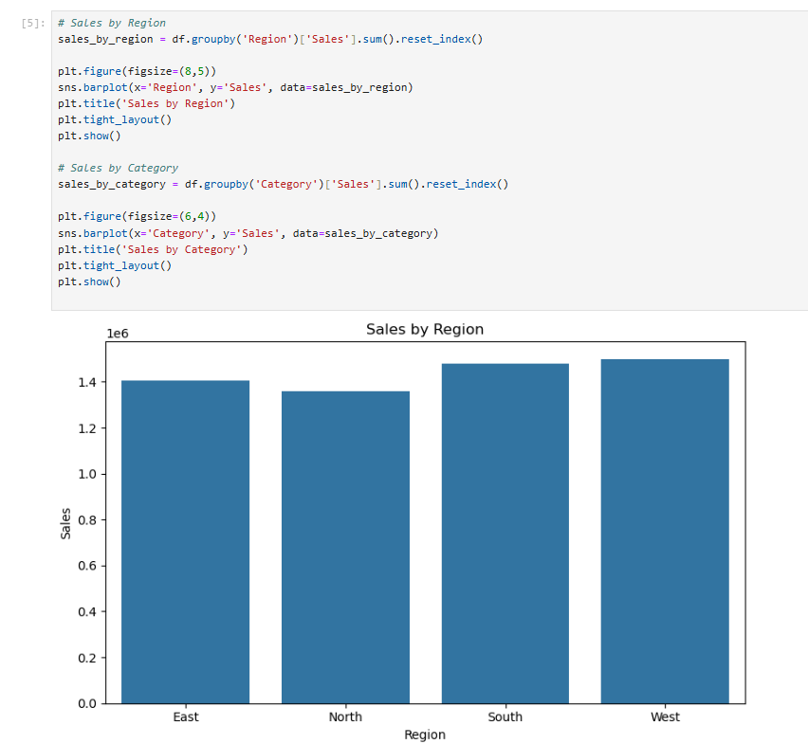

Image-4

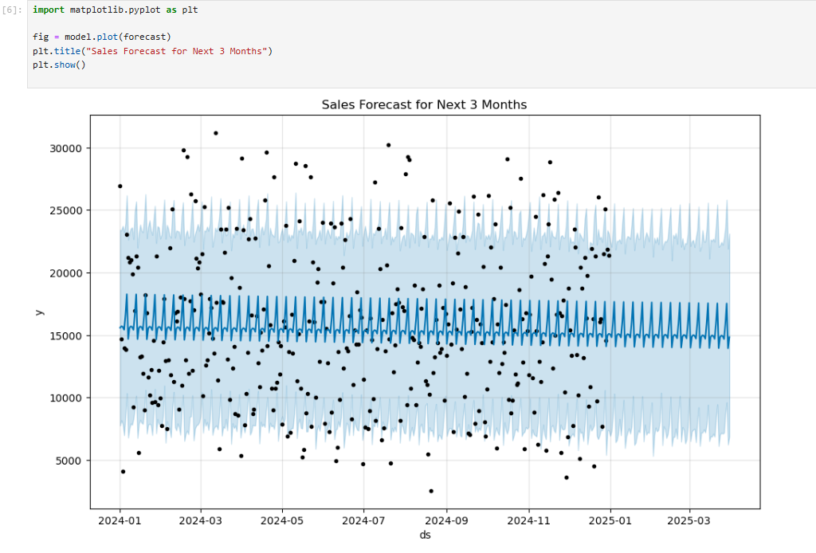

Image-5

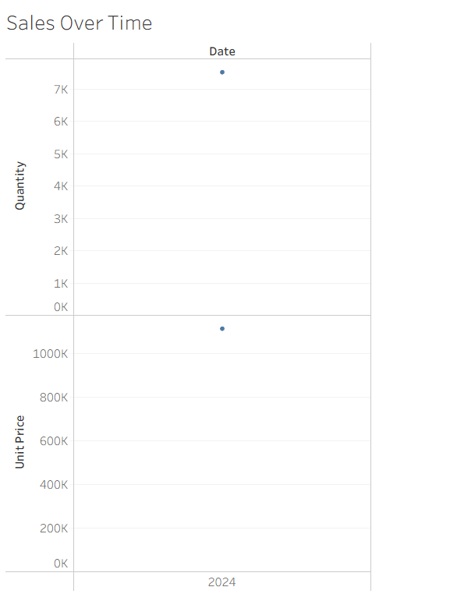

Image-6

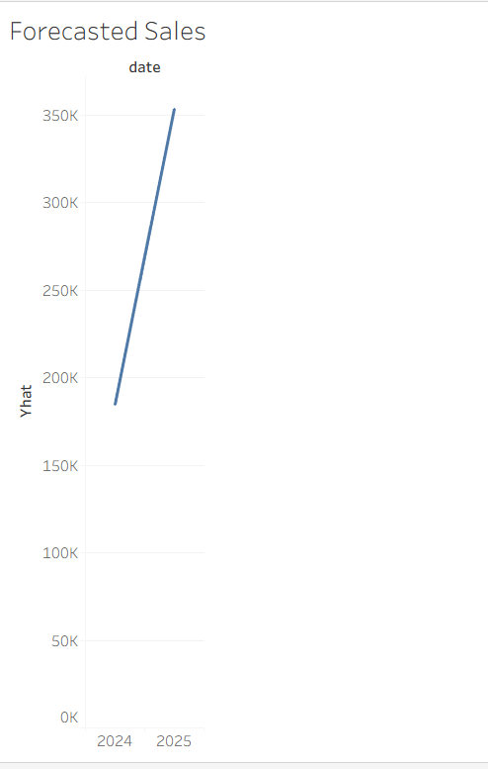

Image-7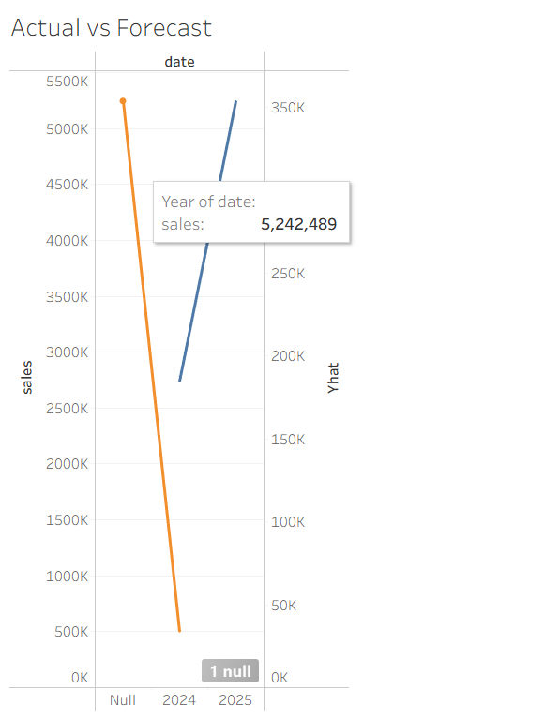

Image-8

Github Repository link :- <https://github.com/Karshmistry/Sales-Analysis-and-Forecasting/>