Lab #6: Dynamic Memory Allocation
  - Karson Dahl
  - 11/4/2024

  - Algorithm
This program will demonstrate dynamic memory allocation. This will be done using three files: CompletedJob.cpp, CompletedJob.h, and RevenueCalculator.cpp. main will be held inside of RevenueCalculator. The general logic of the program is for creating an invoice with the total revenue in a month. The number of jobs within a month could be any number from 1 to 1000, and will be determined by the user, represented as an int numJobs. The name for the month will also be taken in from the console, and will utilize getline. There will be a double pointer CompletedJob** jobs, pointing to a new array CompletedJob*[numJobs]. Then a for loop will loop through the same # of times as numJobs and will create CompletedJob* newJob object using the new operator and the default constructor. At this point, rand will be used to give the job object an invoice number with newJob->setinvoiceNum(rand() % 1000 + 1). Then the loop will prompt for either initializing this job from the user in the userJob() function, or from a file with the fileJob() function. after each job is created, a float finaltotal will use += to add the total of all jobs together. This will then save the newJob object as jobs[i] = newJob. After the loop has run its course, a prompt will be given for the output file. Finally, the functions fileInvoice and coutInvoice will run. The first will print out the invoice to a file, and the second will print out the invoice to the console.

Screen-Shots of Running Program
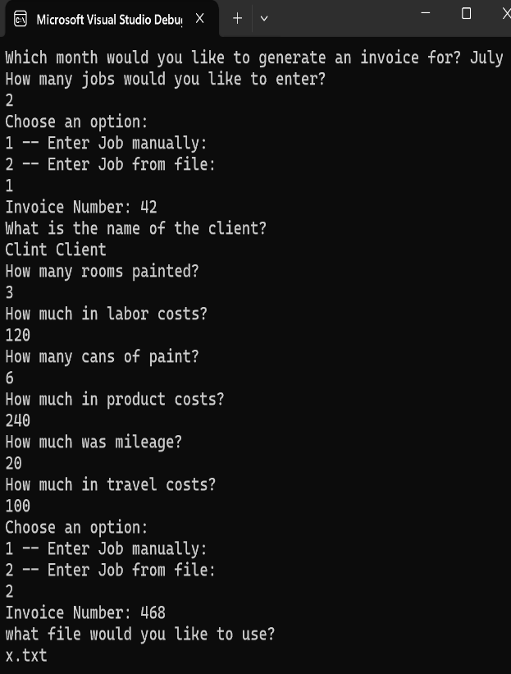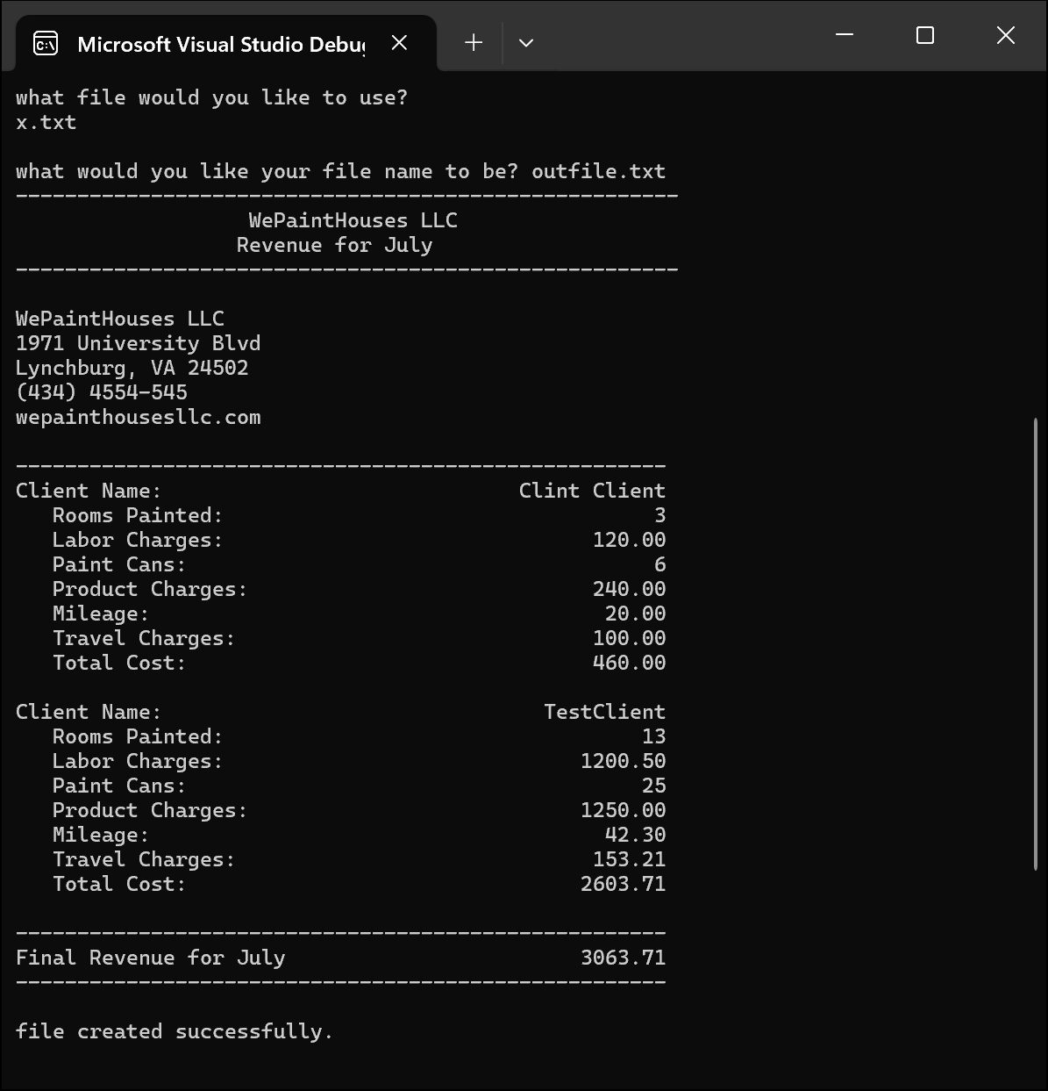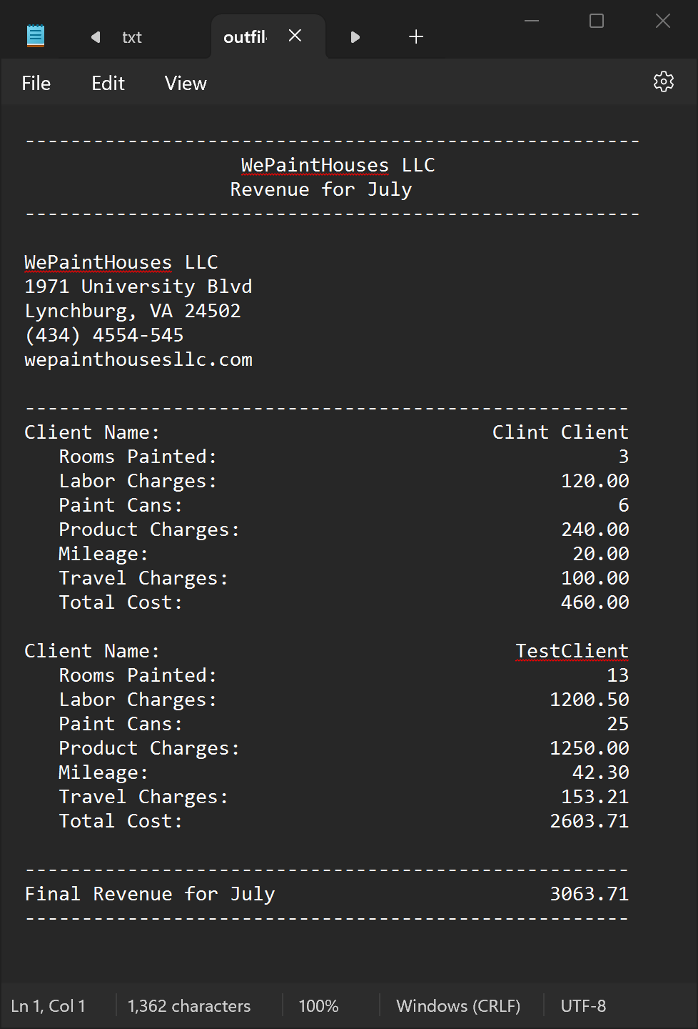

  - Integrity Statements
As a protective measure, WePaintHouses LLC has also asked you to verify the integrity of your code with every project. This is a liability measure to ensure that no copyright issues occur down the road, and that you have not broken the contract terms and used outside code. To this end, please make sure that the following integrity statements are included in every submission:
- I have not shared the source code in my program with anyone other than the pre-approved human sources.
  - Please include a note here if you have used one or more of the pre-approved human sources or received special permission from me.
- I have not used source code obtained from another student, or any other unauthorized source, either modified or unmodified.
- If any source code or documentation used in my program was obtained from another source, such as the course textbook or course notes, that has been clearly noted with a proper citation in the comments of my program.
  - It would also be helpful to include a note here of which sources you used
- I have not knowingly designed this program in such a way as to defeat or interfere with the normal operation of any machine it is graded on or to produce apparently correct results when in fact it does not.
Note: These statements serve as your personal promise that the above is true. If I find that you have not been true to ALL of the four statements above, you will get a zero for the assignment and receive an academic violation report (which goes on your academic record). Both are minor compared to the loss of your integrity.
  - Change Orders
This section will not apply to all submissions, but inevitably there are some students that wish to take a solution one step further than the directions and/or accomplish the solution in a different manner than intended. If that is the case for one of your labs, you must get prior permission from me before submission. This is to make sure that the integrity of the assignment is maintained and that any changes do not result in one or more of the learning outcomes being missed.
If you wish to modify one or more portions of a given submission, you must first set up an office appointment with me to discuss. This allows me to evaluate whether the proposed change would still measure the same objectives. Together, we will come up with an altered scope of work for the assignment, which I will ask you to include here. I encourage creativity! Please feel free to make these assignments your own, we just need to use a bit of caution to make sure you are still learning the required concepts.

