Lab #7: Department Profit Calculator
  - Karson Dahl
  - 11/19/2024

  - Algorithm
This program will create departments, containing managers and employees, and will in the end calculate net income. This will be accomplished using Main.cpp, Date.h, Person (.cpp and .h), Employee (.cpp and .h), Department (.cpp and .h), and Manager (.cpp and .h). these files will be used to create the menu, with the following options: Add Manager, Add Employee, Remove Employee, List Department Info, and Print Final Profit. The logic of the program will begin with adding a department, creating a department object containing a string for name, an int for the capacity (max # of employees) a float for product costs, a Manager object, and a vector for employee objects. The department will also have functions for setting, getting, and manipulating the vector. The Employee and Manager objects will both inherit from the Person object, which will contain string for first name and last name, date objects for hiring date and for birthday, and finally an int for ID number. Within employee, these values will be present as well as an int for miles traveled, a float for their employee rating, and finally a vector for jobs (float of revenue). The Manager class will specifically have a date object for promotion date, a string for title, and a float for salary. All of these values when taken in will run through the errorCheckNum function that utilizes templates, or errorCheckString respectively. Now onto main: the department will be prompted for first, and then a switch case with the aforementioned options will be presented and looped through until the user asks for the final print out of final profit. The Add Manager option will check first if the manager is equal to the default constructor, and if so will allow the user to set a new manager. If a unique manager already exists, it will inform the user and will not allow them to overwrite the already existing manager. The logic for adding employees will use a similar looping logic, but instead of checking for default case, it will take the number (obtained from a function for the size of the vector in department.cpp) and will allow the user to input information for the employee and will pushback the employees vector in department.cpp accordingly. The next function is to Remove Employee, which will only run if the size of the vector is greater than zero meaning an employee exists. This will erase the vector at the id # attached the employee. This will also prompt the user to confirm the employee they would like to delete. The next function lists department information, and utilizes the ability to overload operators, namely the extraction operator <<. Earlier in the program, the == operator is overloaded for the conditions for the earlier functions. The final part of the switch case will Print Final Profit. This will loop through the employees vector and calculate the final total income, distance, and rating average of the employees. It will then print out department name and capacity, followed by manager (if one exists), total income, cost of products, cost of labor, cost of travel, average employee rating, and final profits.
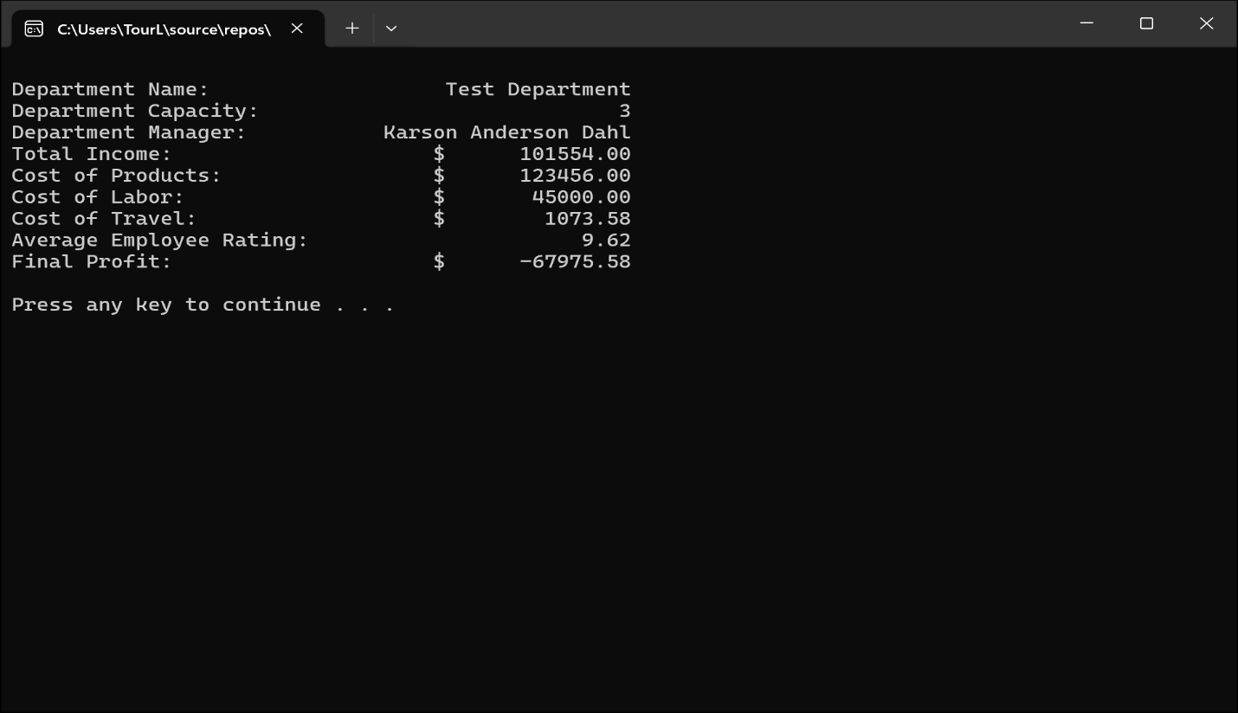
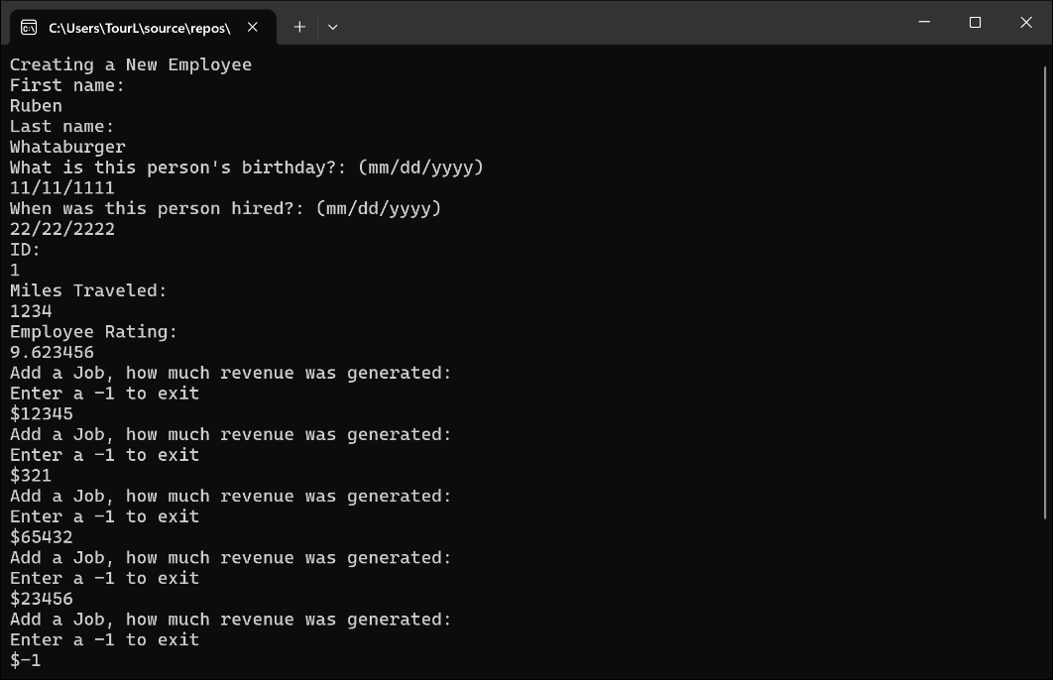
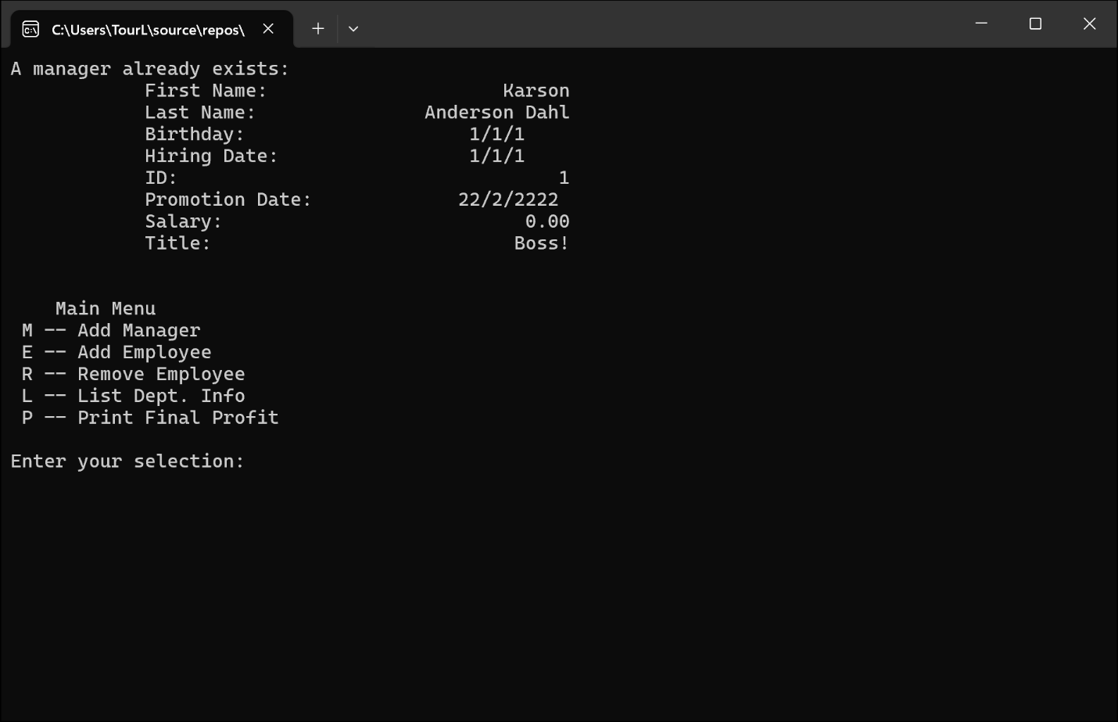
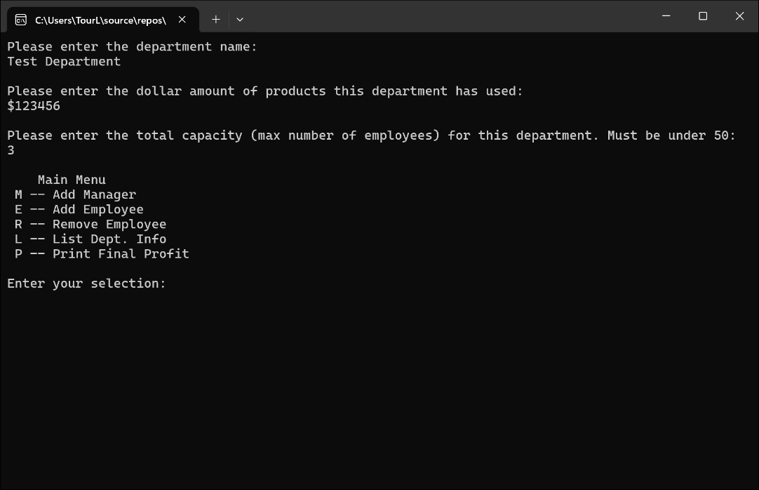
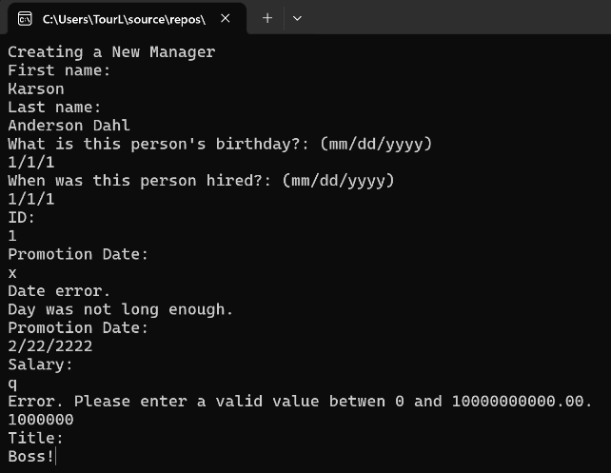
  - Screen-Shots of Running Program

  - Integrity Statements

As a protective measure, WePaintHouses LLC has also asked you to verify the integrity of your code with every project. This is a liability measure to ensure that no copyright issues occur down the road, and that you have not broken the contract terms and used outside code. To this end, please make sure that the following integrity statements are included in every submission:
- I have not shared the source code in my program with anyone other than the pre-approved human sources.
  - Please include a note here if you have used one or more of the pre-approved human sources or received special permission from me.
- I have not used source code obtained from another student, or any other unauthorized source, either modified or unmodified.
- If any source code or documentation used in my program was obtained from another source, such as the course textbook or course notes, that has been clearly noted with a proper citation in the comments of my program.
  - It would also be helpful to include a note here of which sources you used
- I have not knowingly designed this program in such a way as to defeat or interfere with the normal operation of any machine it is graded on or to produce apparently correct results when in fact it does not.
Note: These statements serve as your personal promise that the above is true. If I find that you have not been true to ALL of the four statements above, you will get a zero for the assignment and receive an academic violation report (which goes on your academic record). Both are minor compared to the loss of your integrity.
  - Change Orders
This section will not apply to all submissions, but inevitably there are some students that wish to take a solution one step further than the directions and/or accomplish the solution in a different manner than intended. If that is the case for one of your labs, you must get prior permission from me before submission. This is to make sure that the integrity of the assignment is maintained and that any changes do not result in one or more of the learning outcomes being missed.
If you wish to modify one or more portions of a given submission, you must first set up an office appointment with me to discuss. This allows me to evaluate whether the proposed change would still measure the same objectives. Together, we will come up with an altered scope of work for the assignment, which I will ask you to include here. I encourage creativity! Please feel free to make these assignments your own, we just need to use a bit of caution to make sure you are still learning the required concepts.

