Lab #8: Inventory System
  - Karson Dahl
  - 11/21/2024

  - Algorithm
For this program, the basic logic is going to use two different menus, prompting the user for different kinds of paints and then looping through prompting user for different ways to change/show the paint information. This program will have Paint.h, and the following classes will be derived from it: Flat.h, Eggshell.h, Satin.h, SemiGloss.h, and HighGloss.h. The Paint.h file will contain the Paint class, and private pointers string *color, float *num_cans and *gloss_level. The Paint class will also contain a virtual void function “help()”, that will be redefined in each of the derived class with void help override(). The Paint class will also overload <<, =, and != operators. The logic of the program will be contained within the Inventory.cpp file. The first loop of the program will be for adding in paint objects. In Inventory.cpp, Paint* paints[7] array will hold 7 different paint objects. First a printmenu() function will cout the types of paints, and will use a switch case for user input. for options 1 through 5 that correspond to the different header files, a template function T addColor() will be initialized as a new object of the appropriate type, and will be saved at the appropriate location per the looping condition in the Paint* paints[] array. The gloss level will be determined using random number generation between the bounds that apply to each of the types, and will pass in the choice from the switch case. The 6th and final option will prompt the user to load paints[] from a file, and will pass the array into the addFromFile function, and utilize fstream to add values to the array. The type of paint for the object will be determined by the gloss level, and will be saved accordingly. That logic for the file will loop 7 times, and determine the entire paints[]. Once the paints[] array has all 7 elements, the second half of the program will begin. The sinsistersecondmenu() void function will print the second menu, which allows the user to: 1 - adjust the inventory with void adjust(paints) 2 – View the help function for a selected paint object with void viewHelp(paints) 3 – view the entire inventory with void printInventory(paints) 4 – print the entire inventory to a file with void printToFile(paints) and finally 5 – quit to exit the program. The adjust function works by prompting the user for which paint to adjust the number of cans stored and stores the initial input as an int choice, utilize the overloaded << from Paint to cout << *paints[--choice];. Using the prefix -- ensures that the array will change the correct spot. After printing it out a statement informing the user of which number is being changed again with ++choice, the *paints[-choice] and prompting the user for the new number of cans float newCans and changing the value for *paints[choice]->setNumCans(newCans). The second option will again show the user what they have selected with cout << *paints[--choice]; and then will run paints[choice]->help() and print out the help message according to the appropriate object. The third option will use a for loop 7 times using int x , x < 7, x++ and go through the array, printing out paints[x]->get for each of the three variables. The fourth option will employ essentially the same function, but swaps cout for ofstream outfile, after first prompting the user for a name for the new file. After the user enters a 5 to quit, a for loop will run and print the entire inventory along with each type’s help message.
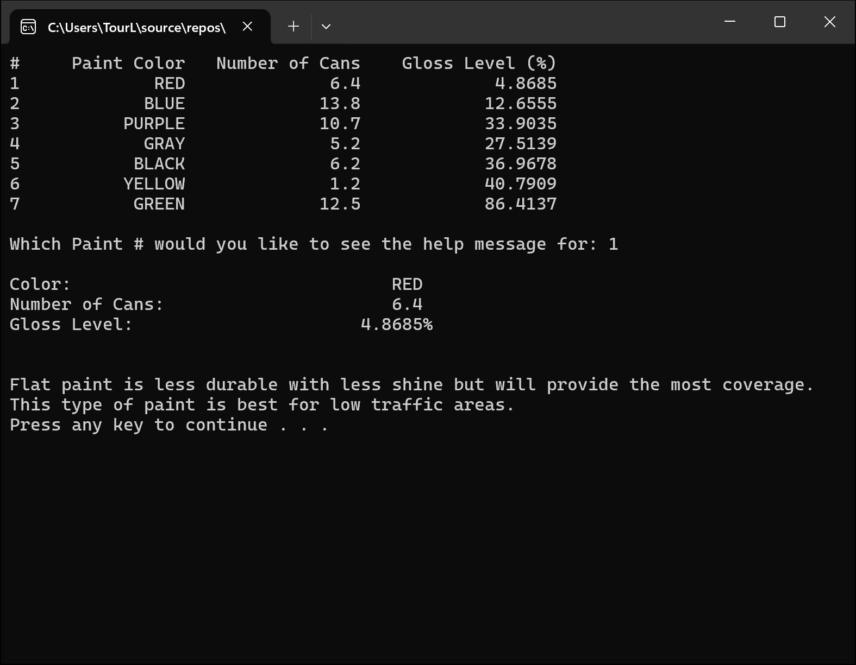
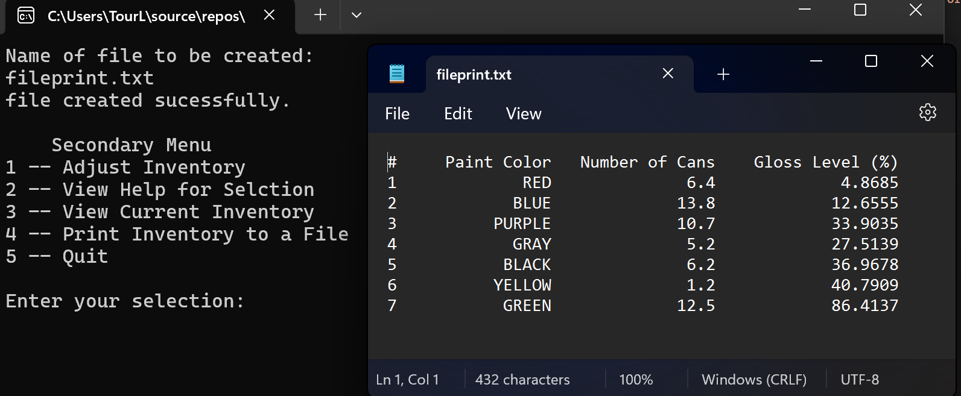
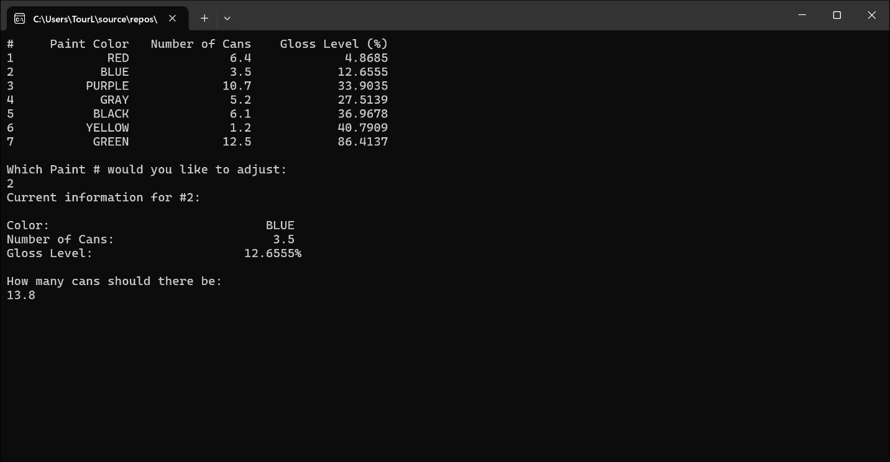
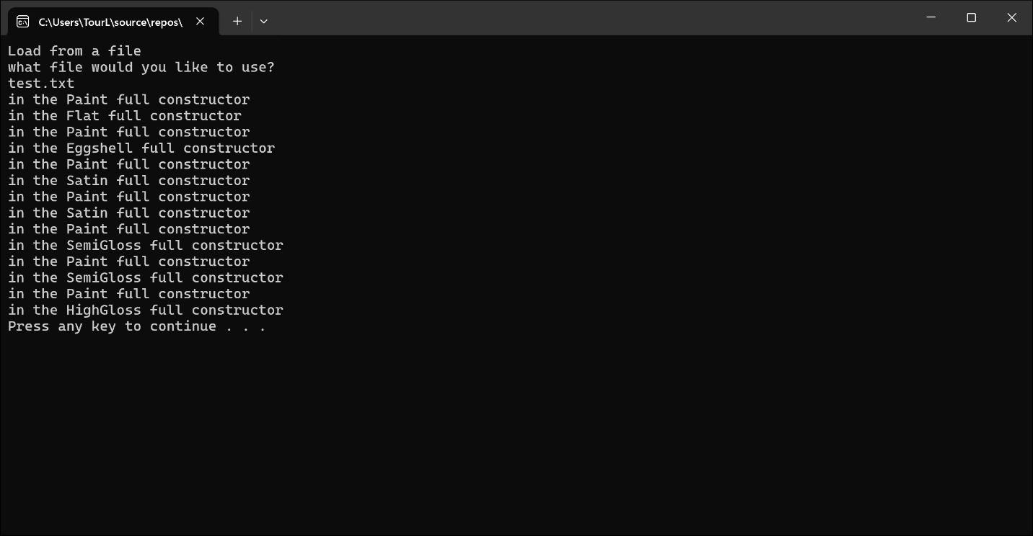
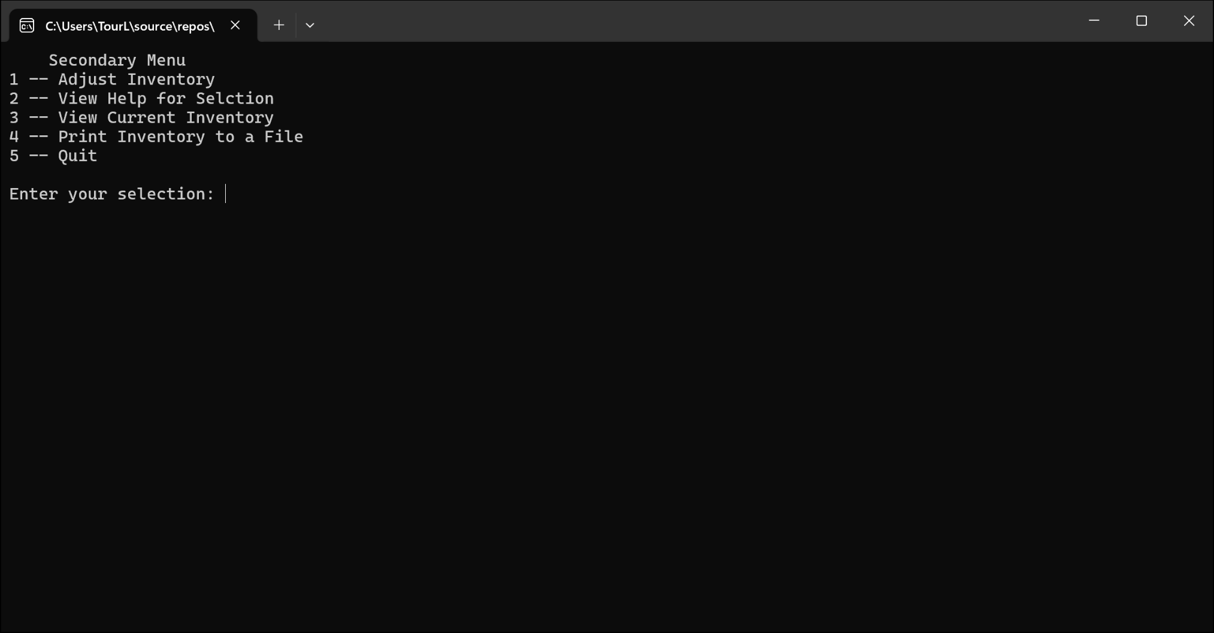
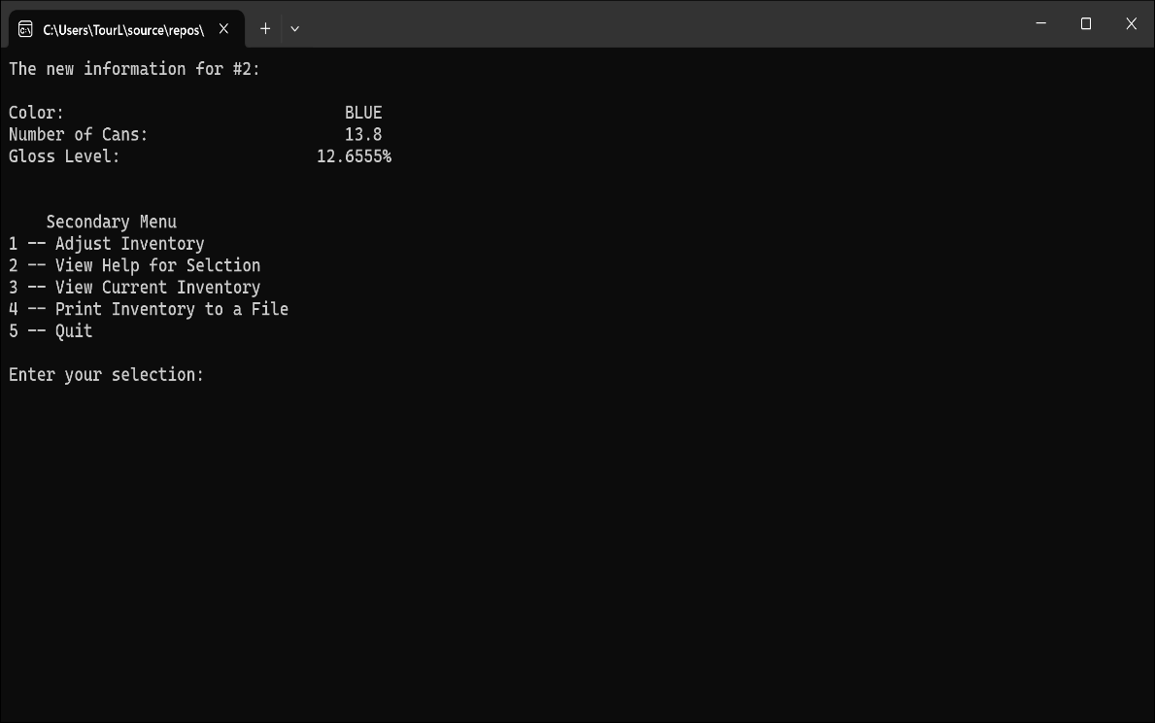
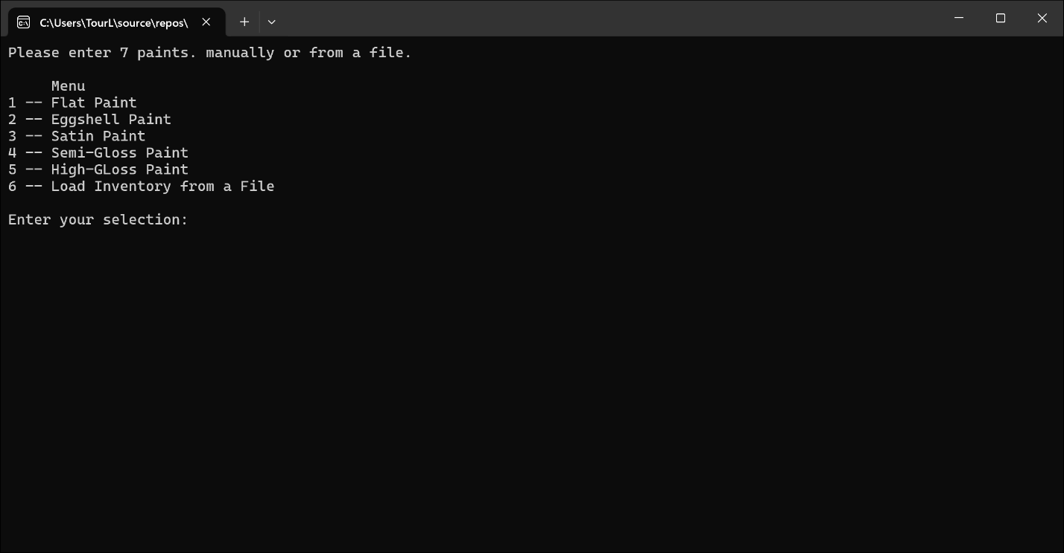
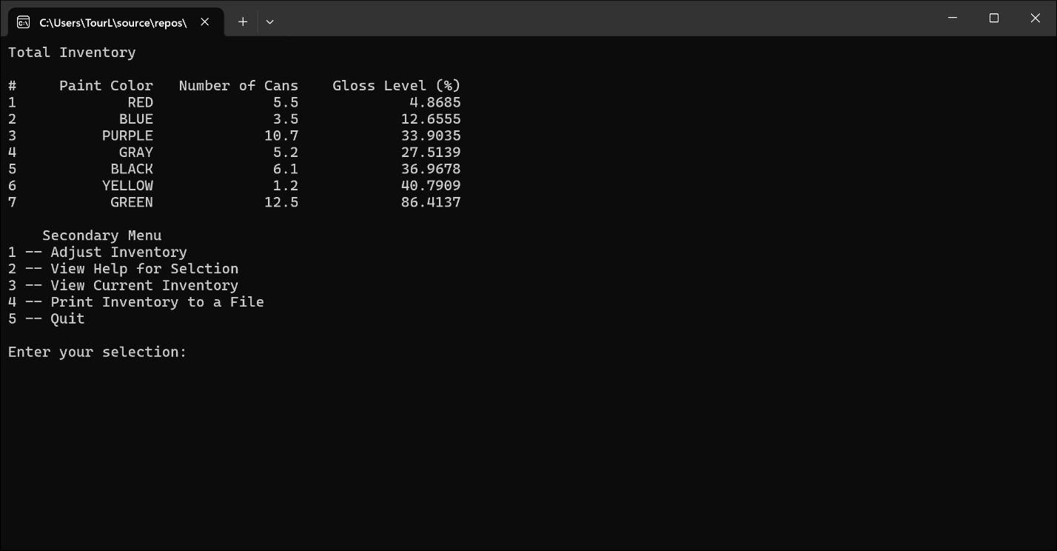
  - Screen-Shots of Running Program
  - Integrity Statements

As a protective measure, WePaintHouses LLC has also asked you to verify the integrity of your code with every project. This is a liability measure to ensure that no copyright issues occur down the road, and that you have not broken the contract terms and used outside code. To this end, please make sure that the following integrity statements are included in every submission:
- I have not shared the source code in my program with anyone other than the pre-approved human sources.
  - Please include a note here if you have used one or more of the pre-approved human sources or received special permission from me.
- I have not used source code obtained from another student, or any other unauthorized source, either modified or unmodified.
- If any source code or documentation used in my program was obtained from another source, such as the course textbook or course notes, that has been clearly noted with a proper citation in the comments of my program.
  - It would also be helpful to include a note here of which sources you used
- I have not knowingly designed this program in such a way as to defeat or interfere with the normal operation of any machine it is graded on or to produce apparently correct results when in fact it does not.
Note: These statements serve as your personal promise that the above is true. If I find that you have not been true to ALL of the four statements above, you will get a zero for the assignment and receive an academic violation report (which goes on your academic record). Both are minor compared to the loss of your integrity.
  - Change Orders
This section will not apply to all submissions, but inevitably there are some students that wish to take a solution one step further than the directions and/or accomplish the solution in a different manner than intended. If that is the case for one of your labs, you must get prior permission from me before submission. This is to make sure that the integrity of the assignment is maintained and that any changes do not result in one or more of the learning outcomes being missed.
If you wish to modify one or more portions of a given submission, you must first set up an office appointment with me to discuss. This allows me to evaluate whether the proposed change would still measure the same objectives. Together, we will come up with an altered scope of work for the assignment, which I will ask you to include here. I encourage creativity! Please feel free to make these assignments your own, we just need to use a bit of caution to make sure you are still learning the required concepts.

