Lab #1: Recursion
  - Karson Dahl
  - 9/5/24

  - Algorithm
  - This program will calculate a loan payment and produces an amortization schedule. It will prompt user for principal (amount borrowed),annual interest rate ((taken in as a percent will need to be /10 for decimal) will need to be /12), and 5, 10, or 15 year fixed loan (this will give us n, our # of iterations [60, 120, 180]). Then it will calculate the payment as per the formula given as balance + total interest and include the arte based on the equation provided. Then it will print a menu displaying the relevant information for the user. This will be done by recursively looping through the same principle of a loan and subtracting per payment and printing it out. An if loop should suffice. For iterations less than total in period, take the principal and subtract the payment times the monthly interest rate.
  - Screen-Shots of Running Program
  - 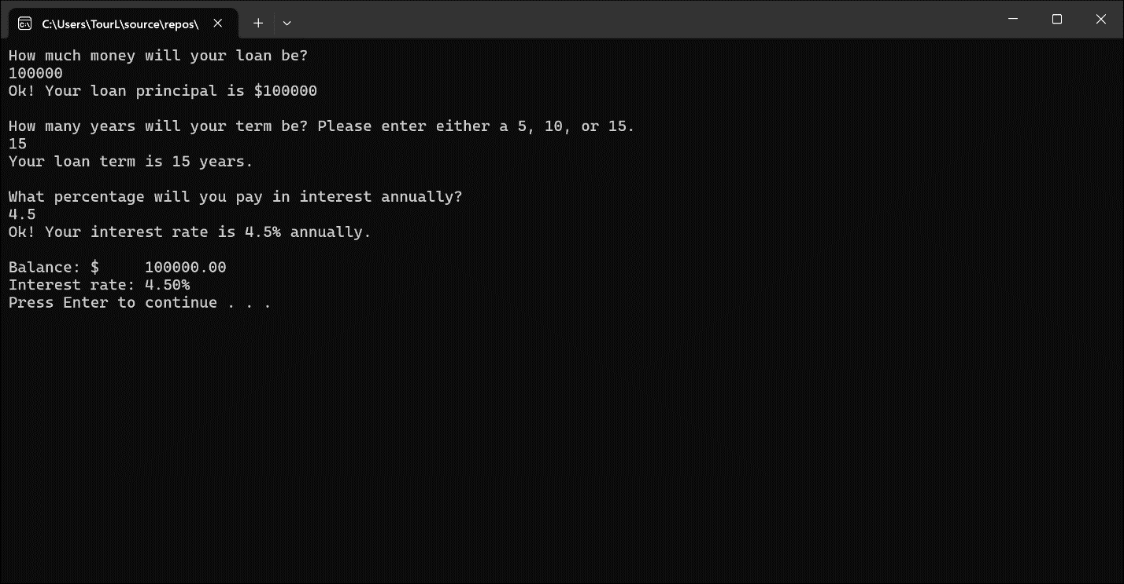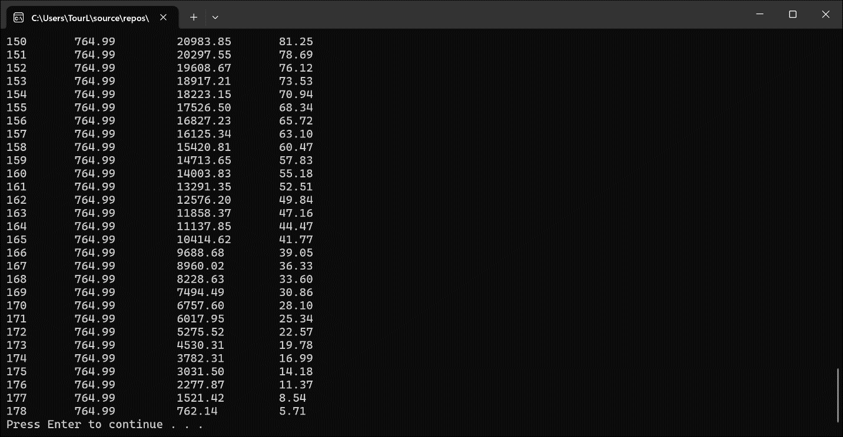
  - Integrity Statements
As a protective measure, WePaintHouses LLC has also asked you to verify the integrity of your code with every project. This is a liability measure to ensure that no copyright issues occur down the road, and that you have not broken the contract terms and used outside code. To this end, please make sure that the following integrity statements are included in every submission:
- I have not shared the source code in my program with anyone other than the pre-approved human sources.
  - Please include a note here if you have used one or more of the pre-approved human sources or received special permission from me.
- I have not used source code obtained from another student, or any other unauthorized source, either modified or unmodified.
- If any source code or documentation used in my program was obtained from another source, such as the course textbook or course notes, that has been clearly noted with a proper citation in the comments of my program.
  - It would also be helpful to include a note here of which sources you used
- I have not knowingly designed this program in such a way as to defeat or interfere with the normal operation of any machine it is graded on or to produce apparently correct results when in fact it does not.
Note: These statements serve as your personal promise that the above is true. If I find that you have not been true to ALL of the four statements above, you will get a zero for the assignment and receive an academic violation report (which goes on your academic record). Both are minor compared to the loss of your integrity.

