Lab #2: Painting Class
  - Karson Dahl
  - 9/12/2024

  - Algorithm
  - This program will prompt the user for the dimensions of the room--height, width, and length. This information will be used to determine dimensions, volume, and paintable area (floor and ceiling will be excluded). Then it will print the information for the user. The final step will be a calculation of how many gallons of paint will be required. This process will be repeatable until the user enters a '-1'.
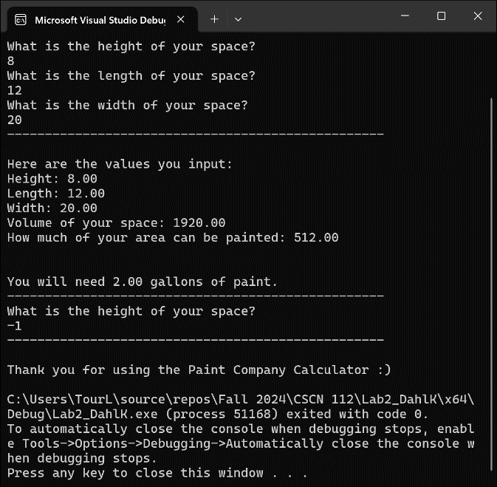
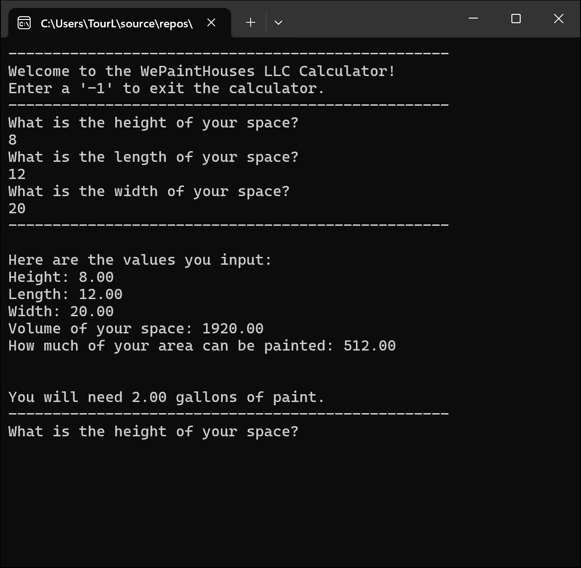
  - Screen-Shots of Running Program

  - Integrity Statements
As a protective measure, WePaintHouses LLC has also asked you to verify the integrity of your code with every project. This is a liability measure to ensure that no copyright issues occur down the road, and that you have not broken the contract terms and used outside code. To this end, please make sure that the following integrity statements are included in every submission:
- I have not shared the source code in my program with anyone other than the pre-approved human sources.
  - Please include a note here if you have used one or more of the pre-approved human sources or received special permission from me.
- I have not used source code obtained from another student, or any other unauthorized source, either modified or unmodified.
- If any source code or documentation used in my program was obtained from another source, such as the course textbook or course notes, that has been clearly noted with a proper citation in the comments of my program.
  - It would also be helpful to include a note here of which sources you used
- I have not knowingly designed this program in such a way as to defeat or interfere with the normal operation of any machine it is graded on or to produce apparently correct results when in fact it does not.
Note: These statements serve as your personal promise that the above is true. If I find that you have not been true to ALL of the four statements above, you will get a zero for the assignment and receive an academic violation report (which goes on your academic record). Both are minor compared to the loss of your integrity.
  - Change Orders
This section will not apply to all submissions, but inevitably there are some students that wish to take a solution one step further than the directions and/or accomplish the solution in a different manner than intended. If that is the case for one of your labs, you must get prior permission from me before submission. This is to make sure that the integrity of the assignment is maintained and that any changes do not result in one or more of the learning outcomes being missed.
If you wish to modify one or more portions of a given submission, you must first set up an office appointment with me to discuss. This allows me to evaluate whether the proposed change would still measure the same objectives. Together, we will come up with an altered scope of work for the assignment, which I will ask you to include here. I encourage creativity! Please feel free to make these assignments your own, we just need to use a bit of caution to make sure you are still learning the required concepts.

