**Minor Project Synopsis On**

**Real-Time Face Mask Detection**

**Under the Guidance of:** Mr. Surendra Kumar

**Undertaken by: (Group 59)**

Manan Chaudhary (9919103178)

Kartikeya Consul (9919103183)

Megha Jain (9919103188)

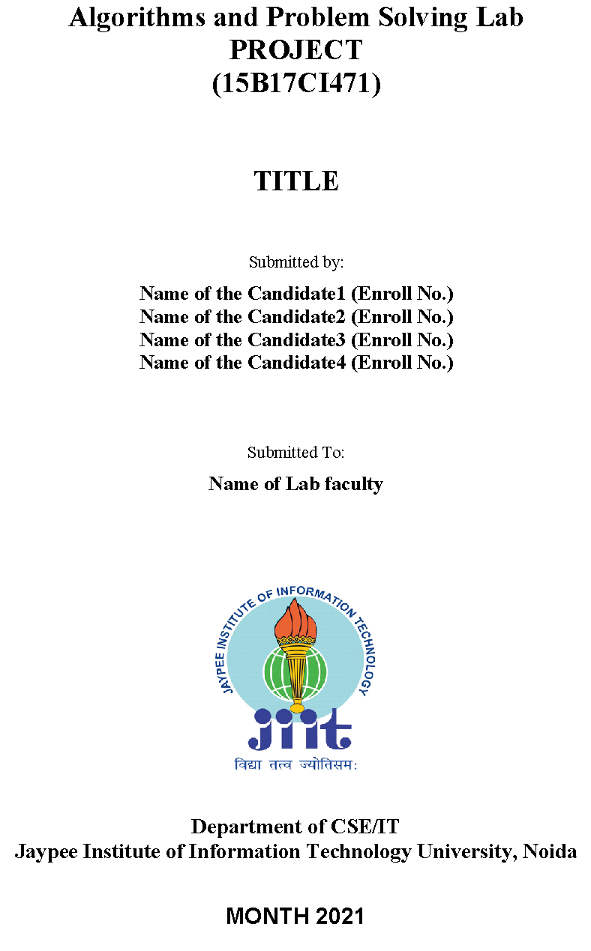

**Department of CSE/IT**

Jaypee Institute of Information Technology University, Noida

**MONTH 2021**

**Table of Contents**

* Introduction
* Background of the Study
* Statement of the Problem
* Objectives of the Study
* Motivation of the Study
* Limitations of the Study
* Datasets and Data Types
* Research Design
* Libraries and Modules Used
* References

**Introduction**

**T**he world is facing a huge health crisis due to the rapid transmission of coronavirus (COVID-19). Several guidelines were issued by the World Health Organization (WHO) for protection against the spread of coronavirus. According to WHO, the most effective preventive measure against COVID-19 is wearing a mask in public places and crowded areas, but it is very difficult to monitor people manually in these areas. To maintain this, we might take help of AI to make a model to help us monitor people whether they are wearing a mask or not.

**Background of the Study**

**I**n this paper, a CNN (Convolutional Neural Network) model is proposed to automate the process of identifying the people who are not wearing mask. The proposed model is built by fine-tuning the pre-trained state-of-the-art deep learning model, MobileNetV2. The proposed model is trained and tested on the Face Mask Detection Dataset. Image augmentation technique is adopted to address the limited availability of data for better training and testing of the model. The model outperformed the other recently proposed approaches by achieving an accuracy of 99.6% during training and 99.8% during testing.

**Statement of the problem**

**N**ot wearing mask is a huge problem and the barrier to prevent Covid crisis. It is not an easy task to aware people about this pandemic. This pandemic causes great economic crisis to the world. We saw GDP clash of many countries in the previous year. The world economy is still not stable. In many countries Covid cases are still rising in a rapid way. Before vaccination is widely available, it is so difficult to stop this virus to rise. Only way is prevention. It is said that ‘Prevention is better than Cure’. To prevent this virus, we need to be aware, wear mask and sanitize ourselves on a regular basis.

**Objectives of the Study**

• **T**o make a Face Mask detector proto-type

• **T**o monitor people in public places that they are following prevention protocol

• **T**o check if a person is wearing a mask or not

• **T**o make the face mask detection process from manual to automatic

• **T**o lower costs and human efforts

• **T**o maximize the effectiveness of the process

• **T**o learn about deep learning methods through the research work

• **T**o develop our knowledge and experience by working on this project

**Motivation of the Study**

• This reduces costs as well as human effort

• Authorities can monitor more people remotely by using security cameras only

• Increasing public awareness will be much easier

• Researcher can observe human behaviour towards the pandemic

• Maximize the effectiveness of the process

**Limitations of the Study**

• The model is smaller here as the dataset is smaller

• Lack of proper knowledge in the related fields

• The accuracy of the model might not be the best as the data is limited

• Lack of resources

• Lower implementation possibility as it is a sample project

**Datasets and Data Types**

**H**ere, we have used two samples as input to train the machine. The first set contains different images of people wearing different types of masks. Moreover, the other set contains different types of without mask images. We have tried to use different types of images to ensure getting a good model. The data that we have collected was categorical data. Later, the data was transformed into numerical data by using Label Binarizer. As machine cannot process categorical data, we have to transform them into numerical. The datasets that we have used for the research purpose was mainly secondary data as we have collected them from external sources. The datasets were collected from the GitHub account of ‘Balaji Srinivas’ which has been appreciated in the reference (S., 2020). There are total 1915 images in the folder named ‘with\_mask’. Moreover, the ‘without\_mask’ folder contains 1918 images. We believe, if the datasets could be larger, it would have produced much better model. But unfortunately, we had limitations of providing datasets as our devices would not be able to process such huge amount of data. A glimpse of the datasets is shown below:

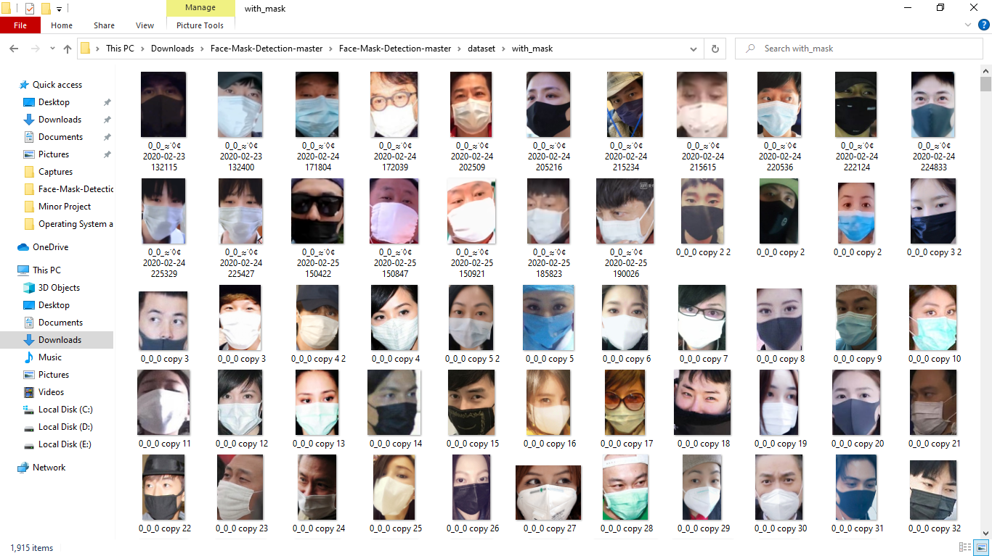

**Figure 1: With mask Dataset**

**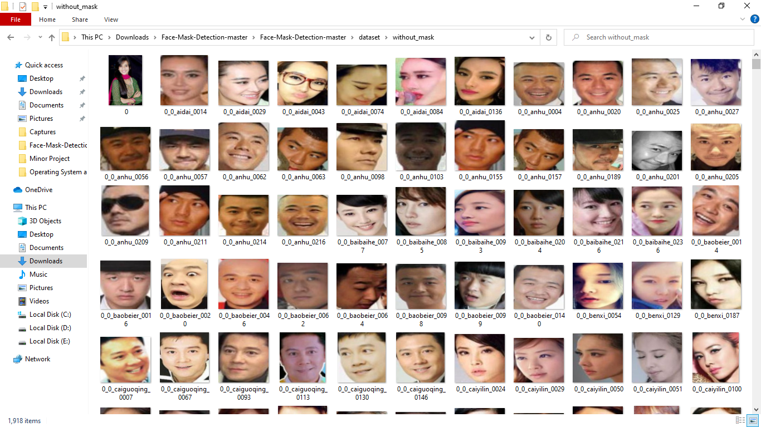**

**Figure 2: Without mask Dataset**

**Research Design**

**T**his project is actually a quantitative research. Because we had to collect data, analyse and visualize them with python programming language, train model using the python tools and finally get an output from a raw input, which can detect mask in human face. All the characteristics show that our paper is actually a result of quantitative research. In addition, this project is descriptive research as the aim of the project is to develop model with higher accuracy and precision. We can also call this research as an experimental as well as an action research. Preparation of this project can be described shortly through the following figure.

## C:\Users\consu\Videos\Captures\Sriman_Mitra_111161294.pdf - Google Chrome 11-09-2021 14_31_20 (2).png

## **Figure 3: Research Design**

**Libraries and Modules Used**

* **TensorFlow:** is a Python library for fast numerical computing created and released by Google. It is a foundation library that can be used to create Deep Learning models directly or by using wrapper libraries that simplify the process built on top of TensorFlow.
* **OpenCV:** is a library of Python bindings designed to solve computer vision problems. It is used for image processing and video capture in real time.
* **Matplotlib:** is a low-level and is one of the most widely used plotting libraries.
* **NumPy:** is a Python library used for working with arrays. Here, images are converted into pixels which are manipulated by storing in arrays.
* **Scikit-Learn:** is the most useful library in Python. Here, it is used to: manipulate the categorical data into NumPy arrays, it is also used to split the data into training and testing data and at last it is used to make a classification report of the model.
* **OS:** module in Python that provides functions for interacting with the operating system.
* **ImUtils:** A series of convenience functions to make basic image processing functions such as translation, rotation, resizing, displaying Matplotlib images, sorting contours, detecting edges, and much more easier with OpenCV and both Python 2.7 and Python 3.
* **Keras:** is a powerful and easy-to-use free open source Python library for developing and evaluating deep learning models. It wraps the efficient numerical computation libraries Theano and TensorFlow and allows you to define and train neural network models in just a few lines of code.

**References**

* [**https://www.tutorialspoint.com/python3/**](https://www.tutorialspoint.com/python3/)
* [**https://stackoverflow.com/**](https://stackoverflow.com/)
* [**https://en.wikiversity.org/**](https://en.wikiversity.org/)
* [**http://pythoncentral.io**](http://pythoncentral.io/)
* [**http://thepythonguru.com**](http://thepythonguru.com/)
* [**https://code.tutsplus.com**](https://code.tutsplus.com/)