###### Lab 5—Igneous rocks

**WHAT ARE IGNEOUS ROCKS?**

“Igneous rocks (from the Greek word for fire) form when hot, molten rock crystallizes and solidifies. The melt originates deep within the Earth near active plate boundaries or hot spots, then rises toward the surface. Igneous rocks are divided into two groups, intrusive or extrusive, depending upon where the molten rock solidifies.

“Intrusive Igneous Rocks:

Intrusive, or plutonic, igneous rock forms when magma is trapped deep inside the Earth. Great globs of molten rock rise toward the surface. Some of the magma may feed volcanoes on the Earth's surface, but most remains trapped below, where it cools very slowly over many thousands or millions of years until it solidifies. Slow cooling means the individual mineral grains have a very long time to grow, so they grow to a relatively large size. Intrusive rocks have a coarse-grained texture.

“Extrusive Igneous Rocks:

Extrusive, or volcanic, igneous rock is produced when magma exits and cools above (or very near) the Earth's surface. These are the rocks that form at erupting volcanoes and oozing fissures. The magma, called lava when molten rock erupts on the surface, cools and solidifies almost instantly when it is exposed to the relatively cool temperature of the atmosphere. Quick cooling means that mineral crystals don't have much time to grow, so these rocks have a very fine-grained or even glassy texture. Hot gas bubbles are often trapped in the quenched lava, forming a bubbly, vesicular texture.” (USGS, 2019a)

TEXTURAL TERMS

* ***Pegmatitic***—consisting of very-coarse-grained minerals—usually greater than 1 cm in diameter
* ***Phaneritic—***consisting of coarse-grained minerals large enough to be identified without the use of a hand lens (larger than 1 mm in diameter but smaller than about 1 cm)
* ***Aphanitic***—consisting of fine-grained minerals, mostly too small to be distinguished by the unaided eye (crystals less than 1 mm in diameter).
* Porphyritic
  + *with coarse-grained groundmass*—larger crystals (phenocrysts) set in a groundmass (matrix) of finer/smaller grained crystals
  + *with fine-grained groundmass*—large crystals (phenocrysts) set in a groundmass (matrix) of very fine-grained crystals
* ***Vesicular***—filled with “air bubbles” that have formed as gas bubbles try to escape during a quick cooling process
* ***Glassy***—no crystals formed because cooling was so fast that the internal structure is disordered
* ***Glassy with Vesicles****—****also called frothy***—no crystals due to a disordered inner structure, but small vesicles (“air-bubbles”) present
* ***Pyroclastic***—formed from quickly-cooled material ejected from a volcanic vent

BOWEN’S REACTION SERIES

“Within the field of geology, **Bowen's reaction series** is the work of the petrologist, Norman L. Bowen who summarized, based on experiments and observations of natural rocks, the crystallization sequence of typical basaltic magma undergoing fractional crystallization (i.e., crystallization wherein early-formed crystals are removed from the magma by crystal settling, say, leaving behind a liquid of slightly different composition). Bowen's reaction series is able to explain why certain types of minerals tend to be found together while others are almost never associated with one another. He experimented in the early 1900s with powdered rock material that was heated until it melted and then allowed to cool to a target temperature whereupon he observed the types of minerals that formed in the rocks produced. He repeated this process with progressively cooler temperatures and the results he obtained led him to formulate his reaction series which is still accepted today as the idealized progression of minerals produced by cooling basaltic magma that undergoes fractional crystallization. Based upon Bowen's work, one can infer from the minerals present in a rock the relative conditions under which the material had formed.

“The series is broken into two branches, the continuous and the discontinuous (Fig. 5.1). The branch on the right is the continuous. The minerals at the top of the illustration are first to crystallize and so the temperature gradient can be read to be from high to low with the high temperature minerals being on the top and the low temperature ones on the bottom. Since the surface of the Earth is a low temperature environment compared to the zones of rock formation, the chart also easily shows the stability of minerals with the ones at bottom being most stable and the ones at top being quickest to weather, known as the Goldich dissolution series. This is because minerals are most stable in the conditions closest to those under which they had formed. Simply put, the high temperature minerals, the first ones to crystallize in a mass of magma, are most unstable at the Earth's surface and quickest to weather because the surface is most different from the conditions under which they were created. On the other hand, the low temperature minerals are much more stable because the conditions at the surface are much more similar to the conditions under which they formed.” (Wikipedia, 2019).

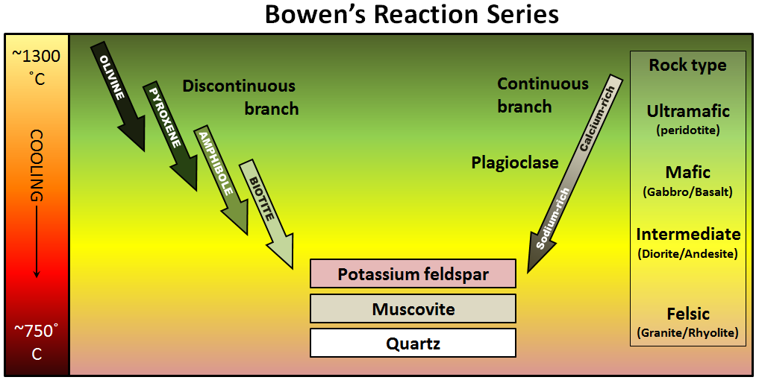

Figure 5.1. Bowen’s reaction series illustrates the sequence in which minerals form as magma cools (Earle, 2016).

###### Table 5.1. Classification of igneous rocks. To use this table as an igneous rock identification tool, identify the most prevalent minerals and the corresponding chemical composition term in the top two rows. This will determine what column you’re working with. Then identify the visual texture of the rock—its crystal size, not what it feels like—to determine which row the rock is in. At the intersection of the row and the column, you will find the name of the rock.

|  |  |  |  |  |  |
| --- | --- | --- | --- | --- | --- |
| **Chemical composition** → | **Felsic** | **Intermediate** | | **Mafic** | **Ultramafic** |
| **Minerals Present** → | **Mostly:** Quartz, K-Feldspar,  Na-Plagioclase **Some:** biotite, muscovite, and amphibole | **Mostly:**  Na-Plagioclase, Ca-plagioclase, amphibole **Some:** biotite | | **Mostly:** Ca-plagioclase, pyroxene  **Some:** amphibole | **Mostly:** pyroxene and olivine |
| **Rock texture**  **↓** |
| *Phaneritic*  *(crystals 1 mm–1 cm)* | **Granite** | **Diorite** | | **Gabbro** | **Peridotite** |
| *Pegmatitic*  *(crystals larger than 1 cm)* | Granite  Pegmatite | Diorite  Pegmatite | | Gabbro  Pegmatite |  |
| *Porphyritic with coarse-grained groundmass* | Porphyritic Granite | Porphyritic Diorite | | Porphyritic Gabbro |  |
| *Aphanitic (crystals smaller than 1 mm)* | **Rhyolite** | **Andesite** | | **Basalt** |  |
| *Porphyritic with fine-grained groundmass* | Porphyritic  Rhyolite | Porphyritic Andesite | | Porphyritic Basalt |  |
| *Vesicular* |  |  | | Vesicular Basalt |  |
| *Glassy* | Obsidian | |  | |  |
| *Glassy with vesicles (more vesicles than rock, very light-weight)* | Pumice | | Scoria | |  |
| *Pyroclastic* | Tuff | | | |  |

54

|  |  |  |  |  |  |  |
| --- | --- | --- | --- | --- | --- | --- |
| **6** | **5** | **4** | **3** | **2** | **1** | **Sample Number** |
|  |  |  |  |  |  | **Texture(s) Present** |
|  |  |  |  |  |  | **Composition**  **(Ultramafic, Mafic,**  **Intermediate, Felsic)** |
|  |  |  |  |  |  | **Minerals Present**  **and their %**  **Abundance** |
|  |  |  |  |  |  | **Rock Name** |
|  |  |  |  |  |  | **Inferred Rock Origin/History (cooling rate, Bowens**  **Reaction Series)** |

|  |  |  |  |  |  |  |  |
| --- | --- | --- | --- | --- | --- | --- | --- |
| **Inferred Rock Origin/History (cooling rate, Bowens**  **Reaction Series)** |  |  |  |  |  |  |  |
| **Rock Name** |  |  |  |  |  |  |  |
| **Minerals Present**  **and their %**  **Abundance** |  |  |  |  |  |  |  |
| **Composition**  **(Ultramafic, Mafic,**  **Intermediate, Felsic)** |  |  |  |  |  |  |  |
| **Texture(s) Present** |  |  |  |  |  |  |  |
| **Sample Number** | **7** | **8** | **9** | **10** | **11** | **12** | **13** |

55

***REFERENCES***

Earle, Stephen, 2014, “Bowen's Reaction Series,” <https://opentextbc.ca/physicalgeologyearle/wp-content/uploads/sites/145/2016/06/Bowen-reaction2.png>; last access: 2022-07-06.

USGS, 2019a, “What Are Igneous Rocks?” United States Geological Survey. Accessed September 3, 2019. https://[www.usgs.gov/faqs/what-are-igneous-rocks?qt-news_science_products=0#qt-](http://www.usgs.gov/faqs/what-are-igneous-rocks?qt-news_science_products=0&qt-)news_science_products.

Wikipedia, “Bowen’s Reaction Series,” <https://en.wikipedia.org/wiki/Bowen%27s_reaction_series>; last access: 2019-09-30.