LT428 / PT5201 Analog audio part

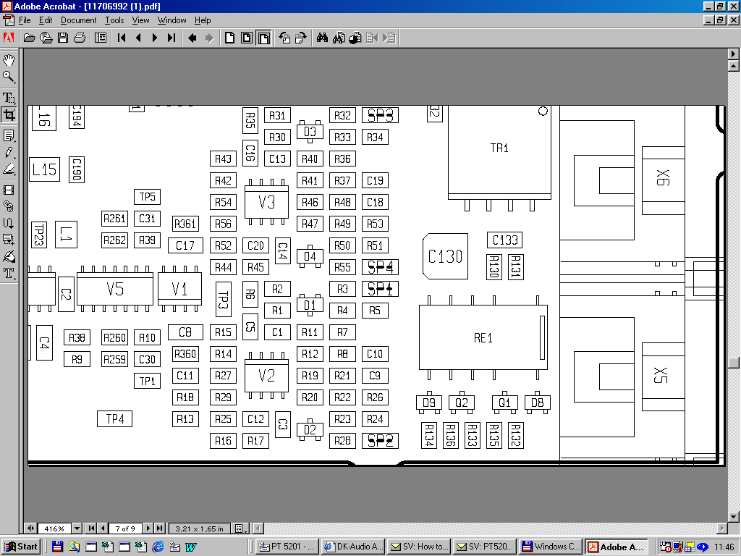
R360 & R361

