DK-Audio A/S

Marielundvej 37D
DK-2730 Herlev
Denmark

PT 5211 VariTime™Changeover

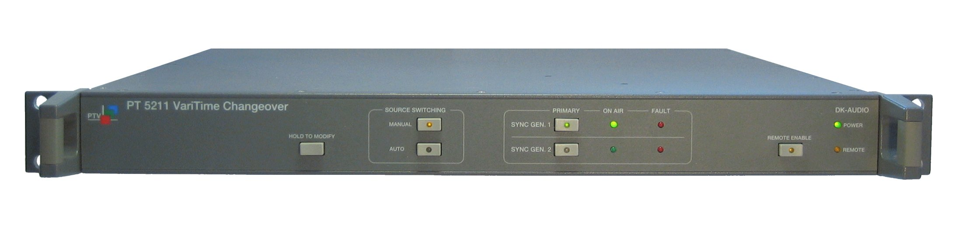

Instruction Manual

PT 5211 VariTime™Changeover, Instruction manual

Copyright © 2003 | DK-Audio A/S, Denmark  All Rights Reserved
Printed in Denmark: 17-02-2004
Revision: 4
Publication number: 9499 493 10111

