DK-Technologies A/S
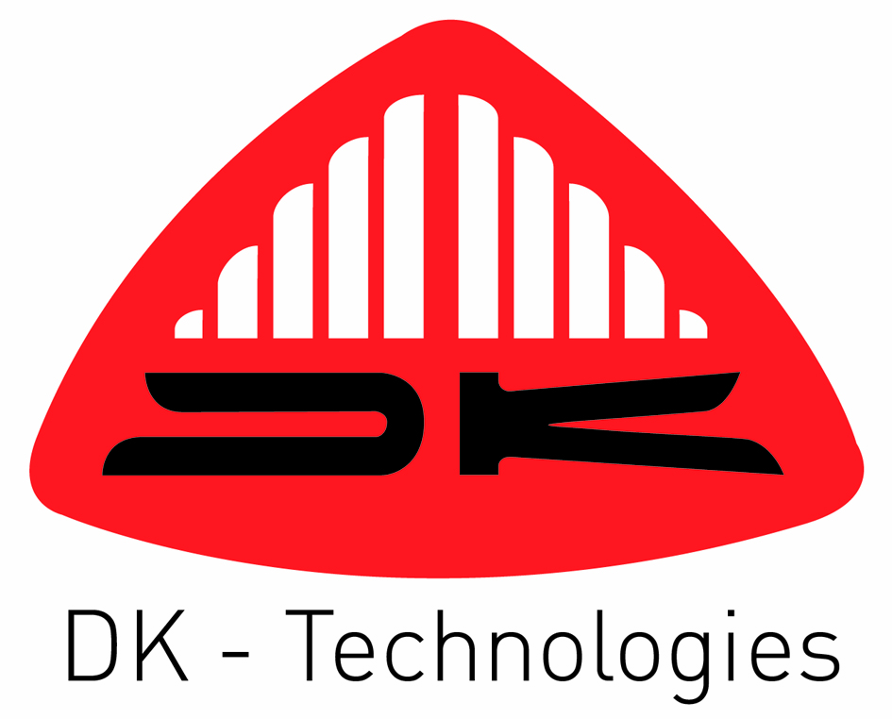

Marielundvej 37D
DK-2730 Herlev
Denmark

PT 5211 VariTime™Changeover

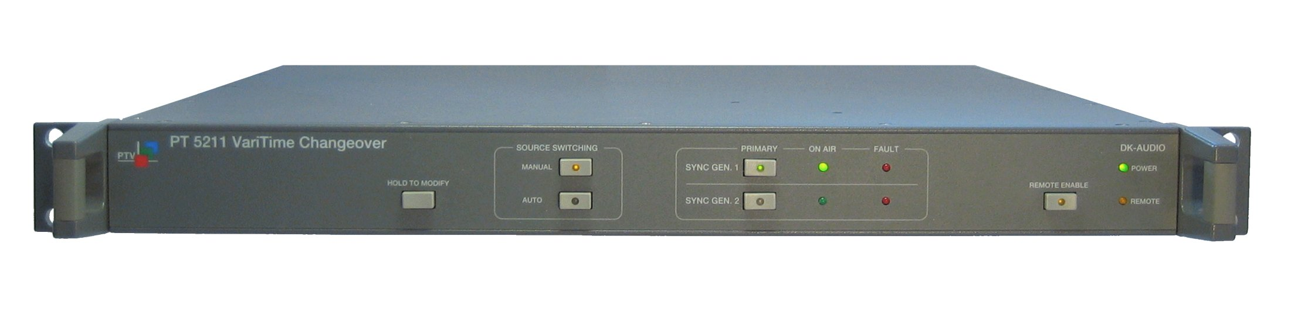

Instruction Manual

PT 5211 VariTime™Changeover, Instruction manual

Copyright © 2003 | DK-Technologies A/S, Denmark  All Rights Reserved
Printed in Denmark: October 2009
Revision: 5
Publication number: 9499 493 10111

