
DK-Audio A/S
Marienlundvej 37D
DK-2730 Herlev
Denmark

PT 5664
Digital & Analog Component/
Composite WFM

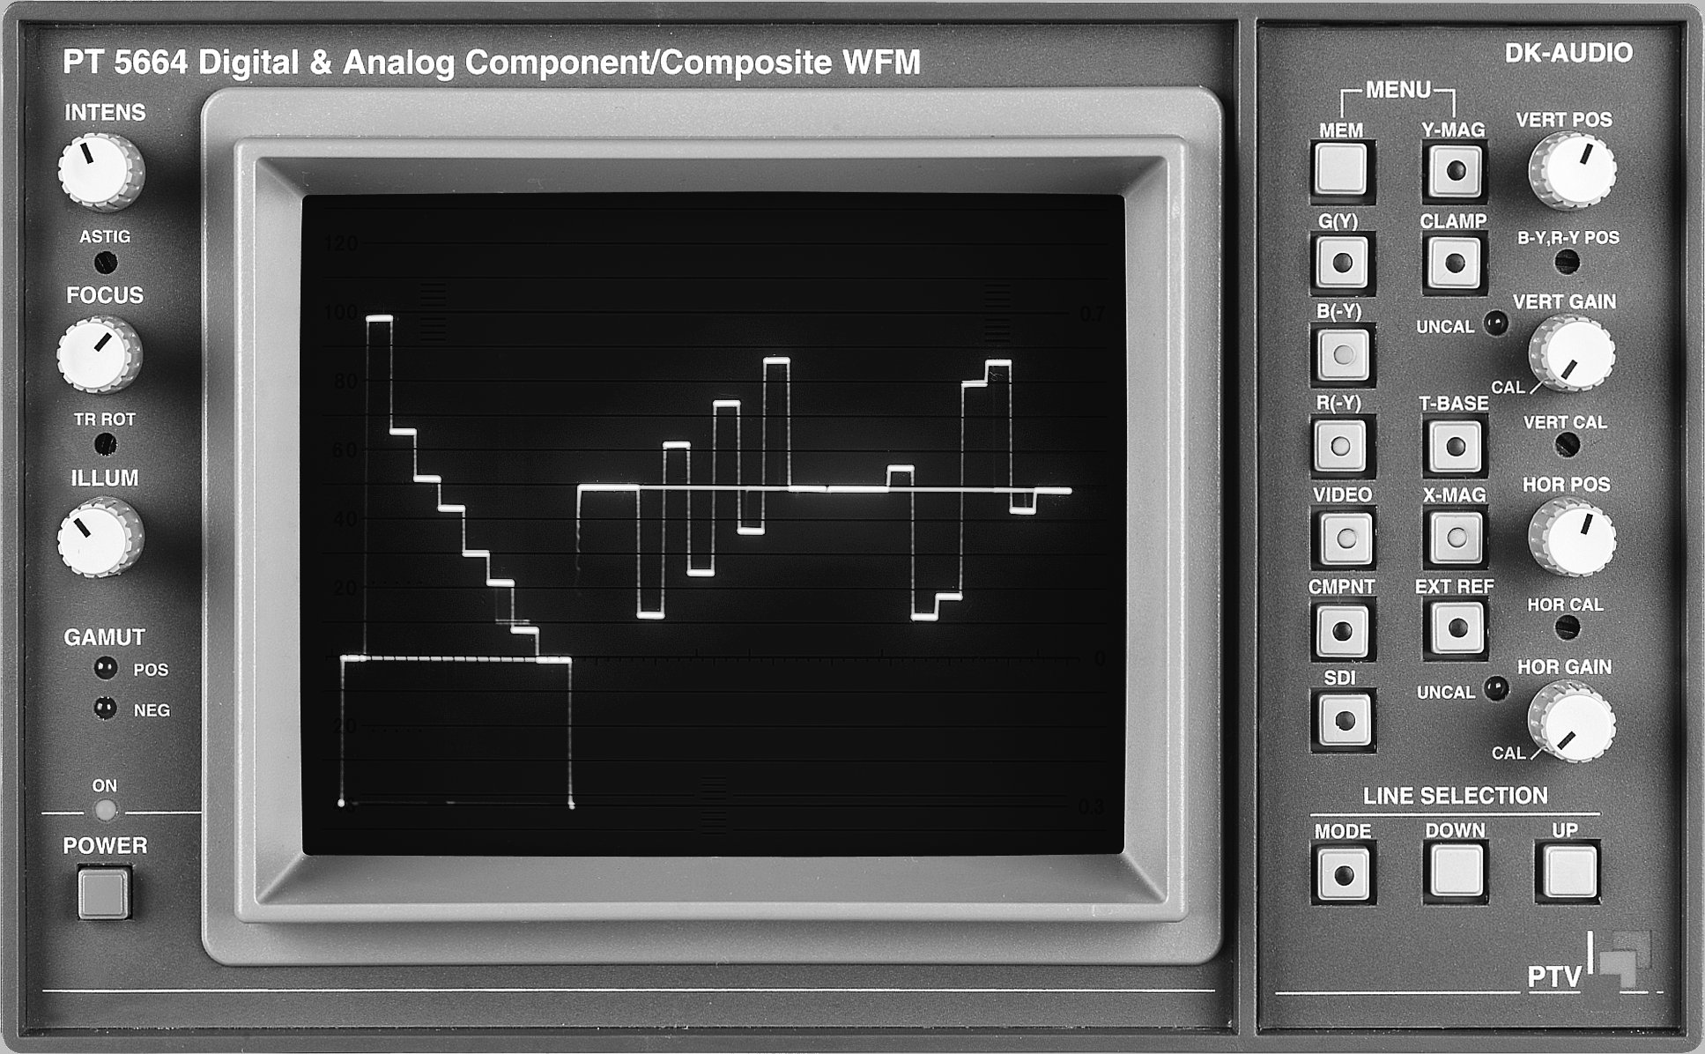

Service Manual

PT 5664 Digital & Analog Component/Composite WFM: | Total number of pages:  Text : 33  Drawings:

Copyright © 2003 | DK-Audio A/S, Denmark  All Rights Reserved
Printed in Denmark 2003-09-08
Revision: 4
Publication number: 9499 495 10111

Contents

1 Safety 1-1
1.1 Introduction 1-1
1.2 Safety Precautions 1-1
1.3 Caution and Warning markings. 1-1
1.4 Impaired Safety Protection 1-1
1.4.1 Technical Specifications 1-2
1.4.2 Equipment Ratings 1-2
1.5 Parts lists. 1-3
1.6 Diagram Symbols Description 1-3
1.6.1 Block diagram 1-3
1.6.2 Detailed diagrams 1-3
2 Safety Symbols 2-4
3 Block diagram description 3-5
3.1 Main functions of the units 3-5
3.1.1 Power Supply 3-5
3.1.2 CRT Control 3-5
3.1.3 Deflection Amplifiers 3-5
3.1.4 Signal Processor 3-5
3.1.5 Potentiometer Board 3-7
3.1.6 Keyboard 3-7
3.1.7 SDI and Control Board 3-7
3.1.8 RGB Monitor Out 3-7
4 Access to units 4-8
4.1 Removing the Cover 4-8
4.2 Access to Signal Processor (Unit 4) and SDI & Control Board (Unit 7) 4-8
4.3 Access to and Removal of the Power Supply - Unit 1 4-9
4.4 Access to and Removal of the CRT Control Unit - Unit 2 4-10
4.5 Access to the Deflection Amplifier - Unit 3 4-10
4.6 Access to the Potentiometer Board - Unit 5 and the Keyboard - Unit 6 4-10
4.7 Access to the RGB Monitor Out Unit - Unit 8 4-11
4.8 CRT Replacement 4-11
5 Power Supply - Unit 1 5-13
5.1 General Information 5-13
5.2 Circuit Description 5-13
5.3 Test and Adjustments 5-15
6 CRT Control - Unit 2 6-16
7 Deflection Amplifiers - Unit 3 7-16
7.1 General Information 7-16
7.2 Circuit Description 7-16
8 Signal Processor - Unit 4 8-17
8.1 General Information 8-17
8.2 Circuit Description 8-17
8.3 Test and adjustments 8-21
9 Potentiometer Board - Unit 5 9-23
10 Keyboard - Unit 6 10-23
11 Control Board - Unit 7 11-23
11.1 General Information 11-23
11.2 Circuit Description 11-24
11.3 Test and Adjustments 11-26
12 RGB Monitor Out - Unit 8 12-27
12.1 General Information 12-27
12.2 Circuit Description 12-27
12.3 Gamut Detector 12-27
12.4 Test and adjustments: 12-28
14 Diagrams and component placement. 14-29

Safety
Read this chapter carefully before attempting to repair the instrument.

Introduction
The instrument described in this manual is designed to be used by properly trained personnel only.

Adjustment, maintenance and repair of the exposed equipment shall be carried out only by qualified personnel who are aware of hazards involved.

Safety Precautions
For the correct and safe use of the instrument, it is essential that both operating and servicing personnel follow generally accepted safety procedures in addition to the safety precautions specified in this manual. Specific warning and caution statements, where applicable, are found throughout this manual. Warning and caution statements and/or symbols are marked on the instrument where necessary.

If covers are opened or parts removed, except those parts to which access can be gained by hand, live parts may be exposed.

The instrument must be disconnected from all power sources before performing any adjustment, maintenance, or repair which requires the instrument to be opened.
If adjustment, maintenance or repair of the opened instrument is unavoidable, it must only be carried out by a skilled person who is aware of the hazards involved.

Caution and Warning markings.
Caution
Used to indicate correct operation or maintenance in order to prevent damage to, or destruction of equipment or other property.

Warning
Used to indicate a potential hazard that requires correct procedures or practices in order to prevent personal injury.

Impaired Safety Protection
Whenever it is likely that safe operation is impaired, the instrument must be made inoperative and secured against unintended operation. The appropriate servicing authority must then be informed.
For example, safety is likely to be impaired if the instrument fails to perform the intended measurements or shows visible damage.

Technical Specifications
This manual provides technical information important for safe servicing of the equipment.

Technical assistance may be obtained from your local PTV/DK-AUDIO customer support organisation or from:

DK-AUDIO A/S
Marielundvej 27
DK-2730 Herlev
Denmark
Phone: +45 4485 0255
Fax: +45 4485 0250
E-Mail: info@dk-audio.com
Website: http://www.dk-audio.com

Equipment Ratings
The instrument can be used with a mains voltage supply of:
Voltage:
90 V AC - 250 V AC.
Frequency:
48 – 65 Hz.
The power consumption:
Does not exceed 72 VA.

The instrument is designed for the following environmental conditions:
Indoor use
Altitudes up to 2000 m
Temperatures between 5ºC and 40ºC
Maximum relative humidity of 80% for temperatures up to 31ºC decreasing linearly to 50% relative humidity at 40ºC.

The terminals of the instrument are protected from becoming hazardous live by means of basic insulation and protective screening.

Whenever it is likely that safe operation is impaired, the instrument must be made inoperative and secured against unintended operation. The appropriate servicing authority must be informed.

For example, safety is likely to be impaired if the instrument fails to perform the intended measurements or shows visible damage.

WARNING: Protection provided by the equipment may be impaired, if the equipment is used in a manner not specified by this manual.



Parts lists.
Parts lists are with a short description of the part and with reference to the order number.

Diagram Symbols Description

Block diagram
The block diagram and the wiring diagram shows how the different parts are connected. Each block in the diagram has in the lower corner reference to the appropriate unit,

Detailed diagrams
Component placement and diagrams are all placed at the end of this service manual. Their size is optimised for printing on A3 landscape format.

Safety Symbols
Symbol | Colour: | Explanation:
 | Red | High voltage terminal: a terminal at which a voltage, with respect to another terminal or parts exists or may be adjusted to 1000 V or more. (High voltage > 1000 V).
 | Black/Yellow | Live part shock risk of electric shock.
 | Black/Yellow | To preserve the instrument from damage the operator must refer to an explanation in the instruction manual.
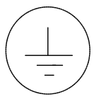 | White/Black | Protective earth (grounding) terminal.
~ | Black | Alternating current (placed on the indetification plate).
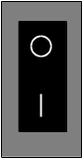 | White/Black | Off (supply - mains switch).  On (supply - mains switch).

Block diagram description
The PT 5664 consists of 8 (10) units.
These are:
Power Supply Unit 1
CRT Board Unit 1A
Illumination Panel Unit 1B
CRT Control Unit 2
Deflection Amplifiers Unit 3
Signal Processor Unit 4
Potentiometer Board Unit 5
Keyboard Unit 6
SDI input and Control Unit Unit 7
RGB Monitor Out Unit 8

Main functions of the units

Power Supply
The Power Supply delivers various regulated and unregulated voltages used by other parts of the instrument. Also supplies the CRT with the necessary voltages like FOCUS, High Tension, and filament voltage.

CRT Control
The CRT Control unit contains 6 potentiometers used to control Intensity, Astigmatism, Focus, Trace Rotation, and Illumination.

Deflection Amplifiers
This unit contains amplifiers, which amplify the horizontal and vertical signals to the proper level with respect to the deflection plates of the CRT.

Signal Processor
The three analog component signals from the input connectors are fed, each via a different amplifier, to the Input Switch selecting between the analog input signal and the SDI-to-analog converted signal.
The selected signal is next fed to the Monitor matrix, the Display matrix, and the RGB Display switch. The output of the RGB Display switch is fed to the Format Switch, the Reference Switch and the H- and V-selector

If the input signals are in RGB mode, they are fed directly via the Format switch to the output buffers on unit 8. If the input signals are in YUV mode, they are converted into RGB mode by the Monitor matrix circuit.

The Display matrix works the opposite way. If the input signals are in YUV mode, there are two display modes:
- Presentation of signals in YUV, when signals are fed directly to the V- and H-selectors.
- Presentation of signals in RGB in waveform and parade, when signals are directed from the output of the Monitor Matrix to the RGB Display switch, which feeds the V- and H-selectors.
If the input signals are in RGB mode, they are converted into YUV mode by the Display matrix circuit.

The Vertical Selector circuit selects the input for the Variable Gain circuit. The selected signal can be fed through the band-pass section of the Non-Linearity filter (selectable in menu in the display), the function of which is to remove chroma information and differentiate the luminance steps. The variable gain amplifier is controlled by the VERT GAIN potentiometer on the front panel. The graticule generator in the two TEST modes also adds a “reference” signal here.

From the Variable Gain Amplifier the signal is fed to a polarity switch, which may invert the signal. Only the non-inverting is used in standards instruments. Then a clamp is applied to the vertical signal (if selected). This clamp pulse provides also the clamp of the U and V component to the 50% level in YUV parade mode. The vertical signal is then fed either via the second part of the Non-Linearity filter (low-pass) or, if selected, through the Vertical Low-Pass filter (4th order filter). The filter switch is used to select one of these two filters.

The input signal to the vertical drive amplifier comes either from the Filter switch, the Graticule Generator (VGV), or in Bowtie mode via the H-SIGNAL switch. A DC voltage from the VERT POS potentiometer has also been added. The gain of the Vertical Drive amplifier depends on whether the instrument is in The Normal mode or Y-MAG (x5) has been selected. The vertical deflection signal is then fed via the Vertical Output Amplifier on unit 3 to the CRT.

The signal selected with the Horizontal selector is fed through a Variable Gain amplifier, a Polarity switch, and a Low-Pass filter, all similar to the circuits in the vertical signal path. In the buffer, which comes after the Low-Pass filter DC voltage from the HOR POS, potentiometer is added to the signal. This signal is used for horizontal deflection when the Vector or Star mode has been selected (X/Y-mode). If one of the waveform modes is selected, a sawtooth signal from the sawtooth generator is used. A horizontal line time pulse is used as clockpulse for the Sawtooth Generator. This is derived from the Sync Separator circuit via the Clamp Generator. The Sync Separator also contains an oscillator, which provides a line "substitution" signal in case no external sync is provided. The Sawtooth Generator generates 6 different ramp signals depending on the selected display mode (V, 2V, H, 2H, Parade-H, Parade-V). The signal selection switch is controlled by the microprocessor (Unit 7).

The input signal to the Horizontal Drive Amplifier is comes either from the signal selection switch or from the Graticule Generator (HVG). The gain of the Horizontal Drive Amplifier depends on whether the instrument is in normal mode or X-MAG (x5) has been selected. The horizontal deflection signal is then fed via the Horizontal Output Amplifier (Unit 3) to the CRT.

Finally, unit 4 contains a Calibration Generator, which provides a 100kHz used in TEST mode to check the horizontal timing and vertical deflection. This signal is fed to the V-selector circuit, while a 12.5kHz signal derived from the 100kHz signal is fed to the Sync Separator as a horizontal timing pulse.

Potentiometer Board
The Potentiometer Board houses the potentiometers for adjustment of the horizontal and vertical gain, horizontal and vertical position, X- and Y-gain, and the position of the B-Y and R-Y signals in the PARADE display mode.

Keyboard
The Keyboard contains all the selectors on the front panel. The output of the keyboard is input to the Unit 7 Control Board.

SDI and Control Board
The SDI and control board contains the processing of the digital SDI input signal. The SDI signal on the input connector is equalised and fed to an active SDI output amplifier and to the De-serialiser. Next, the signal is demultiplexed into 3 data streams and fed to a D/A converter with postfiltering.

The board also contains a microcontroller to control the function of the instrument, an electronic graticule generator. The microcontroller provides various control signals to the other parts of the instrument, either by use of an I²C bus or an 8-bit parallel databus line (for unit 4). Input to the microcontroller is line and field information, the keyboard, and the remote connector.

The Electronic Graticule Generator provides the electronic graticule and the menu text on the CRT display.

RGB Monitor Out
This unit contains the RGB video output buffers with clamp drivers for the PIX MONITOR Output’s, an amplifier for the external reference signal, a composite video amplifier for the monitor out, and a gamut detector.
The gamut detector determines whether the level of a primary colour component exceeds 735mV (±5mV), or -35mV (±5mV): If it does, this will be indicated on the GAMUT LED’s and on the PIX MON OUTPUTS as a flickering area on the monitor screen displaying the error area.

Access to units
General information
For the location of connectors on the various units, please see Figs. ?? and ??? (wiring diagrams).

Removing the Cover
- Remove the PT 5664 cover by unscrewing two screws "A" at the rear panel (see fig. 7-1)
- Pull the instrument out of the cover
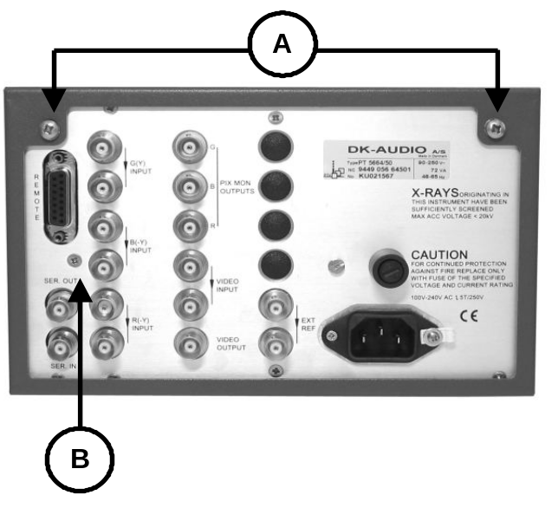
Fig. 4-1 Rear plate

Access to Signal Processor (Unit 4) and SDI & Control Board (Unit 7)
Access to the solder side of Unit 4:
- Remove flat cable connectors "C", "D", and "E" at the rear of Unit 4
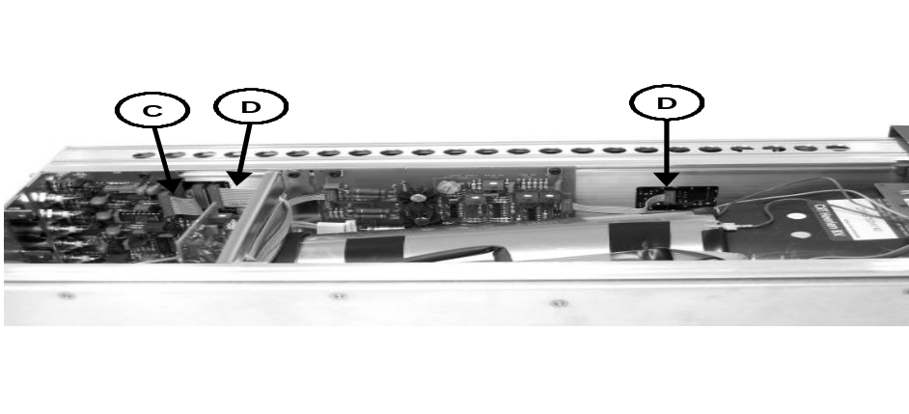

Fig. 4-2 View of connectors
- Remove the screw "B" on the rear panel. Care-fully pull the Signal board and the CPU unit out from the front of the instrument
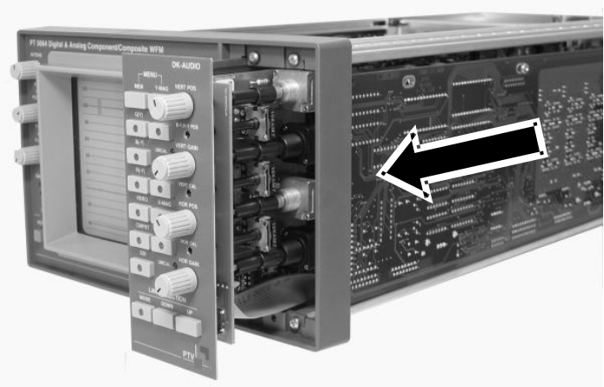
Fig. 4-3 Slide-out units

- Access to the component side of the Signal board and the CPU unit is obtained by unscrewing the three screws "F" and open the two units carefully
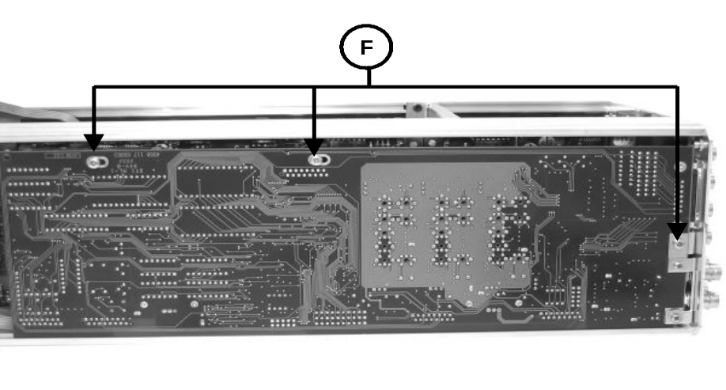
Fig. 4-4 Screws on CPU unit.

Access to and Removal of the Power Supply - Unit 1
- Turn the PT 5664 upside-down
- Remove three screws "G" and lift the Power Supply unit out carefully
- To get access to the solder side, the 10 screws holding the PCB onto the plate underneath must be removed
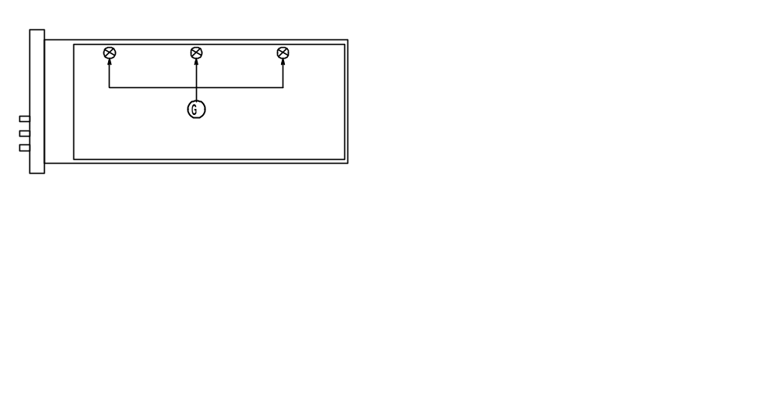
Fig. 4-5 Power Supply unit

Access to and Removal of the CRT Control Unit - Unit 2
- Remove the three knobs "H" (see fig. 7-6)
- Remove the "upper" hexagonal screw which holds the PCB onto the frame of the instrument
- Remove Unit 1 as described in paragraph 3.3
- Remove the "lower" hexagonal screw which holds the PCB onto the frame of the instrument
- Pull out the unit

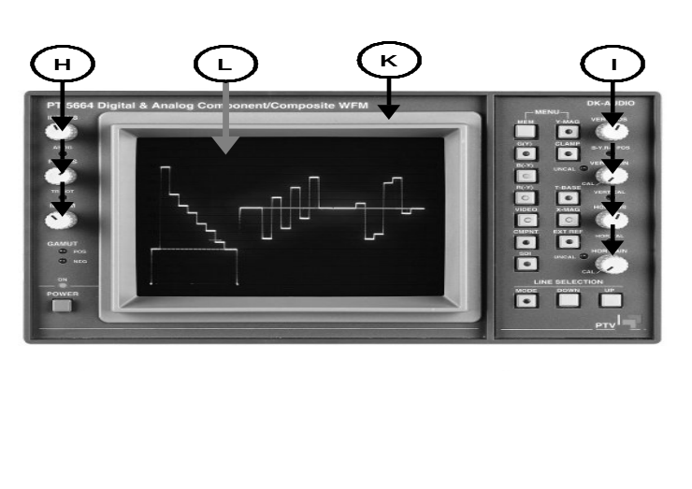
Fig. 4-6 Front of instrument.

Access to the Deflection Amplifier - Unit 3
- Remove the plugs on connectors XE, XP, and XJ (see fig. ????)
- Remove the unit by unscrewing the four screws holding the PCB onto the frame of the instrument

Access to the Potentiometer Board - Unit 5 and the Keyboard -
Unit 6
- Remove the Signal Board as described in section 3.2
- Remove the plug on connector XP on the Key-board panel
- Remove the two screws "M"

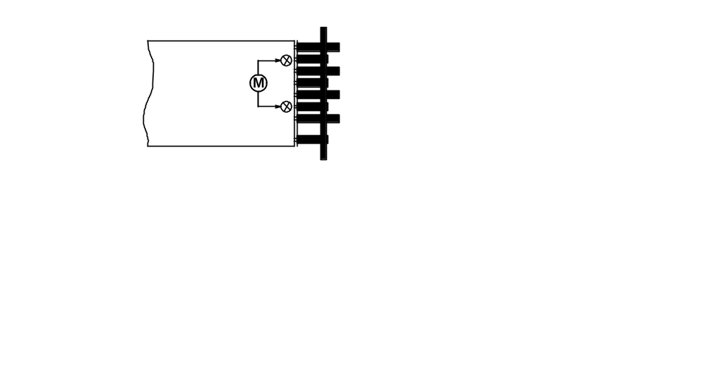

Fig. 4-7 Signal board, solder side

- Remove the plug on connector XN on the Signal Board
- For full access to the Keyboard, remove the 4 knobs marked "I" in Fig. 3-6 and the two screws marked "O" in fig. 7-7
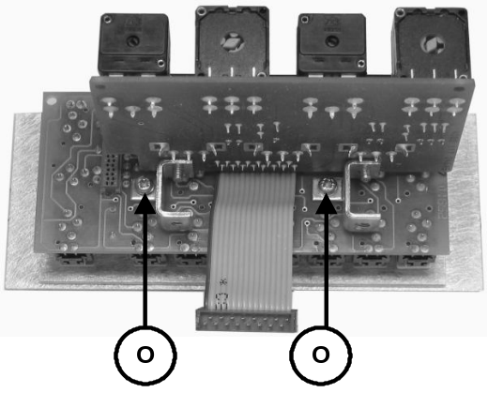
Fig. 4-8 Keyboard, solder side.

Access to the RGB Monitor Out Unit - Unit 8
- Remove the plug on connector XK on Unit 8
- Remove the unit by unscrewing the four screws holding the PCB onto the frame of the instrument

CRT Replacement
- Remove the window marked "K" and the grey filter marked "L" in fig. 7-6
- Remove the plug from the connector on the Illumination panel
- Disconnect the Power Supply as mentioned in section 7.2.3 ?
- Remove the H.T. supply socket mounted on the anode of the CRT
- Discharge the anode on the CRT
- Remove the plug from connector XE on the Deflection amplifier unit
- Remove the plugs from connectors XG, XE, and XH on the CRT board
- Remove the CRT board
- Pull off the ground connection wire on the shielding
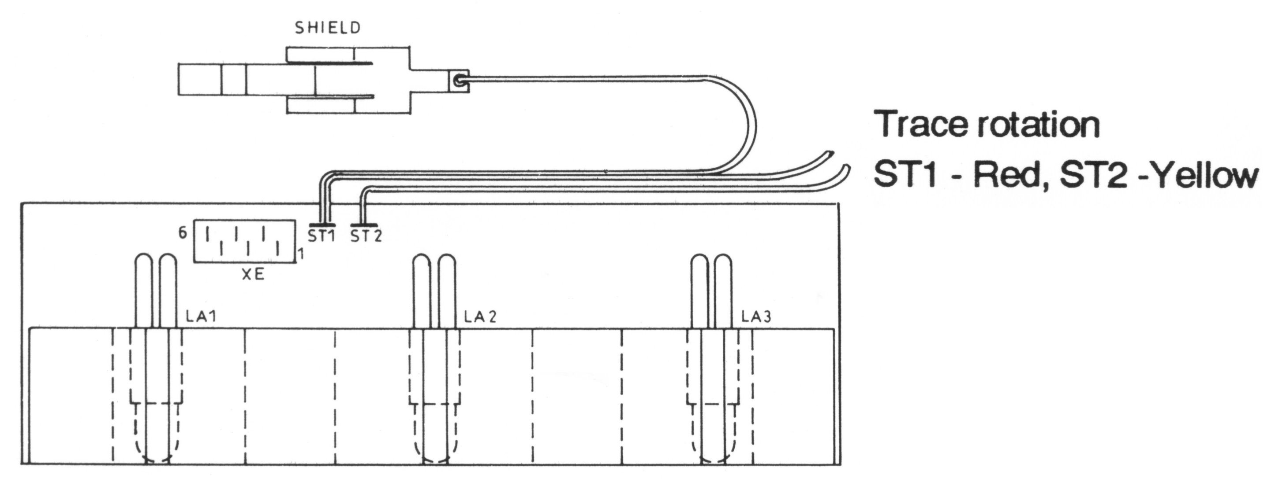
- Unsolder the wire yellow and the red wire coming from the trace rotation coil on the Illumination panel (ST 1 and ST 2) (see fig. 7-9)

Fig. 4-9 Wiring Illumination panel

- Pull out the Illumination panel
- Remove the plug on connector XP on the Deflection amplifier unit
- Release four screws "P" holding the fixing plate in position in respect to the CRT

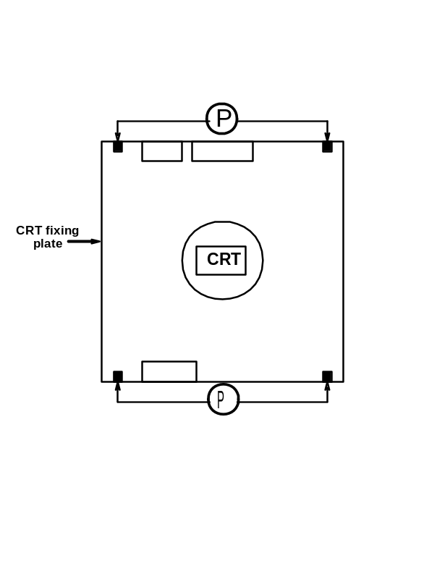
Fig. 4-10 CRT fixing plate

- Pull out towards the back and then flip out from the bottom the CRT-including shielding and rubber bushing towards the bottom
- Pull the shielding off the CRT

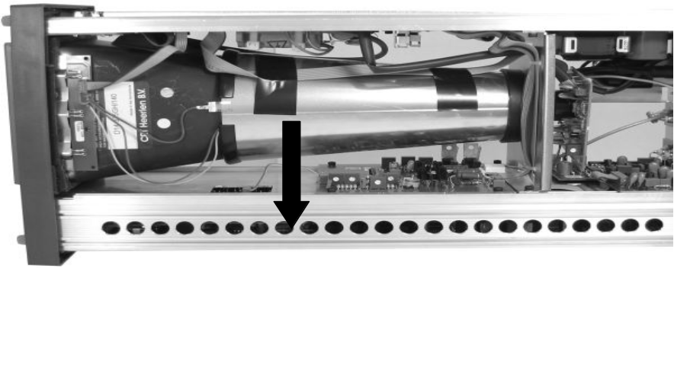

Fig. 4-11 CRT Removal.

Power Supply - Unit 1

General Information
The Power Supply provides various regulated and unregulated voltages used by other parts of the instrument. The instrument may be powered by a mains voltage of 85-240V AC_{RMS}, 120-264V DC. The mains voltage primary is protected by a 1.5A (slow) fuse (F1) located at the rear of the instrument.

Circuit Description
Mains Rectifier
The mains voltage is rectified by the diode bridge (D1). The DC voltage is then smoothed by the choke L1, and capacitors C2 and C3. The DC voltage is then fed into the Converter circuit, which consists of a Switch controller, Converter switch, and dV/dt limiter.

Converter Circuit
The flyback converter consists of transistors Q2 and Q3 and their associated components. The converter frequency depends on the input voltage. For 110V AC it is approx. 35kHz and for 220V AC approx. 50kHz. These frequencies may vary, since the frequency also depends on the load connected to the power supply.

Transistors Q2 and Q3 conduct on the forward stroke and feed the current into pin 3-4 of T1. The voltage at R15-R16 increases with the current of T1. When the voltage at R13 exceeds approx.0.7V it will fire switch D11, which when switches Q2-Q3 off. The energy in T1 will during flyback time induce a voltage at the secondary windings, which will be rectified and fed into the DC output capacitors. Also during flyback time, a voltage will be induced at pin 1-2 of T1. This voltage will recharge capacitor C4 via the path D10, D9, Q1, R6/R8, C4, and L2. When a certain value is reached, D11 is switched off. Q2-Q3 is then switched on and the sequence starts all over again. The signal at the gate of Q2 is a square wave signal received from the Voltage Stabiliser. The dV/dt limiter (L4, C12 and D14) serves to eliminate the switching spikes at the collector of Q3.

R3 is used to start up the power supply when the instrument is first switched on.

DC Output
The DC Output circuit rectifies the signal from T1. The DC voltages are smoothed by the capacitors. The +12V and -12V are regulated by V4 and V5. DC voltages for use in other parts of the instrument come from this circuit.

Voltage Control - Reference
The Voltage Reference circuit ensures an accurate 10V reference to the Voltage Control. The Voltage Control compares the reference voltage with the -15V output. If there is a change in the -15V supply (e.g. due to increasing load at any output) the output of V1-B will correct the output via the opto-coupler and bring DC levels back to normal.

Optocoupler
The current through R7 is determined by the Optocoupler, this current also runs through R13. Together with the current from R14 they determine the intervals at which switch D11 is fired. When the output from the Power Supply decreases (e.g. due to increasing load) the current through R7 will decrease. The intervals at which D11 fires will be longer due to the smaller current contribution from R7. The energy in T1 will then increase and the output voltage will return to normal.

Voltage Protection
The Protection circuit is used to protect the Power Supply against too-low or too-high voltages at the outputs. With too high an output voltage at the +15V output, Q5 will switch on. D29 in the ±43V output will turn on and short-circuit the outputs. If one of the outputs short-circuits, the power supply will operate at a low frequency (approximately 2kHz). When the output voltages are too low, Q4-Q6 will also switch on D29 and short-circuit the output. R40/C21 ensures that a virtual short circuit of the output is ignored when the instrument is first switched on.

High Voltage Generator - Tripler
The output from the oscillator (Q8-Q9) is transformed by T2 and fed to the tripler. The frequency is controlled by T2 (approx. 65kHz). The amplitude is controlled by the output from V3-a via Q7. The control circuit receives a feedback (-2k6V) from the output and the reference voltage from V1-A. The H.T. supply also supplies the CRT with filament voltage. -2.6kV is fed to the Black Level circuit and the AC/DC converter on the CRT Board. The tripler supplies the CRT anode with +14kV.

Trace Rotation
The Trace Rotation circuit (Q10-Q11) determines the strength and direction of the current passed to the trace rotation coil wound around the neck of the CRT. The current is controlled by a front panel screwdriver operated potentiometer control.

Illumination Control
The Illumination circuit (V3-B, Q14) determines the amount of current passed to the Graticule Illumination lamps (LA1-3) of the CRT, and the amount of current is controlled by the ILLUM potentiometer on the front panel. Q13 controls whether the Illumination lamps are on or off.

Z-Amplifier
The intensity of the beam is controlled by the Z-Amplifier. An oscillator signal (Z-OSC), which controls the intensity, is led from the High-Voltage Generator to a limiter - circuit (Intensity - LF), which controls the peak-peak amplitude of the oscillator signal, depending on the setting of the intensity potentiometers.

The different modes (Vector, Waveform, Test, etc.) need different light - intensities at the same potentiometer setting. This is controlled by the analog switches V7, which connects different resistor values to the emitter of Q20 depending on the selected mode. and V8, which shifts, depending on the selected mode, between the MENU, INTENS, and ILLUM potentiometer to control the voltage at the base of Q20. The analog switches are con-trolled by three inputs (I0, I1, and I2) derived from the Signal Processor (Unit 4). These three lines make up the set-up shown in table 7-1

AC/DC Converter (Unit 1A)
The AC/DC converters (D43-D44) convert the oscillator signal a DC voltage, which is fed to G1 on the CRT and thereby controls the intensity on the screen. The blanking pulses from the Z-Amplifier are fed directly to the AC/DC converter via C78. The negative pulses will switch off the beam.

Black Level (Unit 1A)
The black level circuit is used to ensure that the beam is switched off when the INTENS potentiometer is in minimum position. This is adjustable by means of R4 (use a trimmer with an isolated tip). Q1 determine the minimum current through transistors Q2-Q4 and thus the voltage on the cathode of the CRT.

Focus Voltage Conversion
This circuit produces the focus voltage required by the CRT. The FOCUS potentiometer and the current through R107 determine the current through transistors Q2, Q3, and Q4 and thus the G3 focus voltage to the CRT. When the intensity on the screen changes, the focus voltage must change too. To ensure stable focus, the output from the Z-Amplifier with information on the intensity is connected to the Focus circuit via the Dynamic Focus circuit.

I0 | I1 | I2 | Potentiometer (V8) | Resistor (V7) | Function (Mode)
0 | 0 | 0 | INTENS | R142 | Waveform
0 | 0 | 1 | INTENS | R143 | Waveform, single line
0 | 1 | 0 | R159/160 | R144 | Text, single line
0 | 1 | 1 | MENU | R145 | Menu text
1 | 0 | 0 | ILLUM | R146 | Text
1 | 0 | 1 | ILLUM | R147 | Graticule
1 | 1 | 0 | ILLUM | R148 | Dots
1 | 1 | 1 | MENU | None | Blanking

Table 4-1.

Test and Adjustments
Equipment
- DVM
- High voltage probe

Power supply (unit 1) and CRT-board unit (1A)

1. Reference voltage - R28.
- Connect a digital voltmeter to TP 7
- Adjust R28 to 14.8 V ±20mV

2. High voltage generator - R49.
- Connect a High voltage probe to connector XT pin 2
- Adjust R49 to 2540 V ±10V

CRT Control - Unit 2
The CRT Control unit consists of 6 potentiometers (of which 5 are accessible from the front of the instrument) and LED’s for ON and GAMUT indication. The potentiometers are used to control the Intensity, Astigmatism, Focus voltage of the CRT, Trace rotation, and the Illumination of the graticule light. The last potentiometer, which is not accessible from the front of the instrument, is used for adjustment of the MENU intensity.

Diode D1 reduces drift of the intensity.

Deflection Amplifiers - Unit 3

General Information
This unit contains the final amplifiers needed to supply the CRT plates with proper signal amplitudes.

Circuit Description
Horizontal Output Amplifier
The signal from the Unit 4 X-Driver enters the clipper circuit formed by the two double diodes D5 and D6, which limit the signal amplitude to approximately ±1V. Via gain control R17, the signal from the clipper enters the base of V1-b on the first differential amplifier V1-B/V1-C. V1-D controls the bias in the output stage, which at R23 is adjusted to approximately -14V at outputs XE5 and XE6 at 0V input. A balanced signal from the collectors of V1-B and V1-C is sent to the bases of Q1 and Q2, which together with Q3, Q4, Q5, and Q6 form a differential amplifier cascode-operated with its current source (Q5-Q6) at the collectors. The output is low-impedance due to the emitter output. R4/R19 and R12/R21 determine gain and D1-D4 functions as temperature compensation. D2 and D3 (LED’s) light up under normal operating conditions.

Due to minor deviations of the physical 90° relationship between the vertical and horizontal deflection plates of the CRT, it may be necessary to compensate by feeding a horizontal signal component to the Vertical amplifier, thereby eliminating the fault. Resistors R27-29, which feed this orthogonality signal to the Vertical Output amplifier, are only mounted in instruments, whose CRT needs this compensation.

Vertical Output Amplifier
The signal from the Unit 4 Y-Driver enters the clipper circuit formed by the two double diodes D9 and D10, which limit the amplitude of the signal to approximately ±1V. Via gain control R40, the signal from the clipper enters the base of Q43 of the first differential amplifier (Q42-Q43). The second differential amplifier consists of Q44 and Q45. Q41 and Q46 are current sources for these two differential amplifiers. A balanced signal from the collectors of Q44 and Q45 is fed to the two cascode-coupled output stages Q48-Q49 and Q50-Q51.
Q47 controls the bias in the output stage, which on R77 is adjusted so that the voltage on the output XE1 and XE2 is approximately 0V at 0V input. The frequency response of the amplifier can be adjusted at R72/C54. The DC offset at the two outputs XE1 and XE2 can be adjusted by changing the DC balance (R50) in the First Differential amplifier.

Signal Processor - Unit 4

General Information
This unit is the heart of the instrument because it is here all the signal processing is done. This unit contains circuits for Waveform, Vector, and Test; the signal paths through the circuits are controlled by the microprocessor on Unit 7. Furthermore the unit contains three looped-through inputs CH1, CH2 and CH3.

Circuit Description
Input Buffer and switches
Since the three input buffer CH1, CH2, and CH3 are identical, only CH1 is described.

The input buffer is constructed as a Non-Inverting amplifier with a gain of one. At the input of the amplifier is an AC/DC switch, (Q1). When 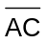 is high, Q1 short-circuits and the amplifier is DC-coupled.
From the AC/DC switch the signal enters the video amplifier, V14-c. At R7 it is possible to adjust the current so that the DC offset on the buffer output is zero.
The input switch V2 selects between the signal from the analog input buffer and the converted signal from the SDI interface on Unit 7. A second switch, which is based on two video amplifiers V12-A and V-12B, selects between the signal coming directly from the input switch and a processed signal from the MONITOR MATRIX. The video amplifiers are enable with the 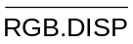 control. This function enables the display of YUV signals as RGB (Waveform and Parade only).

The output of the input switch V2 is buffered by V16 for the driving the two matrices: MONITOR MATRIX and DISPLAY MATRIX.

Calibration Generator
The calibration generator is built around the IC V5. This counter is provided with a 6.4MHz X-tal oscillator. The 6.4MHz signal is divided to 100kHz (TEST) and to 12.5kHz for the sync separator.

Sync Separator
The sync separator is constructed as a small sub-unit comprised of SMD components and considered one single component.

The sync separator receives its input from multiplexer V6.

The following signals are available to the Sync Separator:
- CH1 (CVS low)
- Composite video (ERS low and CVS high)
- External sync signal (T-SEL, ERS and CVS high), and
- 12.5 kHz signal from the calibration generator (T-SEL low and ERS, CVS high)

Following signals are available from the Sync Separator:
- Composite sync (SYNC)
- A line-sequential sync (LINE)
- A field-sequential sync (FIELD), and
- A frame-sequential square-wave signal (FIELD1)

Monitor Matrix
The monitor matrix circuit converts the input signals from the input buffers from YUV mode into RGB mode. If the input signals are R, G, and B, the matrix is by-passed by means of the multiplexer V8.
The output from the monitor matrix is also used for displaying YUV signals as RGB in WAVEFORM and PARADE mode.

Display Matrix
The Display Matrix circuit converts the input signals from RGB mode into YUV mode. This is accomplished by a resistor array (R91) and the operational amplifiers V15-A-C-D.

Vertical Selector
The Vertical Selector circuit selects the input to the Variable Gain circuit. The selected signal can be fed through the band-pass section of the Non- Linearity filter by means of the V206 switches (NON low).

Non-Linearity Filter
The Non-Linearity filter is divided into two parts:
- A band-pass section before the Variable Gain circuit and
- A low-pass section after it.
This is done to eliminate non-linearity errors deriving from the variable gain circuit.

The Non-Linearity filter, built up around the transistors Q214, Q215 and Q311, removes the chroma information and differentiates the luminance steps. The output from the filter is spikes expressing the amplitude of the luminance steps in the incoming video signal.

Variable Gain Vertical
The signal from the V-selector circuit is fed to the one part of a balanced input on the double-balanced modulator IC, V202 (pin 4). It also enters the inverting amplifier Q211-Q213, which produces a balanced input for balanced modulator V202 (pin 1). The inverting amplifier has a gain of -1.0.

A "reference" signal, Vertical Graticule Variable (VGV), from the graticule generator can be added to the input signal via R270-R271 and V206-B. This is active in the two TEST modes in which you add a signal as reference (700mV or variable level).

The V-BAL potentiometer (R268) is adjusted so that the DC offset at the output of V202 is independent of the gain settings. The OFFSET ADJ. potentiometer is adjusted for minimum offset.

The gain of V202 can be controlled either by the V-CAL or by the V-VAR GAIN potentiometer on the Potentiometer Board (Unit 5). When the V-VAR GAIN (VERT GAIN) is turned away from its left-most position, the "V-UNCAL" switch is closed due to its mechanical connection to the V-VAR GAIN potentiometer. When the V-UNCAL switch is closed, the microprocessor on Unit 7 switches V207-C to the V-VAR GAIN potentiometer via the VVE signal (Vertical Variable Enable).

From V207-C the control voltage is fed to pin 10 of modulator IC V202. A reference voltage (approx. 3.8V) is connected to pin 8. The DC voltage obtained across double-diode D201 is used to control the gain of the Vertical signal, so that maximum gain is obtained at approximately 100mV and minimum gain at 0mV.

R205/C201 and R285/C220 compensate for low-frequency (field) errors.

Polarity Switch and Buffer, Vertical
The polarity switch may invert the signal from the output of the balanced modulator V202. In standard instruments only the non-inverting function is used, which means that the VI signal at V207-B, pin 10 always is low, which again makes the switch activate Q201/Q204 by lowering the DC voltage at the base of the transistors to 6V (Off: 8V).

The current mirror Q205-Q206 converts the balanced signal to a single current flowing into the input of the current to voltage converting amplifier (Q207-Q209).

Multiple Clamp, Vertical
The input to the clamp is taken from the output of response switch V303 and fed to the non-inverting input of transconductance amplifier V205-D. The inverting input is connected to ground or - if the YUV parade signal is selected, in which the U and the V components are clamped to the 50% level - to the B(-Y), R(-Y) potentiometer on the Potentiometer Board (Unit 5).

When the Clamp Pulse (CP) from the Clamp Generator is fed via Q210 to the amplifier, the voltage difference between the inputs is detected. A correction voltage is then sent to one of the "clamp" capacitors via switch V204 and back through the switch and a voltage buffer (V208-C) to the input of the current to voltage converter (Q207-Q209). The switch switches between the three clamp capacitors C208-C210 (one for each input channel). This is controlled by the microprocessor on Unit 7 and synchronised to line shift. If "clamp" is not selected (off), the buffer (V208-C) is connected to ground through the switch.

Vertical-LP Filter
This filter consists of two second-order low-pass blocks built around Q301/Q302 and a buffer amplifier (V208-D/Q305) with a gain of approximately 1.5. This makes it a 4th order filter of the Bessel type with less than 1% overshoot. The output of the buffer amplifier is fed to response switch V303.

Vertical Drive Amplifier
The input signal to the vertical drive amplifier comes either from the Graticule Generator via V301-C, response switch V303, or through the H-SIGNAL switch V207-a (Bowtie mode). When the graticule signal is selected, Q303 is switched in to eliminate "interference" from the response switch.

A DC voltage to control the vertical position is added from the Potentiometer Board via switch V509-B and a buffer amplifier (V506-A).

The Vertical Drive amplifier itself is a current-to-voltage amplifier, built around the transistor array (V304/Q304). This ensures low-temperature drift.

When transistor V304-C is switched on, the amplifier-gain is increased 5 times. C304 and C324 are used to adjust the frequency compensation in the x1 and x5 modes respectively.

Horizontal Selector, Variable Gain (H), Polarity Switch, Buffer, Multiple Clamp (H), and Horizontal LP-Filter.
For descriptions of the above-mentioned circuits, please see the descriptions for respective circuits in the vertical section (similar).

Time Base
The Time Base circuit delivers sawtooth signals for the horizontal drive amplifier with six different ramp rise-times. It consists of a current generator, 3 timing capacitors, a buffer amplifier and some control circuits.

The Current Generator is built around V501-A and Q505. The non-inverting input of V501-A is kept at a voltage determined by the resistors R509-512. The same voltage will be at the emitter of Q505. This voltage determines the current flowing from the collector of Q505 into the timing capacitors C505-506. In V mode, C507 also acts as timing capacitor.

The linear charging of the timing capacitors makes the positive-going ramp of the sawtooth signal. The negative-going ramp is obtained when the transistor Q506 short-circuits timing capacitors (C505, C506, and C507).

The sawtooth signal is fed via a buffer amplifier (V501-B) to the response switch V503. The amplifier gain is set by the switch V502-B, depending on whether the field frequency of the incoming signal is 50Hz or 60Hz.

The Control circuit consists of two flip-flops and three gates. Input is line sync (H) from the free-run oscillator and the TBR-signal from the microprocessor. TBR controls the start of the positive-going ramp of the sawtooth signal. It triggers V505-B, making pin 9 low for a period determined by R516 and C510. In this period transistor Q506 is switched on the gate V507-A, making the negative-going ramp.

The six ramp rise-times are partly obtained by changing the current from current generator Q503-Q504, and partly by switching in the timing capacitor C507 with V502-C.

Horizontal Drive Amplifier
The input signal to the Horizontal Drive Amplifier either comes from the Graticule Generator via V301-B or from the Response switch V503. When the graticule signal is selected, transistor Q509 is switched on to short-circuit the signal from the Response switch.

The amplifier, built around the transistors V504-A-B and Q504, is identical to the Vertical Drive Amplifier. When transistor V504-C is switched on, the gain is increased 5 times. C522 and C519 provide frequency compensation adjustment in the x1 mode and x5 modes respectively.

Microprocessor Interface
The Microprocessor Interface consists of a fast working port (V601-V603) whose inputs are connected to the microprocessor output port on unit 7, and a slow-working port V605-V606 connected to the I²C bus coming from Unit 7. The fast signals are synchronised to the line signal by the latches V609-V611 and V608-D.

Free Run Oscillator and Clamp Generator
If line sync pulses from an external sync signal are present, the Free-Run Oscillator, built around V608-A, receives its input from the Sync Separator and works as an inverter. In case there is no external line sync it will start oscillating at a frequency of approximately 14kHz and thereby make a sync substitution signal. The output is delayed by the one-shot circuit V607-B so that it corresponds to the back porch of the line sync. The clamp pulses are generated by the one-shot V607-A, which again is controlled by V608-B-C. The clamp pulses are fed to both the Horizontal and Vertical Clamp circuits and the Video Output buffers.

Test and adjustments
Equipment:
- Video Test signal generator, e.g. PM5640
- Oscilloscope
- Analog Component generator

Black level - R4/R6
- Use the menu to select: WAVEFORM
- Adjust R4, CRT-board unit 1A until the text is visible
- Select: MENU
- Adjust R6 to the menu text is at suitable level

DC balance - R7/R22/R37
- Use the menu buttons to select:
WAVEFORM, RGB, G-Off, B-Off, R-Off, CLAMP-Off and Y-MAG-On
- Terminate “G/Y”, “B(-Y)” and “R(-Y)” Input connectors with 75Ohm, 0.1%
- Switch between G-On and G-Off
- Adjust R7 to minimum DC variation on the screen.
- Switch between B-On and B-Off
- Adjust R22 to minimum DC variation on the screen
- Switch between R-On and R-Off
- Adjust R37 to minimum DC variation on the screen

DC balance on YMAG - R50 (unit 3)
- Use the menu and buttons to select:
WAVEFORM, G-Off, B-Off, R-Off, CLAMP-ON, 2H and YMAG-ON
- Terminate the “G/Y”, “B(-Y)” and “R(-Y)” Input connectors with 75ohm 0.1%
- Adjust VERT POS to zero line.

- Switch Y-MAG-Off
- Adjust R50 to zero line
- Switch between Y-MAG-On and Y-MAG-Off
- Adjust VERT POS and R50 again until minimum variation

Centering of sync - R26. (Unit 3)
- Use the menu and buttons to select: WAVEFORM, G-On and 2H
- Apply a black burst signal to “G(Y)” Input connector
- Adjust HOR POS to sync is positioned in the middle of the screen

- Select: X-MAG
- Adjust R26 (unit 3) to sync is positioned in the middle of the screen
Level meter - R2712
- Use the menu to select: TEST, VARIABLE
- Adjust the level to 700 mV
- Select: Y-MAG
- Apply a white bar signal to “G(Y)” Input connector terminated with 75 Ohm 0.1%
- Adjust R271 to reference level (700 mV)

Calibration generator ampl. - R53
- Use menu to select: TEST, 100 kHz
- No input signal
- Adjust R53 to 1V_{PP} squarewave signal (100kHz) on the scale.

Sawtooth gain - R545
- Use menu to select: TEST, 100 kHz, and 2H
- No input signal
- Adjust R545 until timing of the square wave signal (100 kHz) fits the graticule marks on the time scale (10 period’s of the signal fits 10 major)

Sawtooth gain - R524
- Use the menu to select: TEST, 100 kHz, and H
- No input signal
- Look at the display
- Adjust R524 until timing of the square wave signal (100 kHz) fits the graticule marks on the time scale (1 period of the signal fits 1 major)

Vertical drive freq. response - C206/C324
- Use the menu to select: WAVEFORM and V
- Set variable gain to max. Position
- Connect a 10 MHz vertical sweep signal to “G/Y” input connector terminated with 75ohm 0.1%
- Adjust C206 to best possible at 10 MHz
- Select: Y-MAG.
- Adjust C324 to best possible at 6 MHz

Delay - H-cal gain.
- Use the menu to select: TEST, BOWTIE, WFM, and Y-MAG
- Connect instrument to generator as shown on fig ?
- Select H-signal on the generator
- Adjust HOR-CAL (front) to minimum. signal

Vertical drive (variable gain) freq. response - C406
- Use the menu to select: TEST, BOWTIE, WFM, and Y-MAG
- Connect instrument to generator as shown on fig.
- Select H-sweep 6 MHz on the generator
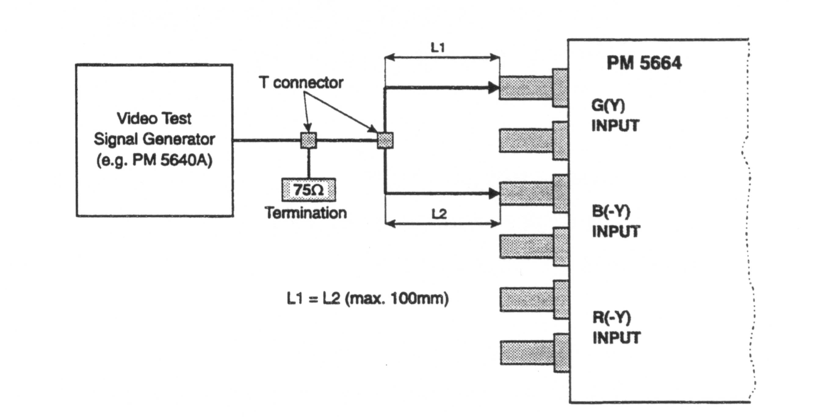
- Adjust C406 to minimum. signal

H-Graticule size - R533
- Use the menu to select: VECTOR, RGB 100%
- Connect 100% white bar RGB signal to “G/Y”, “B(-Y)” and “R(-Y)” input connectors terminated with 75ohm 0.1%
- Adjust R533 until the dot is in the centre of Y tolerance field

STAR RGB gain - R540
- Use the menu to select: STAR, RGB 100%
- Connect 100% white bar RGB signal to “G/Y”, “B(-Y)” and “R(-Y)” input connectors terminated with 75 ohm 0.1%
- Adjust R540 until the dot is in the centre of Y tolerance field

STAR VECTOR gain - R316
- Use the menu to select: VECTOR, RGB 100%
- Connect 100% white bar RGB signal to “G/Y”, “B(-Y)” and “R(-Y)” input connectors terminated with 75ohm 0.1%
- Adjust R316 until the dot is in the center of Y tolerance field

Potentiometer Board - Unit 5
The Potentiometer Board houses the potentiometers for adjustment of the horizontal and vertical gain, horizontal and vertical position, X and Y gain, and the position of the B-Y and R-Y signal in the PARADE display mode.

Keyboard - Unit 6
The Keyboard is a 4 x 4 matrix.
The switches are provided with built-in LED’s.

Control Board - Unit 7

General Information
This unit contains the converter from the SDI to analog for the serial digital input and also the equalised and re-clocked SDI output. The D/A converted signal is fed to the switching function of unit 4.

The unit contains a microcontroller, which controls the function of the instrument, and a graticule generator that controls the CRT display.

The circuit can be separated into a microprocessor circuit, a reset circuit, a control input circuit, an intensity control, a display/keyboard circuit and a graticule generator.

The unit also contains an amplifier for external reference signal.

Circuit Description
SDI input
The SDI input consist of:
- A cable equaliser circuit, V403
- An output buffer, V405, driving the “SER OUT” connector
- A serial to parallel converter, V404, which converts the 270Mbit/s data stream into 27Mbit/s parallel data

The SDI to analog converter
The D/A converter receives from the data-demultiplexer 3x10 bits, representing the 3 channels in the SDI digital component signal. These 3 data streams are converted into analog currents by V501; these currents are then converted to analog voltages by V503, V505 and V507. The amplitude can be adjusted by means of 3 potentiometers.
The low-pass filters, or Anti-aliasing filters, are conventional LC-filters with delay equalisation. The filter has a pass-band of 5.8MHz. After low-pass filtering, the signals are fed to the 3 output amplifiers, which also perform the necessary sin/x correction.
Finally, a sync pulse regenerated from the SDI input is added to the Y-signal

Microprocessor Circuit
The Microprocessor circuit is based on the microcontroller V103, which is used in a standard configuration with V104 as address latch, V101 as external RAM, V102 as external ROM, battery back-up B101, and an address decoder, V109, for addressing the external ports.
From the input port V201 the microprocessor receives information on activation of the keyboard, the actual field (1st or 2nd), whether the variable gain is on or off, and whether the actual input video signal is a 625 or 525 line signal.

Other microprocessor input are reset, remote control input (via the I2C bus), field interrupt, line counter input, ready flag from the graticule generator, and an I²C bus.

The Graticule Generator and Intensity Control are both controlled by the microprocessor via the output port V303.

The clock signal from the Crystal Oscillator is buffered by transistor Q102 and fed to the Graticule Generator.

Reset Circuit
A Reset circuit with voltage sensor V105 is introduced to get a controlled power-up and power-down. If the supply voltage reaches the low level of 3.6V, determined by R104 and R105, the Voltage Sensor resets the microprocessor and blocks the RAM. This makes the battery backup take over the power supply of the RAM.

Remote Control Input
From the Control Input it is possible to activate the store and recall functions. The selection of function is sensed by the microprocessor when reading the I²C port V107.

Intensity Control
The heart of the intensity control is the Programmable Gate Array (PGA), which is downloaded by the microprocessor when the monitor is turned on. The intensity of the CRT is decoded by V111, controlled by the microprocessor. V111 also filters the field information from the Sync Separator on Unit 4 to avoid triggering errors. The gamut window signal for the Gamut Detector (Unit 8) is also derived from V111.

Display/Keyboard Circuit
The keyboard switches and display indicator LED’s are located on Unit 6 and connected to Unit 7 through the connector XP. The switches and the LED’s are working in a matrix. Here the microprocessor activates the relevant switches for the selected set-up through V202 and Q201-204 and <R>reads the switches in the "vertically direction" by means of V201. The relevant LED’s for the set-up are activated in the "horizontally direction" by the LED scanning circuit V205 and in the "vertically direction" by V206 and the IC V203 driver. V207 is an oscillator/divider, which provides the relevant scanning frequency.

Graticule Generator
The Electronic Graticule generator provides the electronic graticule and menu text on the CRT display. The system distinguishes between three kinds of figures:

1. Graticules
2. Characters
3. Voltages

The idea is to generate the requested figure in small parts by creating a horizontal and vertical voltage sweep on the output of V308-A and B (HGV and VGV).

The generator receives its orders from the microprocessor via the port V308 and the control lines BEGIN, LOADPOS, and UPDATE.

The END-signal is a reply message from the generator back to the microprocessor.

Graticules
A graticule is started when the CPU begins ad dressing the graticule memory V304 and the BEGIN signal goes low. This enables frequency divider V318 that via V315-D and V314-D drives the address counter V301-302. Data information is then transmitted from memory V304 to the Digital-to Analog Converter (DAC) V306 for each piece of line in the graticule. The DAC contains a 12-bit D/A converter for both horizontal as well as vertical data information. For each piece of line 4 byte is needed from the memory to load the double D/A converter. The DAC outputs are current outputs, but they are converted into voltages by the four <R>opamps V1-A-B and V2-A-B. V309 and V310 sample this voltage, which then drive integrators V308-A and -B.

By feeding back HGV and VGV outputs to the input of the sample/hold amplifiers, the outputs will be proportional with the actual and the previous sample value. Thus it will take the same amount of time to draw the line-part in question, no matter what length it is. With R304 and R308 it is possible to adjust the horizontal shape and vertical shape respectively.

The D6-pulse through V316-B signals that a part of the graticule line should be blanked. The D7-pulse through V315-C and V317-B signals that the graticule "drawing" is finished by generating the END-signal to the microprocessor.

Characters
When a character is drawn, the microprocessor starts by sending the LOADPOS pulse and the most significant bits to the DAC via V110-C-D and V305. This is to locate the position on the screen from which the character is drawn. Then the microprocessor sends a BEGIN pulse and the memory V304 delivers the least significant bits to the DAC until the character is finished.

Voltages
Generation of a voltage is in general done the same way as generation of a character. Only the microprocessor sends an UPDATE pulse instead of the BEGIN pulse. The DAC values will then be sampled one time via V312-D, V316-A, V315-A-B and V106-F without starting the address counter V301. The voltage on the outputs HGV and VGV will then correspond to the input values.

Test and Adjustments
Equipment
- SDI Test signal generator, e.g. PT5230
- DVM
- Digital Video analyser
- Video level meter
- Oscilloscope

Adjustment of SDI input
Performance check:
SDI input:
- Connect an SDI 625/50signal to the ”SER IN” input
- Check that the signal comes out of ”SER OUT” output (active loop through)

Adjustments:
- Connect a SDI signal to the ”SER IN” input
- Monitor the voltage at TP 403
- Tune R459 first so that the PLL loses lock at the low end (lower loop voltage)
- Then slowly increase the voltage to determine the error-free low limit of the capture range
- Use a suitable CRC or EDH measurement method to determine error free operation
- Record the loop voltage at the point, then adjust R459 so that the voltage is 250mV above

Adjustment of SDI to analog converter
Adjustment of Y-channel:
- Adjust the video level by means of R507 to 700 mV
- Adjust the sync level by means of R458 to 300 mV
- Use a SDI generator with multiburst or sweep signal, e.g. PT5230 as source to the SDI input
- Connect the test output PP502 connector to the network analyser input
- Select a multiburst signal
- Check that the frequencies0.5, 1, 2, 4, and 4.8 MHz are within 1% of reference level and
5.8 MHz within 2% of reference level

Adjustment of P_{B} and P_{R} channels:
- Adjust the PB and PR levels by means of R508 and R509 respectively
- Use a SDI generator with multiburst or sweep signal, e.g.. PT5230 as source to the SDI input
- Connect the test output PP502 connector to the network analyser input
- Select a multiburst signal
- Check that the frequencies0.5, 1, 2, 4, and 4.8 MHz are within 1% of reference level and 5.8MHz within 2% of reference level

RGB Monitor Out - Unit 8

General Information
This unit contains the RGB Video Output buffers with clamp drivers, a Composite Video Amplifier for the monitor out, External reference input and a Gamut Detector.

Circuit Description

RGB Video Buffers
Since the three video buffers are identical only the G-AMP circuit will be described.

The amplifier consists of three transistors (Q1, Q2, Q3) coupled as a Non-Inverting Amplifier where R3 and R7 determine the gain. The amplifier is feedback-clamped by the double Operational Transconductance Amplifier (OTA) V2-A and -B and the clamp capacitor C2. The output impedance is kept low by emitter follower Q3, and the output impedance is set to 75 Ohm by means of R4.

Composite Video Amplifier
The Composite Video Amplifier consists of three amplifiers:
- An INPUT amplifier,
- A MONITOR OUT amplifier, and
- A DISPLAYED COMPOSITE VIDEO amplifier.
All three amplifiers are Non-Inverting Amplifiers, and where the INPUT amplifier (Q15/Q17) and the DISPLAYED COMPOSITE VIDEO amplifier (Q16/Q19) both have a gain of 1, the MONITOR OUT amplifier (Q18/Q20) have a gain of approximately 2 (set by R55 and R56).

Gamut Detector
The main function of the Gamut Detector is to detect it if the level of a primary colour component exceeds 735mV (±5mV), which makes the LED "POS" on unit 2 light up, or -35mV (±5mV), which makes the LED "NEG" on unit 2 light up. Also a level excess will be indicated on the PIX MON OUTPUTS as a flickering area on the monitor screen displaying the error area.

The Gamut Detector consists of a positive and a negative peak detector, a 2Hz generator, and two one-shot circuits.

The Positive Peak Detector is a comparator made as a Differential Amplifier where the transistors V6-A-B-C are coupled in parallel to one transistor. Q10 is introduced to increase the gain of the comparator. If one of the inputs G, B, or R exceeds the level adjusted by means of R36 (735mV), the collector of Q10 will go high and via gate V4-B trigger one-shot V3-A and the 2Hz generator V4-C. The output of gate V4-B is low-pass filtered to avoid very short pulse to trigger. The one-shot circuit is introduced to make the gamut LED flash for a minimum period of 0.5 seconds. The 2Hz generator will make the error area flash on the PIX MON OUTPUTS.

The Negative Peak Detector is similar to the positive, except that the R, G, and B inputs here are connected to the emitters of the difference transistor V6-A-B-C.

Test and adjustments:
Equipment:
Video Test signal generator
Oscilloscope

Monitor out gain - R66
- Use the menu to select: WAVEFORM, VIDEO and “G/Y”
- Connect white bar signal to “G/Y” input connector
- Connect the other “G(Y)” connector to “VIDEO INPUT” connector with a cable
- Terminate the other “VIDEO INPUT” connector with 75 Ohm 0.1%

Adjust R66 until the gain is the same.

Gamut test - R36/R43
- Select: WFM CLAMP On, and Y-MAG
- Connect 770mV Sawtooth signal with set up -35mV to “G/Y” Input connector
- Connect input connectors: “G/Y” to “B(-Y)” and the other “B(-Y)”to “R(-Y)” with cables
- Terminate the other “R(-Y)” with 75 Ohm 0.1%
- Connect “G PIX MONITOR OUT” to Oscilloscope
- Adjust R43 until the negative going signal is jumping, then adjust again until the signal is just not jumping
- Adjust R36 until the positive going signal is jumping, then adjust until the signal is just not jumping

Diagrams and component placement.
Note: Diagrams are listed in sequence with to list below

Block diagram 1 page
Wiring diagram 1 page
Unit 1 - Power Supply
Component Location 1 page
Diagrams 2 pages
Unit 1a - CRT Board and Illumination Panel
Component Location & Diagram 1 page
Unit 2 - CRT Control
Component Location & Diagram 1 page
Unit 3 - Deflection Amplifier
Component Location 1 page
Diagrams 2 pages
Unit 4 - Signal Processor
Component Location 1 page
Diagrams 6 pages
Sub-unit: Sync Separator 2 pages
Unit 5 - Potentiometer Board
Component Location & Diagram 1 page
Unit 6 - Keyboard
Component Location & Diagram 1 page
Unit 7 - Control & SDI Board
Component Location 1 page
Diagram 5 pages
Unit 8 - RGB Monitor
Component Location 1 page
Diagram 1 page

END OF TEXT DOCUMENT

