DK-Audio A/S
Marielundvej 37D
DK-2730 Herlev
Denmark

PT 5664
Digital & Analog Component/
Composite WFM

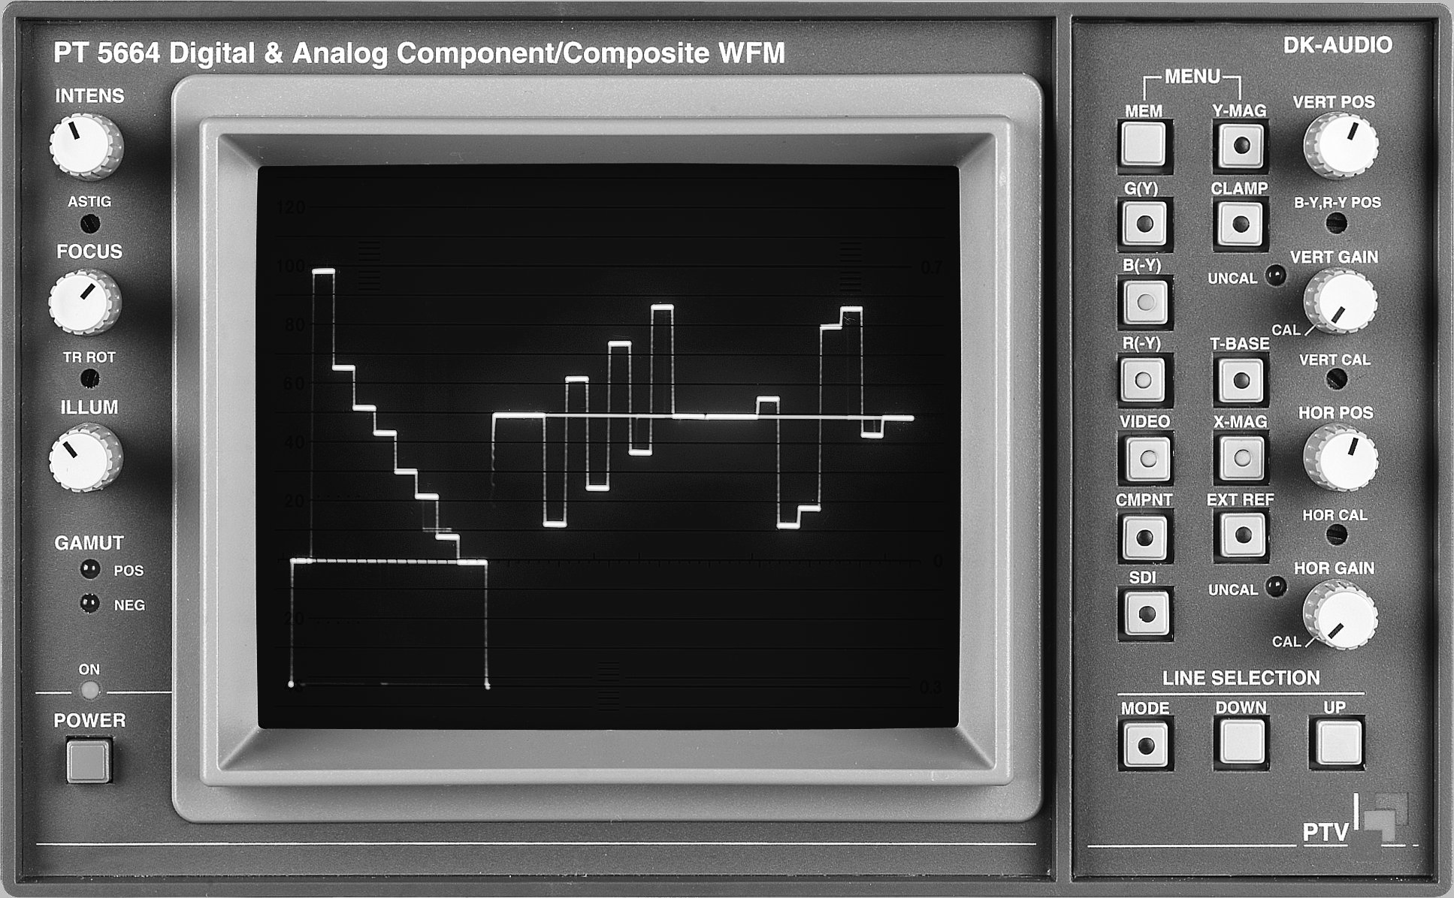

Service Manual – section 2:

Diagrams and component placements



Diagrams and component placement.
Note: Diagrams are assembled in a sequence as below:

Block diagram 13-2
Wiring diagram 13-3
Unit 1 - Power Supply
Component Location 13-4
Diagrams 13-5
Unit 1a - CRT Board and Illumination Panel
Component Location & Diagram 13-7
Unit 2 - CRT Control
Component Location & Diagram 13-8
Unit 3 - Deflection Amplifier
Component Location 13-9
Diagrams 13-10
Unit 4 - Signal Processor
Component Location 13-12
Diagrams 13-13
Sub-unit: Sync Separator 13-19
Unit 5 - Potentiometer Board
Component Location & Diagram 13-21
Unit 6 - Keyboard
Component Location & Diagram 13-22
Unit 7 - Control & SDI Board
Component Location 13-23
Diagram 13-24
Unit 8 - RGB Monitor
Component Location 13-29
Diagram 13-30

