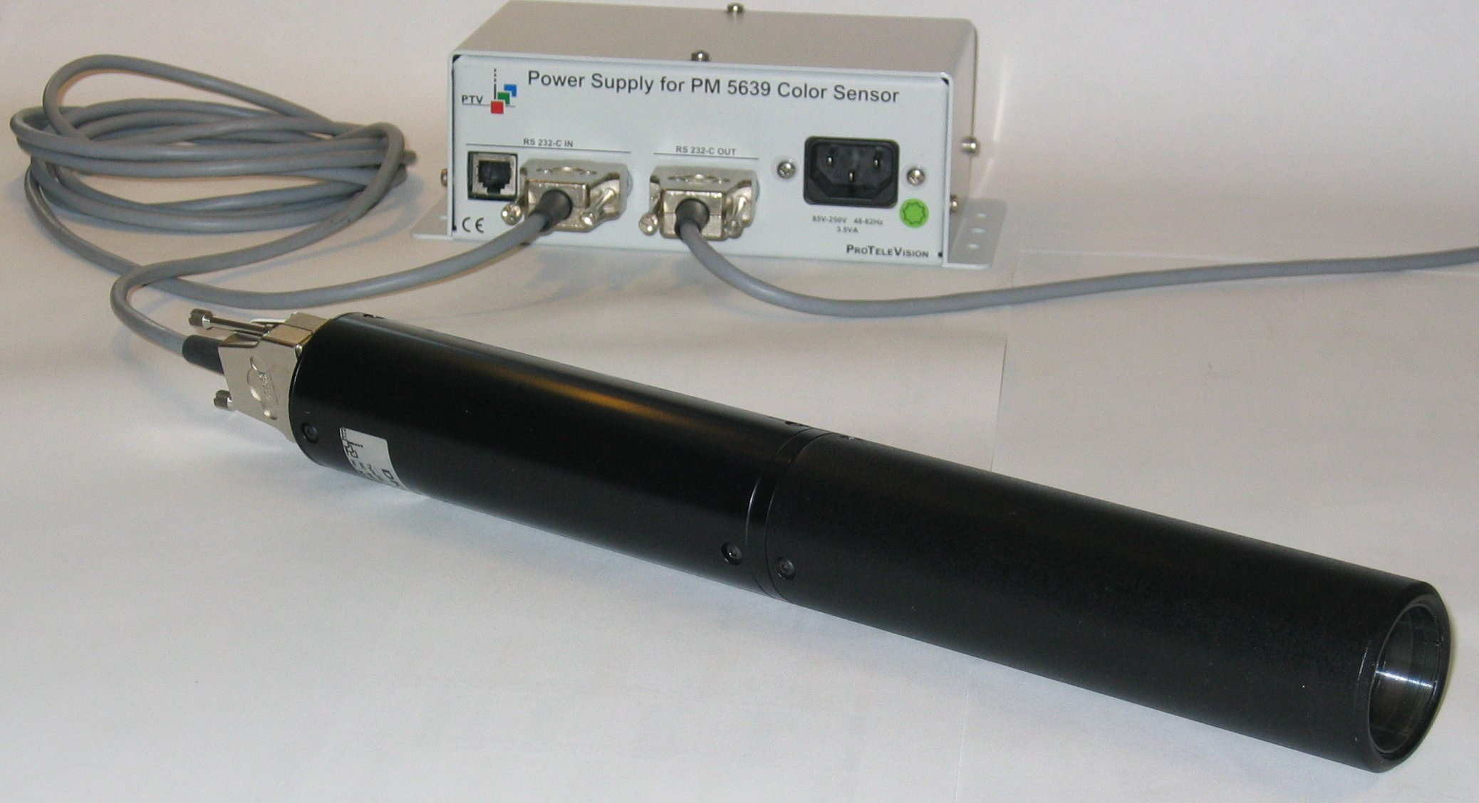

- Colour balance alignment of LCD/EL displays
- Optical system for spot measurements
- High speed operation for automatic manufacturing systems
- Communicates with standard RS-232 interface
- True CIE Standard Observer characteristics
- Numerical outputs of CIE XYZ values
- Calibration to any white reference
- Operates independent of field rate, also computer graphics and HDTV
- Calibration traceable to international standards

LCD Colour Analyser, PM 5639/06, handheld

LCD Colour Analyser, PM 5639/26, industrial

LCD Colour Sensor, PM 5639/94

The PM 5639 LCD Colour Analyser family has been developed for the purpose to assure the same high standard of picture quality as we have achieved with CRT colour nalysers.
As flat panel display technology increases its presence on the market, from computers to the monitors on the broadcast industry, the same need for controlling colour fidelity, as for the CRT’s, is necessary.
The LCD Colour Sensor, PM 5639/94 can be delivered as 2 systems: one for handheld operation and one for industrial use.

LCD Colour Analyser, PM 5639/06; handheld use
This system consists of the LCD colour sensor and a handheld display unit. A rechargeable battery in the display unit enables easy operation anywhere. The units are delivered in a suitcase.
LCD Colour Analyser, PM 5639/26, Industrial and PC-based

The industrial version consists of a LCD colour sensor and a software package, which runs under DOS, or in a DOS-window under Windows 95 or 98. A ruggedized power supply and necessary cables complete the package.

The LCD colour sensor is designed for measurement at a certain distance from the display. Although calibrated at fixed distance it can be used at distances from a few millimetres up to some 20cm. Only the luminance value is slightly affected of the distance. A correction table to be applied.

Test signals
When the sensor is used together with the handheld display unit, full benefits of the PM 5639/82 and PM 5639/83 Colour Alignment Generators can be achieved. The display unit works in this set-up as a control unit for the generator. The required test signals can then be recalled automatically

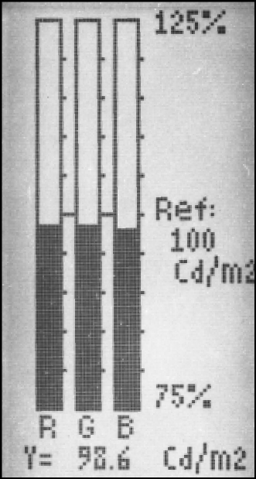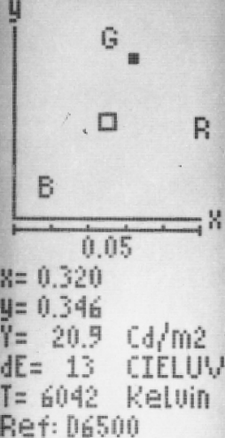The Absolute Measuring Modes: xyY and u’v’Y

Measurement and Display modes
Two absolute measuring modes both defined by CIE the International Commission on Illumination are realised in the PM 5639. The xy system is the original CIE 1931 colour measuring system. The u’v’ CIE 1976 is later made as a change to the original xy system. The latter system is more colour uniform than the original, meaning that the system is a better description of the human colour perception, related to the perception of colour differences. It is possible by numeric calculation to convert from the one system to the other.

The colour coordinates is showed in either an xy or an u’v’ diagram, and at the same time the numerical chromaticity values are shown together with the luminance value (Y) and the correlated colour temperature. In the RGB bargraph display the difference between the reference values and the measured values are displayed. In all modes the colour error dE CIELUV is calculated as the difference between the reference and the actual colour according to the CIE 1976 L*u*v* (CIELUV) colour space definition. 1 CIELUV is very close to the smallest colour difference, detectable by the human eye.

The display, either on the Display Unit or on the PC, will show the measurement graphically in a coordinate system, where the pre-programmed colour reference is shown as a small box and the measured colour as a dot. The monitor is adjusted correctly when the dot falls within the box. Using the zoom function this adjustment can be done very accurately. The luminance Y is shown in the unit selected by the user i.e. candela/m², NIT or foot-Lambert.
These absolute measurements are made possible by using the concept, which relies on optical interference (dichroic) filters.
The concept makes it possible to make CIE filters, which are completely equal the colour response of the Standard Observer as defined by CIE. This together with a traceable calibration assures a correct white reference on any monitor independent of the actual phosphor.

RGB Measuring Mode
In the RGB measuring mode the red, green and blue values are shown as three analogue bars. These bars are displayed relative to the white reference. There are four possibilities.
- Two of the primary colours are related to the third
- All three primary colours are related to a pre-programmed white reference
- All three primary colours are related to one of the measurements stored in the memory of the colour analyser
- All three primary colours are related to an absolute reference level selected by the user
In all cases the absolute luminance value will be displayed in Candela/m², NIT or foot-Lambert as selected by the user.
In the RGB display mode, the adjustment is carried out by bringing the amplitude of the three bars into the centre of the display. It is also possible to use a zoom function to increase the resolution and make a more accurate adjustment.
For the RGB mode to work correctly, the instrument has to know the actual phosphor. This is accomplished in a couple of minutes by use of the monitor controls and the Colour Analyser "learn" mode. The "learn" mode procedure removes the interaction (crosstalk) between phosphors when viewed by the trireceptors. The phosphor can be stored and named in the colour analyser for later use.

The following parameters have been factory programmed. The user can program more himself:

- Two different standard phosphors have been pre-programmed: EBU and SMPTE "C"
- A maximum of 28 different phosphors can be stored with the "learn" facility
- The three most used references: D6500, 3200 K and 9300 K are preset from the factory. Different white references can be programmed into Display unit or PC either as a measurement of the CRT, or the reference can be entered directly as x and y values
- Three different measuring units. The user can select between Canela/m², NIT or foot-Lambert

Sensor Head PM 5639/94

Measurement Range
- Luminance 0.5 to 1000 Cd/m²
(0.15 to 300 FtL)
- x and y values 0.000 to 0.800
- Correlated Colour Temperature:
1900 K CCT to 12.000 K CCT
- Angle of aperture: ±10°
- Measuring distance:
calibrated at 130mm.
Luminance within ±2 Cd/m² in range 5 to 200mm
Accuracy
- The following specifications apply to a measurement with an illuminant D6500 standard monitor¹) at a luminance level of 80 Cd/m² (23.3 FtL) and at a distance of 130mm and at an ambient temperature of 15°C to 30°C (59°F to 86°F)

- Chromaticity (measured on white):
Accuracy: ±0.002
Repeatability: ±0.002
- Luminance
Accuracy at reference distance:
±2% ±1 digit
Repeatability: ±0.3% ±1 digit
- XYZ/RGB bars: ±1%
Repeatability: ±1%
Luminance(Y): ±2% ±1 digit
- Measuring rate:
When used with the display software:
3 and 10 measurements/second.
When used wth the communication modules: up to 15 measurements/second programmable
- Correlated colour temperature:
±50 K CCT

LCD Colour Analyser PM 5639/06 with display unit
Scan Rates
The PM 5639/94 automatically adjusts itself to the field-scanning rate including HDTV and graphical systems
Accessories:
The PM 5639/94 is delivered without any accessories but the Operating Manual.

1) Calibration of the standard monitor is traceable to NIST, USA with respect to chromaticity, and to BIPM, France with respect to luminance

Handheld LCD Colour Analyser
This stand-alone system consists of the LCD Colour Sensor, Display Unit plus necessary accessories. For the basic measurement specification, refer to chapter above.
Display
- Type:64 by128 dot matrix LCD display with switchable back-lighting (auto switch-off function is provided)
Display Modes
- CIE xyY mode: x and y coordinates are plotted in a CIE1931 xy diagram and shown numerically together with the correlated colour temperature and the colour error in CIELUV.
- CIE u'v'Y mode: u' and v’ coordinates are plotted in a CIE1976 u’'v’ diagram and shown numerically together with the colour error in CIELUV.
- The x'y' and u'v' modes give readout of the difference between the measured and the reference chromaticity coordinates.
- RGB mode: Red, Green and Blue values are shown as bar graphs. The colour balance is displayed relative to a selected reference:
one of the bars, the luminance, an absolute level or relative to a previous measurement (memory location)
Memory
- References:
10 memories for colour white references
- Range for x and y: 0.2 to 0.6
- CRT-phosphors:
30 memories for different phosphors
- Set-ups: 10 memories for different measuring set-ups.
Factory Programming
- White references:
D6500 (x=0.313, y=0.329)
3200K (x=0.423, y=0.399)
9300K (x=0.285, y=0.293)
Other white references may be stored by using the “Learn white reference” function. The numbers, as measurements, can also be input directly into the file.

Power Supply
- Battery operated. Interchangeable NiCd rechargeable 7.2 V battery pack.
- Consumption:
85 mA (illumination off)
115 mA (illumination on)
- Operating time:
>5 h with fully charged batteries
- Battery charging time:
<14 h with instrument off
- Mains voltage:
85-140 V AC or 187-250 V AC
- Consumption of charger: < 6 VA
- Frequency: 48 Hz to 65 Hz
Accessories
The PM 5639/06 package includes:
- PM 5639/94 LCD Colour Sensor
- PM 5639/80 Display Unit
- Interconnection Cable
- Rechargeable Battery Pack
- 110V AC or 230V AC Battery Charger
- Operating Manual
- Carrying Case

LCD colour Analyser PM 5639/26 for PC-solutions

LCD Colour analyser for Industrial use and PC-based solutions.
This stand-alone system consists of the LCD Colour Sensor, Power Supply, PC-Software plus necessary accessories. For the basic measurement specification, refer to chapter above.
The Display Software Module
The display software shows the measured results directly as CIE values, or as differences between the pre-programmed white reference and the actual measured colour on a PC picture monitor. The results may also be shown as relative RGB values. The display software module uses the 4800 baud mode only.
- The xyY, u’v’ and uv modes.
The chromaticity coordinates are plotted in the relevant CIE chromati-
city diagram:
xy uses CIE 1931 definition
u’v’ uses CIE 1976 definition
uv uses CIE 1960 definition
The luminance value Y and the colour difference between the reference and the measurement are displayed as numerical values below the display.
- The δxδy, δu’δv’ and δuδv modes.
The difference modes display a coordinate system with origin at the selected white reference and the measured colour deviation from this reference. The numerical values are shown below the coordinate system.
- The bargraph modes
The XYZ and RGB modes show the measured values as bar graphs. The graphs may be normalised to a selected phosphor, a specific luminance level or relative to the measured luminance.
The Communication Software
The communication with the PM 5639/26 sensor is with standard RS 232 interface. The communication software modules explain how to implement application specific programs. Examples are written in Basic, C and Pascal. The modules in Basic and Pascal can be used in the 4800 baud mode only, whereas the C modules are for both 4800 and 9600 baud modes.
Memory
- References: The white references are stored in the computer. Legal values for x and y are between 0.200 and 0.600
- CRT/Phosphors: 30 different phosphors may be stored in the sensor, additional phosphors may be stored in the computer. Phosphors may be stored via the “Learn phosphor” function. The phosphors are only applicable when using the RGB bar graph display
- Set-ups: an unlimited number of measuring set-ups may be stored in the computer. A measuring set-up includes the display mode, CRT/Phosphor (RGB displays only), white reference and measuring units
- Measurements: an unlimited number of measurements may be stored and recalled for later investigation and statistical analysis. Stored measurements may also be used as white references
Factory Programming
- White references:
D6500 (x=0.313, y=0.329)
3200K (x=0.423, y=0.399)
9300K (x=0.285, y=0.293)
Other white references may be stored by using the “Learn white reference” function. The numbers, as measurements, can also be input directly into the file.
Hardware Requirements
- PC with RS 232 port
- Floppy disk drive 3½”
- Operating system: MS-DOS, Windows 95 and 98.
The software is DOS-based with a Windows like appearance. It runs in most Windows 95 or 98 environments in a DOS-box

Power supply box:
A rugged unit interfacing between sensor and PC
Size: 185 x 95 x 65 mm
(7.3 x 3.8 x 2.6”)

General Specification

Environmental condition
- Operating temperature: 10°C to 40°C (50°F to 104°F) (non-condensing)
- Storage temperature: -10°C to 70°C (-14°F to 158°F) (non-condensing)
- Vibration: IEC 68-2-6 F;
5-50-200 Hz 0.7 mm_{PP} 50 m/s²; 1 octave/min; 3x30 min
- Bump: IEC 68-2-29 part 2;
350 m/s 1000 bumps in 3 directions
- Repetitive bump: 120 m/s²

Mechanical data Colour Sensor
- Diameter of sensor: 40 mm (1.6”)
- Length: 300 mm (11.8”)
- Weight: 270 g (0.6 lb)

Accessories

Accessories: PM 5639/06
The PM 5639/06 LCD Colour Analyser package includes:
- PM 5639/94 LCD Colour Sensor
- PM 5639/80 Display Unit with Rechargeable Battery Pack
- Interconnection Cable between sensor and display unit.
- 110V AC or 230V AC Battery Charger
- Operating Manual
- Carrying Case
Accessories: PM 5639/26
The PM 5639/26 LCD Colour Analyser package includes:
- PM 5639/94 LCD Colour Sensor
- Software package with display module and communication modules with source code in Pascal, C and Basic
- Power supply box for one sensor
- Interface cable between controller and power supply box
(9 pole sub-D connectors)
- Interface cable between sensor and power supply (9 pole sub-D connectors)
- Mains cable
- Operating manual, including Source Code documentation
Accessories: PM 5639/94
The PM 5639/94 is delivered with:
- Operating manual

.

Optional Accessories

PM 5639/82 and /83
The optional PM 5639/82 Colour Alignment Generator Component and the PM 5639/83 Colour Alignment Generator Composite are designed to operate automatically together with the Display Unit of the PM 5639/00 and PM5639/06.
The generators may be connected to the display unit, which thus operates as a remote control unit. The required test signals for the different calibrations of the monitor can then be recalled automatically. This is especially time saving when performing the low level and high level white balance adjustments.

PM 5639/00 9449 056 39001 CRT colour analyser with hand-held display unit

PM 5639 Related Products
PM 5639/01 9449 056 39011 CRT colour analyser with PC interface & software
PM 5639/02 9449 056 39021 CRT Colour Alignment System for Barco® Monitors
PM 5639/03 9449 056 39031 CRT Colour Alignment System for Sony® Monitors Projector
PM 5639/06 9449 056 39061 LCD Colour Analyser with handheld display unit
PM 5639/20 9449 056 39201 Industrial CRT Colour Analyser, single sensor version
PM 5639/21 9449 056 39211 Industrial CRT Colour Analyser, double sensor version
PM 5639/25 9449 056 39251 Miniature CRT Colour Analyser
PM 5639/26 9449 056 39261 LCD Colour Analyser for Industrial and PC-applications
PM 5639G/82 9449 056 39823 Colour Alignment Generator, component 625 lines
PM 5639M/82 9449 056 39828 Colour Alignment Generator, component 525 lines
PM 5639G/83 9449 056 39833 Colour Alignment Generator, composite 625 lines, PAL
PM 5639M/83 9449 056 39838 Colour Alignment Generator, composite 525 lines, NTSC

Options
PM 5639/61 9449 056 39611 Expansion kit - to upgrade PM 5639/20 to PM 5639/21
PM 5639/62 9449 056 39621 Expansion kit -.to upgrade PM 5639/00 to PM 5639/01
PM 5639/63 9449 056 39631 CRT Auto Colour Alignment Option for Barco® Monitors
PM 5639/64 9449 056 39641 CRT Auto Colour Alignment Option for Sony® Monitors
PM 5639/80 9449 056 39801 Display unit
PM 5639/90 9449 056 39901 CRT Colour sensor
PM 5639/92 9449 056 39921 Industrial CRT sensor
PM 5639/93 9449 056 39931 Miniature CRT colour sensor
PM 5639/94 9449 056 39941 LCD Colour Sensor
PM 8549/06 9449 085 49061 6 m extension cable for PM 5639
PM 8549/10 9449 085 49101 10 m extension cable for PM 5639
PM 8550 9449 085 50001 Calibrating software for PM 5639/90 and PM 5639/92-93
PM 8563 9449 085 63001 Interface cable for PM5639/80 to connect to PM8639/93 and PM5639/94
PM 8664 9449 085 64001 Auto set-up cable for auto alignment of Barco HDM 5049 monitor series

Ordering Information

PM 5639/06 9449 056 39061 LCD Colour Analyser with handheld display unit
PM 5639/26 9449 056 39261 LCD Colour Analyser for Industrial and PC-use
PM 5639/94 9449 056 39941 LCD Colour Sensor

FOR FURTHER INFORMATION
Contact the PTV sales office in your area, or contact us directly:

Data subject to alteration without notice.
Printed in Denmark
2003-09-03

International: DK-AUDIO A/S • Marielundvej 37D • DK-2730 Herlev • Denmark
Tel: +45 44 85 02 55 • Fax: +45 44 85 02 50 • e-mail: info@dk-audio.com
UK: DK-AUDIO (UK) Ltd • Crableck Lane • Sarisbury Green • Southhampton SO31 7ZN • England
Tel: +44 870 2414 118 • Fax: +44 870 2414 119 • e-mail: apa@dk-audio.com
Germany: DK-AUDIO Germany • Ziegeleiweg 16 • D-31832 Springe • Germany
Tel: +49 (0) 5041 80 29 80 • Fax: +49 (0) 5041 80 29 99 • e-mail: info.de@dk-audio.com
USA: DK-AUDIO America Inc. • 4417 East Villa Rita Drive, Phoenix, AZ 85032, USA
Tel: +1 602 765 0532 • Fax: +1 602 765 1473• e-mail: jdt@dk-audio.com

