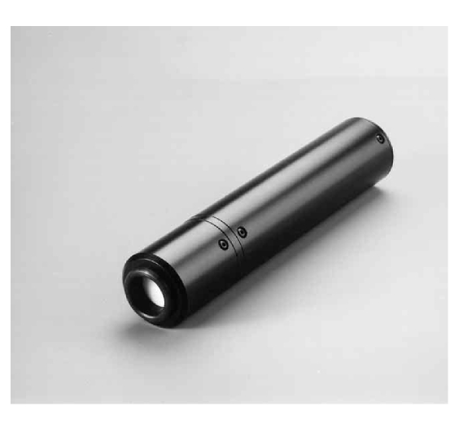

- High speed operation for automatic manufacturing systems
- Up to 25 sensors simultaneously on 17” screens
- Communicates with standard RS-232 interface
- Program source code for integration into automatic manufacturing systems
- True CIE Standard Observer characteristics
- Numerical outputs of CIE XYZ values
- Calibration to any white reference
- Operates independent of field rate, also computer graphics and HDTV
- Calibration traceable to international standards
- Independent of phosphor type

Miniature Colour Analyser, PM 5639/25

Miniature Colour Sensor, PM5639/93

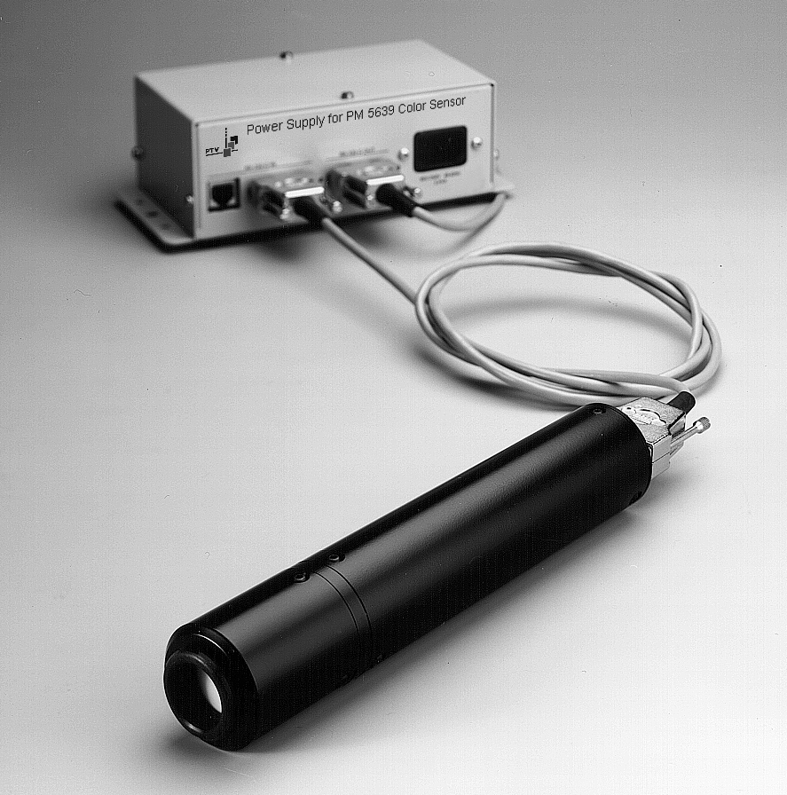

The PM 5639/25 Miniature Colour Analyser is used for automatic manufacturing of CRT based display monitors and for quality control. The size of the sensor allows measurement at different positions on the monitor, even very close to the corners, in order to evaluate display uniformity. The adjustment may include black level, the colour of “black”, contrast level, the colour of “white” and the colour balance and luminance level at any point in between. The communication between the sensor and the controller is based on an RS-232 standard interface. The PM 5639/26 includes a PM 5639/93 Miniature Colour Sensor, a power supply, cables and a software package.

DK-AUDIO

The PM 5639/93 Miniature Colour Sensor can be used in multi-sensor automatic manufacturing systems. Traditionally, monitors used in TV sets have traditionally been aligned based on measurements taken in the centre only. In modern microprocessor controlled monitors used for graphics it is now possible to make individual alignment at different positions on the display.

Multi-sensor applications
The size of the sensor allows the use of up to 25 sensors on 17” CRTs though normally 2, 5 or 9 sensors are used simultaneously. The PM 5639/93 communication speed can be selected to either 4800 baud or 9600 baud.

The higher speed is used in multisensor applications. The sensor delivers the output directly on a standard RS-232 line, which makes the use of a display box between the sensor and the computer superfluous. When several sensors are used they must each be connected to a standard multiport RS-232 interface.

The Display Software Module
The display software can show the measured results directly as CIE values, or as differences between the pre-programmed white reference and the actual measured colour. The results may also be shown as relative RGB values. The display software module uses the 4800 baud mode only. Two sensors may be used simultaneously with the display software module.
- The xyY, u’v’ and uv modes.
The chromaticity coordinates are plotted in the relevant CIE chromati-
city diagram:
xy uses CIE 1931 definition
u’v’ uses CIE 1976 definition
uv uses CIE 1960 definition
The luminance value Y and the colour difference between the reference and the measurement are displayed as numerical values below the display.
- The δxδy, δu’δv’ and δuδv modes.
The difference modes displays a coordinate system with origin at the selected white reference and the measured colour deviation from this reference. The numerical values are shown below the coordinate system.

- The bargraph modes
The XYZ and RGB modes shows the measured values as bar graphs. The graphs may be normalised to a selected phosphor, a specific luminance level or relative to the measured luminance.

The Communication Software
The communication with the PM 5639/25 sensor is with standard RS 232 interface. The communication software modules show how to communicate with the sensor. This explains how to implement application specific programs. The example modules are written in Basic, C and Pascal. The modules in Basic and Pascal can be used in the 4800 baud mode only, whereas the C modules are for both 4800 and 9600 baud modes.

Product Data

Measurement Range
- Luminance 0.1 to 1000 cd/m²
(0.03 to 300 FtL)
- x and y values 0.000 to 0.800
- Correlated Colour Temperature:
1900 K CCT to 12,000 K CCT

Accuracy
- The following specifications apply to a measurement with an illuminant D6500 standard monitor¹) at a luminance level of >10 cd/m² (3 FtL) and at an ambient temperature of 15°C to 30°C (59°F to 86°F)
- xy coordinates: ±0.002
Repeatability: ±0.002
- Luminance (Y): ±2%±1 digit
Repeatability: ±0.3% ±1 digit
- XYZ/RGB bars: ±1%
Repeatability: ±1%
Luminance(Y): ±2% ±1 digit
- Measuring rate:
When used with the display software:
3 and 10 measurements/second.
- When used wth the communication modules: up to 15 measurements/second programmable
- Correlated colour temperature:
±50 K CCT

1) Calibration of the standard monitor is traceable to NIST, USA with respect to chromati-city, and to BIPM, France with respect to luminance

Memory
- References: The white references are stored in the controller. The number is limited by the computer only. Legal values for x and y are between 0.200 and 0.600
- CRT/Phosphors: 30 different phosphors may be stored in the sensor, additional phosphors may be stored in the controller. Phosphors may be stored via the “Learn phosphor” function. The phosphors are only applicable when using the RGB bar graph display
- Set-ups: an unlimited number of meas uring set-ups may be stored in the controller. A measuring set-up includes the display mode, CRT/Phosphor (RGB displays only), white reference and measuring units
- Measurements: an unlimited number of measurements may be stored and recalled for later investigation and statistical analysis. Stored measurements may also be used as white references
Factory Programming
- White references:
D6500 (x=0.313, y=0.329)
3200K (x=0.423, y=0.399)
9300K (x=0.285, y=0.293)
Other white references may be stored by using the “Learn white reference” function. The numbers, as measurements, can also be input directly into the file.

General Specification

Power Supply
- The colour sensor is powered from a power supply box inserted between the controller and the sensor.
- Sensor consumption: 5 V, <50 mA
- Power consumption: 85 to 250 V AC, 15 VA, 48 to 65 Hz
Environmental condition
- Operating temperature: 10°C to 40°C (50°F to 104°F) (non-condensing)
- Storage temperature: -10°C to 70°C (-14°F to 158°F) (non-condensing)

- Vibration: IEC 68-2-6 F;
5-50-200 Hz 0.7 mm_{PP} 50 m/s²; 1 octave/min; 3x30 min
- Bump: IEC 68-2-29 part 2;
350 m/s 1000 bumps in 3 directions
- Repetitive bump: 120 m/s²
Mechanical data Colour Sensor
- Diameter of sensor: 40 mm (1.6”)
- Diameter rubber shadow pad:
approx. 65mm
- Length: 200 mm (7.9”)
- Weight: 270 g (0.6 lb)

Power supply box:
- Size: 185 x 95 x 65 mm
(7.3 x 3.8 x 2.6”)
Hardware Requirements
- PC with RS 232 port
- Floppy disk drive 3½”
- Operating system: MS-DOS, Windows 95 and 98.
- The software is DOS-based with a Windows like appearance. It runs on most Windows 95 or 98 environments in a DOS-box

Accessories

Accessories: PM 5639/25
The PM 5639/25 Miniature Colour Analyser package includes:
- PM 5639/93 Miniature LCD Colour Sensor
- Software package with display module and communication mo-dules with source code in Pascal, C and Basic

- Power supply box for one sensor
- Interface cable for use between controller and power supply
(9 pole sub-D connectors)
- Interface cable for use between sensor and power supply (9 pole sub-D connectors)

- Mains cable
- Operating manual, including
source code documentation
Accessories: PM 5639/93
The PM 5639/93 is delivered without accessories. For multi-sensor applications the required accessories are to be agreed upon.

PM 5639/00 9449 056 39001 CRT colour analyser with hand-held display unit

PM 5639 Related Products
PM 5639/01 9449 056 39011 CRT colour analyser with PC interface & software
PM 5639/02 9449 056 39021 CRT Colour Alignment System for Barco® Monitors
PM 5639/03 9449 056 39031 CRT Colour Alignment System for Sony® Monitors Projector
PM 5639/06 9449 056 39061 LCD Colour Analyser with handheld display unit
PM 5639/20 9449 056 39201 Industrial CRT Colour Analyser, single sensor version
PM 5639/21 9449 056 39211 Industrial CRT Colour Analyser, double sensor version
PM 5639/25 9449 056 39251 Miniature CRT Colour Analyser
PM 5639/26 9449 056 39261 LCD Colour Analyser for Industrial and PC-applications
PM 5639G/82 9449 056 39823 Colour Alignment Generator, component 625 lines
PM 5639M/82 9449 056 39828 Colour Alignment Generator, component 525 lines
PM 5639G/83 9449 056 39833 Colour Alignment Generator, composite 625 lines, PAL
PM 5639M/83 9449 056 39838 Colour Alignment Generator, composite 525 lines, NTSC

Options
PM 5639/61 9449 056 39611 Expansion kit - to upgrade PM 5639/20 to PM 5639/21
PM 5639/62 9449 056 39621 Expansion kit -.to upgrade PM 5639/00 to PM 5639/01
PM 5639/63 9449 056 39631 CRT Auto Colour Alignment Option for Barco® Monitors
PM 5639/64 9449 056 39641 CRT Auto Colour Alignment Option for Sony® Monitors
PM 5639/80 9449 056 39801 Display unit
PM 5639/90 9449 056 39901 CRT Colour sensor
PM 5639/92 9449 056 39921 Industrial CRT sensor
PM 5639/93 9449 056 39931 Miniature CRT colour sensor
PM 5639/94 9449 056 39941 LCD Colour Sensor
PM 8549/06 9449 085 49061 6 m extension cable for PM 5639
PM 8549/10 9449 085 49101 10 m extension cable for PM 5639
PM 8550 9449 085 50001 Calibrating software for PM 5639/90 and PM 5639/92-93
PM 8563 9449 085 63001 Interface cable for PM5639/80 to connect to PM8639/93 and PM5639/94
PM 8664 9449 085 64001 Auto set-up cable for auto alignment of Barco HDM 5049 monitor series

Ordering Information

PM 5639/25 9449 056 39251 Miniature Colour Analyser
PM 5639/93 9449 056 39931 Miniature Colour Sensor

FOR FURTHER INFORMATION
Contact the PTV sales office in your area, or contact us directly:

Data subject to alteration without notice.
Printed in Denmark
2003-08-21

International: DK-AUDIO A/S • Marielundvej 37D • DK-2730 Herlev • Denmark
Tel: +45 44 85 02 55 • Fax: +45 44 85 02 50 • e-mail: info@dk-audio.com
UK: DK-AUDIO (UK) Ltd • Crableck Lane • Sarisbury Green • Southhampton SO31 7ZN • England
Tel: +44 870 2414 118 • Fax: +44 870 2414 119 • e-mail: apa@dk-audio.com
Germany: DK-AUDIO Germany • Ziegeleiweg 16 • D-31832 Springe • Germany
Tel: +49 (0) 5041 80 29 80 • Fax: +49 (0) 5041 80 29 99 • e-mail: info.de@dk-audio.com
USA: DK-AUDIO America Inc. • 4417 East Villa Rita Drive, Phoenix, AZ 85032, USA
Tel: +1 602 765 0532 • Fax: +1 602 765 1473• e-mail: jdt@dk-audio.com

