PROTELEVISION TECHNOLOGIES A/S

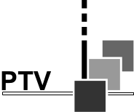

Miniature Color Sensor with Lens
PM 5639/94

Supplementary Instructions for the DEMO:
PM 5639/94 Serial number KU DEV#1

This paper is supplementary to the instruction manual for the standard PM 5639/25

The PM 5639/94 sensor is equipped with a front including a lens. This system allows measurement made on a distance from the display to be measured. The system is of a fix focus type.
The distance from the front of the sensor to the display should be 130 ±10 mm to give the optimal results.
The painting on the demo model is not the final solution
The command set is equal to the command set used with the PM 5639/93 Miniature Color Sensor (Please be aware that the internal ID string is the same as in a PM 5639/93. This will be changed in the final version)
We are considering to reduce the length of the lens front part. We have not yet calculated the possible reduction.

