1.6 Symbols

Symbol: Color: Explanation:
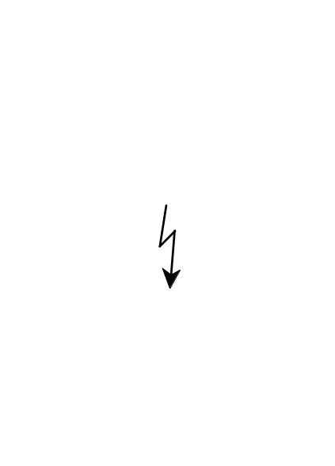
Red High voltage terminal: a terminal at which a voltage, with respect to another terminal or parts exists or may be adjusted to 1000V or more. (High voltage ≥1000V)

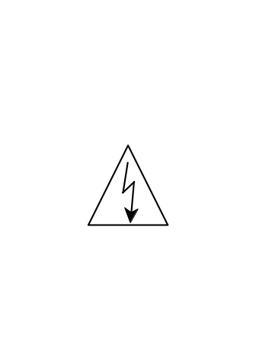

Black/Yellow Live part


Black/Yellow To preserve the instrument from damage the operator must refer to an explanation in the instruction manual.

