DK-Audio A/S
Marielundvej 37D
DK-2730 Herlev
Denmark

PM 5664 & PM 5664D
Component Waveform Monitor

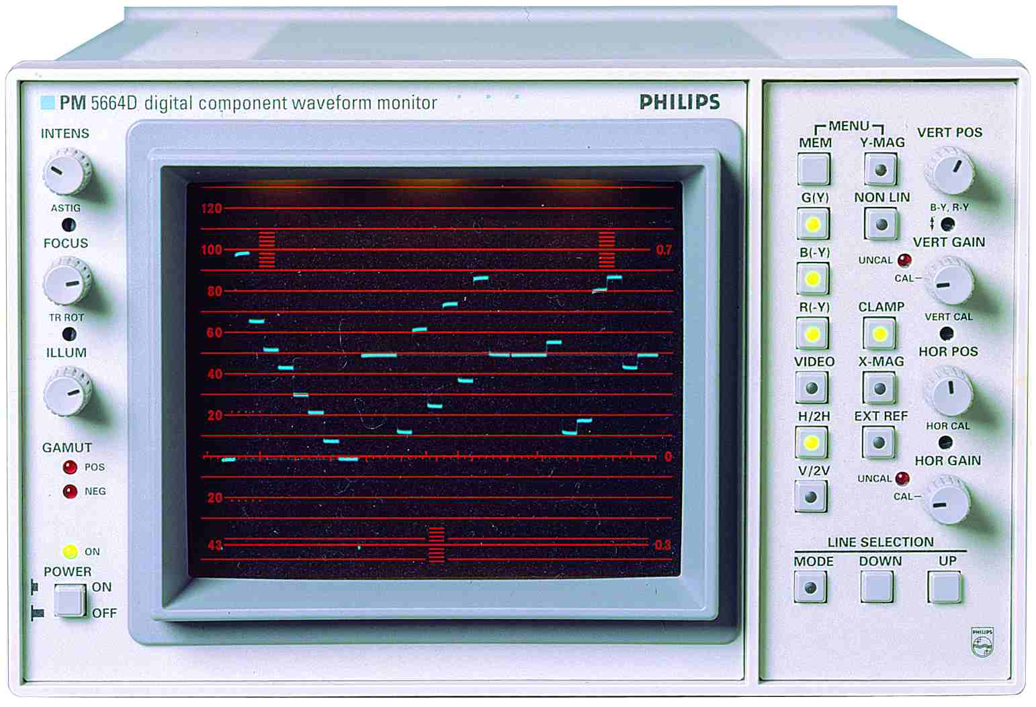

Service Manual – section 2:

Diagrams and component placements



Diagrams and component placement.
Note: Diagrams are assembled in a sequence as below:

Block diagram 13-1
Wiring diagram 13-2
Unit 1 - Power Supply
Component Location 13-3
Diagrams 13-4
Unit 1a - CRT Board and Illumination Panel
Component Location & Diagram 13-6
Unit 2 - CRT Control
Component Location & Diagram 13-7
Unit 3 - Deflection Amplifier
Component Location 13-8
Diagrams 13-9
Unit 4 - Signal Processor
Component Location 13-11
Diagrams 13-12
Sub-unit: Sync Separator 13-18
Unit 5 - Potentiometer Board
Component Location & Diagram 13-20
Unit 6 - Keyboard
Component Location & Diagram 13-21
Unit 7 - Control Board
Component Location 13-22
Diagram 13-23
Unit 8 - RGB Monitor
Component Location 13-26
Diagram 13-27

Unit 9 SDI input (Only in PM 5664D)-
AJA module D10C no service information available

