PT 8602
SDI Test Signal Generator

and

PT 8603
SDI Test Signal Generator

The PT 8602 and PT 8603 SDI Test Signal Generators can be installed in the PT 5210 VariTime™ Digital Sync generator.

Packing list:
Check that the PT 8602/03 options package contains the following items:
 | Description: | Item | Quantity
 | Nut for BNC Connector | 2422 034 17419 | 2
 | Lockwasher for BNC Connector | 2422 034 17421 | 2
 | Ribbon Cable with micro 20 pole connectors | 4008 105 04030 | 1
 | Distance Piece M3 | 4008 107 36490 | 8
 | SDI Test Signal Generator Assy | 4008 109 83300 | 1

The system is “plug and play” meaning that when the unit is mounted no configuration is needed in order to enable the PT 8602 or the PT 8603.

Installation procedure:
- Open the PT 5210 by removing the top cover.
- Remove the plastic blinds from the back panel for the two SDI output connectors, marked “SDI SIG”.
- Remove the cable connected to the remote interface board (in the interface board end only).
- Remove the 8 screws placed where the hexagonal spacers are placed on picture page 1. Keep the screws. Install the 8 hexagonal spacers, do not overtighten.
- Place the printed circuit board on the spacers, with the connectors through the back of the generator.
- Mount the lockwasher and nut on the BNC connectors, do not tighten.
- Mount the 8 screws into the spacers, do not tighten.
- Tighten the nut’s on the BNC connectors.
- Tighten the 8 screws fixing the printed circuit board to the hexagonal spacers.
- Mount the ribbon cable from the PT 8603 printed circuit board to the PT 5210 main board. Observe that the cable is correctly turned. A guide pin in one end of the connectors should fit into a hole in the PCB.
- Reconnect the cable to the remote interface.
- Mount the top cover on the PT 5210.
- Turn on power, and observe that the menu includes the SDI test signal generator.
14. Place the option type plate on the side of the generator in order to make later identification possible.
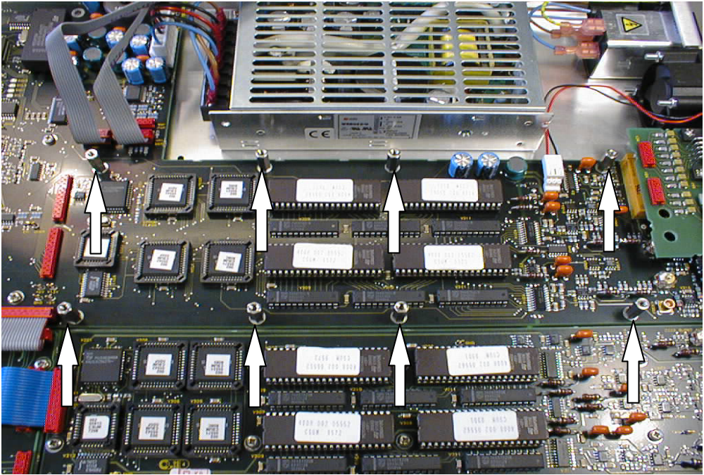

Picture 1

Picture 1: The positioning of the hexagonal spacers. The spacers are placed where the screws have been removed.
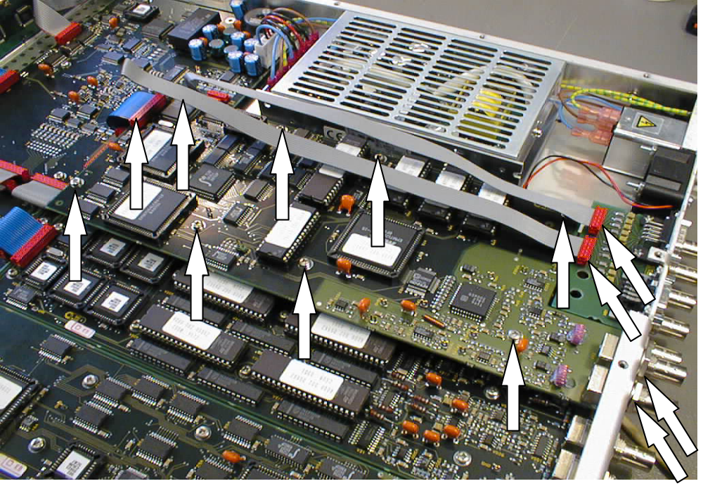
Picture 2.

Picture 2: The final, installed PM 8602 or PM 8603 SDI test signal generator. The arrows indicate positions where work has been done during the installation.

