Adjustments on SDI-black & color bar generator. PT8609 or a unit in PT5210/xx, where xx is ∈[04;12].

There is no user accessible adjustments on this generator. Adjustment of this generator is restricted to a performancecheck.

From the factory timing of each unit is calibrated and data is stored in E²-Prom V51. For description of measuring setup, see chapter ‘Timing adjustment of SDI-generators’.

Performancecheck:

To perform a performance check, you need an instrument that is able to measure following parameters:

TRS-errors, jitter, amplitude of serial video, video level (digital information), detection of sound (preferable an instrument that can convert the sound information to analog sound) and calculations of EDH-codes. Suggested is PT5474.

In system 625/50 check following: (the generator should free running, i.e. in GENLOCK-menu select Internal).

Connect output SDI BLK to measuring device.
Select a black signal without sound or EDH-codes.

ß Observe TRS-errors, there must be none.
(TRS = Timing Reference Signal).
ß Measure jitter, must be <0.15 UI. Measure over 4 frames without lowpass-filtering.
ß Measure level of serial video, must be 800 mV ±80mV.
ß Select the 75 % color bar signal. Check the white level, must be 235.00_{d.}
Using waveform display, check for errors in waveform.
ß Select the 100 % color bar signal. Check the white level, must be 235.00_{d.}
Using waveform display, check for errors in waveform.
ß Add sound (silence) to the signal. Observe that there is added sound samples to the SDI-signal. By converting to analog voltage, you get a good indication if any biterror is present in the signal.
ß Check for reserved code errors. Values 00.x_{Hex} and FF.x_{Hex} must not appear in the data stream outside TRS-words.
ß Add EDH-codes to the signal. Observe presence of codes in the signal, and if possible, that they are generated correct.
(EDH = Error Data Handling).
ß Check level detectors. Connect PP1 on the generator. Notice which connector the generator is connected to (BB3-4, BB5-6 or BB7-8). Watch the front plate with the menu in top position. A message ‘level error at Bbx-x’ should be seen.

Select system 525/59.94.

ß Observe TRS-errors, there must be none.
(TRS = Timing Reference Signal).
ß Select the SMPTE-color bar signal. Check the white level, must be 180.25_{d.} (line 25).

This unit has two outputs.

ß Connect the other output to measuring device, and check level of data signal, it should be 800 mV ±80mV.

SDI Test signal generator, PT8602/PT8603.

Checkes som SDI-black generator, dog er der flere billeder og flere lydniveauer/-frekvenser.

Timing adjustment of SDI-generators:

The purpose of this adjustment is to give a well defined output timing when front plate display shows V: +0 H: +000 T: +00000.0.

This calibration requires SDI digital genlock option, PT8606 and another SDI digital generator. An instrument that can measure the timing difference between two SDI-signals is also needed. At the factory a Rhode & Schwartz ‘Digital Video Component analyzer VCA’ is used.

Procedure:
A SDI digital signal is connected to SDI genlock input. In menu GENLOCK select genlock to SDI signal.

The output from genlock unit and output from SDI-generator to adjust are compared, and the SDI-generator is adjusted to the same timing as the reference generator, i.e. no timing difference is present.

Analog test signal generator, PT8601.

Adjustment on this generator:

ß Amplitude of the sinewave from 13.5 MHz NCO.
ß Lowpass filter and sinx/x correction.

These two adjustments have an influence on timing and Sc-H phase adjustments, which only is software adjustable (factory adjustment).

ß Timing of the signal compared to reference sync generator.
ß SC-H phase of the generated signal.
ß Amplitude of the generated signal.
ß Blanking offset of the generated signal.

These four adjustments are software adjustable and should be factory adjusted.

Adjustments NCO-part:

- Connect an oscilloscope probe to TP94.
- Check that the amplitude of the 13.5 MHz sinewave is approx. 1.2 V_{pp} . It has a DC- offset of 2.5 V.
- If not OK adjust L1 for maximum amplitude.

Check video level and blanking level:

- Select SYSTEM 625/50 and EBU C.bar.
- Connect ANL SIG to an oscilloscope.
- Measure blanking level. Must be 0V ±5mV.
- Connect ANL SIG to a video level meter.
- Select color bar signal.
- Measure white bar level. Must be 700mV ±3.5 mV ??

If one or both of these check’s fails, refer to start of this chapter.

Lowpass-filter adjustments:

Test equipment:
Network analyzer: e.g. HP3577A
Oscilloscope:
Test cable: See drawing

Drawing 10073892.eps (fra PM5655).

Procedure:
- Select system 625/50.
- Connect ANL SIG to network analyzer input.
- Connect Network analyzer output to PP1 with test cable.
- Adjust the 3 zeros:
L20: 8.05 MHz
L21: 10.0 MHz
L19: 16.8 MHz
- Adjust delay-equalizer L15/L17 and L16/L18 so the delay-variations is less than 5ns to 5MHz (see figure below).
- Adjust sinx/x correction L22/C83 for best high frequency performance, 4-5.8MHz (see figure below).
- Connect ANL SIG to an oscilloscope/video analyzer. Make sure PP1 is correct mounted.
- Select pattern MULTIBURST
- Check the frequency response. It must be flat within 1% to 5MHZ and within 2% to 5.8MHz. Small adjustments of delay equalizer sections could be necessary
- Re-check, with network analyzer, the delay characteristic.

From remote interface it is possible to select some special test patterns. With these test patterns, check: (see figures)

Select patterns from remote:
- Send command:
- SINX/X:
- PULSE & BAR:

- Symmetry of sinx/x pulse Pattern: SINX/X.
- 20 T gain and delay:
Delay-difference should be < 4ns. Pattern: Pulse & bar.
- Symmetry of 2T-pulse see figure below.

When filter adjustment is completed, it is necessary to check the timing and Sc-H phase of composite signal.

Her kopieres fra analog black genratorerne

Figure of network analyzer display:

Passband: | Stopband:
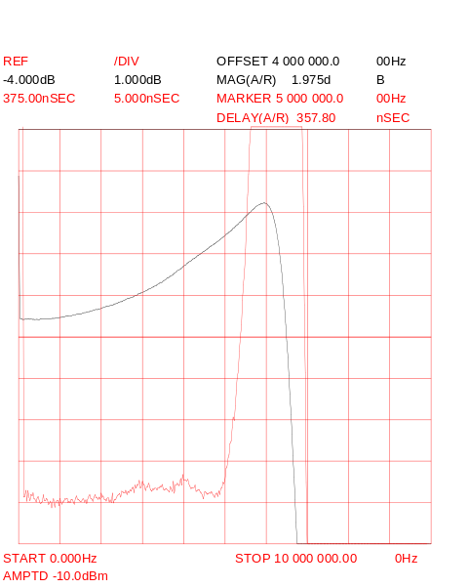 | 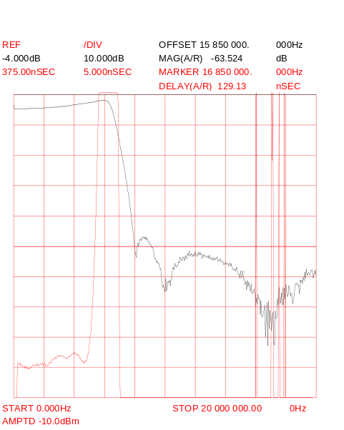
Fil: LP5210 | Fil: LPSTOP

Testpatterns selected from remote interface:

SINX/X-pulse: | 2T-pulse
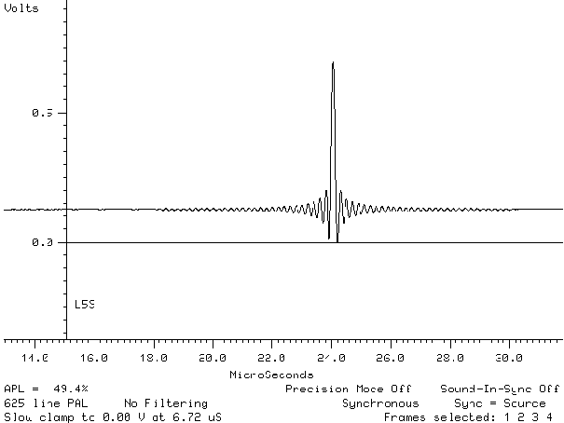 | 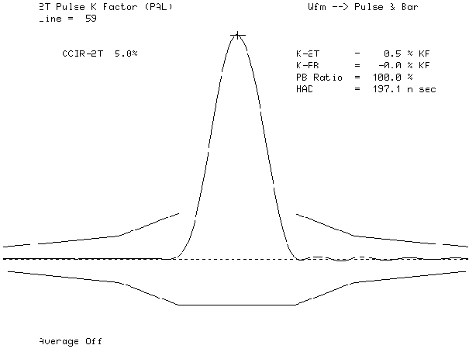
Fil: SINC5210.PCX | Fil: 2T5210.PCX

