C R Y S T A L S P E C I F I C A T I O N

TFC-TECH P/N: XT 2908

CUSTOMER : DK Audio

FREQUENCY RANGE: 27.0000 MHz

TYPE OF CUT: AT

HOLDER STYLE: HC-26/U GLASS

MODE: FUNDAMENTAL

CIRCUIT CONDITION: ANTI-RESONANT

LOAD CAPACITY: 15 pF

CALIBRATION TOL AT T.P. : +/- 15 PPM

T.P TEMPERATURE : 70 +/- 5 DEG C

FREQUENCY STABILITY: +/- 1.5 PPM / +65 TO + 75 DEG C

EQUIV. SERIES RESISTANCE: 15 OHMS MAX.

MOTIONAL CAPACITANCE (C1): 25 fF +/- 25%

STATIC CAPACITANCE (Co): 7 pF MAX.

SPUR. ATTENUATION: To be determined

BAND BREAKS ( 65 TO 75 DEG C) ESR VARIATION < +/- 25%
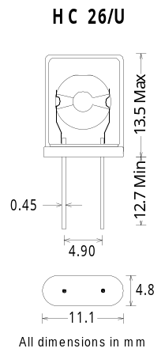

DRIVE LEVEL: < 100 uW

MARKING: 27.0000
XT 2908
TFC DATE
TP
September 11, 2002
March 8,2004. Cal Tol. Changed to +/- 15 ppm from +/- 10 ppm.
TP temperature changed to 70 +/- 5 deg C from +/- 3 deg C
C1 and BAND BREAKS added.

September 19,2001

