
How to connect cables for a Demo Studio

PT 5230
PT 5211
PT 5210
Analog/TSG
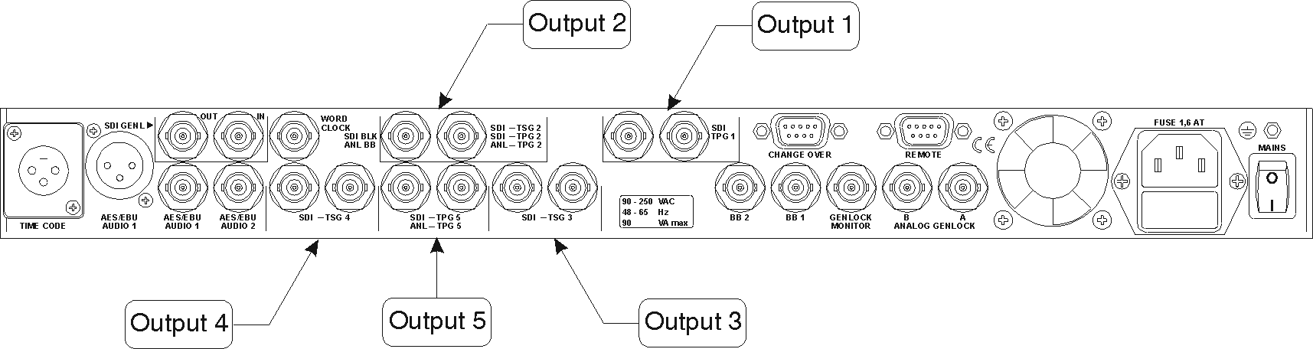
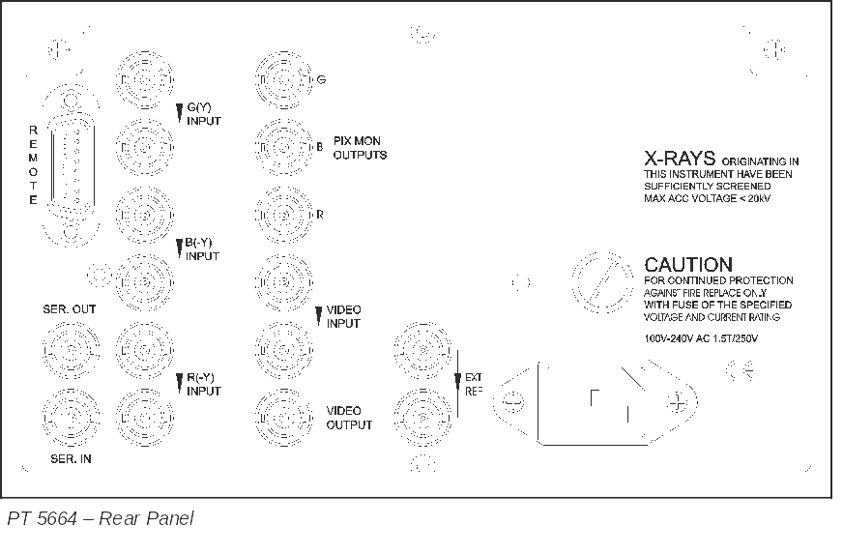
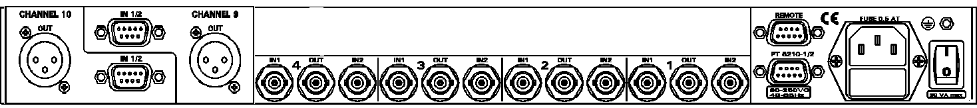
BB 1
SDI/BB
Analog TSG
SDI TSG
SDI TSG

