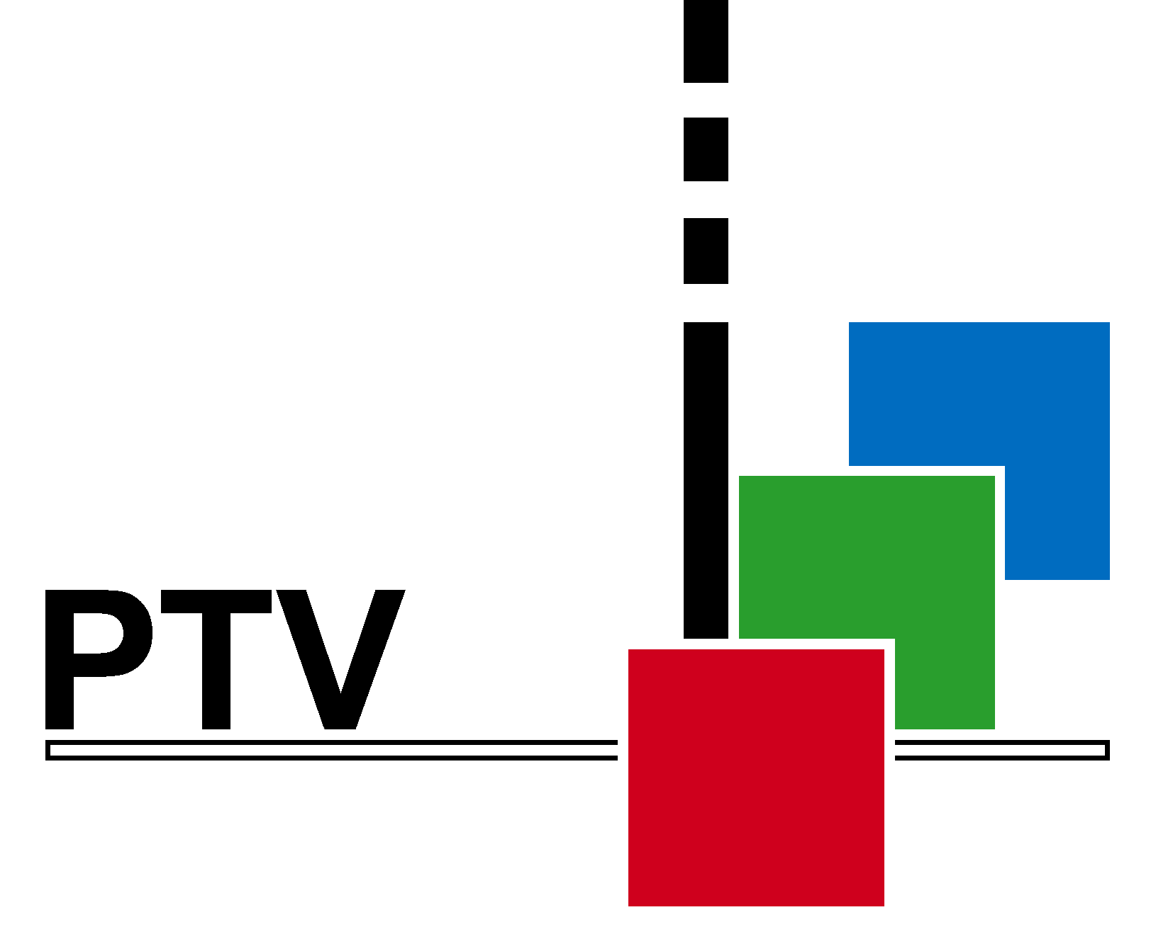Block Diagram for Studio Demo set-up

Genlock
BB1

PT 5210

PT 8609

PT 8601

PT 8603

PT 8605

SDI BB/CB

Analog TSG

PT 5211

1

2

3

4

PT 8618 9

SDI/TSG
BB1

PT 5664/50

Composite Input

SDI Input
AES/EBU
SDI BB/CB

75 Ω
Analog TSG/Analog input
Analog TSG 75 Ω SDI/TSG AES/EBU AES/EBU
SDI TSG

PT 5230

PT 8631

PT 8633

PT 8635

PT 8637
75 Ω
75 Ω
BB1

