DESCRIPTION
Prepared by: Bjarne Læsøe

Application
Hvad kan produktet anvendes til og i hvilke sammenhænge?
The PT 5211 VariTime™ Sync Changeover Unit is used in applications where the reliability of a single sync pulse generator is insufficient. The PT 5211 is used together with two sync generators in order to raise the total system reliability.
The PT 5211 is designed to operate together with two PT 5210/xx VariTime™ Digital Sync Generators. The PT 5210 design is based on a modular concept with a multitude of applications in mind. The PT 5211 is also based on a modular concept in order to be the natural solution together with the T 5210.
Some new thoughts where included in the PT 5210 compared to traditional sync generators. The detection of the valid signal output is included in the generator instead of in the change over unit. This makes it simple to detect both on the outputs of the active as well as on the outputs of the back-up generator and at the same time removing complexity from the change over unit - giving higher reliability.
In practice the system reliability only depend upon the reliability of the interconnections and the function of the change over unit.

Target User Profile
Hvordan “ser” den typiske bruger og/eller kunde ud - hvad lægger han/hun vægt på: betjeningsvenlighed, multistandard, servicevenlighed, tekniske specifikationer etc.
The function of the change over is to improve the reliability of a single sync generator by doing automatic selection of a warm back-up sync generator unit.
Undisturbed transmission, recording or producing is of the highest importance in the following cases:
- Life transmission. For instance sport transmission
- “One of” recordings. Situation which can not be redone.
- Recordings where re-recording or delays will be very expensive. For instance in situations where many people are involved or where scenery is destroyed during the recording.
- Transmission of commercials. When commercials are not transmitted the broadcaster or station is not paid for the commercials.
- Large systems operating together. For instance large broadcasters having many studios operating genlocked so that every connection is possible. In this case the master has to operate to keep the system genlocked.
The user of the change over is defined by the above applications.
Some national organizations require (i.e. FCC) a certain accuracy of the frequency of the signals transmitted. The easiest way to obtain this is in most cases to the have the complete facility genlocked to the same very high stability (and in some cases also very expensive) reference, and having the TV-system reference backed up.

Operation Principles
Hvordan fungerer produktet? Hvordan ser for- og bagpladen ud? Hvad sker der, når man trykker på knapperne? Hvordan indgår det sammen med andre produkter?
Ease of use and reliability is the parameters of highest importance in the design and use of a change over unit. The reliability has been optimized by reducing the complexity of the change over unit. The operation has been optimized with emphasis on the hectic minutes when the system in not operating and “someone” has to press the right button to get the studio on air.
A block diagram of a simple change over system is shown below

The PT 5211 VariTime Changeover selects between the two sync generators. The main function is to select the back-up unit when the master unit fails.
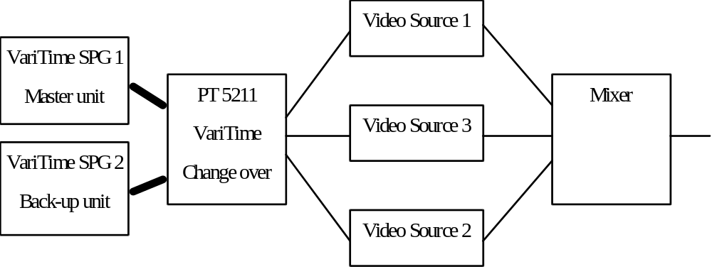
The PT 5211 allow different programming: Automatic changeover, manual selection of one generator (override mode). It is possible to select either one of the two generators as the primary and the other as back-up. This allows daily change to check the continued function of both circuits.
The PT 5211 includes front panel indication of which generator is used, the mode of operation and if one or both of the generators has failed.
A TTL remote function allows both selection and surveillance of the function of the change over.
The remote allow selection of the same functions as the keyboard, reading of the status of changeover and the error status of the generators. A set of floating relay contacts gives connection for external alarm circuit. The contacts are connected when an error is observed (it is also detected as an error if the instrument is powered down).

The following indications are given on the text plate:
Which generator(s) is out of order (indicated by 2 red fault indication led’s)
Which generator is used (indicated by a yellow ON AIR led).
The type of change over function selected, manual or automatic (indicated by a yellow led).
The status of the parallel remote (enabled indicated by a yellow led).
Power on (indicated by a green led)
Which generator is selected as primary and which generator is selected as back-up (indicated by two green led’s)
It has to be decided if it is needed to have a memory with information if any of the generators has failed. This will require two additional led’s and a reset button.

The following functional keys are included on the text plate:
Selection of automatic or manual change over control, 2 switches w. led’s
Selection of which generator is primary and which is back-up (the generators are named 1 and 2), 2 switches w. led’s and , 2 separate led’s
Enable/disable of the parallel remote interface, one toggle switch w. led
A modify key which has to be pressed while any other key is used in order to change the setting. A green led which only lights when the key is hold down is integrated in the button.

Main Selling Propositions
Hvilke ting skal produktet sælges på? Hvilke fordele opnås med lige netop dette produkt? Husk: en fabrikant af boremaskiner sælger ikke boremaskiner, men produktivitet hos en entreprenør, eller bedre arbejdsmiljø for en tømrer, eller blot og bart: huller i væggen!
Main selling propositions angives ofte ved “USP’s” - “Unique Selling Propositions”, men punkterne behøver ikke være 100% unikke for at være gode salgsargumenter!
The PT 5211 is dedicated to operate together with the PT 5210 VariTime™ Digital Sync Generator. The changeover unit together with two PT 5210 operate as an integrated system. The PT 5211 is designed with modules to suit the different configurations of the PT 5210.
The PT 5211 is the sole changeover unit on the market which also makes it possible to have backup of the balanced output digital AES/EBU audio.

Variants and Versions
Hvilke varianter skal produktet laves i (f.eks. med eller uden Sc-H måling, enkeltkanal eller multikanal)? Hvilke versioner skal produktet laves i (f.eks. B/G, D/K eller M)?
The PT 5211 is multistandard exactly as the PT 5210. All the BNC channels can operate as composite video NTSC or PAL, SDI, single ended AES/EBU audio or with the genlock signal.
The PT 5211 comes as standard with 4 change over channels (12 BNC connectors). Additional BNC channels can be included as single modules with 2 channels (6 BNC connectors) or a one double module with two XLR channels. A maximum of 4 additional BNC modules may be simultaneously installed giving a maximum of 12 BNC channels. One XLR module can be installed in which case only two additional BNC modules can be installed.
As standard the PT 5211 is delivered with all text plates for the installation of the complete number of BNC channels. The not used holes are blinded with hole plugs.
The XLR module gives changeover function on the balanced LTC signal and the balanced digital AES/EBU output.

Options
Hvilke tilbehør og options kan man få sammen med produktet?

PT 86xx: 2 BNC changeover channels
The BNC changeover option switches all the signals with 75Ω BNC connector. This is the black burst, analog video, SDI black&CB, SDI signals, AES/EBU (75Ω) and the genlock signals.

PT 86xx 2 XLR changeover channels, with cables to connect to two PT 5210
The XLR changeover option switches the balanced timecode and AES/EBU signals on XLR connectors.
For connecting the XLR outputs on the PT 5210 to the PT 5211 some special cables are needed (dual XLR to 9-pin Sub-D). These cables are supplied by PTV, included with the option using the cables
The text plate for the BNC changeover modules are included together with the standard instrument. The special textplate for use together with the XLR changeover channels is included with the XLR option.

Accessories
An interface cable to connect the changeover to the two sync generators is included together with the changeover.
Separate Sub-D 9 pole cable connectors are available.

