DEVELOPMENT ASPECTS
Prepared by: Stig Bangsbye

User Interface

Operating facilities
Switch operation (The main function) is performed on request from the connected two sync generators only if the PT 5211 Change Over Unit has been set into “AUTO” mode, i.e. the automatic switch over mode. Otherwise switch operation is performed via a manual control from the frontplate or a command from the remote interface.
Manual operation takes place from the frontplate. The frontplate is quite simple containing less than 12 pushbuttons and LED´s. Alfa numeric- or other displays are not used. Instrument control takes place using push-buttons and instrument status information using LED´s.
Remote operation takes place via a connector on the rear plate. The standard instrument is supplied with a TTL interface that makes it possible to control the instrument and get staus information the same way as via the frontplate.
Mechanical precautions have been made for a future installation of a RS 232/422 option instead of the TTL interface. This option has yet not been specified or designed.

Connections

The BASIC INSTRUMENT is supplied with the following signal connectors:
 | BNC connectors: | 4 x Input (0-300MHz) from Sync generator #1
 |  | 4 x Input (0-300MHz) from Sync generator #2
 |  | 4 x Output (0-300MHz) with signals either from Sync generator #1 or #2
 | Sub-D, 9 pins: | 1 x TTL remote interface
 |  | 1 x PT 5210 control - That connects the instrument to two PT 5210 Sync generators

OPTIONALLY the basic instrument can be supplied with BNC connectors to a maximum shown below:
 | BNC connectors: | 12 x Input (0-300MHz) from Sync generator #1
 |  | 12 x Input (0-300MHz) from Sync generator #2
 |  | 12 x Output (0-300MHz) with signals from Sync generator #1 or #2

OPTIONALLY the basic instrument can be supplied with two XLR channels for AES-EBU audio signals and Timecode signals and BNC channels to a maximum shown below:
 | BNC connectors: | 8 x Input (0-300MHz) from Sync generator #1
 |  | 8 x Input (0-300MHz) from Sync generator #2
 |  | 8 x Output (0-300MHz) with signals from Sync generator #1 or #2
 | Sub-D, 9 pins: | 1 x Input (0-10MHz) AES-EBU Audio from Sync generator #1 and #2
 |  | 1 x Input (0-10MHz) Timecode signals from Sync generator #1 and #2
 | XLR connectors: | 2 x Output (0-10MHz) AES-EBU Audio and Timecode signals from Sync generator #1
 |  | 2 x Output (0-10MHz) AES-EBU Audio and Timecode signals from Sync generator #2

Hvordan præsenterer produktet sig for brugeren rent betjeningsmæssigt? Skitsér for- og bagpladen, og beskriv hvordan apparatet skal forbindes til “omverdenen”. Beskriv hvordan apparatet betjenes i alle situationer

Mechanical Design/Styling
The instrument cabinet is of the well known PM 5655 type. It has been required that the PT 5211 should contain as many channels switches as possible, thus being able to switch as many of the PT 5210 Sync signals as possible. This includes signals transmitted via BNC connectors as well as via XLR connectors.
The basic instrument is supplied with only 4 channel switches and BNC sockets and corresponding text. Additional text and “blinded holes” on the rearplate is prepared for the optional 8 BNC channels.
The BNC channels 9 to 12 may be exchanged with two channels of the XLR type . (These XLR channels take double as much room than the BNC channels).

Option philosophy.
The flexible solution using options to a wide extend in the PT 5210 is also to be used for this instrument. Furthermore eventually options to be added to the basic instrument should be mounted without adjustment at the customers place. This means that special cables to be used together with these options are to be supplied with the options.
The options shall be modular designed. In this way the most common option (2 x BNC channels) may be mounted in 4 different places inside the instrument.
The total number of 12nc´s used for the total solution has been minimized
Connecting an option takes place using “Flat cables” internally for control signals and power supply. Connectors for the signal inputs from the Sync generators however, will be placed directly on the pcb of the option..
This has the advantage of minimizing the intenal cabling thus bringing the signal routing to a minimum.

Other precautions.
A modular power supply is to be used. It is cheap. It is sufficient (Switch mode) in order to control the relays. No signals are to be treated using active electronics.
Crosstalk and proper return loss may call for special precautions in the pcb-layout, screening and cabling inside the instrument. This especially is the case for the 0-300MHz BNC channels used to switch the video SDI signals.
Future extentions are treated by designing into the cabinet mounting fittings for extra pcb´s and for extended pcb´s.
Hvordan ser apparatet ud? Størrelse og vægt? Anvendte farver, knapper og displays? Passer det designmæssigt med andre Philips (eller andre) apparater, det må forventes, det skal kunne arbejde sammen med?

Technical Description
From the BLOCK DIAGRAM shown below the modular design can be seen. The diagram is so simple that it does not call for a closer description

Block diagram.
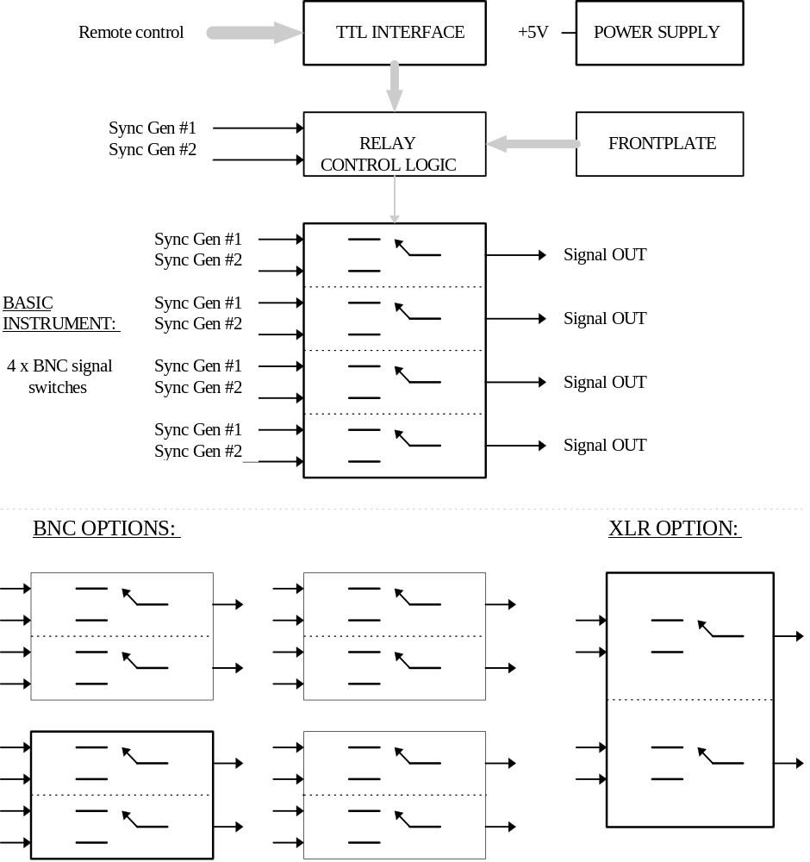

Beskrivelse af apparatet og de anvendte kredsløb på - mindst - blok-diagram-niveau.

New Components and Technologies
This instrument does not contain components of the latest discoveries, that means that only well known components with a well known behavior are used.
Unusual is the amount of relays used in the instrument. Still this has been found to be the best solution as far as economical and technical aspects are concerned.
Unusual is that NO μ-processor or other highly integrated circuits have found its way into the design.
The electrical circuitry will be implemented on double sided PCB´s. The reason is the sync signals IN/OUT will just pass one relay contact, thus the the routing will be kept to a minimum .
No signals but the control signals (+5V logic) are processed by electronical circuitry.

Her beskrives nødvendige nye komponenter og anvendte teknologier - ikke blot kredsløbsmæssigt men også produktionsmæssigt.

