DEVELOPMENT ASPECTS
Prepared by: Stig Bangsbye

User Interface
Operating facilities

Switch operation (The main function) is performed on request from the connected two sync generators only if the PT 5211 Change Over Unit has been set into “Automatic switch over mode”.

Manual operation takes place from the frontplate (See ch. 10). The frontplate is quite simple containing less than 10 pushbuttons and LED´s. No alfa numeric- or other displays are not used. Instrument control takes place using push-buttons and instrument status information using LED´s.

Remote operation takes place via a connector on the rear plate (See ch. 10). The standard instrument is supplied with a TTL interface that makes it possible to control the instrument and get staus information the same way as via the frontplate. (A later developed RS 232 option may replace the TTL interface).

Connections

The BASIC INSTRUMENT is supplied with the following signal connectors:

 | BNC connectors: | 4 x Input (0-300MHz) from Sync generator 1
 |  | 4 x Input (0-300MHz) from Sync generator 2
 |  | 4 x Output (0-300MHz) with signals either from Sync generator 1 or 2
 | Sub-D, 9 pins: | 1 x TTL remote interface
 |  | 1 x PT 5210 control - That connects the instrument to two PT 5210 Sync generators

OPTIONALLY the basic instrument can be supplied with BNC connectors to a maximum shown below:

 | BNC connectors: | 12 x Input (0-300MHz) from Sync generator 1
 |  | 12 x Input (0-300MHz) from Sync generator 2
 |  | 12 x Output (0-300MHz) with signals either from Sync generator 1 or 2

OPTIONALLY the basic instrument can be supplied with two XLR channels for AES-EBU audio signals and Timecode signals and BNC channels to a maximum shown below:

 | BNC connectors: | 8 x Input (0-300MHz) from Sync generator 1
 |  | 8 x Input (0-300MHz) from Sync generator 2
 |  | 8 x Output (0-300MHz) with signals either from Sync generator 1 or 2
 | Sub-D, 9 pins: | 1 x Input (0-10MHz) AES-EBU Audio from Sync generator 1 and 2
 |  | 1 x Input (0-10MHz) Timecode signals from Sync generator 1 and 2
 | XLR connectors: | 2 x Output (0-10MHz) AES-EBU Audio and Timecode signals from Sync generator 1
 |  | 2 x Output (0-10MHz) AES-EBU Audio and Timecode signals from Sync generator 2

Hvordan præsenterer produktet sig for brugeren rent betjeningsmæssigt? Skitsér for- og bagpladen, og beskriv hvordan apparatet skal forbindes til “omverdenen”. Beskriv hvordan apparatet betjenes i alle situationer

Mechanical Design/Styling
The instrument cabinet is of the well known PM 5655 type. It has been required that the PT 5211 should contain as many switch channels as possible of the standard BNC connector type as well as of the standard AND optionally a maximum of the two XLR types that are also present in the sync generator PT 5210.

Text on the rearplate may thus introduce delicate problems to be solved.

Option philosophy.

The flexible solution using options to a wide extend in the PT 5210 is also to be used for this instrument. Furthermore eventually options to be added to the stasndard basic instrument should be easy mounted and adjusted at the customers place. This means that special cables to be used together with these options are to be supplied with the options.

The options shall be modular designed. In this way the most common option (2 x BNC channels) may be mounted in three different places inside the instrument. One way of mounting this option is that it may be placed upside down. Besides reducing the total number of 12nc´s used for the total solution it is also easier to handle in the sales and service situation.

Connecting an option takes place using “Flat cables” for control signals and power supply. Connectors for the signal inputs from the Sync generators however, will be placed directly on the pcb of the option.. This has the advantage of minimizing the intenal cabling and thus bring the signal routing to a minimum.

Other precautions.

A modular power supply is to be used. It is cheap. It is sufficient (Switch mode) in order to control the relays. No signals are to be treated using active electronics.

Crosstalk and proper return loss may call for special precautions in the pcb-layout, screening and cabling inside the instrument. This especially is the case for the 0-300MHz BNC channels used to switch the D1 signals.

Future extentions are treated by designing into the cabinet mounting fittings for extra pcb´s and for extended pcb´s.

Hvordan ser apparatet ud? Størrelse og vægt? Anvendte farver, knapper og displays? Passer det designmæssigt med andre Philips (eller andre) apparater, det må forventes, det skal kunne arbejde sammen med?

Technical Description
From the BLOCK DIAGRAM shown below the modular design can be seen. The diagram is so simple that it does not call for a closer description

Block diagram.
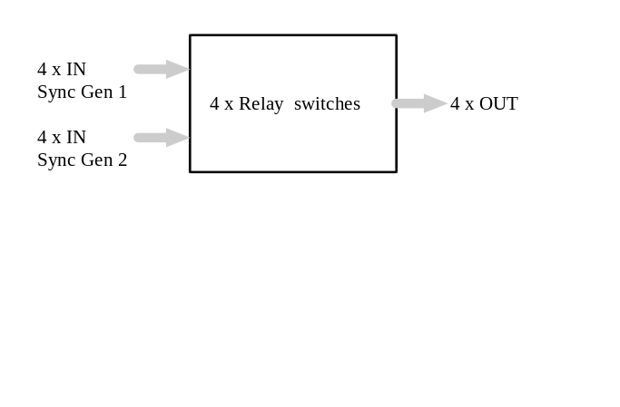

Beskrivelse af apparatet og de anvendte kredsløb på - mindst - blok-diagram-niveau.

New Components and Technologies
Her beskrives nødvendige nye komponenter og anvendte teknologier - ikke blot kredsløbsmæssigt men også produktionsmæssigt.

