DISTRIBUTION

Senior Management Group Copy number
Maurits van Tol, G&A 1
Poul Wachmann, OPR 2
Jesper Dahl Kristensen, G&A 3
Ole Skrydstrup, DEV 4

Departmental Managers:
Kurt Møller Nielsen, FMS 5
Niels Berendt, DEV, Development Manager 6
Bjarne Læsøe, DEV, Technical Product Manager 7
Ole Plett, SAL, Commercial Product Manager 8
Rolf Søbirk, SAL 9
Gunner Bækgaard, DEV 10
Jens Bjørn Hansen, Q&P 11
APD file, PT 5210, DEV 12

CONTENTS

Klik i teksten nedenfor og tryk F9 for at regenerere indholdsfortegnelsen.
1. INTRODUCTION
2. DESCRIPTION
2.1 Application
2.2 Target User Profile
2.3 Operation Principles
2.4 Main Selling Propositions
2.5 Variants and Versions
2.6 Options
3. MARKETING ASPECTS
3.1 Size of Target Market and Market Share
3.2 Competition
3.3 Positioning
3.4 Strengths, Weaknesses, Opportunities and Threats
3.5 Weaknesses.
3.6 Opportunities
3.7 Threats
3.8 Release Aspects
3.9 Promotion Aspects
3.10 Distribution Aspects
4. CUSTOMER SUPPORT ASPECTS
4.1 Quality Data
4.2 Service Level
4.3 PTV Calibration and Tools
4.4 NSO Calibration and Tools
4.5 Field Calibration and Tools
4.6 Test Documents
4.7 Training
4.8 Spare Parts
4.9 Operational and Service Manual
4.10 Customer Support Ressources
5. DEVELOPMENT ASPECTS
5.1 User Interface
5.2 Mechanical Design/Styling
5.3 Technical Description
5.4 New Components and Technologies
6. PRODUCTION ASPECTS
6.1 Manufacturing Technology
6.2 Testing Requirements
6.3 Capital Investments
6.4 Production Preparation/Run in
6.5 Production Resources
7. ENVIRONMENTAL ASPECTS
7.1 Production Process and Materials
7.2 Use of the Product
7.3 Disposal of the Product
8. FINANCIAL ASPECTS
8.1 Cost Calculations
8.2
8.2 Contribution Margin Analysis and Cash Flow Analysis
9. TENTATIVE OPERATING INSTRUCTIONS
10. FRONT AND REAR PLATE LAY-OUT
11. QUALITY ACTIVITY PLAN
12. PROJECT PLAN
13. PRODUCT DATA
13.1 BNC Channels
13.2 XLR Channels
13.3 Remote control
13.4 Environmental
13.5 Power Supply
14. BLOCK DIAGRAMS
15. MARKET, TURNOVER AND FINANCIAL ISSUES

INTRODUCTION
Prepared by: Bjarne Læsøe
Her angives et kort resume af projektet inkluderende en ganske kort opsummering af:
∗ Anvendelsesområder
∗ Målgruppe (kunder/brugere)
∗ Produktet
∗ Positionering
Kapitlet bør ikke fylde mere end én side.

For at starte indtastning af et afsnit placeres markøren i slutningen af den sidste skjulte linie og der trykkes på return. F.eks. her ---->
The PT 5211 VariTime™ Change Over has been developed only to operate together with the PT 5210 VariTime™ Digital Sync Generator. When the PT 5210 was first introduced at the IBC 96 exhibition it became clear that the there was a need for a change over unit together with the sync generator.
The purpose of the change over is to improve the reliability of the sync generator seen as a function. This is obtained by use of a warm back-up unit. In case of failure of the primary the backup is selected automatically by the change over unit. The customers for this type of application are customers where down-time is very expensive. This is most important for life transmission, recording of “one of” situations, when many people are involved in the recording situation or where the missed income from commercials is of importance.
In order to fulfill the required improvement in the reliability of the sync function the most important parameter is the reliability of the change over itself. This asks for a simple instrument with operation which can be operated without error even in hectic situations.
The change over is used together with the PT 5210 and is not designed to be used together with competitors sync generators. The change over is priced competitively compared with other units on the market.

DESCRIPTION
Prepared by: Bjarne Læsøe

Application
Hvad kan produktet anvendes til og i hvilke sammenhænge?
The PT 5211 VariTime™ Sync Changeover Unit is used in applications where the reliability of a single sync pulse generator is insufficient. The PT 5211 is used together with two sync generators in order to raise the total system reliability.
The PT 5211 is designed to operate together with two PT 5210/xx VariTime™ Digital Sync Generators. The PT 5210 design is based on a modular concept with a multitude of applications in mind. The PT 5211 is also based on a modular concept in order to be the natural solution together with the T 5210.
Some new thoughts where included in the PT 5210 compared to traditional sync generators. The detection of the valid signal output is included in the generator instead of in the change over unit. This makes it simple to detect both on the outputs of the active as well as on the outputs of the back-up generator and at the same time removing complexity from the change over unit - giving higher reliability.
In practice the system reliability only depend upon the reliability of the interconnections and the function of the change over unit.

Target User Profile
Hvordan “ser” den typiske bruger og/eller kunde ud - hvad lægger han/hun vægt på: betjeningsvenlighed, multistandard, servicevenlighed, tekniske specifikationer etc.
The function of the change over is to improve the reliability of a single sync generator by doing automatic selection of a warm back-up sync generator unit.
Undisturbed transmission, recording or producing is of the highest importance in the following cases:
- Life transmission. For instance sport transmission
- “One of” recordings. Situation which can not be redone.
- Recordings where re-recording or delays will be very expensive. For instance in situations where many people are involved or where scenery is destroyed during the recording.
- Transmission of commercials. When commercials are not transmitted the broadcaster or station is not paid for the commercials.
- Large systems operating together. For instance large broadcasters having many studios operating genlocked so that every connection is possible. In this case the master has to operate to keep the system genlocked.
The user of the change over is defined by the above applications.
Some national organizations require (i.e. FCC) a certain accuracy of the frequency of the signals transmitted. The easiest way to obtain this is in most cases to the have the complete facility genlocked to the same very high stability (and in some cases also very expensive) reference, and having the TV-system reference backed up.

Operation Principles
Hvordan fungerer produktet? Hvordan ser for- og bagpladen ud? Hvad sker der, når man trykker på knapperne? Hvordan indgår det sammen med andre produkter?
Ease of use and reliability is the parameters of highest importance in the design and use of a change over unit. The reliability has been optimized by reducing the complexity of the change over unit. The operation has been optimized with emphasis on the hectic minutes when the system in not operating and “someone” has to press the right button to get the studio on air.
A block diagram of a simple change over system is shown below

The PT 5211 VariTime Changeover selects between the two sync generators. The main function is to select the back-up unit when the master unit fails.
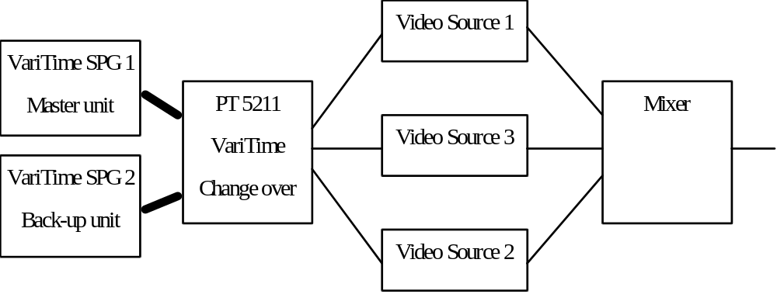
The PT 5211 allow different programming: Automatic changeover, manual selection of one generator (override mode). It is possible to select either one of the two generators as the primary and the other as back-up. This allows daily change to check the continued function of both circuits.
The PT 5211 includes front panel indication of which generator is used, the mode of operation and if one or both of the generators has failed.
A TTL remote function allows both selection and surveillance of the function of the change over.
The remote allow selection of the same functions as the keyboard, reading of the status of changeover and the error status of the generators. A set of floating relay contacts gives connection for external alarm circuit. The contacts are connected when an error is observed (it is also detected as an error if the instrument is powered down).

The following indications are given on the text plate:
Which generator(s) is out of order (indicated by 2 red fault indication led’s)
Which generator is used (indicated by a yellow ON AIR led).
The type of change over function selected, manual or automatic (indicated by a yellow led).
The status of the parallel remote (enabled indicated by a yellow led).
Power on (indicated by a green led)
Which generator is selected as primary and which generator is selected as back-up (indicated by two green led’s)

It has to be decided if it is needed to have a memory with information if any of the generators has failed. This will require two additional led’s and a reset button.

The following functional keys are included on the text plate:
Selection of automatic or manual change over control, 2 switches w. led’s
Selection of which generator is primary and which is back-up (the generators are named 1 and 2), 2 switches w. led’s and , 2 separate led’s
Enable/disable of the parallel remote interface, one toggle switch w. led
A modify key which has to be pressed while any other key is used in order to change the setting. A green led which only lights when the key is hold down is integrated in the button.

Main Selling Propositions
Hvilke ting skal produktet sælges på? Hvilke fordele opnås med lige netop dette produkt? Husk: en fabrikant af boremaskiner sælger ikke boremaskiner, men produktivitet hos en entreprenør, eller bedre arbejdsmiljø for en tømrer, eller blot og bart: huller i væggen!
Main selling propositions angives ofte ved “USP’s” - “Unique Selling Propositions”, men punkterne behøver ikke være 100% unikke for at være gode salgsargumenter!
The PT 5211 is dedicated to operate together with the PT 5210 VariTime™ Digital Sync Generator. The changeover unit together with two PT 5210 operate as an integrated system. The PT 5211 is designed with modules to suit the different configurations of the PT 5210.
The PT 5211 is the sole changeover unit on the market which also makes it possible to have backup of the balanced output digital AES/EBU audio.

Variants and Versions
Hvilke varianter skal produktet laves i (f.eks. med eller uden Sc-H måling, enkeltkanal eller multikanal)? Hvilke versioner skal produktet laves i (f.eks. B/G, D/K eller M)?
The PT 5211 is multistandard exactly as the PT 5210. All the BNC channels can operate as composite video NTSC or PAL, SDI, single ended AES/EBU audio or with the genlock signal.
The PT 5211 comes as standard with 4 change over channels (12 BNC connectors). Additional BNC channels can be included as single modules with 2 channels (6 BNC connectors) or a one double module with two XLR channels. A maximum of 4 additional BNC modules may be simultaneously installed giving a maximum of 12 BNC channels. One XLR module can be installed in which case only two additional BNC modules can be installed.
As standard the PT 5211 is delivered with all text plates for the installation of the complete number of BNC channels. The not used holes are blinded with hole plugs.
The XLR module gives changeover function on the balanced LTC signal and the balanced digital AES/EBU output.

Options
Hvilke tilbehør og options kan man få sammen med produktet?

PT 86xx: 2 BNC changeover channels
The BNC changeover option switches all the signals with 75Ω BNC connector. This is the black burst, analog video, SDI black&CB, SDI signals, AES/EBU (75Ω) and the genlock signals.

PT 86xx 2 XLR changeover channels, with cables to connect to two PT 5210
The XLR changeover option switches the balanced timecode and AES/EBU signals on XLR connectors.
For connecting the XLR outputs on the PT 5210 to the PT 5211 some special cables are needed (dual XLR to 9-pin Sub-D). These cables are supplied by PTV, included with the option using the cables
The text plate for the BNC changeover modules are included together with the standard instrument. The special textplate for use together with the XLR changeover channels is included with the XLR option.Accessories
An interface cable to connect the changeover to the two sync generators is included together with the changeover.
Separate Sub-D 9 pole cable connectors are available.

CUSTOMER SUPPORT ASPECTS
Prepared by: Niels Berendt

This section is replaced by a separate “Customer Support Marketing Plan” prepared by Rolf Søbirk.

Customer support aspects for the PT 5211 will be coupled very close to PT 5210.

The “old” Business Plan sections are:

Quality Data
Overslag over:
- Mean Time Between Calibrations (MTBS)
- Mean Time To Calibrate (MTTC)
- Mean Time Between Failure (MTBF)
- Mean Time To Repair (MTTR)
Både markedets forventninger og hvad der kan opnås med det foreslåede produkt angives.
The MTBF value for the change-over unit alone is dominating the MTBF value for a complete setup consisting of two sync generators and a change-over unit. The reason why, is the fact, that it is very unlikely that both sync generators fail at the same time.

An MTBF of more than 100000 hours is wanted. It seems possible to obtain 180000 hours for the power supply alone which is the most complex of the circuits.

Service Level
Hvilket serviceniveau forventer kunderne: f.eks. 24 timers turn-around service, service i lokalt serviceværksted, eller kan service foretages tilfredsstillende i Supply Centeret?

PTV Calibration and Tools
Hvad er nødvendigt for at Supply Centeret kan foretage kalibreringer på tilfredsstillende vis?

NSO Calibration and Tools
Hvad er nødvendigt for at en National Sales Organisation kan foretage kalibreringer på tilfredsstillende vis?

Field Calibration and Tools
Hvad er nødvendigt for at en kunde kan foretage kalibreringer på tilfredsstillende vis?

Test Documents
Hvilken dokumentation vil kunden forvente (og hvilken kan vi tilbyde) som dokumentation for, at produktet er testet forsvarligt - både i produktion - men også ved senere kalibreringer?

Training
Hvilken træning i betjening og servicering vil kunde/NSO’en forventes at have brug for -og hvilken kan vi tilbyde?

Spare Parts
Hvilke reservedele kan vi forvente, der bliver brug for - og hvordan og hvorfra skal kunden/NSO’en kunne få dem?

Operational and Service Manual
Hvilken type manualer skal der tilbydes? Betjeningsvejledning alene? Gratis servicevejledning på et svarkort? Hvilke sprog skal manualerne udformes på? Skal de være selvforklarende tegneserier? Etc. Etc.

Customer Support Ressources

Hvilke ressourcer lægger dette produkt beslag på til Customer Support

DEVELOPMENT ASPECTS
Prepared by: Stig Bangsbye

User Interface

Operating facilities
Switch operation (The main function) is performed on request from the connected two sync generators only if the PT 5211 Change Over Unit has been set into “AUTO” mode, i.e. the automatic switch over mode. Otherwise switch operation is performed via a manual control from the frontplate or a command from the remote interface.
Manual operation takes place from the frontplate. The frontplate is quite simple containing less than 12 pushbuttons and LED´s. Alfa numeric- or other displays are not used. Instrument control takes place using push-buttons and instrument status information using LED´s.
Remote operation takes place via a connector on the rear plate. The standard instrument is supplied with a TTL interface that makes it possible to control the instrument and get staus information the same way as via the frontplate.
Mechanical precautions have been made for a future installation of a RS 232/422 option instead of the TTL interface. This option has yet not been specified or designed.

Connections

The BASIC INSTRUMENT is supplied with the following signal connectors:
 | BNC connectors: | 4 x Input (0-300MHz) from Sync generator #1
 |  | 4 x Input (0-300MHz) from Sync generator #2
 |  | 4 x Output (0-300MHz) with signals either from Sync generator #1 or #2
 | Sub-D, 9 pins: | 1 x TTL remote interface
 |  | 1 x PT 5210 control - That connects the instrument to two PT 5210 Sync generators

OPTIONALLY the basic instrument can be supplied with BNC connectors to a maximum shown below:
 | BNC connectors: | 12 x Input (0-300MHz) from Sync generator #1
 |  | 12 x Input (0-300MHz) from Sync generator #2
 |  | 12 x Output (0-300MHz) with signals from Sync generator #1 or #2
OPTIONALLY the basic instrument can be supplied with two XLR channels for AES-EBU audio signals and Timecode signals and BNC channels to a maximum shown below:
 | BNC connectors: | 8 x Input (0-300MHz) from Sync generator #1
 |  | 8 x Input (0-300MHz) from Sync generator #2
 |  | 8 x Output (0-300MHz) with signals from Sync generator #1 or #2
 | Sub-D, 9 pins: | 1 x Input (0-10MHz) AES-EBU Audio from Sync generator #1 and #2
 |  | 1 x Input (0-10MHz) Timecode signals from Sync generator #1 and #2
 | XLR connectors: | 2 x Output (0-10MHz) AES-EBU Audio and Timecode signals from Sync generator #1
 |  | 2 x Output (0-10MHz) AES-EBU Audio and Timecode signals from Sync generator #2

Hvordan præsenterer produktet sig for brugeren rent betjeningsmæssigt? Skitsér for- og bagpladen, og beskriv hvordan apparatet skal forbindes til “omverdenen”. Beskriv hvordan apparatet betjenes i alle situationer

Mechanical Design/Styling
The instrument cabinet is of the well known PM 5655 type. It has been required that the PT 5211 should contain as many channels switches as possible, thus being able to switch as many of the PT 5210 Sync signals as possible. This includes signals transmitted via BNC connectors as well as via XLR connectors.
The basic instrument is supplied with only 4 channel switches and BNC sockets and corresponding text. Additional text and “blinded holes” on the rearplate is prepared for the optional 8 BNC channels.
The BNC channels 9 to 12 may be exchanged with two channels of the XLR type . (These XLR channels take double as much room than the BNC channels).

Option philosophy.
The flexible solution using options to a wide extend in the PT 5210 is also to be used for this instrument. Furthermore eventually options to be added to the basic instrument should be mounted without adjustment at the customers place. This means that special cables to be used together with these options are to be supplied with the options.
The options shall be modular designed. In this way the most common option (2 x BNC channels) may be mounted in 4 different places inside the instrument.
The total number of 12nc´s used for the total solution has been minimized.

Connecting an option takes place using “Flat cables” internally for control signals and power supply. Connectors for the signal inputs from the Sync generators however, will be placed directly on the pcb of the option..
This has the advantage of minimizing the intenal cabling thus bringing the signal routing to a minimum.

Other precautions.
A modular power supply is to be used. It is cheap. It is sufficient (Switch mode) in order to control the relays. No signals are to be treated using active electronics.
Crosstalk and proper return loss may call for special precautions in the pcb-layout, screening and cabling inside the instrument. This especially is the case for the 0-300MHz BNC channels used to switch the video SDI signals.
Future extentions are treated by designing into the cabinet mounting fittings for extra pcb´s and for extended pcb´s.

Technical Description
From the BLOCK DIAGRAM shown below the modular design can be seen. The diagram is so simple that it does not call for a closer description.
Block Diagram
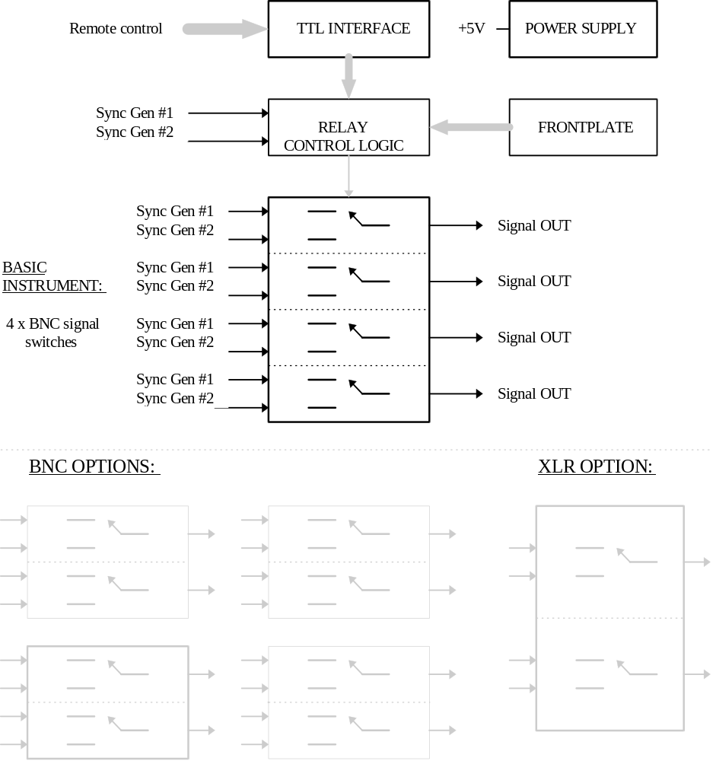

New Components and Technologies
This instrument does not contain components of the latest discoveries, that means that only well known components with a well known behavior are used.
Unusual is the amount of relays used in the instrument. Still this has been found to be the best solution as far as economical and technical aspects are concerned.
Unusual is that NO μ-processor or other highly integrated circuits have found its way into the design.
The electrical circuitry will be implemented on double sided PCB´s. The reason is the sync signals IN/OUT will just pass one relay contact, thus the the routing will be kept to a minimum .
No signals but the control signals (+5V logic) are processed by electronical circuitry.

PRODUCTION ASPECTS
Prepared by: Niels Berendt

Manufacturing Technology
Ordinary PTV manufacturing technology is more than sufficient since the product is far simpler than recently developed PTV instruments.
Hvilken fabrikationsteknologi er nødvendig? Er den kendt for PTV og vores sædvanlige underleverandører? skal vi “i byen” med specielle processer?

Testing Requirements
The product does not require very complicated test facilities due to its few and very simple functions. Still, it is recommended to use PC assisted test equipment to obtain a systematically test of the switch combinations.
Hvilket testudstyr er nødvendigt? Hvor mange nye procespladser er nødvendige?

Capital Investments
The main part of the test equipment is foreseen to be charred with the PT 5210 VariTime Digital Sync Generator test setup. The investment will be limited to special test jigs and one or two PC standard cards. Hopefully less than 15 kDKK materials cost.
Hvilke investeringer i testudstyr er nødvendige?

Production Preparation/Run in
The product is simple and contains no new technologies. This indicates a very smooth introduction.
Hvad skal der til, for at få produktet kørt ind i produktionen? Overvej både udstyr, tid og nødvendig efteruddannelse af prøvemestre?

Production Resources
Hvor mange ressourcer skal der bruges i produktionen til at udvikle produktet og få det kørt ind?
The product requires limited man power for assembling (0,5h) and testing (0,5h) - normal handling excluded. No acute demand for expansion from the start.

ENVIRONMENTAL ASPECTS
Prepared by: Niels Berendt

Production Process and Materials
No special environmental problems with this product is foreseen.
Ordinary electronic and mechanical components are used similar to other PTV products.
Mainly leaded PCB components will be used so the complete assembling process will take place inside PTV.
A considerably amount of electromechanical relays are included.
Hvilke potentielle miljømæssige problemer er der forbundet med produktionsprocessen og de anvendte materialer?

Use of the Product
No special environmental problems are expected during the operational life of the product.
Hvilke potentielle miljømæssige problemer er der forbundet med kundens brug af produktet og eventuelle forbrugsvarer?

Disposal of the Product
Hvilke potentielle miljømæssige problemer er der forbundet med bortskaffelse af produktet efter endt levetid?
No special environmental disposal problems are foreseen according to present requirements.
No batteries or other delicate components are to be included.

TENTATIVE OPERATING INSTRUCTIONS

FRONT AND REAR PLATE LAY-OUT

QUALITY ACTIVITY PLAN
Prepared by: Niels Berendt
One of the results of the ongoing revision of the development process is that the former separate Quality Activity Plan is integrated with the Gannt Plan.

This means that the quality activities are included in the document “PROJEKTPLAN PT 5211 VariTime Sync Change-Over Unit” rel. 1, sheet B22.

PROJECT PLAN
Prepared by: Niels Berendt

Reference is made to the separate document:

“PROJEKTPLAN PT 5211 VariTime Sync Change-over Unit” rel.1, sheet B22;
this document includes:

- Project phases
- Gannt plan
- Project organization
- Other resources
- Risks
- Status report

The planning and the realization of the PT 5211 will be influenced by the very short time from start of development till delivery in several ways:

- Purchasing of components will have to start before normal verification has taken place
- Phases will overlap
- Sub modules will have to be preliminary approved before a complete test report has been made with the module functioning in its final surroundings.

PRODUCT DATA

BNC Channels
Connector: Input: 2x75Ω BNC; Output: 1x75Ω BNC
Impedance: 75 Ω
Return loss:> 30 dB to 10 MHz, > 15 dB to 270 MHz
Insertion loss: <0.2 dB to 135 MHz <1 dB to 270 MHz
Crosstalk from any other channel: <-80 dB at f_{SC}, <-60 dB to 10 MHz, <-30 dB to 135 MHz, <-15 dB to 360 MHz
The crosstalk may to be further analyzed. The error possibilities caused by crosstalk from the different type of signals is not completely analyzed.

XLR Channels
Connector: Input: 2x9 pole Sub-D; Output: 1xXLR male 110 Ω balanced for AES/EBU audio and 1xXLR male <30 Ω for balanced timecode.
Impedance: AES/EBU: 110 Ω balanced; Timecode: <30 Ω balanced
Return loss: >30 dB to 10 MHz
Insertion loss: <0.2 dB to 10 MHz
Crosstalk from any other channel: <-30 dB to 10 MHz

Remote control
Connector: 9 pole Sub-D
Type: Input: TTL compatible with pull up resistor integrated (value TBD);
Output: TTL compatible with included protection circuit;
Relay output: Floating max. voltage to ground 100 V; Max. current capacity 2 A DC or AC; Contacts connected when fault is detected, including power failure.

Environmental
EMI: EN 50081-1/1994 (emission)
EN 50082-1/1994 (immunity)
FCC Rules & Regulations, part 15 subpart J, level B (emission)
It has to be decided how to specify and secure the immunity for the application with the relay.

Power Supply
Voltage: 90 - 132 V AC, 180 - 250 V AC (the instrument will operate with 264 V AC though the supply voltage is out of specification)
Frequency: 48 - 62 Hz
Power consumption: < 35 W maximum with all options. (The exact value may be reduced during the design process)

BLOCK DIAGRAMS

No block diagrams are included here.

Please see the “Development Aspects” chapter.

MARKET, TURNOVER AND FINANCIAL ISSUES

A one range power supply is not specifically needed, but it is expected that a switch-mode one range power supply will be used.

