PT 5211/902 Varitime change Over

Subject: Modification supplement

This supplement is an addendum to the operating manual 9499 491 10111

The supplement describes the modifications made to the standard instrument:

This special version has been created for the DR-Ørestad project, which make use of 4 PT5211 Change-over Units in a special configuration.

NOTE:
All four PT5211/902 Change-over Units have the same modifications.

Description:

The project is configured with 2 independent, galvanically isolated segments.
If one segment fails completely, automatically switching to the other segment takes place.

Each of the 2 segments consists of 2 SPG’s with a PT5211 Change-over unit for automatically change to other SPG. Each segment has a PT5211 for cross-switching the other segment into operation

Operating modes
- If both SPG’s in a segment fails, the directly controlled Change-over unit delivers a control signals to the REMOTE connector, telling that both SPG*s have errors.
- This control signal is feed to the input of the succeeding PT5211, which then switches to the other segment.
- This switch-over will stay permanently until the alarm is released by simultaneously pressing buttons:
HOLD TO MODIFY plus MANUAL,
HOLD TO MODIFY plus SYNC GEN 1,
or HOLD TO MODIFY plus SYNC GEN 2
- If audio beeper is enabled, it gives an acoustic alarm only when both SPG’s in segment fails. Beeper is off by default.

To ease the understanding of the system, each segment is consider as one single SPG. Change-over operation is therefore similar to a normal change-over system in respect to e.g. single or multiple switching.

Connector Descriptions
Changes compared to standard products are shown in Bold and Italic

PT 5300 (PT5210 & PT5230)

Label of connector “CHANGE OVER”
Type: female, 9-pole sub-D
Changes: NONE
Pin no. | Function | Additional information
1 | Error detected:  0: Error in SPG.  1: No error | Standard configuration  Unused pins are floating.
2 |  | Standard configuration  Unused pins are floating.
3 |  | Standard configuration  Unused pins are floating.
4 |  | Standard configuration  Unused pins are floating.
5 | GND | Standard configuration  Unused pins are floating.
6 |  | Standard configuration  Unused pins are floating.
7 |  | Standard configuration  Unused pins are floating.
8 |  | Standard configuration  Unused pins are floating.
9 |  | Standard configuration  Unused pins are floating.

Label of connector “REMOTE”
Type: male, 9-pole sub-D
Configured to parallel remote (configurable also to RS232), refer to User’s manual.
Changes: NONE
Pin no. | Function | Additional information
1 | Preset 0 (LSB) | Standard configuration
2 | Preset 1 | Standard configuration
3 | Preset 2 (MSB) | Standard configuration
4 | Genlock/Preset selection:  0: Selects pin 6 active (pin 1-3 inactive) – genlock  1: Selects pin 1-3 active (pin 6 inactive) – preset | Standard configuration
5 | Ground | Standard configuration
6 | Genlock selection: (1)  0: Selects external genlock (the result is unlocked if no valid signal is found in the active input)  1: Selects internal reference | Standard configuration
7 | Genlock Status output:  0: Unlocked (using external reference)  1: Genlocked or internal | Standard configuration
8 | Warning output (2)  0: Error detected internal in generator  1: No errors | Standard configuration
9 | Remote enable:  0: Remote enabled  1: Remote disabled | Standard configuration
- The function equals the function of the GENLOCK button on the front of the generator
- The function equals the response of the warning LED on the front on the generator

Note: all outputs have internal pull-up resistors to +5V

For additional information, refer to manual

PT 5211/902

Label of connector: “PT5210 – 1/2”
Type: female, 9-pole sub-D
Pin no. | Function | Additional information
1 | GND
2 | Fault Gen 1
3 | No connection
4 | Fault Gen 2
5 | GND | Not grounded in standard product
6 | +5V pull-up (no connection in standard version) | Added in /902
7 | No connection
8 | Output (3)  0: Fault on sync generator 1  1: No fault on sync generator 1 | Error status flag for sync generator 1  Note: During power failure in the changeover, pins 6 and 7 indicate fault on sync generators both 1 and 2
9 | Output (3)  0: Fault on sync generator 2  1: No fault on sync generator 2 | Error status flag for sync generator 1  Note: During power failure in the changeover, pins 6 and 7 indicate fault on sync generators both 1 and 2

Label of connector “REMOTE”
Type: male, 9-pole sub-D
Pin no. | Function | Comments / changes to standard
1 | Input  0: Remote enable  1: Remote disable | Control function to enable remote controlled operation if remote control is enabled on the front of the instrument. The output signal from the remote connector are active and indicate the status even when the remote control is disabled.  Note: If the remote control is enabled on the front of the instrument and nothing is connected to the remote connector, the operation of the instrument is unchanged
2 | Input:  0: Selection of sync gen. 1 as primary  1: Selection of sync gen. 2 as primary | Selects which sync source has been selected as the primary  The primary generator is always selected “ON AIR” in manual mode  The primary is the preferred “ON AIR” generator in Auto mode
3 | Input:  0: Selection of manual mode  1: Selection of auto mode | Selects if switching is manual or automatic.
4 | Output:  0: Segment error, both SPG’s fails at same time.  1: Segment is OK, at least one SPG is working properly | Was originally “ON AIR” indication. Now output from preceding changeover unit.
5 | Ground connection
6 | Output (3)  0: Fault on sync generator 1  1: No fault on sync generator 1 | Error status flag for sync generator 1  Note: During power failure in the changeover, pins 6 and 7 indicate fault on sync generators both 1 and 2
7 | Output (3)  0: Fault on sync generator 2  1: No fault on sync generator 2 | Error status flag for sync generator 1  Note: During power failure in the changeover, pins 6 and 7 indicate fault on sync generators both 1 and 2
8/9 | Relay contacts (4)  Closed during fault conditions | Was: Floating Relay contacts to be used for an external powered alarm circuit  Now used for switching the other segment. Similar function as pin 4, except it is floating

(3): Indicates fault in the preceding SPG or segment.
(4): Floating relay contacts

Note:
Disconnection of control cables or switching of the preceding unit will trigger the change-over function.

Cabling

- Standard configured cable is used between the 2 SPG’s and the succeeding Changeover unit.
Please refer to table above and drawing

- Special cabling between 2 changeover and the following change-over units, which switches between the 2 segments.
Please refer to table above and example in drawing
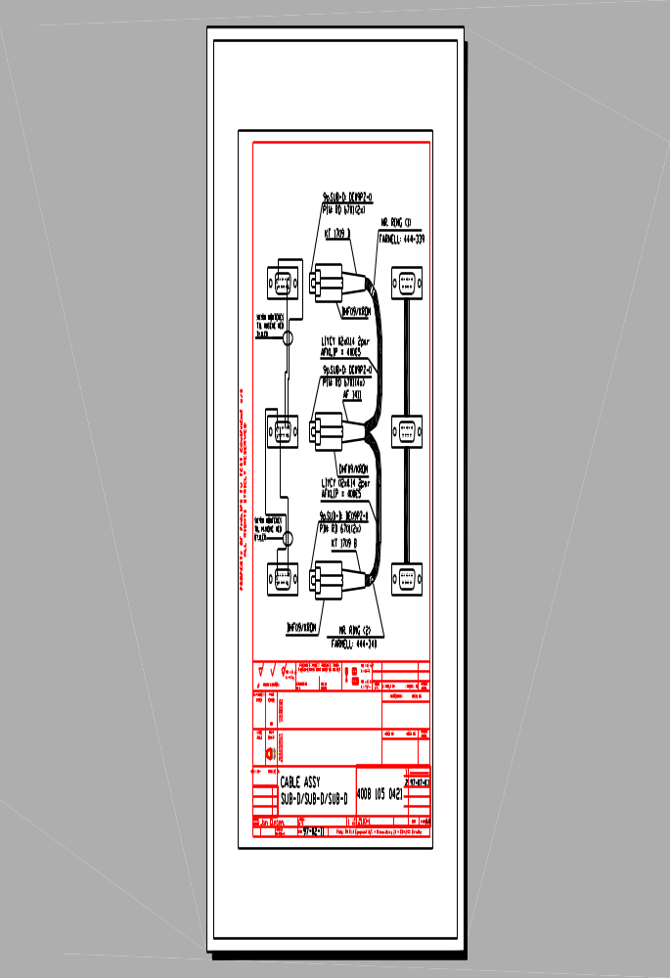
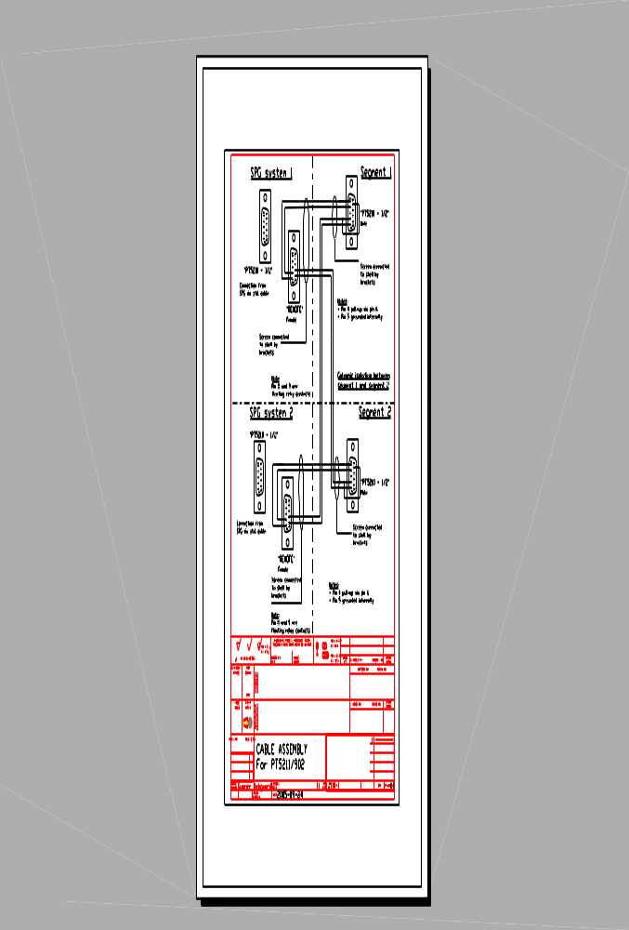

Hardware modifications in PT5211:

Please refer to following page

