PT 8631/905 Analog Test Pattern Generator

Subject: Modification supplement

This supplement is an addendum to the operating manual 9499 491 02811

The supplement describes the modifications made to the standard instrument:

Modification of PT 8631:

Philips pattern has been modfied with logo as descibed in picture file supplied by EUROCOM Broadcast.

The logo parts (two) of the picture have been shaped to give a reasonable video bandwith. The resolution has been changed to fit resoution in the generator.

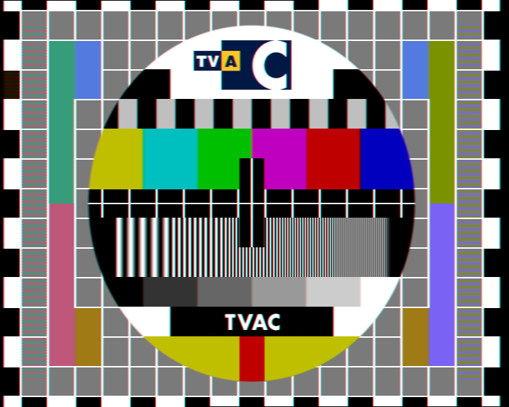
Plot of modified data stored in PROM’s (Antipal ON)

PT 8631.
New PROMs installed

Position: Code number Checksum
V64 4008 119 54111 B1D0
V65 4008 119 54112 66FA
V66 4008 119 54113 42FE
V67 4008 119 54114 B920
V68 4008 119 54115 1C20

