PT 8633/909

SDI Test Pattern Generator

Supplement to: PT 5230 Reference: Manual no. 9499 491 02811

The supplement describes the modifications made to the standard instrument.
Modification of PT 8633
The Philips pattern, 4:3 525 lines, has been modified with the logo as described in picture files supplied by MBC Korea.
The three logo parts of the picture have been shaped to give a reasonable video bandwidth. The resolution has been changed to fit the resolution in the generator.



Plot of the modified data stored in PROM’s

PT 8633/909
New PROMs to be installed.

Position: | Code number | Checksum
V69 | 4008 119 60069 | 09A1
V86 | 4008 119 60086 | 4BD9
V87 | 4008 119 60087 | 7822
V88 | 4008 119 60088 | 5210

Please refer to drawing below for position of IC’s

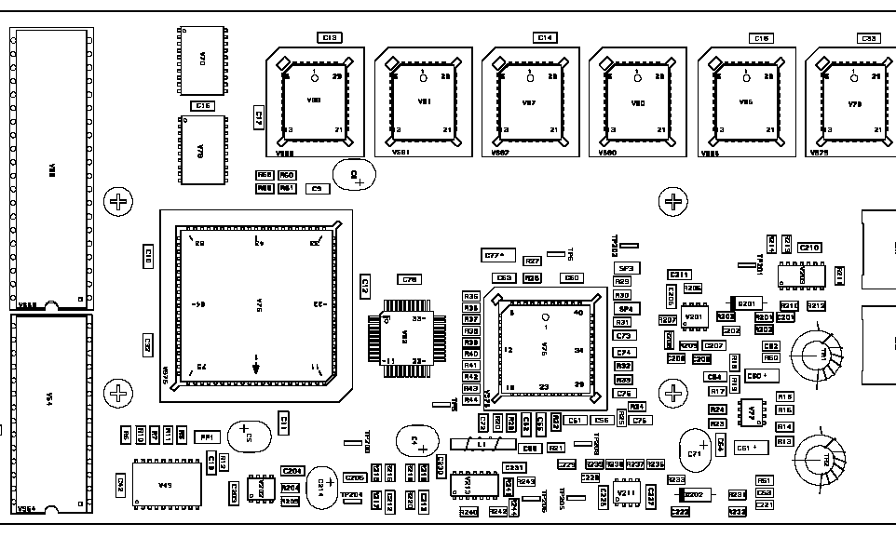
V69
V88
V87
V86

