PT 8633/911

SDI Test Pattern Generator

Supplement to: PT 5230 Reference: Manual no. 9499 491 02811

The supplement describes the modifications made to the standard instrument.
Modification of PT 8633
The Philips pattern, 4:3 625 lines, has been modified with the logo as described in picture files supplied by Riyadh TV Saudia Arabia.
The three logo parts of the picture have been shaped to give a reasonable video bandwidth. The resolution has been changed to fit the resolution in the generator.


Plot of the modified data stored in PROM’s

PT 8633/911
New PROMs to be installed.

Position: | Code number | Checksum
V69 | 4008 119 60069 | FA48
V86 | 4008 119 60066 | 9FB5
V87 | 4008 119 60067 | FCB9
V88 | 4008 119 60068 | 5882

Please refer to drawing below for position of IC’s

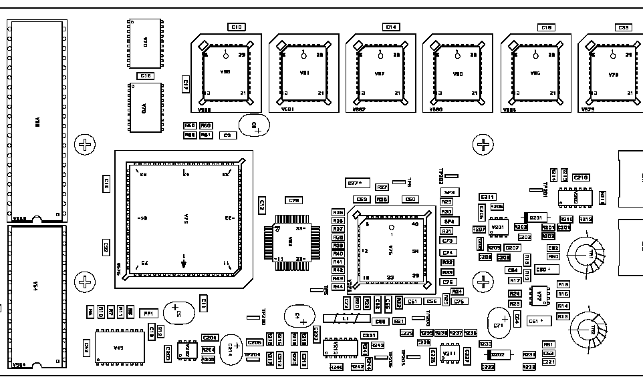
V69
V88
V87
V86

