PT 8633/912

SDI Test Pattern Generator

Supplement to: PT 5230 Reference: Manual no. 9499 491 02811

The supplement describes the modifications made to the standard instrument.
Modification of PT 8633
The Philips pattern, 4:3 525 lines, has been modified with the logo as described in picture files supplied by IDEAL SYSTEM, Taiwan.
The two logo parts of the picture have been shaped to give a reasonable video bandwidth. The resolution has been changed to fit the resolution in the generator.



Plot of the modified data stored in PROM’s

PT 8633/912
New PROMs to be installed.

Position: | Code number | Checksum
V69 | 4008 119 600569 | FFB5
V86 | 4008 119 600586 | AAF0
V87 | 4008 119 600587 | DE7C
V88 | 4008 119 600588 | AD06

Please refer to drawing below for position of IC’s

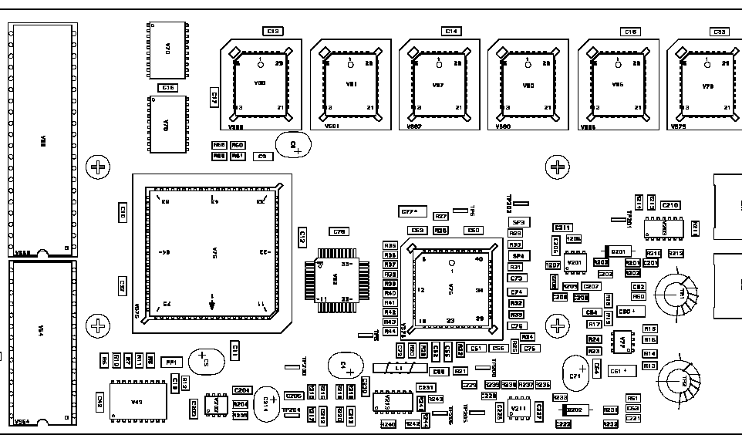
V69
V88
V87
V86

