PT 8633/914

SDI Test Pattern Generator

Supplement to: PT 5300 Reference: Manual no. 9499 491 02811

The supplement describes the modifications made to the standard instrument.
Modification of PT 8633
The Philips pattern, 4:3, 625 lines, has been modified with the logo as described in picture files supplied by
IB3, Spain.

The one logo part of the picture have been shaped to give a reasonable video bandwidth. The resolution has been changed to fit the resolution in the generator.

Plot of the modified data stored in PROM’s

PT 8633/914
New PROMs installed.

Position: | Code number | Checksum
V69 | 4008 119 60091 | E98E
V86 | 4008 119 60092 | D2F9
V87 | 4008 119 60093 | 495F
V88 | 4008 119 60094 | 29D3

Please refer to drawing below for position of IC’s

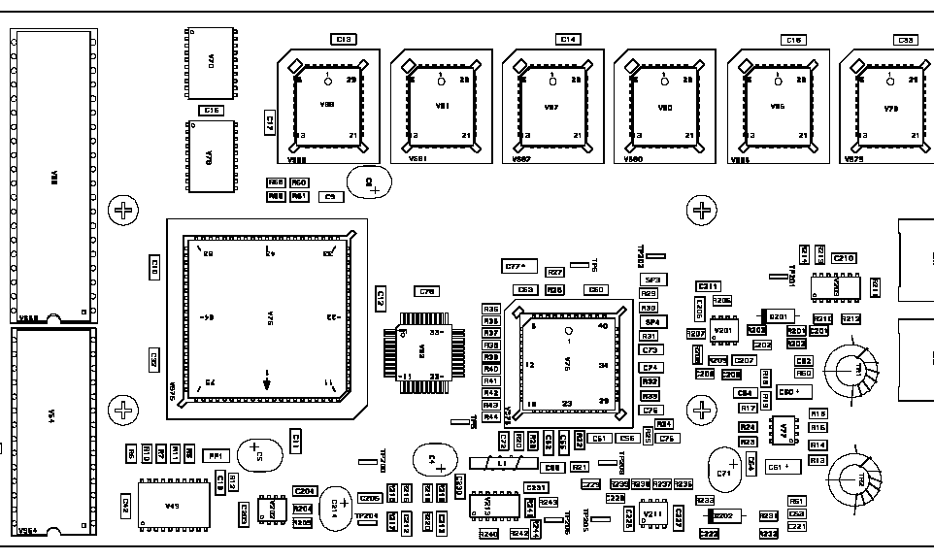
V69
V88
V87
V86

