PT 8633/916

SDI Test Pattern Generator

Supplement to: PT 5300 Reference: Manual no. 9499 491 02811

The supplement describes the modifications made to the standard instrument.
Modification of PT 8633
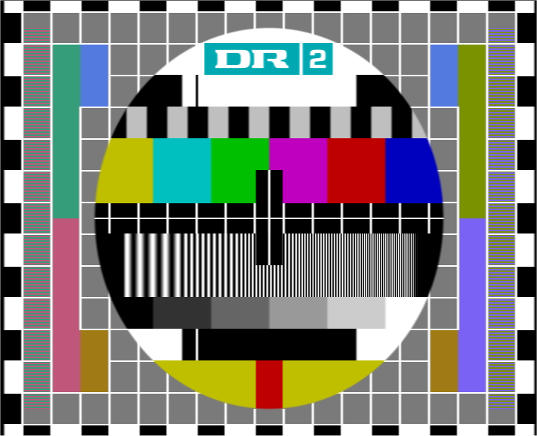
The Philips pattern, 4:3, 625 lines, together with Philips pattern 16:9, have been modified with the logo as described in picture files supplied by Danmarks Radio.

The one logo part of the picture have been shaped to give a reasonable video bandwidth. The resolution has been changed to fit the resolution in the generator.

PT 8633/916
New PROMs installed.
Position: | Code number | Checksum

V69 4008 119 60110 1731
V86 4008 119 60111 1E42
V87 4008 119 60112 E659
V88 4008 119 60113 A108

Please refer to drawing below for position of IC’s

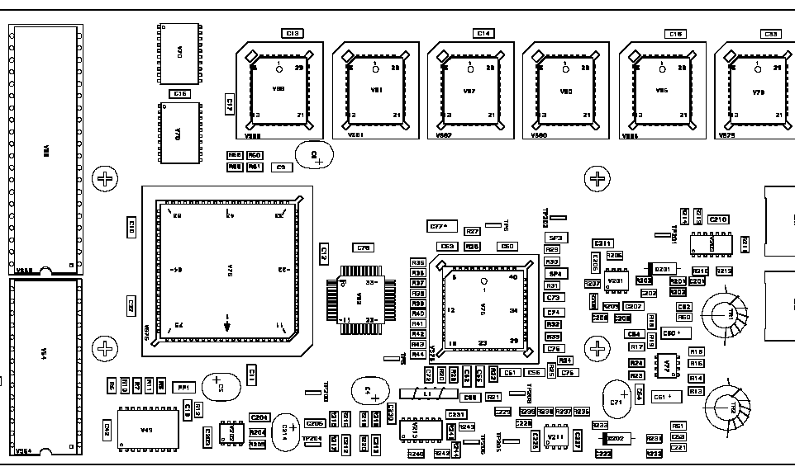
V69
V88
V87
V86

