Date: 26.06.2003

PT5230/907
Varitime Digital Sync Generator

PT 8633/910

SDI Test Pattern Generator

Supplement to: PT 5230 Reference: Manual no. 9499 491 02811

Modification of PT5230/907:

Software in the PT5230/907 has been modified following changes in the PT8633/910, where moving TDC logo has been implemented instead of wandering pin. As the consequence:

1. Sound level of -15 dB of embedded audio on
SDI Test Pattern Generator is no longer available.
2. Movement (in form of moving TDC logo) is only available
on Philips 4x3 pattern in PAL.

New PROM installed.

Position Code number Checksum
V403 4008 119 60403 78CA

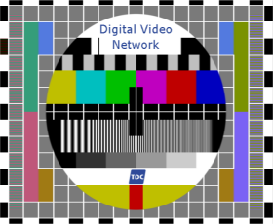

Modification of PT 8633

The Philips pattern, 4:3 625 lines, has been modified with the logo as described in picture files supplied by TDC. The moving pin in lower text fileld has been replaced with moving TDC logo. The click in left audio channel (EBU click) is synchronized to logo movement, so that the click begins when left logo edge passes over left edge of the red bar.
With "StereoEBU1kHz" signal, the click is implemented in Channel 1 and Channel 3.
New PROMs to be installed.

Position: | Code number | Checksum
V69 | 4008 119 70069 | 8CAF
V86 | 4008 119 70086 | BE58
V87 | 4008 119 70087 | 6ECA
V88 | 4008 119 70088 | 2D39
V54 | 4008 119 70054 | 8FD7
V63 | 4008 119 70063 | 800E
V53 | 4008 119 70053 | 07C7

Two IDT71256 RAM ICs are mounted "piggy back" style on top of V56 and V57. They are labeled as:
V56_2 and V57_2. Their pins 27 (wr) and 20 (cs) are not connected to underlaying pins. These pins are connected as follows:
V56_2 pin 27 to V54 pin 39
V56_2 pin 20 to V54 pin 46
V57_2 pin 27 to V54 pin 79
V57_2 pin 20 to V54 pin 41
Finally, pin 23 of V63 is connected to pin 23 of V54.

