PT5664/50 - Modification of PIX Monitor

Functional description.

Standard instrument
The PIX monitor delivers in standard PT5664/50 always RGB on the PIX monitor output via a built-in YUV to RGB transcoder. In case of RGB input the signal is switched directly to to PIX monitor board.
When SDI is input, the signal is converted to analog YV before switching it into the main signal path.
The RGB output signals drive the GAMUT detectors. Gamut errors are shown on the LEDs on the front. Additionally, the area of gamut errors can be highlighted on the RGB output

Modified instrument:
- YUV is output when input is YUV or SDI format. If analog RGB is input the output is also RGB
- No GAMUT indication (neither on LED’s nor highlighting on PIX monitor output.
- Amplitude tolerance as for standard instruments PIX monitor outputs, i.e. approx 2%

Modification description on signal processor board
Getting access:
- Remove the 3 screws on the right hand board (the board with SDI input and sub-D connector
Slide the board a few cm forward and swing the board out.
The lower board is the signal processor board
Make the following modifications (refer to drawing on next page):
- Signals from input switch (selects between analog input and SDI input) is buffered in a video amplifier. These signals are fed to PIX monitor board via connector XK.
The modification is made easily :
Connect XK pin 5 via a 100 Ohm leaded resistor to R95 pin 2 (Y-signal)
Connect XK pin 8 via a 100 Ohm leaded resistor to R95 pin 3 (U signal)
Connect XK pin 11 via a 100 Ohm leaded resistor to R95 pin 1 (V signal)
- Disable V8 switch:
Disconnect pin 6 close to the PCB and make instead a connect to +5V (pin 16)

- Disabling GAMUT LEDs and highlightning of Gamut errors on the screen:
Connect XK pin 12 to XK pin 3 (pin 3 is ground). Driver is protected by 1KOhm series resistor

Reassemble the unit making sure that the flat cables are correctly fitted.
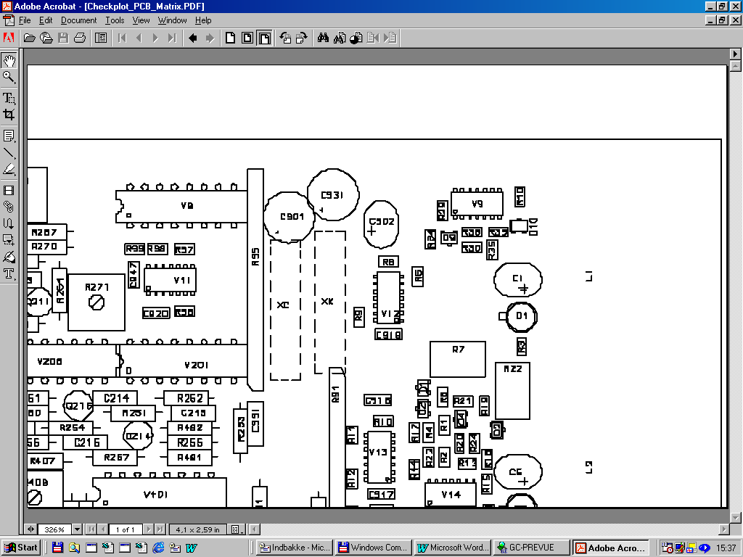
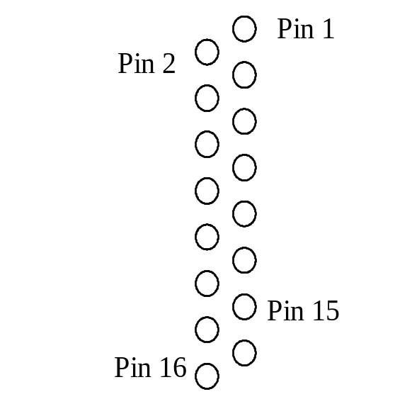
V8
R95 Resistor matrix
Pin 1 in this end

