PT5201

SPG

Architectual Design Document

Document Number:
Revision: 2
Release Date: 00-05-29
Author: Torben Schorlemmer
Signature:
Approved by:
Signature:

Table of content

1. Scope and Purpose 3
1.1 Terms and Abbreviations 3
1.2 References 4
2. General 5
3. Architectual Design Document 6
3.1 SPG Description 6
3.1.1 Architectual Design Description 6
3.1.2 Block diagrams 6
3.1.3 Description of main signal flows 7
3.1.3.1 Input 7
3.1.3.2 Output 7
3.1.3.3 Internal 7
3.1.4 Interface specifications for items on the block diagram 8
3.2 Test and Verification 8
4. New components 9

Scope and Purpose

This document will show the top level design for the Sync Pulse Generator(SPG) in the PT5201 Compact VariTime™ sync pulse generator.

Terms and Abbreviations

Abbreviation | Meaning
PLD | Programmeble Logic Device
PLL | Phase Lock Loop
SPG | Sync Pulse Generator
TBD | To Be Determined
TCXO | Temperature Controled X-tal Oscillator
MASTER | The master controller in the PT 5201
DAC or D/A | Digital to Analog Converter
ADC or A/D | Analog to Digital Converter
OSC | Oscillator
G / PAL | The pal video system
HW | Hardware
M / NTSC | The ntsc video system
SDI | Serial Data Interface

References

Documents related to the SPG
ADD_PT5201_SPG | Architectual Design Document  U:\PT5201\design\ddd\spg_2\add\ADD_PT5201_SPG.doc
DDD_PT5201_SPG | Detailed Design Document  U:\PT5201\design\ddd\spg_2\ddd\DDD_PT5201_SPG.doc
DTD_PT5201_SPG | Detailed Test Document  U:\PT5201\design\ddd\spg_2\dtd\DTD_PT5201_SPG.doc
total01.gdf | The graphic PLD file  U:\PT5201\design\ddd\spg_2\pld\total01.gdf
10986581.dsn | The hardware schematics  U:\PT5201\DESIGN\DDD\DIAGRAM\10986581.dsn

General

The SPG is the 'heart' in the PT5201. It makes all the syncronization signals for the master-controller and the other functions in the PT5201 that is the blackburst-generators, the color-generator and the AES/EBU-generator.

The SPG sync generator will merely have the same functions as the old SPG in PT5210/30:

- Genlock to video-signal , 10MHz input or internal osc.
- Generate sync-signals for both G / M systems.
- 27MHz presission osc.

However the SDI input has been removed from the design and the OCXO has been replaced by an TCXO. Hereafter the design has been checked and new components has replaced old and more expensive components to meet new cost requirements.

Architectual Design Document

SPG Description
Main Functions:

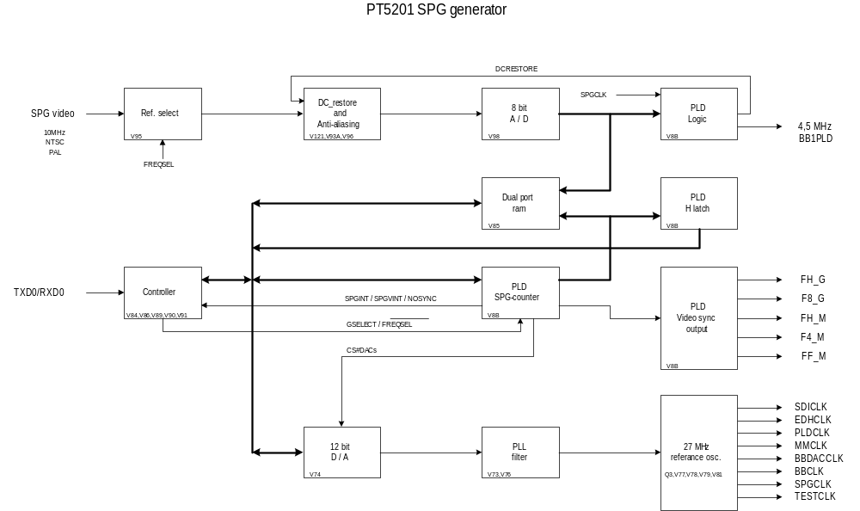Genlock to video-signal , 10MHz input or internal osc.
Generate syncronizing-signals for both G / M systems.
27MHz precision oscillator or TCXO for the PT5201. Accuracy TBD

Architectual Design Description

Block diagrams

Description of main signal flows

Input

The SPG is capeable of locking to three different input signals which are: 10MHz, NTSC and PAL. To communicate with the SPG there is a serial interface: TXD0 / RXD0

Output

The main outputs are the synconizing signals FH_G, F8_G, FH_M, F4_M and FF_M futhermore there is a 4.5MHz enable signal for test purpose and eight 27MHz clk-singals;
SDICLK, EDHCLK, PLDCLK, MMCLK, for the colorbar generator and the master controller.
BBDACCLK, BBCLK for the blackburst generators.
SPGCLK for the SPG.
TESTCLK for the testplug X13p1.

Internal

The DCRESTORE signal indicates if the previous linie had the correct level or not and adjust the ADC according to this.
The GSELECT and the /FREQSEL signals are comming from the SPG-controller to control the generator to use G or M system or frequency from the SPG-input
The SPGINT and the SPGVINT are used to synconize the PLD-logic and the SPG-controller.
The NOSYNC signal indicates that the generator wasn't able to syncronize to the SPG-input.
The CS#DACs signal have two functions first it select the DAC when SPG is running to adjust the onboard osc. second it selects the DAC when the onboard osc. is used as reference.

Interface specifications for items on the block diagram

Ref.select , DC_restore and Antialiasing | Video or 10MHz signals.
DC_restore and Antialiasing , 8 bit A / D | Filtered video or 10MHz signals.
8 bit A / D , PLD Logic and Dual port ram | ADC[7..0] : Signal samples from '8 bit A / D'.
Dual port ram, PLD H latch and PLD SPG-counter | Hs[10..0] : position of the sync-signal found by SPG.
Controller , Dual port ram, PLD H latch , PLD SPG-counter and 12 bit D / A | Ds[15..0] : the internal databus.
12 bit D / A , PLL filter | DC to adjust the internal 13.5 MHz oscillator.
PLL filter , 27MHz reference osc. | A integrated DC for the internal 13.5 MHz oscillator.

For further information on the concept please refer to DDD_PT5201_SPG.doc

Test and Verification

For test and verification report please look in the document U:\PT5201\design\ddd\spg_2\dtd\DTD_PT5201_SPG.doc

New components

COMPANY |  | DEVICE | FUNCTION | PACKAGE
 | Altera | EPF6016 AQC208-3 | PLD | TQFP208
 | Analog Device | AD9280ARS | 8bit adc | Ssop-28
 | Texas | TLV5619CPWR | 1x12bit Dac | Tssop-20

