PT5201

BlackBurst

Architectual Design Document

Document Number:
Revision: 2
Release Date: 00-05-30
Author: Torben Schorlemmer
Signature:
Approved by:
Signature:

Table of content

1. Scope and Purpose 3
1.1 Terms and Abbreviations 3
1.2 References 4
2. General 5
3. Architectual Design Document 6
Block diagram 3ch. blackburst 6
3.2 Architectual Design Description 7
3.2.1 Function diagram for one blackburst 8
3.3 Description of main signal flows 9
3.4 Interface specifications for items on the block diagram 10
3.4.1 Blackburst generator interface 10
3.4.2 Signal sample addresses for the flash BBxR0-7 10
3.4.3 Controller-PLD registers for 3 blackburst 11
3.5 Test and Verification reports 11
4. New components 12

Scope and Purpose

This document will show the top level design for the blackburst generators in the PT5201 Compact VariTime™ sync generator.

Terms and Abbreviations

Abbreviation | Meaning
HW | Hardware
SW | Software
BB | BlackBurst generator
G / PAL | The pal video system with 625 lines
HW | Hardware
M / NTSC | The ntsc video system with 525 lines
PLD | Programmeble Logic Device
TBD | To Be Determined
MASTER | The master controller in the PT 5201
DAC or D/A | Digital to Analog Converter
ADC or A/D | Analog to Digital Converter

References

Documents related to the blackburst
ADD_PT5201_BB | Architectual Design Document  U:\PT5201\design\ddd\bb_2\add\ADD_PT5201_BB.doc
DDD_PT5201_BB | Detailed Design Document  U:\PT5201\design\ddd\bb_2\ddd\DDD_PT5201_BB.doc
DTD_PT5201_BB | Detailed Test Document  U:\PT5201\design\ddd\bb_2\dtd\DTD_PT5201_BB.doc
bb_latch.gdf  Bbmain.gdf | The graphic PLD file  U:\PT5201\design\ddd\bb_2\pld\bb_latch.gdf  U:\PT5201\design\ddd\bb_2\pld\Bbmain.gdf
10986581.dsn | The hardware schematics  U:\PT5201\DESIGN\DDD\DIAGRAM\10986581.dsn
Product data | U:\PT5201\study\datasheet\PT5201 datablad2.doc

General

The blackburst (BB) generators is the main sync signals in the PT5201. It makes the synchronisation signals for the studio. The BB generators are three identical generators with individually fine timing (0.14ns resolution) as the main feature. They run as well G as M systems and has the ident pulse as a programable feature from the Master controller.

Architectual Design Document

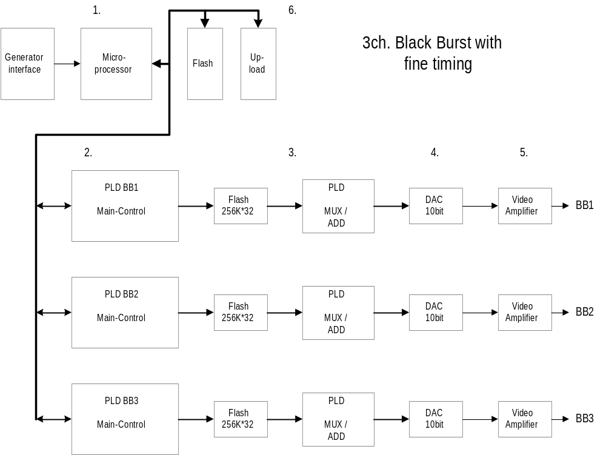Block diagram 3ch. Blackburst

Figure 3.1 Blackburst block diagram

Architectual Design Description

The block diagram fig. 2.1.2 , 3ch. Blackburst consists of:
1. One controller with a flash.
2. Main control PLD's with logic to control 3 BlackBurst outputs. Sync and BlackBurst data in flash.
3. Flash with signal-data and mux.
4. Three 10bit Dac’s.
5. Output drivers and filtering for the BNC connectors.
6. Upload

1. The controller handles the communications with the master processor, e.g. commands, errors and controls the three blackburst generators e.g. loading linetype and phase registers.

2. The PLD's contains logic to control 3 BlackBurst generators with the following main functions:
- communicate with the controller-system holding basic registers.
- running data sequenzer for the dac’s via a lookup table in flash.
The priciple of PLD's is to get the right phase a linetype for the next line to perform the right sync and burst signal. Under initialization of the balckburst-generator the registers in the PLD are loaded with correct data and the generator can then start working with the timing loaded.

3. Flash with signal-data fo all phases and mux to get data-stream from 9MHz to 27 MHz.

4. For each BlackBurst channel the dac are 10 bit’s to maintain the accuracy from former balckburst generators

5. The video-amplifier moduls consist of two op-amps with a filter and an output circuit to obtain 75 ohm on the BNC outputs.

6. To upload the PLD from a PC there is a 10 pole plug. With this plug it will possible to program all the PLDs to the three blackburst generators and the color generator.
NB! There are ten pof-files to be loaded which is done by making a program chain file in Altera's PLD software.

Function diagram for one blackburst

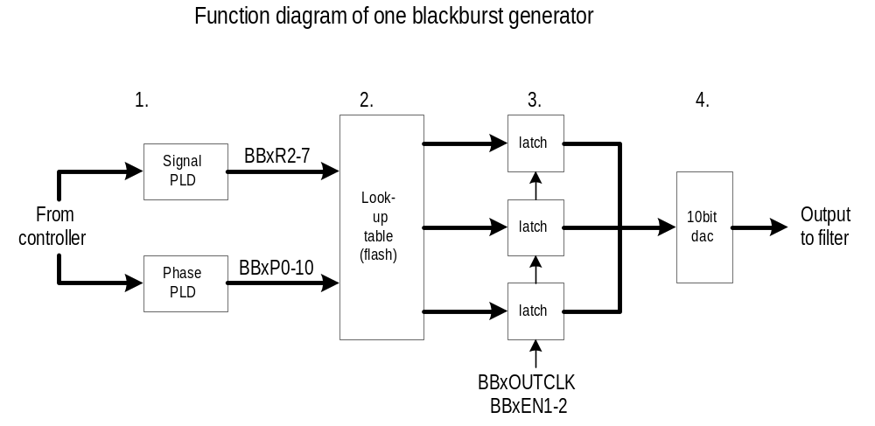

Fig. 3.2.1 Function diagram of one BB-generator

The function diagram fig. 3.2.1 , consists of:
1. Two PLD's to makes the phase-addresses and the signal-addresses.
2. The look-up table is a flash and holds all data for a blackburst generator. It is controled by the phase-addresses and the signal-addresses.
3. Three 10bit latch increases the datarate from 9MHz to 27MHz.
4. The 10bit dac is working at 27MHz to reduse the filtering of the serial data-stream.

Description of main signal flows

BBxR2-7:
These 6 bits are the signal bits and holds the flashprom addresses allong with the BBxP0-10 bits for the active signal edge in the blackburst signal e.g. sync edge and the pedital.
BBxP0-10:
These 11 bits are the phase bits and holds the flashprom addresses allong with the BBxR2-7 bits for the active signal edge in the blackburst signal e.g. sync edge and the pedistal.
BB1OUTCLK:
This clock is used to clock data into the right latch at the right time.

BB1EN0-2, BB2EN0-2, BB3EN0-2:
The figur 2.1.3 shows how the three enable signals are timesliced each running with a 9MHz datatransfer rate. This will bring the total datatransfer rate upto 27MHz to the video dac.
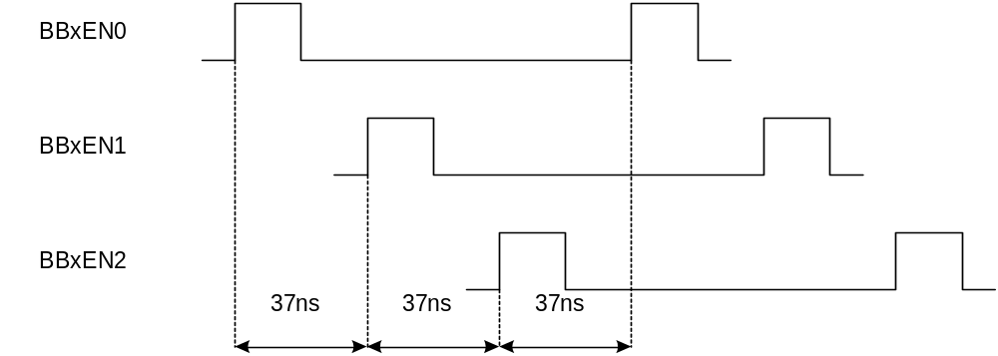

Fig. 3.3 Timing diagram of latch enable.

Interface specifications for items on the block diagram

Blackburst generator interface

- Power: The generator uses +5V, +3.3V and -5V
- V24: The seriel interface specification can be found at U:\PT5201\design\ TBD (KEn)
- Sync.: The four synchronizing signals FH_G, FH_M, F8_G, F4_M comes from the SPG unit and are used to synchronize the three blackburst generators.

Signal sample addresses for the flash BBxR0-7

BB1R0-7: address | Function: | Remarks:
0-127 | BlackBurst | Not all addresses are used. For further informations please refer to the PLD design 'Bbmain.gdf'.
128-159 | SyncDOWN
160-191 | SyncUP
192-223 | PedistalUP
224-255 | PedistalDOWN

Controller-PLD registers for 3 blackburst

Register | Adr. |  |  | Signal bits in databus Ds[7..0] |  |  |  |  |  |  |  | Bbgen
 | As[18..0] |  |  | 7 | 6 | 5 | 4 | 3 | 2 | 1 | 0
WRITE: | XX0 | 0000 XXXX | XXXX XXXX | T3 | T2 | T1 | T0 | Poff | C10 | C9 | C8 | 1
 | XX0 | 0001 XXXX | XXXX XXXX | C7 | C6 | C5 | C4 | C3 | C2 | C1 | C0 | 1
 | XX0 | 0010 XXXX | XXXX XXXX | S7 | S6 | S5 | S4 | S3 | S2 | S1 | S0 | 1
 | XX0 | 0011 XXXX | XXXX XXXX | G/M |  |  |  |  | S10 | S9 | S8 | 1
 | XX0 | 0100 XXXX | XXXX XXXX | F7 | F6 | F5 | F4 | F3 | F2 | F1 | F0 | 1
WRITE: | XX0 | 1000 XXXX | XXXX XXXX | T3 | T2 | T1 | T0 | Poff | C10 | C9 | C8 | 2
 | XX0 | 1001 XXXX | XXXX XXXX | C7 | C6 | C5 | C4 | C3 | C2 | C1 | C0 | 2
 | XX0 | 1010 XXXX | XXXX XXXX | S7 | S6 | S5 | S4 | S3 | S2 | S1 | S0 | 2
 | XX0 | 1011 XXXX | XXXX XXXX | G/M |  |  |  |  | S10 | S9 | S8 | 2
 | XX0 | 1100 XXXX | XXXX XXXX | F7 | F6 | F5 | F4 | F3 | F2 | F1 | F0 | 2
WRITE: | XX1 | 0000 XXXX | XXXX XXXX | T3 | T2 | T1 | T0 | Poff | C10 | C9 | C8 | 3
 | XX1 | 0001 XXXX | XXXX XXXX | C7 | C6 | C5 | C4 | C3 | C2 | C1 | C0 | 3
 | XX1 | 0010 XXXX | XXXX XXXX | S7 | S6 | S5 | S4 | S3 | S2 | S1 | S0 | 3
 | XX1 | 0011 XXXX | XXXX XXXX | G/M |  |  |  |  | S10 | S9 | S8 | 3
 | XX1 | 0100 XXXX | XXXX XXXX | F7 | F6 | F5 | F4 | F3 | F2 | F1 | F0 | 3
WRITE: | XX1 | 1XXX XXXX | XXXX XXXX |  |  |  |  |  | LD | Din | CLK | SerDac
WRITE: | XX1 | 0000 XXXX | XXXX XXXX |  |  |  |  | Test |  |  |  | 1-3

Test and Verification reports

The signal and output requirements according to standards and product data can be found in the document U:\PT5201\study\datasheet\PT5201 datablad2.doc

The test report can be found in the document,
U:\PT5201\work\tsc\ PT5201_BB\ddd\DESIGN\bb_2\dtd\dtd_pt5201_bb.doc

New components

Compamny | Device | Function | Package
Sony | CXD2307R | 3x10bit Dac | LQFP-64
Fujitsu | MBM28F400BT-90 | Flash 4Mbit | So44
Fujitsu | MB88347L | 8x8bit dac | So16
AMD | AM29LV160B90RE | Flash 16Mbit | Tsop48
Altera | EPM3064ALC44-10 | PLD | PLCC44
Altera | EPM3064ATC100-10 | PLD | TQFP100
Beyschlag | MCU0805-25 0.25% P5 75R0 | Resistor | 0805 .25%

