PT5201

BlackBurst

Detailed Design Document

Document Number:
Revision: 2
Release Date: 00-05-30
Author: Torben Schorlemmer
Signature:
Approved by:
Signature:

Table of content

1. Scope and Purpose 3
1.1 Terms and Abbreviations 3
1.2 References 4
2. General 5
3. Detailed Design Document 6
3.1 Block diagram 6
3.1.1 Block diagram Description 7
3.2 Detailed Block Diagram 8
3.2.1 Detailed Block Diagram description 9
3.2.2 Description of main signal flows 10
3.2.3 Function diagram for one blackburst 11
3.2.3.1 The signal PLD 11
3.2.3.2 The look-up table 12
3.2.3.3 The 9 to 27MHz datastream convertion 12
3.2.3.4 Output DAC's 12
3.2.4 Function diagram for dac and output 13
3.2.5 Dac and output description 13
3.2.6 Registers / signals 14
3.2.6.1 Description of the register signals 15
3.3 HW diagrams/schematics 16
3.4 PLD programming chain 16
3.5 Flash data 16
3.5.1 Generate flash data 16
4. Test and Verification report 17

Scope and Purpose

The purpose of this document is to describe the development of the blackburst generators in the PT5201 mini varitime Sync Pulse Generator (SPG) in detail.
The document is addressed for technical persons.

Terms and Abbreviations

Term | Definition
Software | Throughout this document the term software covers all types of executable item generated from a source code. Examples are microprocessor software, PLD programs.

Abbreviation | Meaning
HW | Hardware
SW | Software
BB | BlackBurst
PLD | ProgramableLogicDevice
SPG | Sync Pulse Generator
MASTER | The master controller in the PT 5201
DAC or D/A | Digital to Analog Converter
ADC or A/D | Analog to Digital Converter
G / PAL | The pal video system with 625 lines
M / NTSC | The ntsc video system with 525 lines

References

Documents related to the blackburst
ADD_PT5201_BB | Architectual Design Document  U:\PT5201\design\ddd\bb_2\add\ADD_PT5201_BB.doc
DDD_PT5201_BB | Detailed Design Document  U:\PT5201\design\ddd\bb_2\ddd\DDD_PT5201_BB.doc
DTD_PT5201_BB | Detailed Test Document  U:\PT5201\design\test_doc\bb\dtd\DTD_PT5201_BB.doc
bb_latch.gdf  Bbmain.gdf | The graphic PLD file  U:\PT5201\design\ddd\bb_2\pld\bb_latch.gdf  U:\PT5201\design\ddd\bb_2\pld\Bbmain.gdf
10986581.dsn | The hardware schematics  U:\PT5201\DESIGN\DDD\DIAGRAM\10986581.dsn
Product data | U:\PT5201\study\datasheet\PT5201 datablad2.doc
Flash bb_data1  V27, 34, 41 | U:\PT5201\tpd\prom.std\ 00207231.bin  U:\PT5201\tpd\prom.std\ 00207231.rme
Flash bb_data2  V31, 38, 45 | U:\PT5201\tpd\prom.std\ 00207241.bin  U:\PT5201\tpd\prom.std\ 00207241.rme
Generate bb_data1 and bb_data2 | U:\PT5201\design\ddd\bb_2\flashdata_gen\m.bas  U:\PT5201\design\ddd\bb_2\flashdata_gen\g.bas  U:\PT5201\design\ddd\bb_2\flashdata_gen\prom.bas
Videogen.pof | U:\Pt5201\design\cb_gen\pld\videogen.pof
BB_CB_chain.jcf | U:\PT5201\design\ddd\BB_CB_chain.jcf

General
The blackburst (BB) generators is the main sync signals in the PT5201. It makes the syncronization signals for the studio. The BB generators are three identical generators with individually fine timing (0.14ns resolution) as the main feature. They run as well G as M systems and has the ident pulse as a programable feature from the Master controller.

Detailed Design Document

Block diagram
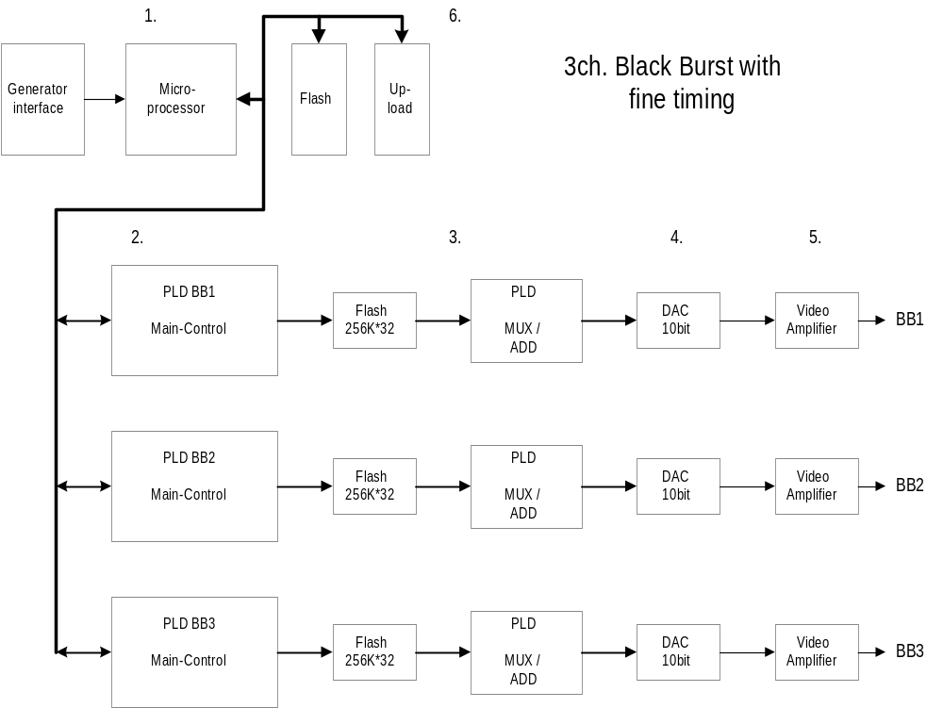

Fig. 3.1

Block diagram Description

The block diagram fig. 3.1.1 , 3ch. Blackburst consists of:
1. One controller with a flash.
2. Main control PLD's with logic to control 3 BlackBurst outputs. Sync and BlackBurst data in flash.
3. Flash with signal-data and mux.
4. Three 10bit Dac’s.
5. Output drivers and filtering for the BNC connectors.
6. Upload

1. The controller handles the communications with the master processor, e.g. commands, errors and controls the three blackburst generators e.g. loading linetype and phase registers.

2. The PLD's contains logic to control 3 BlackBurst generators with the following main functions:
- communicate with the controller-system holding basic registers.
- running data sequenzer for the dac’s via a lookup table in flash.
The priciple of PLD's is to get the right phase a linetype for the next line to perform the right sync and burst signal. Under initialization of the balckburst-generator the registers in the PLD are loaded with correct data and the generator can then start working with the timing loaded.

3. Flash with signal-data fo all phases and mux to get data-stream from 9MHz to 27 MHz.

4. For each BlackBurst channel the dac are 10 bit’s to maintain the accuracy from former balckburst generators

5. The video-amplifier moduls consist of two op-amps with a filter and an output circuit to obtain 75 ohm on the BNC outputs.

6. To upload the PLD from a PC there is a 10 pole plug. With this plug it will possible to program all the PLDs to the three blackburst generators and the color generator.
NB! There are ten pof-files to be loaded which is done by making a program chain file in Altera's PLD software.

Detailed Block Diagram

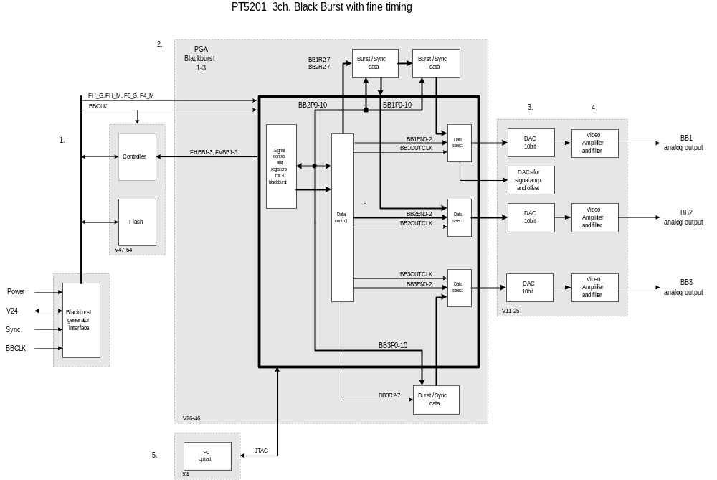

Fig. 3.2

Detailed Block Diagram description

The block diagram fig. 3.2.1 , 3ch. Blackburst consists of:
1. One controller with a flash.
2. Main control PLD's with logic to control 3 BlackBurst outputs. Sync and BlackBurst data in flash.
3. Three 10bit Dac’s
4. Output drivers and filtering for the BNC connectors.
5. Upload

1. The controller handles the communications with the master processor, e.g. commands, errors and controls the three blackburst generators e.g. loading linetype and phase registers.

2. The PLD's contains logic to control 3 BlackBurst generators with the following main functions:
- communicate with the controller-system holding basic registers.
- running data sequenzer for the dac’s via a lookup table in flash.
The priciple of PLD's is to get the right phase a linetype for the next line to perform the right sync and burst signal. Under initialization of the balckburst-generator the registers in the PLD are loaded with correct data and the generator can then start working with the timing loaded.

- For each BlackBurst channel the dac are 10 bit’s to maintain the accuracy from former balckburst generators

4. The video-amplifier moduls consist of two op-amps with a filter and an output circuit to obtain 75 ohm on the BNC outputs.

5. To upload the PLD from a PC there is a 10 pole plug. With this plug it will possible to program all the PLDs to the three blackburst generators and the color generator.
NB! There are ten pof-files to be loaded which is done by making a program chain file in Altera's PLD software which is straightforeward.

Description of main signal flows

FH_G, FH_M, F8_G, F4_M:
These four signals comes from the SPG unit and are used to synconize the three blackburst generators.
BBCLK:
BBCLK is the system clock for the blackburst generator e.g. PLDs and dac.
FHBB1-3, FVBB1-3:
The FHBBx is a line interrupt pulse to tell the blackburst controller to change to the next line. The FVBBx is a field interrupt pulse to tell the blackburst controller to change to the next field.
BBxR2-7:
These 6 bits are the signal bits and holds the flashprom addresses allong with the BBxP0-10 bits for the active signal edge in the blackburst signal e.g. sync edge and the pedital.
BBxP0-10:
These 11 bits are the phase bits and holds the flashprom addresses allong with the BBxR2-7 bits for the active signal edge in the blackburst signal e.g. sync edge and the pedistal.
BB1OUTCLK:
This clock is used to clock data into the right latch at the right time.

BB1EN0-2, BB2EN0-2, BB3EN0-2:
The figur 2.1.3 shows how the three enable signals are timesliced each running with a 9MHz datatransfer rate. This will bring the total datatransfer rate upto 27MHz to the video dac.
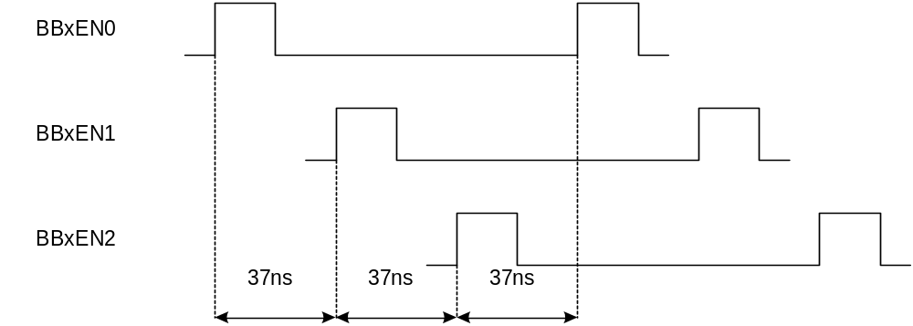

Fig. 3.2.2
JTAG:
For programming the PLDs the use of a standard 10pole male connector will be the only way if they are not programed. The upload can be done with either Alteras bitblaster or byteblaster.
NB! The colorbar and the Master PLD is part of the JTAG chain and the program file have to be loaded via the xx.jcf file.

Function diagram for one blackburst

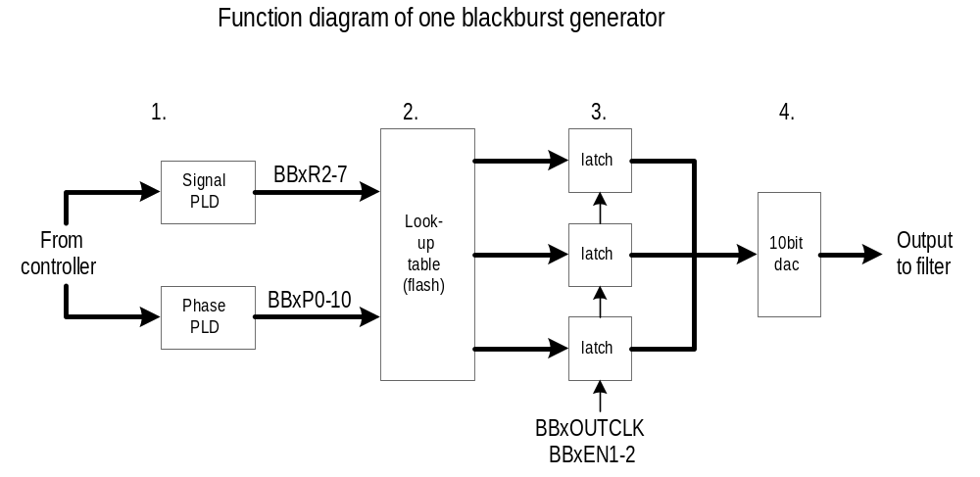

Fig. 3.2.3
The function diagram fig. 3.2.3 , consists of:

The signal PLD

The two PLD's makes the phase-addresses and the signal-addresses.

BBxR0-7: address | Function: | Remarks:
0-127 | BlackBurst | Not all addresses are used. For further informations please refer to the PLD design 'Bbmain.gdf'.
128-159 | SyncDOWN
160-191 | SyncUP
192-223 | PedistalUP
224-255 | PedistalDOWN

BBxP0-10: address | Function: | Remarks:
0-2047 | BurstPhase | Not all addresses are used. For further informations please refer to the PLD design 'Bbmain.gdf'.

The look-up table

Generate bb_data1 and bb_data2 | U:\PT5201\design\ddd\bb_2\flashdata_gen\m.bas  U:\PT5201\design\ddd\bb_2\flashdata_gen\g.bas  U:\PT5201\design\ddd\bb_2\flashdata_gen\prom.bas

2. The look-up table is a flash and holds all data for a blackburst generator. It is controlled by the phase-addresses and the signal-addresses. The PCB has been prepaired for both 3.3V (4 Mb, 8 Mb and 16 Mb) and 5V (4 Mb and 8 Mb) types.

The 9 to 27MHz datastream convertion

3. Three 10bit latch increases the datarate from 9MHz to 27MHz.

Output DAC's

4. The 10bit dac is working at 27MHz to reduse the filtering of the serial data-stream.

Function diagram for dac and output

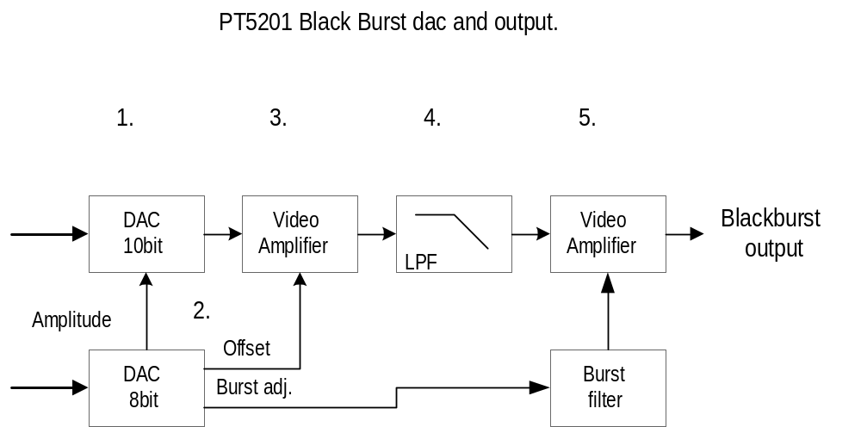

Fig. 3.2.4

Dac and output description

The function diagram fig. 3.2.4 , consists of:
1. The 10bit dac is a videodac running at 27MHz.

2. The 8bit dac is used to adjust the blackburst output from the master-software. The output can be adjusted on three perameters; the videosignal-amplitude, the offset and the burst-amplitude.

3. The first video-amplifier is working as an inverting amplifier and impedens translator. The signal amplification is one.

4. The lowpass filter has a -3dB at 7MHz.

5. The second video-amplifier is working as an noninverting and burst amplitude adjust amplifier. The signal amplification is two and an output-impedanse of 75ohm.

Registers / signals

Register | Adr. |  |  | Signal bits in databus Ds[7..0] |  |  |  |  |  |  |  | BBgen
 | As[18..0] |  |  | 7 | 6 | 5 | 4 | 3 | 2 | 1 | 0
WRITE: | XX0 | 0000 XXXX | XXXX XXXX | T3 | T2 | T1 | T0 | Poff | C10 | C9 | C8 | 1
 | XX0 | 0001 XXXX | XXXX XXXX | C7 | C6 | C5 | C4 | C3 | C2 | C1 | C0 | 1
 | XX0 | 0010 XXXX | XXXX XXXX | S7 | S6 | S5 | S4 | S3 | S2 | S1 | S0 | 1
 | XX0 | 0011 XXXX | XXXX XXXX | G/M |  |  |  |  | S10 | S9 | S8 | 1
 | XX0 | 0100 XXXX | XXXX XXXX | F7 | F6 | F5 | F4 | F3 | F2 | F1 | F0 | 1
WRITE: | XX0 | 1000 XXXX | XXXX XXXX | T3 | T2 | T1 | T0 | Poff | C10 | C9 | C8 | 2
 | XX0 | 1001 XXXX | XXXX XXXX | C7 | C6 | C5 | C4 | C3 | C2 | C1 | C0 | 2
 | XX0 | 1010 XXXX | XXXX XXXX | S7 | S6 | S5 | S4 | S3 | S2 | S1 | S0 | 2
 | XX0 | 1011 XXXX | XXXX XXXX | G/M |  |  |  |  | S10 | S9 | S8 | 2
 | XX0 | 1100 XXXX | XXXX XXXX | F7 | F6 | F5 | F4 | F3 | F2 | F1 | F0 | 2
WRITE: | XX1 | 0000 XXXX | XXXX XXXX | T3 | T2 | T1 | T0 | Poff | C10 | C9 | C8 | 3
 | XX1 | 0001 XXXX | XXXX XXXX | C7 | C6 | C5 | C4 | C3 | C2 | C1 | C0 | 3
 | XX1 | 0010 XXXX | XXXX XXXX | S7 | S6 | S5 | S4 | S3 | S2 | S1 | S0 | 3
 | XX1 | 0011 XXXX | XXXX XXXX | G/M |  |  |  |  | S10 | S9 | S8 | 3
 | XX1 | 0100 XXXX | XXXX XXXX | F7 | F6 | F5 | F4 | F3 | F2 | F1 | F0 | 3
WRITE: | XX1 | 1XXX XXXX | XXXX XXXX |  |  |  |  |  | LD | Din | CLK | SerDac
WRITE: | XX1 | 0000 XXXX | XXXX XXXX |  |  |  |  | Test |  |  |  | 1-3

Description of the register signals

T[3..0] | This is the line type comming from the blackburst controller. The line types are i system 'G' listed in a 2500 lines tabel and i system 'M' in a 1050 lines tabel. The type shall be updated in every video line (64us).
Poff | This bit is only used i system 'M' to indicate if the setup should be on. The bit will be updated when needed.
C[10..0] | This is the coarse line phase which moves the video signal in steps of 37ns with the maximum of 2047 steps. The coarse time steps are changeable via the remote control.
S[10..0] | This register held the actual burst phase for the video line. The type shall be calculated and updated in every video line (64us) and shall be preset by the field interrupt.
G/M | This is the system bit: G = ' 1' and M = ' 0'. The system bit is changeable via the remote control.
F[7..0] | This is the fine line phase which devide the coarse line phase into 256 steps. These steps are about 0.14ns. The fine time steps are changeable via the remote control.
Din | This is the data input bit for the serial dac to control the blackburst outputs.
CLK | This bit clocks the data bit into the serial dac.
LD | LD bit loads the serial data stream in the serial dac.
Test | This bit can be used for test purpose, the access is as ' Poff '.
V[3..0] | The PLD version number (1-9)

HW diagrams/schematics

Please refer to U:\PT5201\Design\Ddd\Diagram\ 11706990revX.pdf (Sh. 9-14)

PLD programming chain

The programming chain for the BB and Color consists of ten files. The name of the file is BB_CB_chain.jcf which consist of some blackburst design files and a colorbar design file.

Nr. in chain file | V nr. | Description | File:
1. | V29 | BB1SELECT | bb1_datasel_45mhz.pof
2. | V101 | COLOR | videogen.pof
3. | V30 | BBMAIN | Bbmain.pof
4. | V26 | BBLATCH | bb_latch.pof
5. | V37 | BBMAIN | Bbmain.pof
6. | V33 | BBLATCH | bb_latch. pof
7. | V44 | BBMAIN | Bbmain.pof
8. | V40 | BBLATCH | bb_latch.pof
9. | V43 | BB3SELECT | bb3_datasel.pof
10. | V36 | BB2SELECT | bb2_datasel.pof

Flash data

The flash data are stored in two chips for each BB generator.

Generate flash data

The generation of flash data is done in two steps. First step is to make the NTSC and PAL data and secondly to merge the two datafiles into two file for the flash which are one flash handle d[0..15) and one handle d[16..29] giving the needed 3 times 10 data bit.
To generate the data there is three programs: m.bas, g.bas and prom.bas. Please look in the references to find the path.

Test and Verification report

Please refer to the 1.2 reference

