PT5201

SPG

Detailed Design Document

Document Number:
Revision: 2
Release Date: 00-05-29
Author: Torben Schorlemmer
Signature:
Approved by:
Signature:

Table of content

1. Scope and Purpose 3
1.1 Terms and Abbreviations 3
1.2 References 4
2. General 5
3. Detailed Design Document 6
3.1 Block diagram 6
3.2 Block diagram description 6
3.3 Detailed Block Diagrams 7
3.3.1 Video input 7
3.3.1.1 Video input block diagram 7
3.3.1.2 Video input description 7
3.3.2 Frequensy input 8
3.3.2.1 Frequensy input block diagram 8
3.3.2.2 Frequensy input description 8
3.3.3 Master osc adjust 9
3.3.3.1 Master osc adjust block diagram 9
3.3.3.2 Master osc adjust description 9
3.3.4 Control 10
3.3.4.1 Control block diagram 10
3.3.4.2 Control description 10
3.4 PLD 11
3.4.1 PLD block diagram 11
3.4.2 Registers / signals 11
3.4.3 PLD timing overview 12
3.4.4 Description of the timing diagram 12
3.4.5 PLD description 13
3.4.5.1 EXTLOG01 input/output 13
3.4.5.2 EXTSEL01 input/output 14
3.4.5.3 LOCDET01 input/output 14
3.4.5.4 UPROC01 input/output 15
3.4.5.5 SPGLOG01 input/output 16
3.4.5.6 TCXO_CHK input/output 17
3.4.5.7 DIV6_50DUTY input/output 18
3.4.5.8 DIV44AA20 input/output 18
3.4.5.9 SPG_FLASH_SEL input/output 19
3.4.5.10 Freqcheck input/output 19
3.4.5.11 DIV130 input/output 20
3.4.5.12 DIV270 input/output 20
4. HW schematics 21
5. Future refinements 22
5.1 Princip diagram 22
6. Test and Verification 23

Scope and Purpose

The purpose of this document is to describe the development of the Sync Pulse Generator (SPG) in the PT5201 mini varitime Sync Pulse Generator in detail.
The document is addressed for technical persons.

Terms and Abbreviations

Term | Definition
Software | Throughout this document the term software covers all types of executable item generated from a source code. Examples are microprocessor software, PLD programs and DSP programs.

Abbreviation | Meaning
HW | Hardware
PLD | Programmeble Logic Device
PLL | Phase Lock Loop
SPG | Sync Pulse Generator
SW | Software
TBD | To Be Determined
TCXO | Temperature Controled X-tal Oscillator
MASTER | The master controller in the PT 5201
DAC or D/A | Digital to Analog Converter
ADC or A/D | Analog to Digital Converter
OSC | Oscillator
H_position | The sample position on a specific line in steps of 74ns
LSB | Least Significant Bit
G / PAL | The pal video system with 625 lines
M / NTSC | The ntsc video system with 525 lines

References
Documents related to the SPG
ADD_PT5201_SPG | Architectual Design Document  U:\PT5201\design\ddd\spg_2\add\ADD_PT5201_SPG.doc
DDD_PT5201_SPG | Detailed Design Document  U:\PT5201\design\ddd\spg_2\ddd\DDD_PT5201_SPG.doc
DTD_PT5201_SPG | Detailed Test Document  U:\PT5201\design\ddd\spg_2\dtd\DTD_PT5201_SPG.doc
total01.gdf | The graphic PLD file  U:\PT5201\design\ddd\spg_2\pld\total01.gdf
10986581.dsn | The hardware schematics  U:\PT5201\DESIGN\DDD\DIAGRAM\10986581.dsn

General

The SPG sync generator will merely have the same functions as the old SPG:

- Genlock to video-signal , 10MHz input or internal osc.
- Generate sync-signals for both G / M systems.
- 27MHz presission osc.

However the SDI input has been removed from the design and the OCXO has been replaced by an TCXO. Hereafter the design has been checked and new components has replaced old and more expensive components to meet new cost requirements.

Detailed Design Document

Block diagram

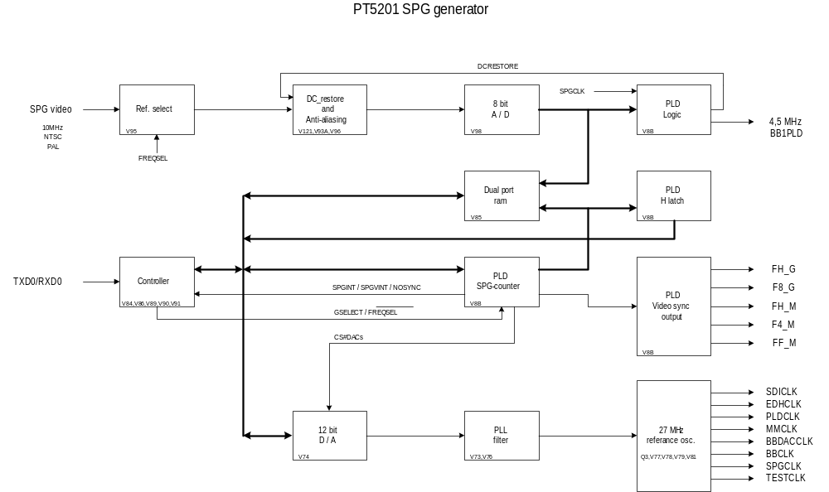
Figure. 3.1 PT5201 Sync Pulse Generator

Block diagram description

The SPG figure 3.1 consist of:
- A analog input circuit to handle video and 10MHz inputs.
- A loop to restore DC on the input signal for the ADC to handle the signal correctly.
- A dual port ram to hold the input signal from the ADC.
- A controller unit to communicate with the PLD and the MASTER.
- A DAC with filter to control the system oscillator.

Detailed Block Diagrams

Video input

Video input block diagram

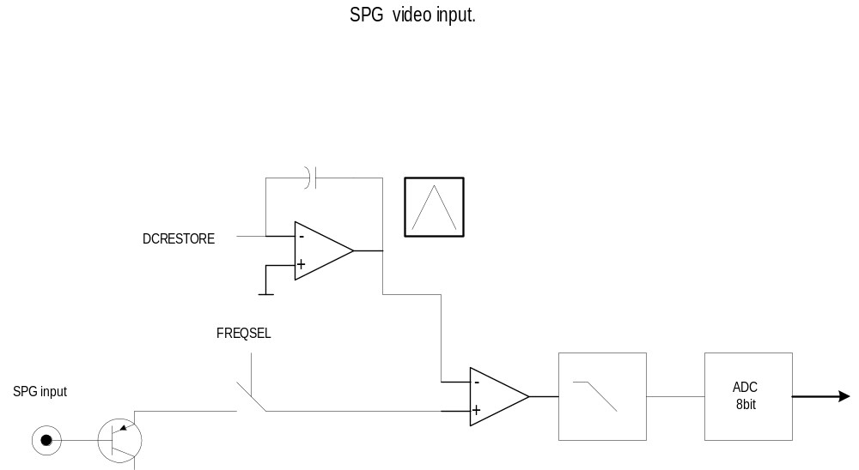

Video input description

The video input is selected via the FREQSEL signal and is along with a integrator signal tuned by the DCRESTORE signal feed to a opamp, the output from the opamp passes through a anti aliasing filter and is converted to a digital signal i the 8bit ADC.

Frequensy input

Frequensy input block diagram
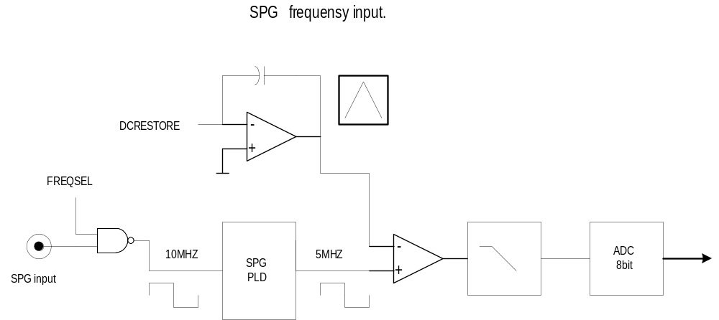

Frequensy input description

The frequensy input is 10MHz which is to much for the filters in the SPG it is therefore devided by two in the PLD. The 5MHz signal is along with a integrator signal tuned by the DCRESTORE signal feed to a opamp, the output from the opamp passes through a anti aliasing filter and is converted to a digital signal i the 8bit ADC.

Master osc adjust

Master osc adjust block diagram

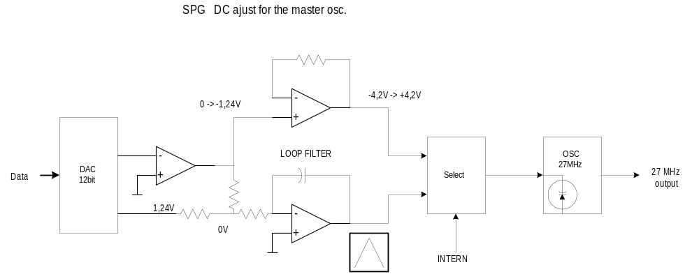
Figure. 3.3.3.1 Dc ajustment for the master osc.

Master osc adjust description

To adjust the master oscillator at 27MHz when locking to a input signal there is a digital adjustable DC for the oscillator.
The adjustment is made by a 12bit DAC and a integrator when locking on a external signal or a opamp which convert the DAC output voltage to a - 4.2volt to + 4.2volt DC. Now the capacitordiode can adjust the output frequency of the master oscillator.

Control

Control block diagram

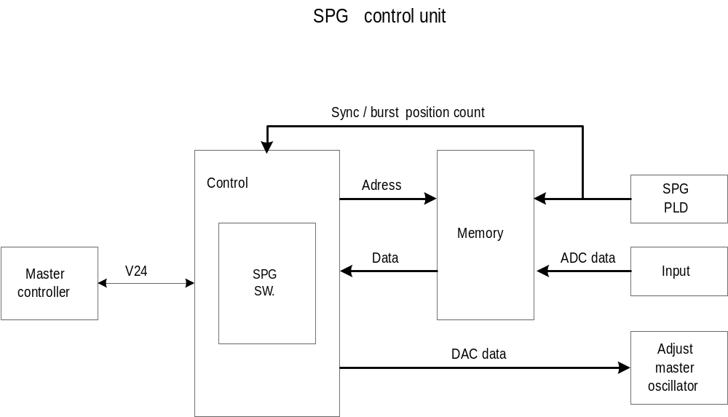
Figure 3.3.4.1 SPG control unit

Control description
The control HW unit handles all the calculations and control signals which are necessary for the SPG. To do this it receives sampled data from the ram and some syncronizing pulses and send some adjust data to the dac.

PLD

PLD block diagram
The translation of the total01.gdf file have to be done in two steps to interface to WORD97 since the output is of a to pur quality please refer to the graphic file: U:\PT5201\...total01.gdf by use of the MAX+II software.

Registers / signals

Register | Adr. |  |  | Signal | Data / adr. bus
 | As[18..0]
READ: | XXX | 000X XXXX | XXXX XXXX | READ_HPOS | Ds[10..0]
 | XXX | 001X XXXX | XXXX XXXX | READ_LOCK | Ds15
 | XXX | 010X XXXX | XXXX XXXX | CE_RAM
WRITE: | XXX | 011X XXXX | XXXX XXXX | CS_DACs | Ds[11..0]
 | XXX | 001X XXXX | XXXX XXXX | ADD | Ds0
 | XXX | 001X XXXX | XXXX XXXX | SUPR | Ds1
 | XXX | 001X XXXX | XXXX XXXX | SAMP | Ds2
 | XXX | 001X XXXX | XXXX XXXX | FRAME | Ds6
 | XXX | 001X XXXX | XXXX XXXX | FV8 | Ds7
 | XXX | 010X XXXX | XXXX XXXX | INTERN | Ds2
 | XXX | 010X XXXX | XXXX XXXX | LEVEL | Ds5

Description of the signals:
READ_HPOS | This bit activates the H-position register and puts the H-position on the databus Ds[10..0].
READ_lOCK | This is the lock-bit generated by the PLD to indicate that the SPG is in lock.
nCE_RAM | This bit is generated by the SPG controller when ever it need access to the dualport ram.
CS_DACS | This bit is generated by the SPG controller when ever it need access to the 12bit dac.
ADD | The ADD bit from the controller activates a six sample add to the sample count
SUBTR | The SUBTR bit from the controller activates a six sample subtract to the sample count
nSAMP | Request from the controller to get access to the dualportram with ADC data.
FRAME | A frame pulse
FV8 | A field 8 pulse
nINTERN | INTERN selects if the reference is to be internal. '0' is internal.
LEVEL | This signal indicates what maximum level the syncpulse may have. '1' is external signal.

PLD timing overview

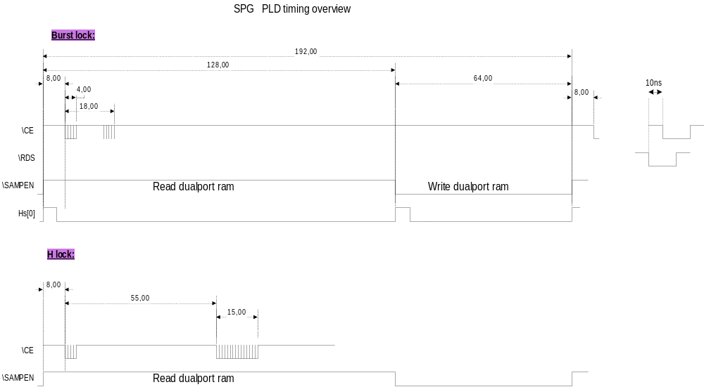

Figure 3.4.3 SPG PLD timing overview

Description of the timing diagram

The overall timing figure 3.4.3 is based on a three line sequence. The sequence ( \SAMPEN ) is 192us long and is basicly a 128us period to read from the ram to the SPG controller and a 64us period to write to the ram from the ADC.
There are two lock modes burtst-lock and h-lock. The h-lock is the worstcase situation and shows that the \CE signal has finished after 78us (8+55+15) of the available 128us.

PLD description

Blocks on the PLD schematic:

EXTLOG01 input/output
EXTLOG01
Input: | SPGCLK: This is the 27MHz system clock.
Input: | ADC[7..0]: This is the sampled data from the SPG input
Input: | INTERN: This signal comming from the SPG controller SW is activated if the SW did not find any signal to lock to. The lock is INTERNal.
Input: | LEVEL: This signal is comming from the SPG controller SW and is activated if the SW did not find any signal to lock to.
Input: | FREQSEL: This signal is comming from the SPG controller SW and is activated if the SW did not find any signal to lock to.
Input: | GSELECT: This signal is comming from the SPG controller SW and indicates which system to run.
Input: | HS[0]: This signal is used to time the h-position and is the LSB of the H_position databus.
Output: | CLP: This is the DCRESTORE output
Output: | NS: This NOSYNC signal indicates if there has been a syncpuls on the input or not.
Output: | V1OUT: This is the line1 field1 puls.
Output: | ELINE: This signal indicates the start of the line ( Hposition ).

EXTSEL01 input/output

EXTSEL01
Input: | NS_VIDEO: This NOSYNC signal indicates if there has been a syncpuls on the input or not.
Input: | FREQSEL: This signal is comming from the SPG controller SW and is activated if the SW did not find any signal to lock to.
Input: | FRAME_VIDEO: This is the line1 field1 puls.
Output: | NS: This NOSYNC signal indicates if there has been a syncpuls on the input or not.
Output: | FRAME: This is the line1 field1 interrupt puls to the SPG controller.

LOCDET01 input/output

LOCDET01
Input: | CLOCK: This is the 27MHz clock.
Input: | WINDOW: This is a 7.26us Hwindow pulse which is active from 2.52us before the sync to 4.74us after.
Input: | ELINE: This signal indicates the start of the line ( Hposition ).
Input: | V1OUT: This is the line1 field1 puls.
Output: | LOCK: This signal indicates if the SPG is in lock or not.

UPROC01 input/output

UPROC01
Input: | WRL_s: This is the writelow pulse from the SPG controller.
Input: | HPOS: This signal indicates the start of the line ( Hposition ).
Input: | Hs[10..1]: This is the adresses where the data on sync or burst are to be found in the ram.
Input: | As13: This is the adress 13 bit from the SPG controller.
Input: | As14: This is the adress 14 bit from the SPG controller.
Input: | As15: This is the adress 15 bit from the SPG controller.
Input: | RD_s: This is the read puls from the SPG controller.
Input: | LOCKBIT: This signal indicates if the SPG is in lock or not.
Input: | SPGBBPRG: This signal comming from the master controller indicates when to program the flash memory.
Input: | TCXO_MOUNTED: This signal tells if the TCXO has been mounted.
Output: | ADD: This signal is active then found sync signal is far to early from the internal hstart to add some clocks to speedup the tuning sequence in the SPG.
Output: | SUBTR: This signal is active then found sync signal is far to late from the internal hstart to substact some clocks to speedup the tuning sequence in the SPG.
Output: | SAMP: This signal is set/reset on request by the SPG controller.
Output: | FRAME: This is a puls comming every 625'th line.
Output: | FV8: This is a puls comming every 8'th field e.g. 2500 lines
Output: | INTERN: This signal indicates if the SPG has to lock on the internal clock.
Output: | LEVEL: This signal is active if the black average is found as expected.
Output: | CS_DACs: This is the chip select signal to the dac.
Output: | Ds[15..0]: This is the SPG data bus.
Output: | CE_RAM: This is the chip select signal to the ram.

SPGLOG01 input/output

SPGLOG01
Input: | CLOCK: This is the 27MHz clock.
Input: | G: This signal is comming from the SPG controller SW and indicates which system to run.
Input: | ADD_IN: This signal is active then found sync signal is far to early from the internal hstart to add some clocks to speedup the tuning sequence in the SPG.
Input: | SUBTR_IN: This signal is active then found sync signal is far to late from the internal hstart to substact some clocks to speedup the tuning sequence in the SPG.
Input: | SAMP_IN: This signal is set/reset on request by the SPG controller.
Input: | FRAMEREF: This is a pulse comming every 625'th line.
Input: | V8REF: This is a puls comming every 8'th field e.g. 2500 lines
Output: | H[10..0]: This is the adresses where the data on sync or burst are to be found in the ram.
Output: | HREFOUT: This is a 7.26us Hwindow pulse which is active from 2.52us before the sync to 4.74us after.
Output: | SPGINT: This is the hint interrupt pulse to the SPG controller.
Output: | SAMP_EN: This is the \CE signal to the ram
Output: | FH_G: This is the line syncpulse output in the system G.
Output: | F8_G: This is the 8field syncpulse output in the system G.
Output: | FH_M: This is the line syncpulse output in the system M.
Output: | FF_M: This is the frame syncpulse output in the system M.
Output: | F4_M: This is the 4field syncpulse output in the system M.

TCXO_CHK input/output

TCXO_CHK
Input: | CLK: This is the 27MHz clock.
Input: | 10M: This is the clock signal from the TCXO ( 10MHz TBD. )
Output: | TCXO_CK: This signal tells if the TCXO has been mounted and run on frequensy about 10MHz.

DIV6_50DUTY input/output

DIV6_50DUTY
Input: | 27MHZ: This is the 27MHz clock.
Output: | 50DUTY: This a 4.5MHz test signal to verify the master clock.

DIV44AA20 input/output

DIV44AA20
Input: | 4_5MHZ: This a 4.5MHz test signal to verify the master clock.
Output: | 1HZ: This signal is used for test

SPG_FLASH_SEL input/output

SPG_FLASH_SEL
Input: | FREQOUT: This is a 10MHz signal from the input when 'FREQSEL' is active.
Input: | SPGBBPRG: This signal comming from the master controller indicates when to program the flash memory.
Input: | NWEHs: This is the writehigh pulse from the SPG controller.
Input: | NWELs: This is the writelow pulse from the SPG controller.
Input: | NRDs: This is the read pulse from the SPG controller.
Input: | NPSENs: This is the psen pulse from the SPG controller.
Input: | As18: This is the adress 18 bit from the SPG controller.
Input: | ALEs: This is the adress latch enable pulse from the SPG controller.
Input: | NRESET: This is the PT5201 reset.
Input: | SPGRESET: This is the SPG reset.
Output: | FREQIN: This is the FREQOUT signal devided by two.
Output: | NWEsf: This is the write pulse for the flash.
Output: | NOEsf: This is the output enable pulse for the flash.
Output: | NCEsf1: This is the chip enable pulse for flash no.1.
Output: | NCEsf2: This is the chip enable pulse for flash no.2.
Output: | TESTLED: This is a test output.

Freqcheck input/output

Freqcheck
Input: | CLK27M: The master clk input to make the function work.  FREQ: This is the 10MHz input devide by 2 (that is 5MHz) to make a frequency which is useable for the filters.
Output: | FREQ_OK: This signal indicates if the 10MHz is within a narrow range ( about ±33kHz )of a nominel 10MHz input. ( '0' = OK )

DIV130 input/output

DIV130
Input: | REFCLK13_5: This is the output from the TCXO with a nominel frequency of 13MHz
Output: | REFCLK/4: This a 100KHz signal are feed to a PLL along with the 27MHz master oscillator.

DIV270 input/output

DIV270
Input: | CLK13_5: This is the output from the master oscillator with a nominel frequency of 13.5MHz
Output: | CLK/4: This a 100KHz signal are feed to a PLL along with the 10MHz TCXO oscillator.

HW schematics

The hardware schematics are made in Orcad Capture version 7.20. Please refer to U:\PT5201\DESIGN\DDD\DIAGRAM\10986581.dsn

Future refinements

To reduse cost in the PT5201 it is possible to fit the dual-port ram into the PLD. The dual-port ram V85 (IDT71V30S35TF) costs about kr. 62,-.
This design proposale will replace the dual-port ram and will NOT need any chances in the exciting software. The princip is to have two 'start loading from the ADC' signals, one 'start load sync' and one 'start load burst'. The PLD file can be found at U:\pt5201\design\ddd\spg_02\pld\extlog_01.tdf

Princip diagram
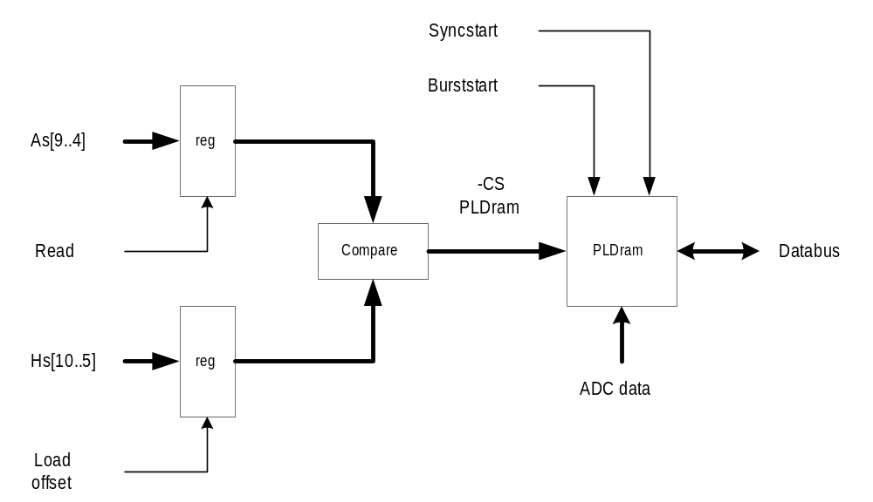

The two signals to start loading the PLD registers:
SYNCSTART = ( G & (E[10..1]==860) ) # ( !G & (E[10..1]==854) & !H0 );
BURSTSTART = (E[10..1]==87) & !H0;

Test and Verification

For test and verification report please look in the document U:\PT5201\design\ddd\spg_2\dtd\DTD_PT5201_SPG.doc

