PT5201

Blackburst

Detailed Test Document

Document Number:
Revision: 2
Release Date: 00-05-31
Author: Torben Schorlemmer
Signature:
Approved by:
Signature:

Table of content

1. Scope and Purpose 3
1.1 Terms and Abbreviations 3
1.2 References 4
2. General 6
3. Test Document 7
3.1 Blackburst Test Description 7
3.1.1 Test verification of the product-data and the standard BT.470 7
3.1.2 Verification on blackburst functions 9
3.2 Final verification 10
3.2.1 Description of the tests 10
3.2.2 Testform 11
4. Troubleshooting on the blackburst 12
4.1 Test procedure 13
4.1.1 Test flowchart 13
4.1.2 Test flowchart description 14
4.2 Chain programming files 15
4.2.1 Chain file for dac and filter 15
4.2.2 Dac and filter test chain files 16
4.2.3 Signal data test chain files 17
4.2.3.1 Signal data bit 0-9 17
4.2.3.2 Signal data bit 10-19 17
4.2.3.3 Signal data bit 20-29 17

Scope and Purpose
This test and verification document shall verify that all product-data and main functions for the blackburst has been verified during development e.g. fine timing, burst amplitude adjustment. EMC test is not covered by this document.

Terms and Abbreviations

Abbreviation | Meaning
G / PAL | The pal video system 625 lines
M / NTSC | The ntsc video system 525 lines
BB | BlackBurst Generator
ScH | Sc-H phase
DUT | Device Under Test
DAC or D/A | Digital to Analog Converter

References

Documents related to the blackburst

3.1.4 | Blackburst testprogram 7108 100 74801 by PF
Standard  ITU-R BT.470-5 | Conventional television systems 1998
Dac and filter test chain files | U:pt5201\design\test_doc\bb\pld\  AND pt5201_bb1_3_dacfilter1mhz.jcf  OR pt5201_bb1_dacfilter1mhz.jcf  OR pt5201_bb2_dacfilter1mhz.jcf  OR pt5201_bb3_dacfilter1mhz.jcf
Signal data test chain files

Signal data bit 0-9 | U:pt5201\design\test_doc\bb\pld\  AND pt5201_bb1_3_testflash0_9.jcf  OR pt5201_bb1_testflash0_9.jcf  OR pt5201_bb2_testflash0_9.jcf  OR pt5201_bb3_testflash0_9.jcf
Signal data bit 10-19 | U:pt5201\design\test_doc\bb\pld\  AND pt5201_bb1_3_testflash10_19.jcf  OR pt5201_bb1_testflash10_19.jcf  OR pt5201_bb2_testflash10_19.jcf  OR pt5201_bb3_testflash10_19.jcf
Signal data bit 20-29 | U:pt5201\design\test_doc\bb\pld\  AND pt5201_bb1_3_testflash20_29.jcf  OR pt5201_bb1_testflash20_29.jcf  OR pt5201_bb2_testflash20_29.jcf  OR pt5201_bb3_testflash20_29.jcf

Pof files used by the programming chain files *.jcf | U:pt5201\design\test_doc\bb\pld\  bb_datasel_dacfilter.pof  bb_datasel_test0_9.pof  bb_datasel_test10_19.pof  bb_datasel_test20_29.pof  testbb_latch.pof  testbb1_1main.pof  testbb1_2main.pof  testbb1_3main.pof  testbbmain_dacfilter.pof

General

The blackburst (BB) generators is the main sync signals in the PT 5201 Compact VariTime™ Sync Generator 1. It makes the syncronization signals for the studio. The BB generators are three identical generators with individually fine timing (0.14ns resolution) as the main feature. They run as well G as M systems and has the ident pulse as a programable feature from the Master controller.

Test Document

Blackburst Test Description
To verify all product-data and all functions, the product datasheet and the BT.470 standard will be used. (PT5201 product-data can be found on www.ProTeleVision.com) The test will be devided into to parts namely an test where the standard as well as the product data has been kept and an final test which will hold some of the product data.

Test verification of the product-data and the standard BT.470

Black Burst PT5201 | System | Product data | Obtained value
Parameter |  |  | BB #1 | BB #2 | BB #3
Sync amplitude | PAL | 300 ± 6 mV (±2%) | 328  272
 | NTSC | 286 ± 5.72mV (±2%)  40 ± 0.8 IRE | 312  259
Sync duration | PAL | 4.7 ± 0.1 μs | 4.7
 | NTSC | 4.7 ± 0.1 μs | 4.7
Sync rise time | PAL | 230 ± 10 ns | 228
 | NTSC | 140 ± 10 ns | 140
Sync fall time | PAL | 230 ± 10 ns | 234
 | NTSC | 140 ± 10 ns | 144
Burst amplitude | PAL | 300 ± 6 mV (±2%) | 308  290
 | NTSC | 286 ± 5.72mV (±2%)  40 ± 0.8 IRE | 294  276
Burst duration | PAL | 2.25 ± 0.23 μs | 2.4
 | NTSC | 2.23 to 3.11 μs  9 ± 1 cycles | 2.55
ScH Phase | PAL | 0 ± 5° | OK
 | NTSC | 0 ± 5° | OK
S/N ratio |  | > 60 dB unwgt 5MHz | 72.6

Black Burst PT5201 | System | Product data | Obtained value
Parameter |  |  | BB #1 | BB #2 | BB #3
resistiv impedans |  | 75 Ω ± 0.375 Ω (0.5%) | 75.3  74.9
Return loss |  | ≥ 36 dB upto 5 MHz | 44 | 46 | 47
Damp of cross talk from an other output |  | ≥ 60 dB for luminans | 85
Damp of cross talk from an other output |  | ≥ 75 dB for chroma | 85
DC output level |  | 0 V ± 50mV | 9
Jitter |  | < 0.5 nsec. pp. | 0.3
Line 7/11 pulse amplitude |  | 500 -700 mV | 650
Line 7/11 Trise / fall |  | 200 ns ±100 ns | 215
4.5MHz to masterclk adjust |  | >100mV | 575
Line duration | PAL | 64 μs | OK
 | NTSC | 63.5555 μs | OK
Field duration | PAL | 20ms | OK
 | NTSC | 16.6833ms | OK
Equalization pulse | PAL | 2.35 ± 0.1 μs | 2.33
 | NTSC | 2.3 ± 0.1 μs | 2.33
Field sync pulse | PAL | 27.3 μs | 27.3
 | NTSC | 27.1 μs | 27.1

Instrument list:

1. Tektronix VM700T, video measurement set Instr. nr. BO30390
2. HP 3577A, network analyzer Instr. nr. 2503A11967
3. PM 5662, waveform mon. / vectorscope Sc-H Instr. nr. Kf. 01-846
4. PT 5201 (DUT), VariTime sync gen. Instr. nr. 5638100002
5. 68BF75 SWR-bridge 32MHz Instr. nr. 71004
6. Oscilloscop PM 3295 Instr. nr. A193343

Verification on blackburst functions

The functions to verify are:
- The fine and coarse timing
- The ident pulse (line 7)
- Systems G and M
These function has been verified via a monitor program.
- Flash 3.3V / 5V
The signal data flash's are tested with both 3.3V (16Mbit types ) and 5V (4Mbit types) devices.

Final verification

These five measurement points will be the final test for the blackburst generators.

Sync amplitude
Burst amplitude
Sc-H Phase
DC output level
Reference - DUT output on an
PM 5662 (a-b)

Description of the tests

This is a short description of the final test, for more information on the test procedure please refer to the testprogram 7108 100 74801 by PF.

Sync amplitude, Burst amplitude, Sc-H Phase and DC output level:
These parameters are interactively tests between an operator and the test-system.

Reference - DUT output on an PM 5662 (a-b):

This is an visuel test to see if the reference blackburst and the DUT are exactly the same.

Testform

Black Burst PT5201 | System | Product data | Obtained value
Parameter |  |  | BB #1 | BB #2 | BB #3
Sync amplitude | PAL | 300 ± 6 mV (±2%)
Burst amplitude | PAL | 300 ± 6 mV (±2%)
ScH Phase | PAL | 0 ± 5°
DC output level |  | 0 V ± 0.05 V
Reference - DUT output on an  PM 5662 (a-b) |  | OK / not OK

Signed:_____________ Date:__________

Troubleshooting on the blackburst

The blackburst generators can each be devided into three functions to reduse troubleschooting time.
- The controller unit. (1)
- The signal data in flash. (3)
- 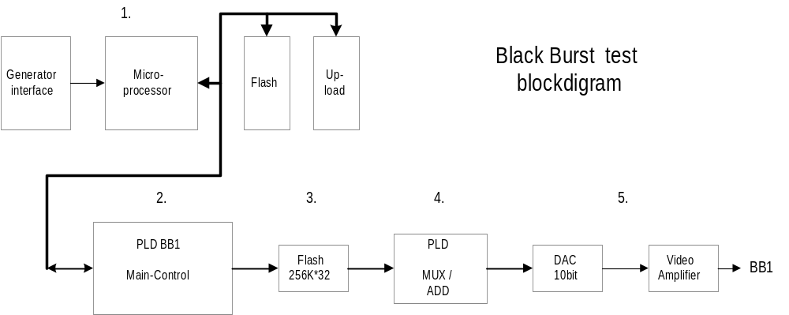Dac and filter. (5)
To verify these functions the block-diagram figure 3.2 can be used.

Fig. 3.2

Test procedure

Test flowchart

This is a coarse flowchart for the test of the blackburst generator (PT5201).

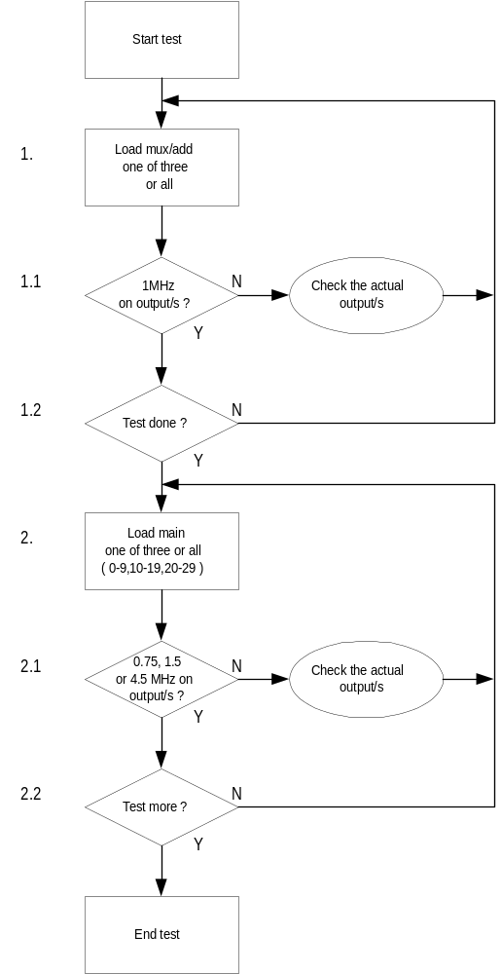

Test flowchart description

1. | Load the defective generator/s mux/add PLD with a test-pattern. The test-chain-file to be loaded is pt5201_bb1_3_dacfilter1mhz.jcf or the specific file for one generator. Please refer to chapter '4.2.2 Dac and filter test'.
1.1 | Check the output with a frequency-counter, it should be 1MHz.
1.2 | If more generators are defective start again at 1. or 1.1 according to what has been loaded.
2. | Load the defective generator/s main-control PLD with a test-pattern. The test-chain-file to be loaded is pt5201_bb1_3_testflash0_9.jcf for bits 0-9, pt5201_bb1_3_testflash10_19.jcf for bits 10-19 and pt5201_bb1_3_testflash20_29.jcf for the last bits 20-29 or the specific file for one generator. Please refer to chapter '4.2.3.1 Signal data bit 0-9, 4.2.3.2 Signal data bit 10-19 and 4.2.3.3 Signal data bit 20-29'.
2.1 | Check the output with a frequency-counter, it should be 0.75MHz for bits 0-9, 1.5MHz for bits 10-19 and 4.5MHz for bits 20-29.
2.2 | If more generators are defective start again at 2. or 2.2 according to what has been loaded.

Chain programming files

The Altera chain programming file (*.jcf) contain a list of parth's to the files to be loaded for the PLDs in the programming chain. To use these programmingsfiles please refer to Altera's documentation on this issue.

Chain file for dac and filter

Example 1. shows the chain file 'pt5201_bb1_3_dacfilter1mhz.jcf' which will enable all three blackburst generators to output a 1MHz signal on each BNC plug . As the chain shows it is not nessesary to program device 1,4 and 7 for this function.

Example 2. shows the chain file ' pt5201_bb1_3_testflash0_9.jcf' which will enable all three blackburst generators to output a 0.75MHz signal on each BNC plug it tests only 0-9 out of a total of 30 bits. As the chain shows it is in this example nessesary to program all device for this function.

Example 1.
JCF002
[JTAG_CHAIN]
DEVICE_1=EPM3064A
DEVICE_2=EPM3064A u:\pt5201\work\..\..\testbbmain_dacfilter.pof
DEVICE_3=EPM3064A u:\pt5201\work\..\.. \bb_datasel_dacfilter.pof
DEVICE_4=EPM3064A
DEVICE_5=EPM3064A u:\pt5201\work\..\.. \testbbmain_dacfilter.pof
DEVICE_6=EPM3064A u:\pt5201\work\..\.. \bb_datasel_dacfilter.pof
DEVICE_7=EPM3064A
DEVICE_8=EPM3064A u:\pt5201\work\..\.. \testbbmain_dacfilter.pof
DEVICE_9=EPM3064A u:\pt5201\work\..\.. \bb_datasel_dacfilter.pof

Example 2.
JCF002
[JTAG_CHAIN]
DEVICE_1=EPM3064A u:\pt5201\work\..\.. \testbb_latch.pof
DEVICE_2=EPM3064A u:\pt5201\work\..\.. \testbb1_2main.pof
DEVICE_3=EPM3064A u:\pt5201\work\..\.. \bb_datasel_test0_9.pof
DEVICE_4=EPM3064A u:\pt5201\work\..\.. \testbb_latch.pof
DEVICE_5=EPM3064A u:\pt5201\work\..\.. \testbb1_2main.pof
DEVICE_6=EPM3064A u:\pt5201\work\\..\.. \bb_datasel_test10_19.pof
DEVICE_7=EPM3064A u:\pt5201\work\\..\.. \testbb_latch.pof
DEVICE_8=EPM3064A u:\pt5201\work\..\.. \testbb1_2main.pof
DEVICE_9=EPM3064A u:\pt5201\work\..\.. \bb_datasel_test20_29.pof

Dac and filter test chain files

Please refer to '4.2.1 Chain file for dac and filter' for examples on the *.jcf files.

pt5201_bb1_3_dacfilter1mhz.jcf
pt5201_bb1_dacfilter1mhz.jcf
pt5201_bb2_dacfilter1mhz.jcf
pt5201_bb3_dacfilter1mhz.jcf

Signal data test chain files

To verify the flash data it is possible to devide the test into three subtests. That is the 'signal data bit 0-9' test, the 'signal data bit 10-19' test and the 'signal data bit 20-29' test. Under each test it is possible to examend one or all BB generators.

Signal data bit 0-9

Please refer to '4.2.1 Chain file for dac and filter' for examples on the *.jcf files.

pt5201_bb1_3_testflash0_9.jcf
pt5201_bb1_testflash0_9.jcf
pt5201_bb2_testflash0_9.jcf
pt5201_bb3_testflash0_9.jcf

Signal data bit 10-19

Please refer to '4.2.1 Chain file for dac and filter' for examples on the *.jcf files.

pt5201_bb1_3_testflash10_19.jcf
pt5201_bb1_testflash10_19.jcf
pt5201_bb2_testflash10_19.jcf
pt5201_bb3_testflash10_19.jcf

Signal data bit 20-29

Please refer to '4.2.1 Chain file for dac and filter' for examples on the *.jcf files.

pt5201_bb1_3_testflash20_29.jcf
pt5201_bb1_testflash20_29.jcf
pt5201_bb2_testflash20_29.jcf
pt5201_bb3_testflash20_29.jcf

