PT5201

SPG

Detailed Test Document

Document Number:
Revision: 2
Release Date: 00-05-31
Author: Torben Schorlemmer
Signature:
Approved by:
Signature:

Table of content

1. Scope and Purpose 3
1.1 Terms and Abbreviations 3
1.2 References 4
2. General 5
3. Test Document 6
3.1 SPG Test Description 6
3.1.1 Block diagram 6
3.1.2 Check of main functions 7
3.1.3 Parameter check/test on version 1 PCB 7
3.1.4 Parameter check on PCB version 2 8
3.1.5 Check of other parameters 8
3.2 Final verification 9
3.2.1 Description of the tests 9
3.2.2 Testform 10
4. Troubleshooting on the SPG 11

Scope and Purpose
This test and verification document shall verify that all product-data and main functions for the SPG has been verified during development e.g. genlock, syncronization signals. EMC test is not covered by this document.

Terms and Abbreviations

Abbreviation | Meaning
G / PAL | The pal video system with 625 lines
HW | Hardware
M / NTSC | The ntsc video system with 525 lines
SPG | Sync Pulse Generator
SW | SoftWare
DDD | Detailed Design Document
PLD | Programmeble Logic Device
PLL | Phase Lock Loop
SW | Software
TBD | To Be Determined
TCXO | Temperature Controled X-tal Oscillator
MASTER | The master controller in the PT 5201
DAC or D/A | Digital to Analog Converter
ADC or A/D | Analog to Digital Converter
OSC | Oscillator
AES/EBU | The standard for the sound generator

References
Documents related to the SPG
ADD_PT5201_SPG | Architectual Design Document  U:\PT5201\design\ddd\spg_2\add\ADD_PT5201_SPG.doc
DDD_PT5201_SPG | Detailed Design Document  U:\PT5201\design\ddd\spg_2\ddd\DDD_PT5201_SPG.doc
DTD_PT5201_SPG | Detailed Test Document  U:\PT5201\design\ddd\spg_2\dtd\DTD_PT5201_SPG.doc
total01.gdf | The graphic PLD file  U:\PT5201\design\ddd\spg_2\pld\total01.gdf
10986581.dsn | The hardware schematics  U:\PT5201\DESIGN\DDD\DIAGRAM\10986581.dsn

General

The SPG is the 'heart' in the PT5201 Compact VariTime™ Sync Generator. It makes all the syncronization signals for the master-controller and the other functions in the PT5201 that is the blackburst-generators, the color-generator and the AES/EBU-generator.
It can syncronize to a video input signal either in PAL or in NTSC or a 10MHz input.

Test Document

SPG Test Description
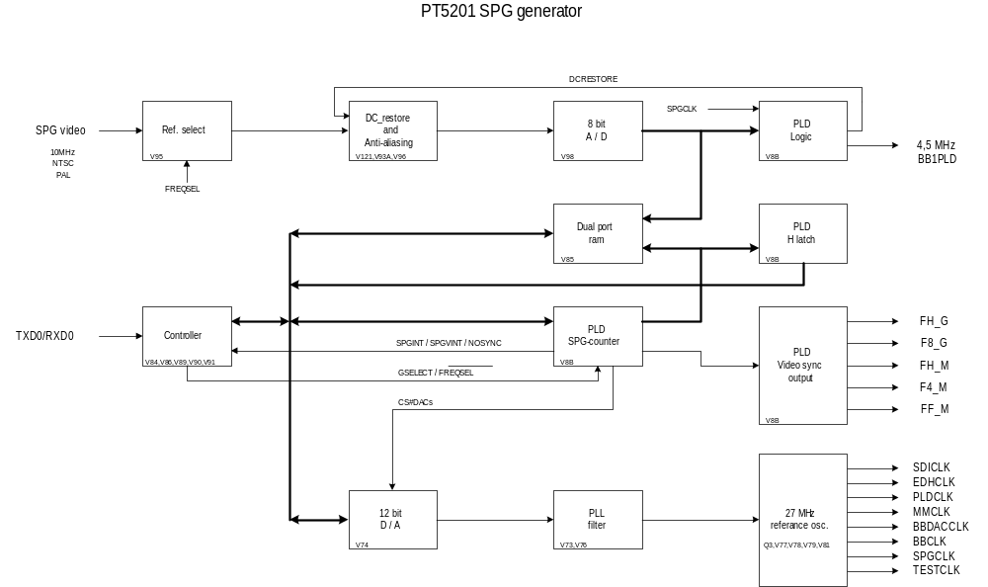To verify all product-data and all functions, the product datasheet will be used. The PT5201 product-data can be found on www.ptv.dk The test will be devided into to parts namely an test where the functions as well as the product data has been kept and an final test which will hold some of the product data.

Block diagram

Check of main functions

SPG PT5201 | Product data | Obtained
Main functions |  | Value
Sync signals | FH_G, F8_G, FH_M, F4_M and FF_M | OK
Lock | PAL, NTSC and 10MHz | OK
TP 25: DC restore | Check DCrestore clamps the signal to black with and without 75 Ω termination | OK
X13p9: | X13p9: Under lock there will be a DC voltage and if the SPG is in internal mode the DC voltage will have only one value which after the final test will be the same. | OK

Parameter check/test on version 1 PCB

SPG PT5201 | System | Product data | Obtained
Parameter |  |  | value
Loop through |  |  | OK
Return loss |  | >36dB to 6MHz | 50
Genlock |  | PAL,NTSC;VIDEO | OK
Amplitude |  | 1V ± 3 dB | OK
Timing range | PAL | ± 4 fields | OK
 | NTSC | ± 2 fields | OK
Timing resolution |  | < 0.5 ns | OK

Instrument list:

1. HP 3577A, network analyzer Instr. nr. 2503A11967
2. PT 5201 (DUT), VariTime sync gen. Instr. nr. 5638100002
3. 68BF75 SWR-bridge 32MHz Instr. nr. 71004
4. Oscilloscop PM 3295 Instr. nr. A193343

Parameter check on PCB version 2

The version 2 PT5201 has got a redesigned main oscillator which will need a test on some parameters.

SPG PT5201 | System | Product data | Obtained
Parameter |  |  | value
Input with noise |  | >26 dB
Sc-H phase |  | ± 45º
Jitter when locked to burst |  | < 0.5º
Jitter when locked to sync |  | < 2 ns
Pull-in range for fsc |  | ± 50 Hz ( 9ppm)

Check of other parameters

D18: This test signal will if the master oscillator runs bee gleaming at about 1Hz.

Final verification

These seven measurement points will be the final test for the SPG.
Input with noise
Pull-in range for fsc
Burst low | PAL
 | NTSC
Burst high | PAL
 | NTSC
Sync low | PAL
 | NTSC
Sync high | PAL
 | NTSC
10MHz

Description of the tests

This is a short description of the final test, for more information on the test procedure please refer to the testprogram 7108 100 74801 by PF.
All parameters:
These parameters are interactively tests between an operator and the test-system.

Testform

SPG PT5201 | System | Product data | Obtained
Parameter |  |  | value
Input with noise |  | >26 dB
Pull-in range for fsc |  | 1V
Burst low | PAL | 150mV
 | NTSC | 20IRE (143mV)
Burst high | PAL | 600mV
 | NTSC | 80IRE (572mV)
Sync low | PAL | 180mV
 | NTSC | 24IRE (171.6mV)
Sync high | PAL | 600mV
 | NTSC | 80IRE (572mV)
10MHz |  | 1V ± 6 dB

Signed:_____________ Date:__________

Troubleshooting on the SPG

The SPG troubleshooting can be done by using the SPG (DDD) Detailed Design Document (path found in 1.2 References) where the basic elements of the SPG are descriped. One extra test feature has been used under development that isTP13 on V8 which indicates that the clamp value is less than 02 hex from the 8bit video ADC. This is useful when testing the DCrestore function.

