
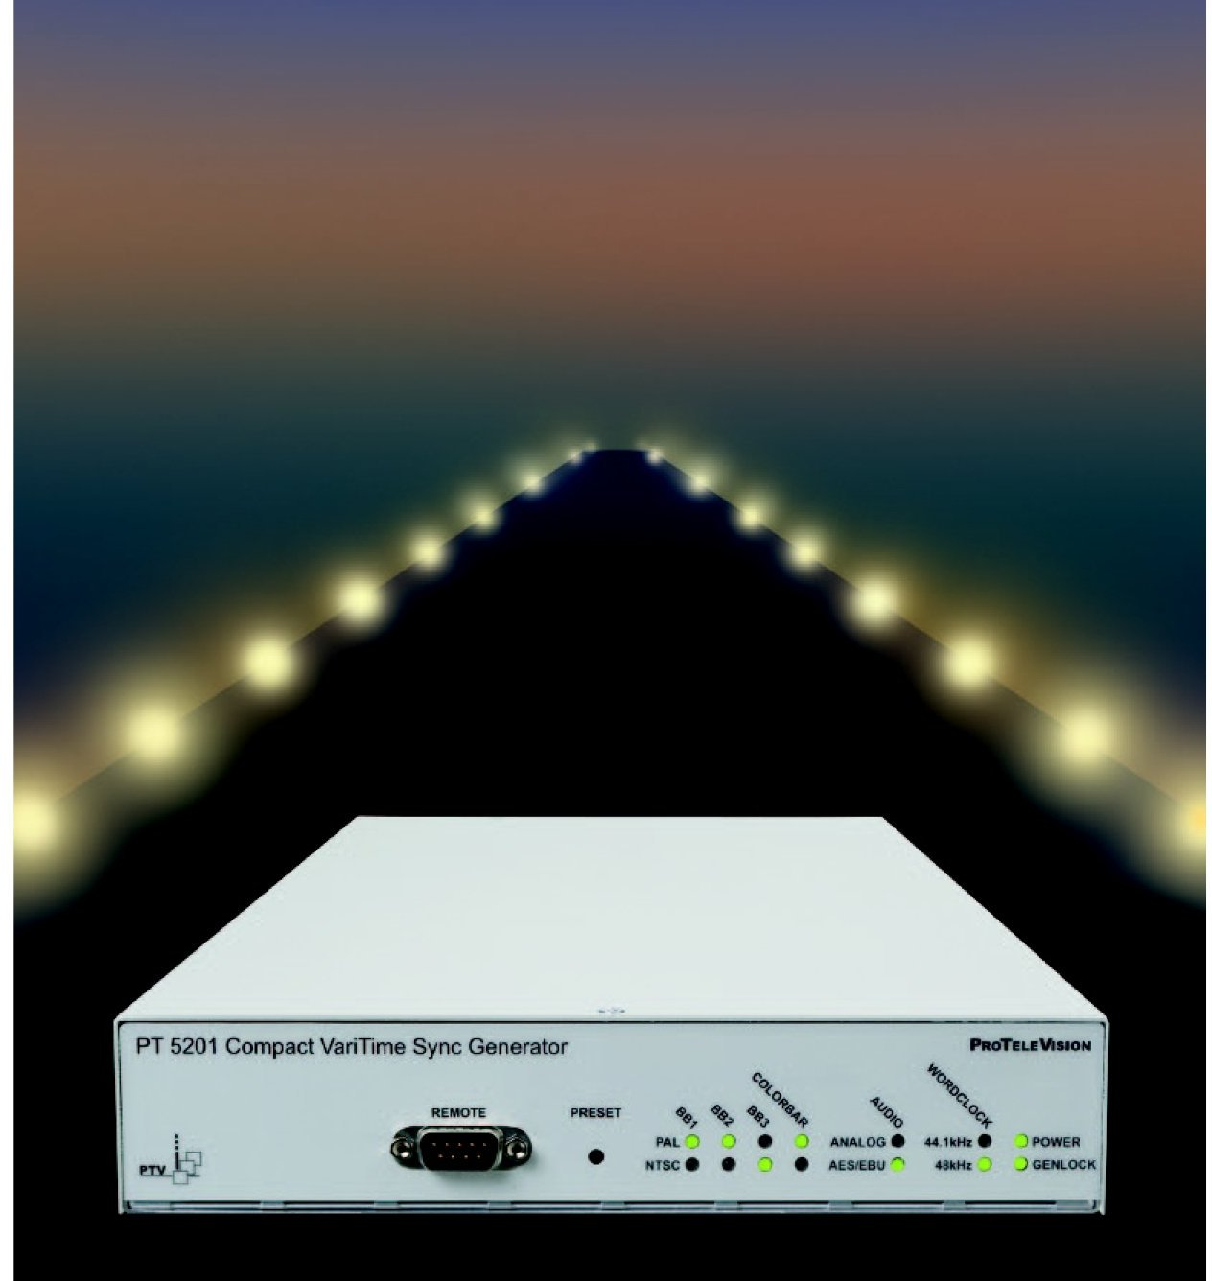

PT 5201 Compact Varitime™ Sync Generator

Click on of the following items to run or install:
- Control via Windows® Interface: PT5201 Remote.exe
- Operating Manual: PT5201 Manual
- Application Note: Where in the Studio does the PT5201 fit ?
- Data Sheet PT 5201 data

Last saved : 30. May 2002 Version: 1.4

DK-Audio A/S
Marielundvej 37 D
DK-2730 Herlev

Denmark

Email:
info@dk-audio.com

Website:
www.dk-audio.com

Date: 30. May 2002

