Modification of first series of PT5201:

This note describes the changes, which will improve the first series of the PT5201’s:

- Reduction of burst jitter gen-lock
- Reduction of H-jitter
- Reduction of SDI jitter

Modifications:

Diagram page 8:

L16 to be removed
LM337 a negative regulator with associated resistors to be mounted instead of L16, see drawimngs below
Output voltage of regulator to be: 2.8-2.9V
V-130 LM337LZ
R-137 332 Ohm , 1%
R-138 267 Ohm, 1%
NB. Other combination of R137 and R138 may be used when only a voltage 2.8-3.0 V is achieved.

Changes in the PCB board:
- Cut tracks as shown later in this document.
- Connect V-78B pin 4 to V79A pin 1 (via the end of the not-mounted R182).
- Connect V-79A pin 3 to via hole (signal REFCLK13.5 going to PLD, V8B pin113).

R289 to be changed to 33R2, 1%

R162 to be changed to 562 Ohm
R174 to be changed to 182 kOhm

Diagram page 10+11:
C324 to be removed
C325 to be removed
C326 to be removed

Diagram page 16:
Tendency to oscillations in Genlock input:
R210 to be changed to 1K00
C244 to be changed to 5p6

Diagram page 7:

R378 to be changed to 100Ohm, 1% (was 8k25)
R379 to be changed to 10k0, 1% (was 1K00)
C333 to be changed to 1nF (was 10pF)

R303 to be changed to 4k75, 1% (was 7k50)
Connection from R303 to via hole at end of resistor to be cut.
Now this free end of R303 to be connected to output of LM337lz by means of a lead.

Component list:
Position | Type | 12 NC
V-130 | LM337 lz, negative adjust. Voltage regulator | 9337 497 30682
R-137 | SMD 332 R 1%, 805 | 4008 100 70460
R-138 | SMD 267R 1%, 805 | 4008 100 70450
R-289 | SMD 33R2. 1%, 805 | 4008 100 70350
R-210 | SMD 1K00 . 1%, 805 | 4008 100 70510
C-244 | CAP SMD 5P6 NP0 P5 0805 | 2222 861 15568
R-162 | SMD 562R 1% 0805 | 4008 100 70160
R-174 | SMD 182 k 1%, 805 | 4008 100 70780
R-378 | RES SMD 100R. 1%, 805 | 4008 100 70410
R-379 | RES SMD 10k0 1%, 805 | 4008 100 70630
C-333 | CAP SMD 1N NPO 1% 1206 | 2222 863 18102
R-303 | RES SMD 4k75 1%, 805 | 4008 100 70590

Note:
Some of the delivered components may be slightly different in values, e.g. 330 Ohm instead of 332 Ohm.

R-378 is 110 Ohm instead of 100 Ohm

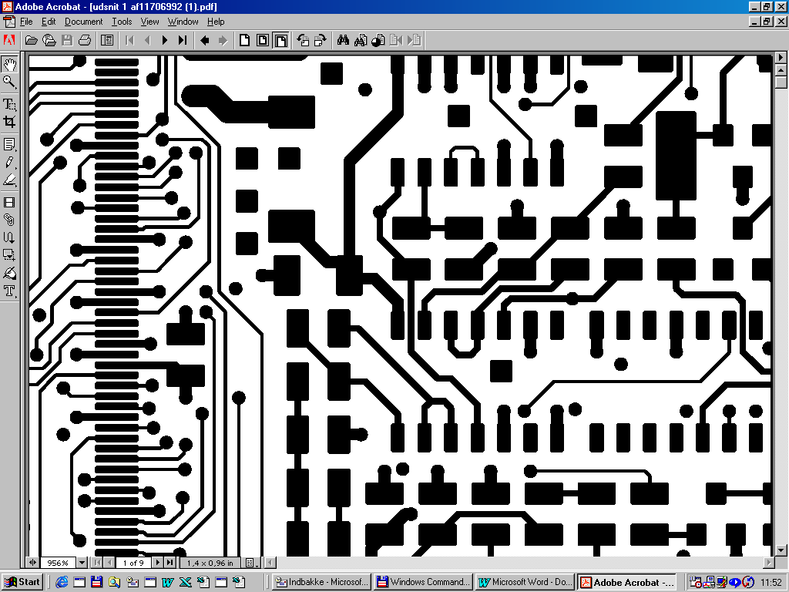
Changes in PCB:
Cut tracks at markings

Connect V-78B pin 4 to V79A pin 1 (via the end of not-mounted R182).

Connect V-79A pin 3 to via hole (signal REFCLK13.5 going to PLD, V8B pin113).

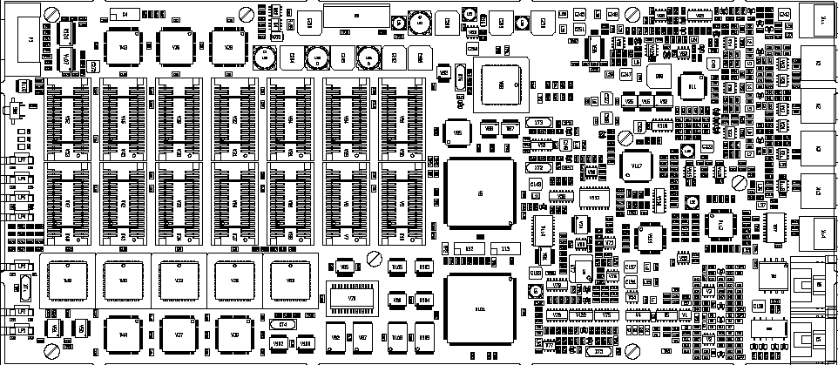

Modification of connection to R303

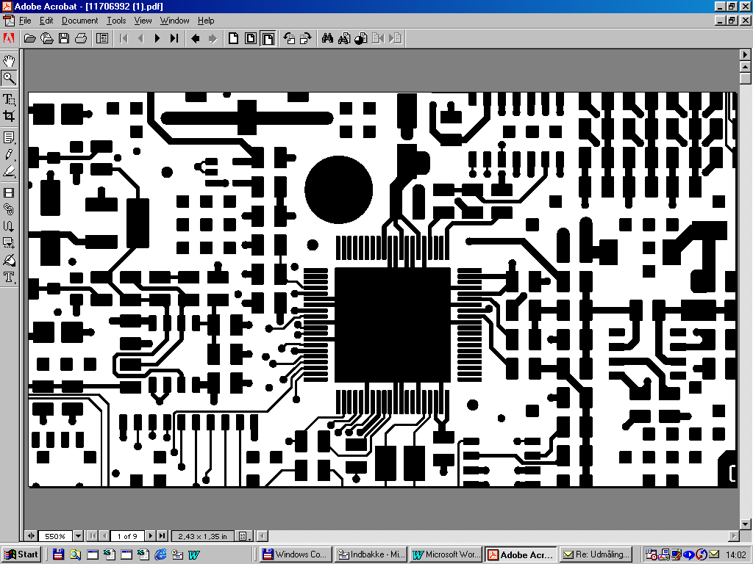
R303 modification
Cut track between via and resistor pad

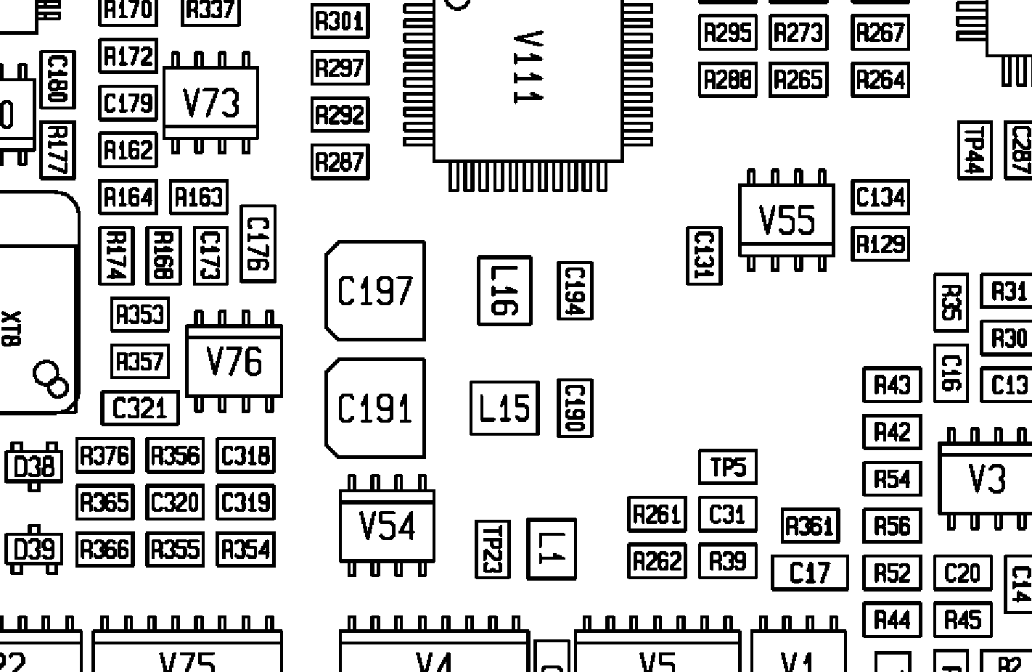

LM337
GND
Connect to
R303
332 Ohm

267 Ohm
Check
Voltage : - 2,8 til -2,9V

Bilag 5

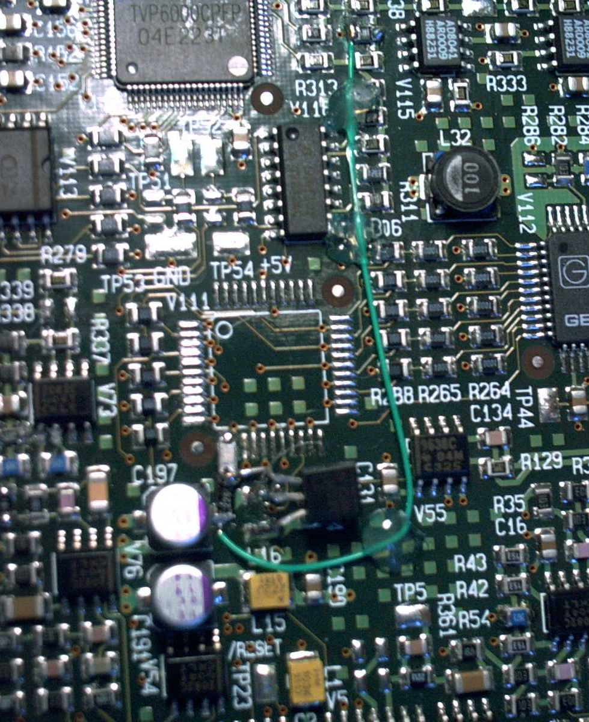

Removal and change of components:

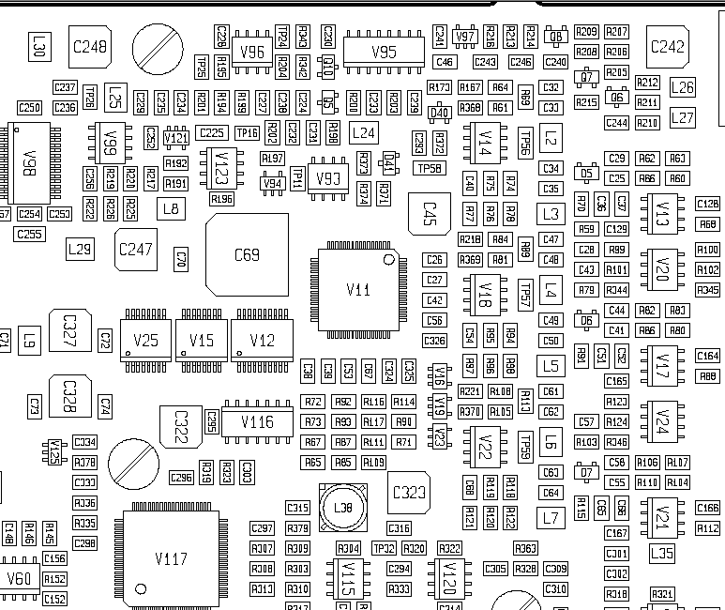
Fjern C324, C325, C326

