- VaritimeTM, 8 fields for PAL
- VariTimeTM, 4 fields for NTSC
- Slave applications, genlocking to PAL, NTSC or 10 MHz clock
- Stand-alone SPG with internal TCXO master reference
- Multistandard: 525/60, 625/50 and dual standard operation
- Outputs:
3 independant Black Bursts
1 SDI Test Signal Generator
(incl. SDI Black)

1 Analog video generator
1 AES/EBU or Analog Audio
1 Word Clock at 44.1 or 48 kHz
- Source identification programmable into colourbar on SDI and analog Video
- Source identification, fixed or scrolling up/down
- Easy operation via menu or serial control via RS232 interface
- Windows user interface application included
- Four programmable presets directly selectable

- 1U, half 19" wide and rackmountable

Compact VariTimeTM Sync Generator,
PT 5202

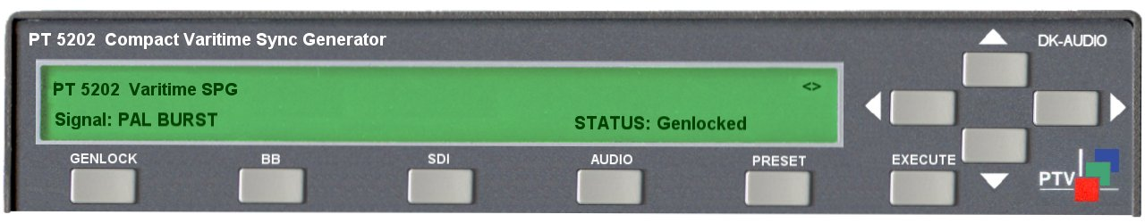
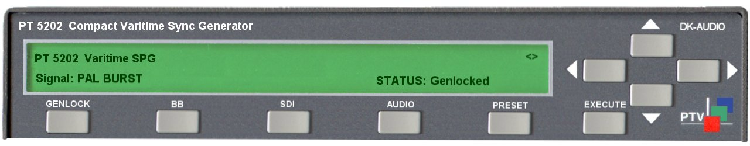

Application
The new digital studios need cost effective and reliable synchronisation for the main equipment to work reliably. For this purpose PTV offers a fully integrated solution eliminating any costs associated with modular structures, support of many different signal types and fancy operating features.

All solutions have been carefully designed to meet the requirements for the modern studio and editing.

PTV/DK-Audio introduces the next generation of the Compact Varitime Sync Generator.
The PT 5202 includes all basic features for professional sync, timing and test signals in one half-sized box.

New is a user friendly frontplate control and moving text on the colourbar pattern.
DK-AUDIO

Ease of Operation
A clearly labelled frontplate with separate pushbutton for quick access to main functions allows intuitive selection of main functions.
When a main function is selected, the detailed menu structure is opened on the LCD screen. In the menus all programmable parameters can be managed, e.g. timing, testsignals and audio parameters.
Also the frontplate gives instant access to 4 presets.

In addition to the frontplate control, all configurations can be set via an RS232 interface.
To facilitate the remote control without having to make a software code, a Windows application program is included with the instrument.
The Windows interface makes it easy to manage all timing, test signals and audio features in one screen. Modification from factory preset can be saved as a file on the PC or uploaded to the PT 5202 as a setup. The setup is uploaded to PT 5202 in an instant mode or stored as a preset in the instrument.
Communication between PT 5202 and PC via standard RS-232 protocol makes it possible to use most PC.

Master/Genlock Applications
The PT 5202 is designed to manage slave as well as master operations, as a stand-alone unit.
In systems where PT 5202 operates as a master unit it is controlled by an internal TCXO reference oscillator.
For use in applications where the PT 5202 operates as a slave the genlock function is used.
The genlock function features genlock to NTSC and PAL video signals, Black Burst, composite or a 10 MHz reference clock, e.g. from a GPS receiver. Furthermore the genlock function features timing and active loop-through of the genlock signal.

Analog Black Burst Outputs
TM analog Black Burst outputs. Each of these Black Burst outputs is individually fully timeable (±4 fields in PAL, ±2 fields in NTSC) and can be configured as NTSC or PAL-generator, in any combination.

NTSC signals are configurable with or without set-up.

SDI Output
An SDI Test Signal generator, fully configurable in system and timing, is also included. This Test Signal Generator provides standard colourbars and testpatterns, according to SMPTE and EBU. For diagnostics in studio setups a list of testsignals is available. The SDI output includes codes for embedded audio, featuring data for 1kHz Stereo and silence
The SDI signals are in general generated as 10 bit signals, except one of the EBU 75% Colourbar signals which is generated with 8 bit according to ITU 801

Analog Video Output
The analog video generator is based on the same digitally signal definitions as the SDI Test Signal Generator. It outputs the same test pattern in the same system and with the same sync timing.The output is configurable with or without set-up.

This output, which is primarily meant for testing purposes, is not consistently locked to the BB's and therefore the colour-frame (ScH phasing) may randomly be one of four at power-up. Consequently this output is not recommended for timing purposes

Source Identification
One line of 16 characters can be programmed into the EBU Colourbar and the SMPTE bar. The text is fixed positioned or can be made scrolling up/down to reveal if a digital transmission link is in a “freeze” condition.

Audio Generators
PT 5202 contains an Analog Audio Generator or an AES/EBU Serial Digital generator. One format at the time as both signals are available on the same XLR connectors.

Analog Audio Outputs
The Analog Audio generator provides three different test tones in a number of levels. The output is available in stereo or mono and includes click markers for identification of left channel. The click interval is selectable.

AES/EBU Serial Digital Audio Outputs
The Serial Digital Audio generator provides three different test tones in a number of levels. The output is available in stereo or mono and includes click mar-kers for identification of left channel. The click interval and samplings frequency for the AES/EBU output is selectable. The ge-nerator also features system lock and timing facilities for elimination of Lip Sync problems.

WordClock Output
The WordClock signal is a continuous reference clock operating at HC-MOS level, used for synchronising audio equipment. The sampling frequency of 44.1 or 48 kHz is selectable. The 48 kHz is phaselocked to video, while the 44.1 kHz is frequency locked only.

Presets
Four complete presets are included to make it easy to change the configu-ration for different setups. Switching between the presets is possible from the frontpanel. The number of presets stored in the configuration PC is unlimited.

Master oscillator

Master Frequency Reference TCXO:
- Temperature drift: 0-50°: ± 2,5 ppm
- Ageing: (1 ppm/year first year, then
- better).

Remote Control
- Input interface: RS-232 port, 9 pole D-sub, male
- Protocol: SCPI based
- Baud rate: 9600 Kbit

Genlock
- Input: 75 Ohm looped through
Connector: BNC
- Return loss: >36 dB to 6 MHz
- Genlock Signal:
Video: PAL, NTSC
Continuous freq.: 10 MHz
- Genlock Video requirements:
Amplitude: nominal ± 3 dB
S/N ratio: >26 dB
Input Sc-H phase: Nominally ±45°
- Genlock Continuous freq.:
Amplitude: 1 V ± 3 dB
- Pull-in range for fsc.: ± 50 Hz
- Jitter when locked to burst: < 0,5°
- Jitter when locked to sync: < 5 ns

- Timing facilities, range:
PAL: ± 4 fields
NTSC: ± 2 fields
- Resolution:
Analog Black Burst < 0.15 ns
SDI and Analog Video: 37 ns

Analog Black Burst Outputs
- Output interface: BNC, 75 Ohm
- Return loss: >36 dB, to 5 MHz
- Sync amplitude:
PAL: -300 mV ± 2%
NTSC: -286 mV ± 2%
- Burst amplitude:
PAL: 300 mV ± 2%
NTSC: 286 mV ± 2%
- NTSC set-up: 0 or 7.5 IRE
- Timing range:
PAL: ± 4 fields
NTSC: ± 2 fields
- Timing resolution: 0.15 ns
- Sc-H phase: Default 0°, adjustment
± 180°, resolution < 1°
- S/N ratio: 60 dB unweighted to 5 MHz
- Jitter on burst: < 0.5 °

SDI Test Signal Output
- Output Interface: BNC, 75 Ohm
- Format:
270 Mb/s serial, complies with ITU-R BT 656 and SMPTE 259 M
- Return loss: >15 dB, 5 – 270 MHz
- Timing range:
PAL: ±1 field
NTSC: ± 1 field
- Timing resolution: 37 ns
- Jitter: < 0.20 UI
- Rise and fall time: 0.75 - 1.50 ns
- Embedded Audio: 1 kHz stereo,
levels: -20 dB_{FS} for 525 lines
-18 dB_{FS} for 625 lines
Silence and Off

- Analog Video Output
- Output interface: BNC, 75 Ohm
- Return loss: >36 dB to 5 MHz
- Sync amplitude
PAL: -300 mV±2%
NTSC: -286 mV±2%
- Burst amplitude
PAL: -300 mV±2%
NTSC: -286 mV±2%
- NTSC set-up: 0 or 7.5 IRE
- Timing resolution: 37 ns
- Sc-H phase:
Default 0°, adjustment ± 180°, resolution ± 1,5°
- S/N ratio:
60 dB unweighted to 5 MHz
- Colourframing compared to BB’s is not consistent, may be either 0°, 90°, 180° or 270° at power-up.

Common test signals, SDI and analog generator:

Specific 525-lines patterns
- SMPTE Colour Bar
- FCC

Specific 625-lines patterns:
- EBU Colour Bar
- 75% Colour Bar with Red
- CCIR 18 Multiburst

Common Test patterns 525 and 625-lines:
- 75% Colour Bar, ITU-R BT.801 (timing and level acc. To ITU 801)
- 100% Colour Bar
- 75% Red
- 10% window
- 15% Window
- 20% Window
- 100% Window
- 15 kHz Black/White
- White 100%
- Black
- SDI Check Field
- Digital Grey
- Staircase, 5 Step
- Staircase, 10 Step
- Crosshatch
- PLUGE

Source Identification on SDI and Video
- Text on EBU colourbar and on SMPTE colourbar
- 1 line of text with up 16 characters
- Text position: fixed or scrolling up/down

Analog Audio Output
- Output Interface:
Balanced XLR, 30 Ohm
- Amplitude: 0 dBu, 775 mV
- Distortion: < 0.1%
- Output signals:
Stereo 500 Hz, no click
Stereo 1 KHz, no click
Stereo 8 KHz, no click
Stereo EBU, 1 KHz, single click in ch A
- Click rate: 1 or 3 sec.
- Levels: From +10 to -36 dBu in
steps and Silence

AES/EBU Audio Output
- Output Interface: Balanced XLR, 110 Ohm ± 20% (According to AES3 1992)
- Amplitude: Typically 3 Vpp
- Rise and fall time: 10 - 30 ns
- Jitter: <20 ns
- Timing range: ± 10 µs in 0.8 µs step
- Data rate: 3.072 Mbit/s
- Sampling frequency: 44,1 kHz or 48 kHz
- Coding: Linear PCM, 20-bits two complement binary, Biphase mark
- Output signals:
Stereo 500 Hz, no click
Stereo 1 kHz, no click
Stereo 8 kHz, no click
Stereo EBU, 1 kHz, single click in ch. A
- Click rate: 1 or 3 sec
- Levels: Silence, 0 -9, -12, -15, -16,
-18, -20 dB_{FS}
• Pre-emphasis: None

WordClock Output
- Output Interface: BNC, 75 Ohm
- Reference output: 44.1 or 48 KHz
HC-MOS level 0-5V unterminated

Power Supply
- Mains supply voltage: 100-240V
- Frequency: 47-63 Hz
- Power consumption: 22W

Mechanical data
19" rackmountable cabinet
- Height: 42 mm ( 1.73")
- Width: 217 mm (8.54")
- Depth: 400 mm (17.3")
- Weight: 2.5 kg (5.5 lbs)

Environmental data
- Operational temperatures:
+5°C to +45°C (41°F to 113°F)
- Storage temperatures:
-30°C to 70°C (-22° to +158°)

Electromagnetic compatibility
- Complies with requirements for immunity and emission in EN55103-1 and EN55103-2

Safety
- Safety: complies with IEC/ EN61010-1

Rackmount
- Rackmount kit included

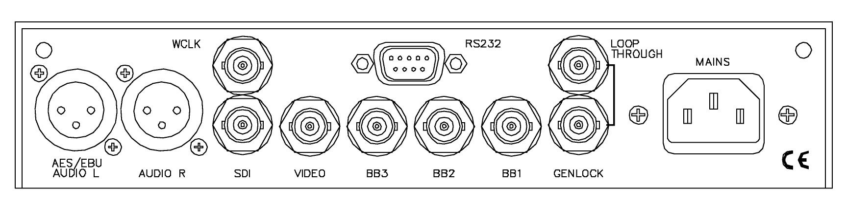

Rearpanel PT 5202

PT 5202 Compact VariTimeTM Sync Generator 9449 052 02001

FOR FURTHER INFORMATION
Contact the PTV sales office in your area, or contact us directly:

Data subject to alteration without notice.
Printed in Denmark
2003-06-23

International: DK-AUDIO A/S • Marielundvej 37D • DK-2730 Herlev • Denmark
Tel: +45 44 85 02 55 • Fax: +45 44 85 02 50 • e-mail: info@dk-audio.com
UK: DK-AUDIO (UK) Ltd • Crableck Lane • Sarisbury Green • Southhampton SO31 7ZN • England
Tel: +44 870 2414 118 • Fax: +44 870 2414 119 • e-mail: apa@dk-audio.com
Germany: DK-AUDIO Germany • Ziegeleiweg 16 • D-31832 Springe • Germany
Tel: +49 (0) 5041 80 29 80 • Fax: +49 (0) 5041 80 29 99 • e-mail: info.de@dk-audio.com
USA: DK-AUDIO America Inc. • 4417 East Villa Rita Drive, Phoenix, AZ 85032, USA
Tel: +1 602 765 0532 • Fax: +1 602 765 1473• e-mail: jdt@dk-audio.com

